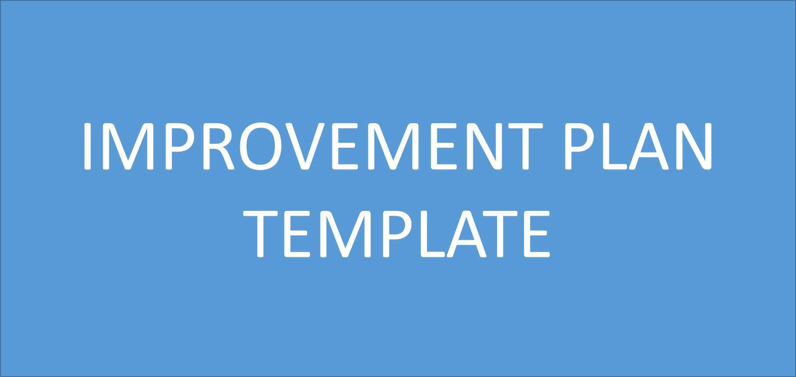
District Mission: Preparing Each Student for A Successful Future
District Vision: A Leader in Academic Success, Dedicated to Community Priorities

School Mission
Insert Mission Here

School Vision
Insert Vision Here

Collective Commitments

Insert Collective Commitments here

Leadership Team

Insert Names of Leadership team here

ACADEMICS
- Literacy
- Numeracy

- Literacy Data Analysis What are your key successes? Key gaps? How do you know?
Key Successes
- .
Key Gaps

PLAN: What is the school literacy goal and its success criteria? | DO: What will the school (teachers, students, and leaders) do to accomplish the plan? | Measures: How will you measure each step in the “DO”?
Professional Learning: What professional learning might be needed to support the “DO”?
(Also include in the School Professional Learning Plan)
STUDY/ACT: Checkpoint:
Based on the results of your measures, what’s working? What adjustments are suggested by the data?

ACADEMICS
- Numeracy Data Analysis What are your key successes? Key gaps? How do you know?
Key Successes

Key Gaps

PLAN: What is the school numeracy goal and its success criteria? | DO: What will the school (teachers, students, and leaders) do to accomplish the plan? | Measures: How will you measure each step in the “DO”?
Professional Learning: What professional learning might be needed to support the “DO”?
(Also include in the School Professional Learning Plan .

STUDY/ACT: Checkpoint
Based on the results of your measures, what’s working? What adjustments are suggested by the data?

Culture
- Attendance
- Site Choice
- Attendance Data Analysis What are your key successes? Key gaps? How do you know?
Key Successes

Key Gaps

PLAN: What is the attendance goal and its success criteria? | DO: What will the school (teachers, students, and leaders) do to accomplish the plan? | Measures: How will you measure each step in the “DO”?
Professional Learning: What professional learning might be needed to support the “DO”?
(Also include in the School Professional Learning Plan)
STUDY/ACT: Checkpoint
Based on the results of your measures, what’s working? What adjustments are suggested by the data?

Culture

- Site Choice Data Analysis What are your key successes? Key gaps? How do you know?
Key Successes

Key Gaps

PLAN: What is the attendance goal and its success criteria? | DO: What will the school (teachers, students, and leaders) do to accomplish the plan? | Measures: How will you measure each step in the “DO”?
Professional Learning: What professional learning might be needed to support the “DO”?
(Also include in the School Professional Learning Plan)
STUDY/ACT: Checkpoint
Based on the results of your measures, what’s working? What adjustments are suggested by the data?

LEADERSHIP
- School Discipline
- Site Choice
- School Discipline Data Analysis What are your key successes? Key gaps? How do you know?
Key Successes
- .
Key Gaps

PLAN: What is the school literacy goal and its success criteria? | DO: What will the school (teachers, students, and leaders) do to accomplish the plan? | Measures: How will you measure each step in the “DO”?
Professional Learning: What professional learning might be needed to support the “DO”?
(Also include in the School Professional Learning Plan)
STUDY/ACT: Checkpoint:
Based on the results of your measures, what’s working? What adjustments are suggested by the data?
LEADERSHIP

- School Choice Data Analysis What are your key successes? Key gaps? How do you know?
Key Successes
- .
Key Gaps

PLAN: What is the school literacy goal and its success criteria? | DO: What will the school (teachers, students, and leaders) do to accomplish the plan? | Measures: How will you measure each step in the “DO”?
Professional Learning: What professional learning might be needed to support the “DO”?
(Also include in the School Professional Learning Plan)
STUDY/ACT: Checkpoint:
Based on the results of your measures, what’s working? What adjustments are suggested by the data?

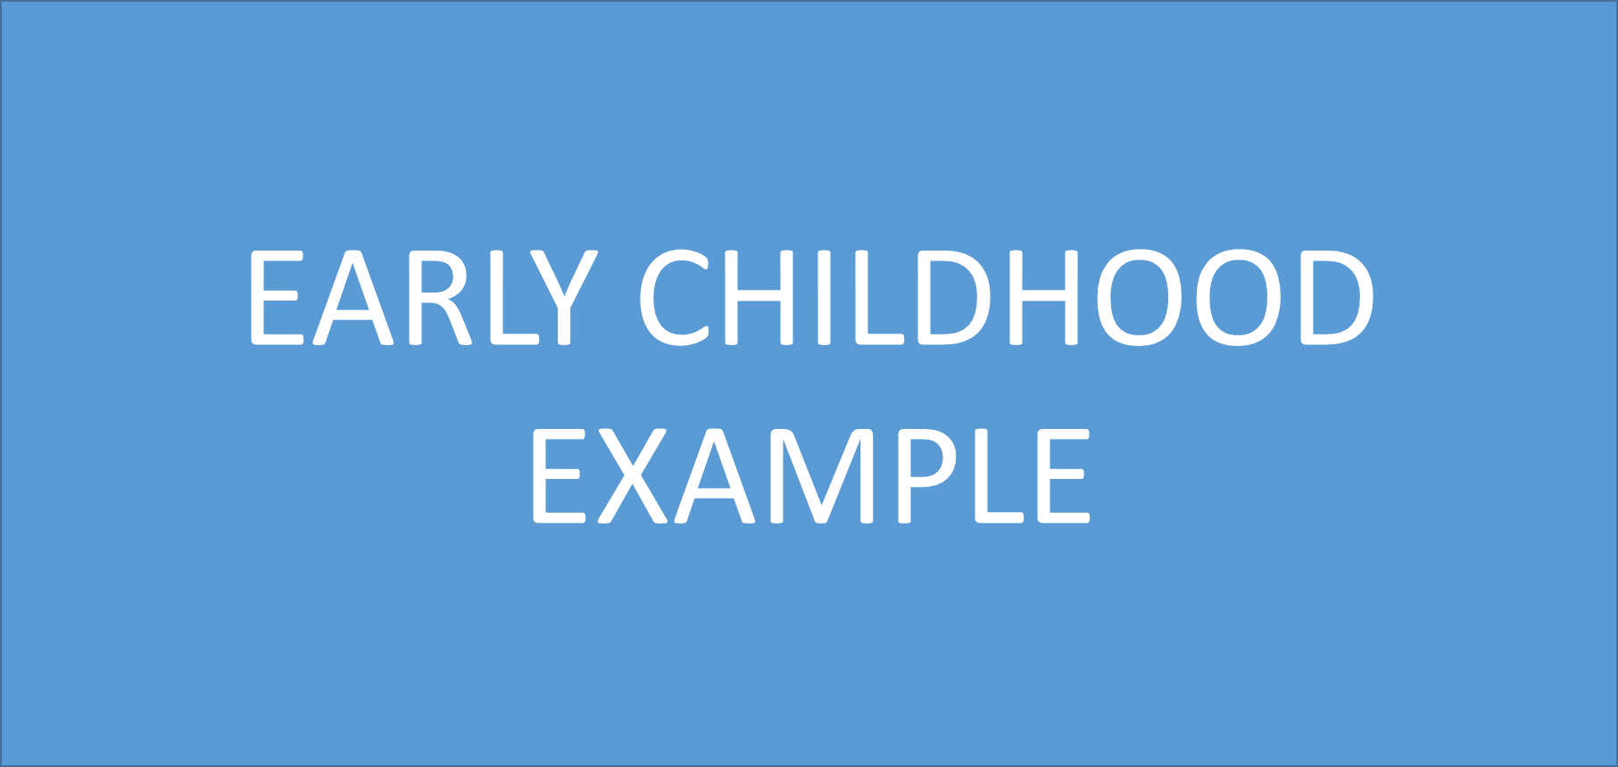
Republic R-III School District 2023-2024 School Improvement Plan

District Mission:
RepMO is preparing each student for future excellence through a safe educational environment

District Vision:
RepMO will be a model community dedicated to education without limitation that empowers learners to create their own success.

Early Childhood Mission
The Republic Early Childhood Center fosters a safe and loving community dedicated to providing a foundation of lifelong learning.

Early Childhood Vision
We will Engage students to Connect, Care, Unite, and Believe they can Succeed.

Collective Commitments
Be Positive, Be Present, Be Professional, Be Purposeful, & Participate

Leadership Team
Amy Allen - PreK Teacher
Kristi Barnes - ECSE Teacher
Sami Bass - PS/PreK Teacher
Alysia Brooks - Specials Teacher
Noelle Gibbs - PreK Teacher
Linse Hawks - Speech Language Pathologist
Courtney Laswell - PreK Teacher
Jennifer Manegold - PreK Aide
Jody Matthews - ECSE Teacher
Shaina McMunn - Assistant Director
Alyssa Phillips - Director
Whitney Stapp - PreK Teacher
Jessica Wiener - PreK Aide
Sherri Wright - Parents As Teacher Educator

ACADEMICS
Literacy Data Analysis What are your key successes? Key gaps? How do you know?

22-23 End of the Year Study/Act
- Key Successes:
  - 92.5% of students achieved academic proficiency in literacy skills on the progress report.
  - Heggerty Phonemic Awareness was implemented in all PreK classrooms.
- Key Gaps:
  - Vocabulary instruction looks different in each classroom.
PLAN: What is the school literacy goal and its success criteria? | DO: What will the school (teachers, students, and leaders) do to accomplish the plan? | Measures: How will you measure each step in the “DO”?
- 80% of students will be proficient in literacy skills on the progress report.  - 80% of students will be proficient on Heggerty phonemic awareness assessments (skills listed on the progress report). | - All literacy components of the Emerging Language & Literacy Curriculum will be implemented:  - Shared Storybook Reading: 15-20 minutes daily  - Phonological Awareness Groups: 10 minutes twice a week  - Learning Centers: 40 minutes twice daily  - Literacy Circle Time: 15 minutes twice daily  - Heggerty Phonemic Awareness Curriculum will be utilized daily. | - Quarterly progress reports will document building progress toward meeting the literacy goal of 80%  - Q1: 75.4%  - Q2: 87.9%  - Q3:  - Q4:  - Quarterly phonemic awareness (blending & segmenting) will document progress toward meeting the phonemic awareness goal of 80%  - Q1: 63% (blend) 45% (segment)  - Q2: 87% (blend) 85.7% (segment)  - Letter identification assessments will document progress doward meeting the goal of 80% proficiency.  - Q1:26% (lower) & 55% (capital)  - Q2: 41% (lower) & 53% (capital)  .
Professional Learning: What professional learning might be needed to support the “DO”? (Also include in the School Professional Learning Plan)
- A research based routine from LETRS training will be shared to support teachers and help them intentionally choose vocabulary words to highlight during instruction and interactions with students. The process will be modeled and then teachers will work collaboratively to prepare lessons to utilize during Storybook Reading Circle time. Formative assessments will be administered and reviewed for next steps during collaborative planning.
- SLPs will provide cues for all phonemes to assist with sound production to assist classroom teachers to better support phonemic awareness & letter id instruction.
- Year one teachers will participate in literacy coaching cycles with the district numeracy specialist.
STUDY/ACT: Checkpoint:
Based on the results of your measures, what’s working? What adjustments are suggested by the data?
Mid-Year Checkpoint:

ACADEMICS
Numeracy Data Analysis What are your key successes? Key gaps? How do you know?

22-23 End of the Year Study/Act
- Key Successes:
  - 96% of students achieved academic proficiency in numeracy skills on the progress report.
  - All PreK teachers received training from the district numeracy specialist regarding implementation of the math with Me Kindergarten Math Readiness & Engagement curriculum. New math mentor texts to support essential math standards were provided.
- Key Gaps:
  - A sequence of math skills has been requested to help guide teachers support students who achieve proficiency early in the school.
PLAN: What is the school numeracy goal and its success criteria? | DO: What will the school (teachers, students, and leaders) do to accomplish the plan? | Measures: How will you measure each step in the “DO”?
- 80% of students will be proficient on numeracy items on the progress report. | - The numeracy component of the Emerging Language & Literacy Curriculum and activities from The Math with Me Kindergarten Math Readiness & Engagement curriculum will be implemented:  - Math & Science Circle Time:15 minutes daily | - Quarterly progress reports will document building progress toward meeting the numeracy goal of 80%  - Q1: 48.9%  - Q2: 72.7%  - Q3:  - Q4:  - Number identification assessments will document progress doward meeting the goal of 80% proficiency.  - Q1: 55% (0-10)  - Q2: 78% (0-10)
Professional Learning: What professional learning might be needed to support the “DO”? (Also included in the School Professional Learning Plan
- A research based routine from LETRS training will be shared to support teachers and help them intentionally choose vocabulary words to highlight during instruction and interactions with students. The process will be modeled and then teachers will work collaboratively to prepare lessons to utilize during Math Circle time. Formative assessments will be administered and reviewed for next steps during collaborative planning.
- Collaboration will take place with the district numeracy specialist to develop a numeracy document with sequence of skills for kindergarten readiness.
- Year two teachers will participate in numeracy coaching cycles with the district numeracy specialist.

STUDY/ACT: Checkpoint
Based on the results of your measures, what’s working? What adjustments are suggested by the data?
Mid-Year Checkpoint:

CULTURE
- Attendance 2. Action Teams 3. Social/Emotional Learning
- Attendance Data Analysis What are your key successes? Key gaps? How do you know?

22-23 End of the Year Study/Act
- Key Successes: A few attendance plan incentives were put in place and informational graphics were shared with staff and families.
- Key Gaps: The attendance average for the 2022-2023 school year was 89%.
PLAN: What is the attendance goal and its success criteria? | DO: What will the school (teachers, students, and leaders) do to accomplish the plan? | Measures: How will you measure each step in the “DO”?
- 93% of students will be in attendance during the 2023-2024 school year. | - An attendance pyramid and attendance plan will be created to outline three levels of tier interventions.  - Classrooms will showcase tiger cub earning stripes on perfect attendance days and participate in celebrations after goal is met.  - Classroom teachers will make parent contact if a pattern of absence occurs OR after two consecutive days of absence.  - EC will celebrate classroom attendance daily by hanging flags outside classroom doors when 100% attendance occurs.  - Students who have 100% weekly attendance will receive a shout-out from the assistant director during monthly announcement videos.  - Administration will review attendance reports monthly, feature attendance quotes once a month on FB.  - Administration will send home letters to families and schedule family conferences for students who display attendance concerns.  - Each month our overall staff average monthly attendance is 95%, we will participate in a sweats day! | - The district quarterly BSIP Report will document building progress toward meeting the goal of 93% or higher ADA.  - EC administrators will meet monthly to review attendance.  Student Attendance August: 96% September 94%: October: 94% November: 94% December:92% January: February: March: April: May: Average for Year: Staff Attendance August: 94% September: 95% October: 94% November: 93% December: 93% January: February: March: April: May: Average for Year:
Professional Learning: What professional learning might be needed to support the “DO”? (Also include in the School Professional Learning Plan)
- Staff will read Dramatically Improving Attendnace by Prick, Alabiso, & Yore and review attendnace graphics from Attendance Works will be reviewed.
STUDY/ACT: Checkpoint
Based on the results of your measures, what’s working? What adjustments are suggested by the data?
Mid-Year Checkpoint:

CULTURE
- Celebrating Action Team Data Analysis What are your key successes? Key gaps? How do you know?

22-23 End of the Year Study/Act
- Key Successes: Mini action teams (tier one behavior support and collective commitment development), were implemented.
- Key Gaps: 24% of staff reported not having an opportunity to serve on a leadership team.
PLAN: What is the supportive student environment goal and its success criteria? | DO: What will the school (teachers, students, and leaders) do to accomplish the plan? | Measures: How will you measure each step in the “DO”?
100% of teachers will serve on an action team related to one of the following areas of focus: culture, academic, or leadership. Classified staff will be invited to participate. | - Educators will meet to plan during:  - August SI Day  - Monthly Faculty Team Meetings  - Early Release Monthly Rotation  - Teams will create a goal for tracking and implementing action team plans that contains:  - Responsibilities  - Timeline  - Notes | - Admin will visit action team meetings to monitor goal tracking each month.  - Culture & Climate survey results will be reviewed in the spring of 2024.  - Survey Question:  - I have the opportunity to serve on a leadership committee/team at EC (Culture & Climate Spring 2023)  - 3.83 on a 5.0 scale (classfied & certified)
Professional Learning: What professional learning might be needed to support the “DO”?
(Also include in the School Professional Learning Plan)
- Opportunities to learn more about the goal tracking process will be provided to leadership team members. Leadership team members will lead their respective teams through the process.
STUDY/ACT: Checkpoint
Based on the results of your measures, what’s working? What adjustments are suggested by the data?
Mid-Year Checkpoint:

CULTURE
- Celebrating Social Emotional Learning Data Analysis

22-23 End of the Year Study/Act
- Key Successes: 80% of staff agree or strongly agree that they felt more empowered/supported after participating in site professional learning.
- Key Gaps: The 2023 PDC Needs Assessment Review indicated the top three area of professional development need to focus around social emotional learning, trauma informed practice, Consious Discipline components, and relate to mental health strategies.
PLAN: What is the supportive student environment goal and its success criteria? | DO: What will the school (teachers, students, and leaders) do to accomplish the plan? | Measures: How will you measure each step in the “DO”?
- Teachers, paras, aides, and administration will participate in social emotional focused professional development. | - Staff will engage monthly in this learning during early release rotation.  - Staff will engage in this learning during an August SI Day (leadership jobs - CD)  - Staff will engage in 7 Habits training during the October & February SI Days.  - Tier 1 and Tier 2 Strategies from the EC Behavior Pyramid will be implemented to support students. | - Survey Question  - Each student has a “leadership job” in their classroom (Culture & Climate Spring 2023)  - Score of 3.75 on a 5.0 scale (certified & classified)  - Score of 3.79 on a 5.0 scale (parents)  - Survey Question  - As a certified employee at EC, the professional development opportunities have been beneficial to me as a professional (Culture & Climate Spring 2023)  - Score of 3.73 on a 5.0 scale (certified)  - Survey Question  - The district supports my overall wellness (Culture & Climate Spring 2023)  - Score of 3.72 on a 5.0 scale (certified & classified)  - Survey Question:  - Clear student discipline expectations are present in my school (November 2022)  - Score of 3.76 on a 5.0 scale (certified)  - Score of 3.33 on a 5.0 scale (classified)
Professional Learning: What professional learning might be needed to support the “DO”?
(Also include in the School Professional Learning Plan)
- Staff will participate in a reverse book study format utlizing the text Reaching and Teaching Children Exposed to Trauma by Barbara Sorrels.
- Staff will engage in Consious Discipline Training and complete the following course: Handling Upset: The Adult-First Mindset Shift.

STUDY/ACT: Checkpoint
Based on the results of your measures, what’s working? What adjustments are suggested by the data?
Mid-Year Checkpoint:

LEADERSHIP
- Increase Involvement in Parent/Family Engagement Events & Communication
- Parent/Family Engagement Events & Communication Data Analysis What are your key successes? Key gaps? How do you know?

22-23 End of the Year Study/Act
- Key Successes: Family engagement opportunities increased and we hosted four events.
- Key Gaps: Climate and Culture Survey data indicated a need for additional special events.
PLAN: What is the school involvement in parent/family engagement and communication goal and its success criteria? | DO: What will the school (teachers, students, and leaders) do to accomplish the plan? | Measures: How will you measure each step in the “DO”?
- EC will host six parent family engagement events:  - Grandparent’s Night  - Fall Party  - Spring Party  - PreK Promotion  - Field Day  - Family Fun Night  - EC will implement a parent presenters program.  - EC will communicate with families via SeeSaw & weekly newsetters | - Staff action teams and PTO will plan events.  - Staff action teams will plan and implement a parent presenter program aligned with the curriculum unit plan.  - Communication:  - Teachers will commit to the following with Seesaw:  - Post a minimum of twice a week  - Expectation is to respond to families within 24 hours on Seesaw and between the hours of 6 a.m. and 6 p.m  - Posts can consist of:  - Engaging or collaborative activities  - Upcoming theme learning  - Class leadership jobs  - Quarterly goals  - Goals achieved (individual or class)  - Celebrations  - Important Dates  - Teachers will commit to the following with classroom newsletters:  - Send weekly  - Components determined collectively by staff | - _/6 events:  - Add dates, agenda, & flyers  - Climate & Culture Survey Question  - The special events at EC help me feel engaged with my student’s school.  - Score of 3.81 on a 5.0 scale (parent)  - Climate & Culture Survey Question  - I feel informed of the growth my student is making toward his or her goals (parent)  - Score of 3.85 on a 5.0 scale
Professional Learning: What professional learning might be needed to support the “DO”? (Also include in the School Professional Learning Plan)

STUDY/ACT: Checkpoint:
Based on the results of your measures, what’s working? What adjustments are suggested by the data?
Mid-Year Checkpoint:

LEADERSHIP
- Provide Parents with Ongoing Education Data Analysis What are your key successes? Key gaps? How do you know?

22-23 End of the Year Study/Act
- Key Successes: EC hosted one parent education event alongside Burrell.
- Key Gaps: Climate and Culture Survey data indicated a need for additional information regarding individual student goals and progress to be shared with families.
PLAN: What is the plan for the provide parents with ongoing education goal and its success criteria? | DO: What will the school (teachers, students, and leaders) do to accomplish the plan? | Measures: How will you measure each step in the “DO”?
Short-term goals (literacy, math, social) will be posted in classrooms. | - Two goals will be posted in each classroom and updated quarterly.  - Short-term goals align to the MEL standards and units currently being taught in the classroom.  - Teachers will create a chart for tracking the percentage of children who meet the goal and display it in their classroom.  - When 80% of the children in the classroom meet the class goal, a whole class celebration will occur and include all children.  - Celebrations will be shared in classroom weekly newsletters, monthly family newsletters, and on the EC FB page.  - Students will be honored monthly on school wall and on FB who practice leadership qualities and actions. | - Administration will do classroom goal checks each quarter.  - Climate & Culture Survey Questions:  - The classrooms at EC set student learning goals (certified & classified)  - Score of 4.61 on a 5.0 scale
Professional Learning: What professional learning might be needed to support the “DO”?
(Also include in the School Professional Learning Plan)
STUDY/ACT: Checkpoint:
Based on the results of your measures, what’s working? What adjustments are suggested by the data?
Mid-Year Checkpoint:
Goal Met
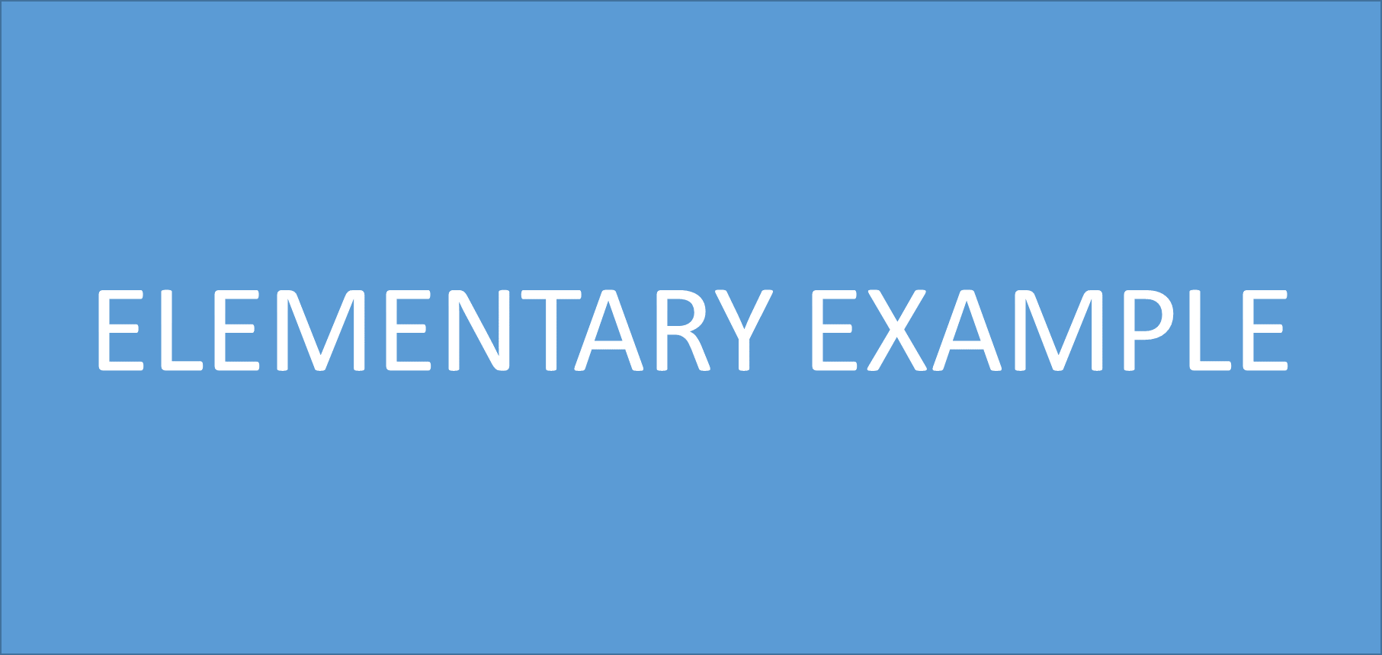

District Mission: RepMO is preparing teacher student for future excellence through a safe educational environment.
District Vision: RepMO will be a model community dedicated to education without limitation that empowers learners to create their own success.

School Mission

Serving together to be kind, high-achieving, lifelong learners!

School Vision

McCulloch Elementary, in partnership with parents and the community, with instill in all students high standards for learning, integrity, leadership, and responsible citizenship.

Collective Commitments

The staff of McCulloch Elementary commit to:
- Putting students first in all decisions.
- Practicing open and honest communication with all stakeholders.
- Contributing to ensure a successful team.
- Valuing, uplifting, and supporting our teammates.
- Being solution focused.

Leadership Team

Camie Lyons, Principal Jill Clock, Kindergarten
Trey Allen, Assistant Principal Emily Hanson, First Grade
Tiffany Jones, K-2 Counselor Cheyanne Weis, Second Grade
Emily McCarty, 3-5 Counselor Mary Martha Ponder, Third Grade
Kristin Maerke, Literacy Specialist Hannah Rebmann, Fourth Grade
Amber Simpson, Lighthouse Coordinator Megan Ganz, Fifth Grade
Brittney Stoecklein, Lighthouse Coordinator Taylor Shields, SLP

McCulloch Elementary School’s Objectives and Data Analysis
ACADEMICS
Literacy
- Literacy Data Analysis What are your key successes? Key gaps? How do you know?
Key Successes
- During the 2022-2023 school year, our building average for reading common assessments exceeded our building goal of 80 percent with 84.92%.
- During the 22-23 school year, the following grades met or exceeded our building goal of 80 percent proficiency on reading common assessments: Kindergarten, First Grade, Fourth Grade, and Fifth grade.
- McCulloch increased proficiency on reading common assessments from the 21-22 school year to the 22-23 school year by 2.06 percent.
- McCulloch’s building average for reading common assessments was 3.34 percent higher than the district average.
- 4th grade MAP proficiency increased from 55.41% in the 21-22 school year to 62.5% proficiency.
- 5th grade MAP proficiency increased from 58.23% proficiency in the 21-22 school year to 60.98% proficiency.
Key Gaps
- 2nd grade reading common assessment data for the 22-23 school year did not meet the building goal with 77.96 percent proficiency.
- 3rd grade reading common assessment data for the 22-23 school year did not meet the building goal with 75.08 percent proficiency.
- 3rd grade MAP proficiency did not increase from the previous year and stayed at 55% proficiency.
PLAN: What is the school literacy goal and its success criteria? | DO: What will the school (teachers, students, and leaders) do to accomplish the plan? | Measures: How will you measure each step in the “DO”?
More than 80% of McCulloch students will be proficient in Reading as assessed by grade level common assessments.  McCulloch students will meet at least 80% proficiency in Writing as assessed by grade level common assessments.  3rd, 4th, and 5th grade students will achieve an average of at least 60% or greater Proficient/Advanced as assessed on the Missouri Assessment Program test administered in the Spring. | - Classroom teachers will collaborate with their grade levels to identify key successes and gaps in their grade level data and to create GLIPs that align with the goals established in this BSIP. The goals established will be reviewed quarterly during data meetings to determine the effectiveness of intervention practices.  - The following next steps in literacy will be implemented during the 2023-2024 school year:  - Units of instruction for phonics and phonemic awareness in K-3  - Heggerty Phonemic Awareness curriculum in Kindergarten, 1st Grade, and 2nd Grade.  - Text Dependent Questions used regularly during small group reading.  - Close Reading lessons incorporated will be consistent with unit of instruction expectations.  - McCulloch Title 1 teachers will collaborate with grade levels monthly to review reading data and help determine effective reading interventions for students who are not making expected progress.  - Identified Non-negotiable standards in literacy will be monitored and tracked through the PDSA process.  - McCulloch will continue with building wide recognitions that celebrate classes that meet the 80% goal in literacy, recognizing those students as “Crown Raisers” during quarterly assemblies, and recognizing classes who have met or exceeded the growth required to meet building wide expectations by the end of the year with the GRIT award. | - Student literacy data will be tracked utilizing district provided common reading assessments and reviewed regularly by classroom teachers during early release time.  - Focus standards for each grade level will be included in Grade Level Improvement plans, along with specific do steps to drive student improvement.  - Data will be reviewed quarterly with grade level teams to determine levels of student learning and determine next steps to promote student achievement.
Professional Learning: What professional learning might be needed to support the “DO”?
(Also include in the School Professional Learning Plan)

- Professional learning will be individualized to the needs of each teacher and/or grade level and will be outlined in educator growth plans.
- Individual grade level data will be analyzed to determine if professional development support is necessary to support student learning standards.
- Professional learning support from the CIA department will be utilized as needed for each grade level and will align to semester literacy and numeracy meetings.
- Professional learning needs will be evaluated at the building level through classroom observations and walkthroughs and additional supports will be established as needed for individual teachers or grade level teams.

STUDY/ACT: Checkpoint:
Based on the results of your measures, what’s working? What adjustments are suggested by the data?
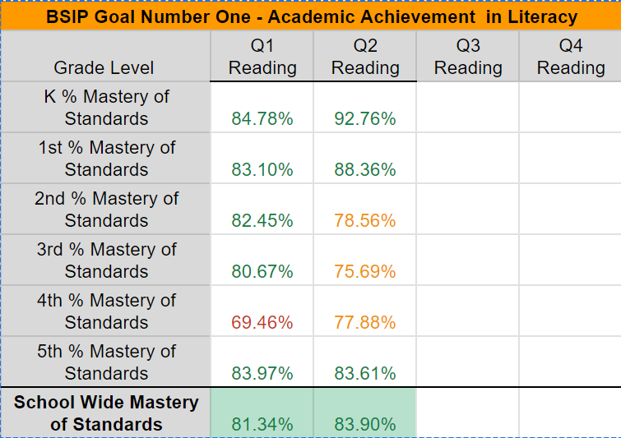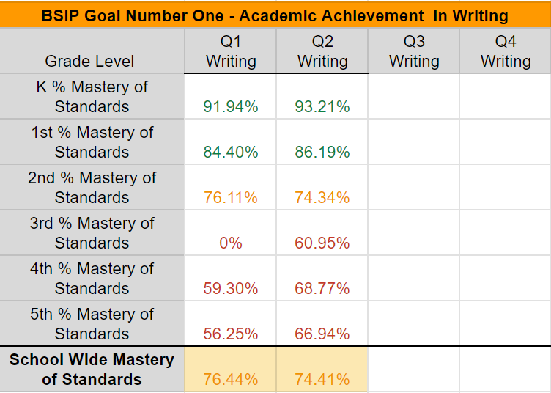

Middle of the Year Study/Act: at the end of quarter two, common assessment data in the area of literacy and writing was examined for each grade level, with schoolwide literacy exceeding the goal of at least 80% mastery for the second quarter. Upon further review of the data, the following key successes were noted:
- 92.76% of kindergarten students met or exceeded grade level expectations in reading as assessed by quarter two common assessments.
- 88.36% of first grade students met or exceeded grade level expectations in reading as assessed by quarter two common assessments.
- 83.61% of 5th grade students met or exceeded grade level expectations in reading as assessed by quarter two common assessments.
- 93.21% of kindergarten students met or exceeded grade level expectations in writing as assessed by quarter two common assessments.
- 86.19% of first grade students met or exceeded grade level expectations in writing as assessed by quarter two common assessments.
- Schoolwide reading data showed that 83.9% of students met or exceeded grade level expectations in reading as assessed by quarter two common assessments.
The following gaps were also identified:
- 21.54% of 2nd grade students were not proficient in grade level standards in reading for 2nd quarter.
- 24.31% of 3rd grade students were not proficient in grade level standards in reading for 2nd quarter.
- 22.12% of 4th grade students were not proficient in grade level standards in reading for 2nd quarter.
- 25.59% of McCulloch students were not proficient in grade level standards for writing in the 2nd quarter.
The building-wide data team met to review data in literacy and to further examine literacy domain data to identify any additional trends that should be addressed going forward in the school year. Individual grade levels participated in quarterly data meetings, where overall data and trends within grade level data to determine if there were any specific grade level standards, learning domains, or overall content areas that should be addressed going into the third quarter. Grade level reflections and individual action steps were documented within Grade Level Improvement Plans (GLIPs), and progress will continue to be monitored as we move through the third quarter.

ACADEMICS
Numeracy
- Numeracy Data Analysis What are your key successes? Key gaps? How do you know?
Key Successes
- During the 2022-2023 school year, our building average for math common assessments exceeded our building goal of 80 percent with 83.72%.
- During the 2022-2023 school year, the following grades met or exceeded our building-wide goal of 80 percent mastery: Kindergarten, First Grade, Fourth Grade, and 5th Grade.
- McCulloch increased proficiency on math common assessments from the 21-22 school year to the 22-23 school year by 2.36 percent.
- McCulloch’s building average for math common assessments was 3.94 percent higher than the district average.
- 4th grade MAP proficiency increased from 62.16% proficiency in the 21-22 school year to 70.83% proficiency.
- 5th grade MAP proficiency increased from 64.56% proficiency in the 21-22 school year to 74.39% proficiency.
Key Gaps
- 2nd grade math common assessment data for the 22-23 school year did not meet the building goal with 79.16 percent proficiency.
- 3rd grade math common assessment data for the 22-23 school year did not meet the building goal with 78.65 percent proficiency.
- 3rd grade MAP proficiency decreased from 59.42% proficiency in the 21-22 school year to 57.97% proficiency.

PLAN: What is the school numeracy goal and its success criteria? | DO: What will the school (teachers, students, and leaders) do to accomplish the plan? | Measures: How will you measure each step in the “DO”?
More than 80% of McCulloch students will be proficient in Numeracy as assessed by grade level common assessments.  3rd, 4th, and 5th grade students will achieve an average of at least 60% or greater Proficient/Advanced as assessed on the Missouri Assessment Program test administered in the Spring. | - Classroom teachers will collaborate with their grade levels to identify key successes and gaps in their grade level data and to create GLIPs that align with the goals established in this BSIP. The goals established will be reviewed quarterly during data meetings to determine the effectiveness of intervention practices.  - Student data will be reviewed weekly during early release time to determine effectiveness of instructional strategies and align response to intervention practices for following weeks.  - Teachers will utilize Response to Intervention time to respond to student data and incorporate interventions determined during early release time.  - Teachers will utilize identified Non-Negotiable standards in order to align instruction and support for essential learning in each grade level, including aligning RTI cycles and Spiral Review to ensure full proficiency in these key areas.  - Identified Numeracy Non-Negotiable standards will be monitored and tracked on classroom PDSAs.  - McCulloch will continue with building wide recognitions that celebrate classes that meet the 80% goal in literacy, recognizing those students as “Crown Raisers” during quarterly assemblies, and recognizing classes who have met or exceeded the growth required to meet building wide expectations by the end of the year with the GRIT award. | - RTI data will be analyzed and measured weekly during early release time.  - Focus standards for each grade level will be included in Grade Level Improvement plans, along with specific do steps to drive student improvement.  - Grade level common assessment data and grade level domain data will be reviewed quarterly with grade level teams to determine levels of student learning and determine next steps to promote student achievement.
Professional Learning: What professional learning might be needed to support the “DO”?
(Also included in the School Professional Learning Plan)

- Professional learning will be individualized to the needs of each teacher and/or grade level and will be outlined in educator growth plans.
- Individual grade level data will be analyzed to determine if professional development support is necessary to support student learning standards.
- Professional learning support from the CIA department will be utilized as needed for each grade level.
- Professional learning needs will be evaluated at the building level through classroom observations and regular recorded walkthroughs.

STUDY/ACT: Checkpoint
Based on the results of your measures, what’s working? What adjustments are suggested by the data?
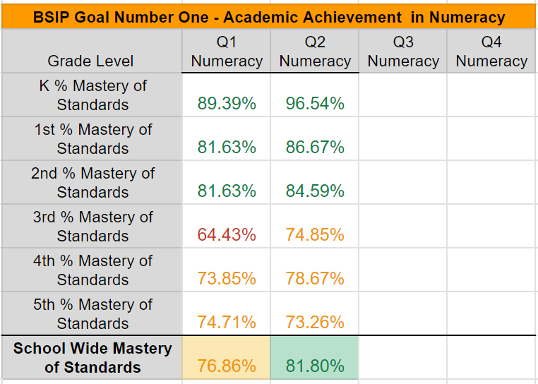

Mid Year Study/Act: At the end of quarter two, common assessment data in the area of numeracy was examined for each grade level, with schoolwide numeracy data exceeding the goal of 80% mastery. Upon further review of the data, the following key successes were noted:
- 96.54% of kindergarten students met or exceeded grade level expectations in numeracy as assessed by quarter two common assessments.
- 86.67% of first grade students met or exceeded grade level expectations in numeracy as assessed by quarter two common assessments.
- 84.59% of second grade students met or exceeded grade level expectations in numeracy as assessed by quarter two common assessments.
- Schoolwide numeracy data showed that 81.8% of McCulloch students met or exceeded grade level expectations in numeracy as assessed by quarter two common assessments.
The following key gaps were also identified:
- 25.15% of 3rd grade students were not proficient in grade level standards in numeracy for the second quarter.
- 21.33% of 4th grade students were not proficient in grade level standards in numeracy for the second quarter.
- 26.74% of 5th grade students were not proficient in grade level standards in numeracy for the second quarter.
The building-wide data team met to review data in numeracy and to further examine numeracy domain data to identify any additional trends that should be addressed going forward in the school year. Individual grade levels participated in quarterly data meetings, where overall data and trends within grade level data to determine if there were any specific grade level standards, learning domains, or overall content areas that should be addressed going into the third quarter. Grade level reflections and individual action steps were documented within Grade Level Improvement Plans (GLIPs), and progress will continue to be monitored as we move through the third quarter.

Culture
Attendance
- Attendance Data Analysis What are your key successes? Key gaps? How do you know?
Key Successes
- After adjustments to our attendance plan during the 22-23 school year, we saw a 6 percent increase in proportional attendance.
- 5th grade had a proportional attendance rate of 94.51 percent during the 22-23 school year.
Key Gaps
- McCulloch’s proportional attendance was 89.4 percent at the end of the 22-23 school year.
- McCulloch’s ADA was 93.96 for the 22-23 school year.
- Kindergarten - 4th grade proportional attendance was below the building goal of 93 percent for the 22-23 school year.
PLAN: What is the attendance goal and its success criteria? | DO: What will the school (teachers, students, and leaders) do to accomplish the plan? | Measures: How will you measure each step in the “DO”?
McCulloch Elementary will maintain a 93% or better proportional attendance rate for the 2023-24 school year.  McCulloch Elementary will maintain a 95% or better average daily attendance (ADA) for the 2023-24 school year. | - Classrooms that achieve >95% ADA for each month will be able to spin the rewards wheel for an extra prize.  - The school will host Attendance Surprise Days at least one time per month where all students in attendance get to participate in that day’s activities.  - Counselors, specials teachers, and admin will create an attendance small group with students who are considered chronically absent (less than 90 percent). The focus of this small group will be to create connection and community so students feel more connected to school.  - McCulloch will implement action steps outlined in the Attendance Pyramid to support and inform families of their child's attendance, including:  - Quarterly attendance letters mailed to families whose student has <95% attendance.  - Monthly attendance letters and teacher/counselor support / contact for students who have <90% attendance.  - Doctors notes will be required for all absences, conference with the principal, and referral to district social worker will be made for students who have <85% attendance  - Attendance will be monitored daily and office secretaries will attempt contact for students who are absent each day. | - Attendance data will be reported and formally reviewed by counselors / administration on a monthly basis to determine additional support needs for families of students who are meeting specified attendance criteria.  - This building BSIP report will be updated quarterly with current grade level and building wide proportional attendance and average daily attendance numbers.  - The building BSIP report will be revisited and revised Quarterly to reflect any adjustments to the action plan that are needed to meet building and district level attendance goals.
Professional Learning: What professional learning might be needed to support the “DO”?
(Also include in the School Professional Learning Plan)
- Administration and counselors will evaluate resources and work to identify professional learning opportunities that could help support students and attendance mentors.
- Administrators will continue to evaluate the effectiveness of current intervention programs and determine individual and whole school needs for professional learning.
STUDY/ACT: Checkpoint
Based on the results of your measures, what’s working? What adjustments are suggested by the data?
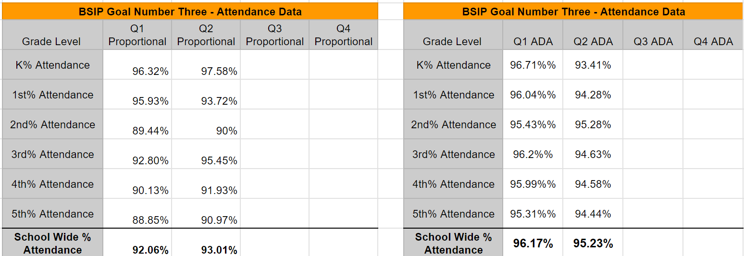

Middle of the Year Study/Act: Attendance data has been reviewed to determine the effectiveness of the action steps listed below. The following celebrations in the data were noted:
- Kindergarten, 1st grade, and 3rd grade are meeting our proportional attendance goal of 93% at the end of quarter 2.
- 2nd grade is meeting our building wide ADA goal of 95% at the end of quarter 2.
The following key gaps were also identified:
- 2nd grade, 4th grade, and 5th grade are below our building wide goal of 93% for proportional attendance.
- Kindergarten, 1st grade, 3rd grade, 4th grade, and 5th grade
The building wide data team met to review data for attendance. Individual grade levels participated in quarterly data meetings, where overall attendance within grade levels was analyzed to determine if there were any specific grade level action steps that should be put in place for the third quarter. Grade level reflections and individual action steps were documented within Grade Level Improvement Plans (GLIPs), and progress will continue to be monitored as we move through the third quarter.

Culture
Trusting Relationships
- Site Choice Data Analysis What are your key successes? Key gaps? How do you know?
Key Successes
- Trusting Relationships maintained from the Spring 2022 Culture and Climate survey (MRA) to the Spring 2023 Culture and Climate survey (MRA) at 74.
Key Gaps
- While maintaining our 74 in Trusting Relationships on the Culture and Climate survey was worth celebrating, we would have liked to experience some growth in this area due to it being a targeted area.
PLAN: What is the goal and its success criteria? | DO: What will the school (teachers, students, and leaders) do to accomplish the plan? | Measures: How will you measure each step in the “DO”?
McCulloch will increase our score on the Climate and Culture survey (MRA) from our current score of 74.  McCulloch Elementary will continue implementing a morning meeting at the start of each day to allow teachers and students to connect, build relationships, work on social skills, and ensure each student starts the day in a regulated state.  McCulloch Elementary will begin implementing structured relationship mapping to ensure each child is connected with their classroom teacher. | - A staff action team will be utilized to align to the goal of supporting teachers in implementing morning meetings in their classroom each day.  - A dedicated time will be built into the McCulloch master schedule to allow each day to start with a classroom morning meeting.  - All classrooms will begin implementing morning meetings in their classroom on a daily basis.  - Counselor and admin will periodically attend morning meetings to determine if additional supports are training are needed.  - A staff action team will be helping lead staff through a structured relationship mapping process to help teachers connect with every student in their classroom | - Performance Measures: McCulloch Elementary will improve from 74 on the yearly MRA Survey in this area.  - Fidelity Measures:  - >95% of classrooms are implementing morning meetings on a daily basis.  - Counselors and/or admin have been able to attend a morning meeting for each classroom by the end of the year.  - The building BSIP report will be updated at the Middle of the Year (January) and End of the Year (May) to reflect any adjustments needed in supporting the implementation of morning meeting and relationship mapping and to document fidelity and performance measures as applicable.
Professional Learning: What professional learning might be needed to support the “DO”?
(Also include in the School Professional Learning Plan)
- Staff will continue to get information and training on effective morning meeting and relationship mapping strategies throughout the 23-24 school year.
STUDY/ACT: Checkpoint
Based on the results of your measures, what’s working? What adjustments are suggested by the data?
Middle of the Year Study/Act: At the middle of the year the McCulloch Lighthouse Team and building Administrators were able to review the overall implementation of this culture goal. The following results of fidelity measures were reported below:
- MET - >95% of classrooms are implementing morning meetings on a daily basis.
- MET - >98% of staff have been trained on the implementation of morning meetings at the start of the school year.
- In Progress - Administrators visit and participate in every classroom’s morning meeting by the end of the year, and are on track to do so during progress checks.
An aligned staff action team will continue to provide additional resources to teachers to continue in the implementation of morning meetings. Further performance evaluation of this goal will take place with the completion of the MRA Survey by our students, teachers, and community. Final results will be updated at the end of the year, but initial signs show positive impacts taking place based on the current action steps available. No major adjustments have been suggested at this point.

LEADERSHIP
School Discipline
- School Discipline Data Analysis What are your key successes? Key gaps? How do you know?
Key Successes
- During the first 3 quarters of the 22-23 school year, McCulloch was on track to meet both building wide discipline goals.
Key Gaps
- There were 230 office discipline referrals during the 22-23 school year.
- There were 87 discipline referrals during the 4th quarter last year.
- 3rd grade discipline accounted for 30 percent of the total referrals.
- 5.4 percent of students had 3 or more discipline referrals.

PLAN: What is the school discipline goal and its success criteria? | DO: What will the school (teachers, students, and leaders) do to accomplish the plan? | Measures: How will you measure each step in the “DO”?
McCulloch will have less than 183 discipline referrals for the 2023-24 school year.  McCulloch will have less than 5% of students with 3 or more discipline referrals at the end of the year. | - Utilize the ROAR Matrix to communicate consistent building wide expectations to all students.  - Use positive reinforcement through tiger paws and ROAR bucks to reinforce student and classroom individual behavior.  - Regularly review building wide expectations utilizing curriculum that was created by a team of teachers during the 22-23 school year. (At least quarterly)  - Utilize morning meetings and LEAD Lessons to target behaviors in need of improvement. | - The number of discipline referrals each month.  - Expectation Bootcamp Checklists submitted to Mr. Allen from all teachers.  - The building BSIP report will be updated quarterly to reflect current data and any adjustments that need to be made to support the implementation and completion of building level goals.
Professional Learning: What professional learning might be needed to support the “DO”?
(Also include in the School Professional Learning Plan)
- Professional Text from Kaye Otten: How to Reach and Teach Students with Challenging Behavior
- Review of building behavior plan at BOY and MOY(refresher)
STUDY/ACT: Checkpoint:
Based on the results of your measures, what’s working? What adjustments are suggested by the data?
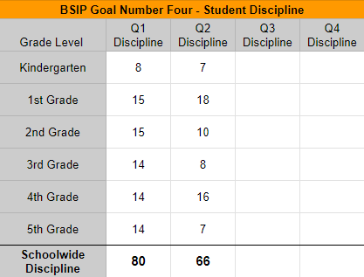
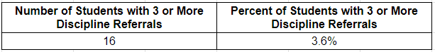

Middle of the Year Study/Act:
Discipline data has been reviewed to determine the effectiveness of the action steps listed below. The following celebrations in the data were noted:
- Schoolwide referrals decreased significantly from 1st quarter to 2nd quarter.
- Kindergarten, 2nd grade, 3rd grade, and 5th grade have had a decrease in the number of referrals from 1st quarter to 2nd quarter.
- Goal is currently being met with only 3.6 percent of students having 3 or more discipline referrals.
The following key gaps were also identified:
- 1st grade and 4th grade continued to have an elevated number of referrals compared to other grade levels
- We are not on track to meet our goal by the end of the school year.
- 6 students have 4 referrals and 5 students have 5 referrals.
The Behavior Action Team will be working to analyze data and push out resources to respond to discipline trends through morning meetings. The Behavior Team will meet and develop this plan on January 18th and will continue to push out resources monthly. Students with 3 or more discipline referrals will be brought to SIT if they are not already receiving interventions through the SIT process. Administration and the district Behavioral Intervention Specialist will be working to implement focused updates to protocol and schedule for suspensions, primarily to decrease the number of referrals from students that already have a referral.

LEADERSHIP
Family Engagement
- School Choice Data Analysis What are your key successes? Key gaps? How do you know?
Key Successes
- Scores on the family culture and climate survey for the indicator “My student’s teacher(s) at this school are approachable and reachable had a score of 4.68.
- Scores on the family culture and climate survey for the indicator “I would recommend this school to other parents” had a score of 4.54.

Key Gaps
- Family Engagement decreased from a 74 to a 70 on the Culture and Climate survey(MRA).
- Family Engagement is currently our lowest section on the MRA survey and the only area that decreased from the 21-22 Spring survey to the 22-23 Spring survey.

PLAN: What is the school goal and its success criteria? | DO: What will the school (teachers, students, and leaders) do to accomplish the plan? | Measures: How will you measure each step in the “DO”?
McCulloch will increase our score on the Climate and Culture survey (MRA) from the building's current score of 70.  McCulloch will begin implementing quarterly individualized communication with families to ensure families have clear communication on their child’s academic performance. | - Administration will create a bi-weekly classroom newsletter frame that has pre-determined sections to help with consistent communication from each classroom.  - Teachers will be developing activities to share with families to support learning standards at home.  - An information survey will be sent out at the beginning of the year to all families to gain information about the dynamics of each family.  - Teachers will communicate and document individualized communication with each family every quarter. The communication will be academic in nature to update them on their child’s academic progress. | - Performance Measures: McCulloch Elementary will improve from 70 on the yearly Culture and Climate Survey (MRA) in this area.  - Fidelity Measures:  - Sending out the family information survey utilizing multiple communication platforms to gather results from as many families as possible.  - 100 percent of grade level teachers are utilizing the classroom newsletter frame.  - >95% of teachers meet the quarterly goal of making individualized communication with each student in their classroom.  - 100 percent of grade levels share activities with families each semester to support learning standards at home.
Professional Learning: What professional learning might be needed to support the “DO”?
(Also include in the School Professional Learning Plan)
- Staff will receive training on Family Engagement through LIM at the beginning of the school year.
- Staff will complete a book study with the book Talk to Me by Kim Bearden to learn more about effective communication with all stakeholders.
STUDY/ACT: Checkpoint:
Based on the results of your measures, what’s working? What adjustments are suggested by the data?
Middle of the year Study/Act: At the middle of the year the McCulloch Lighthouse team and McCulloch Administration were able to review the current progress toward meeting this BSIP Goal. The following reflection on current fidelity measures can be found below:
- MET- Sending out the family information survey utilizing multiple communication platforms to gather results from as many families as possible.
- MET- 100 percent of grade level teachers are utilizing the classroom newsletter frame.
- MET- >95% of teachers meet the quarterly goal of making individualized communication with each student in their classroom.
- MET- 100 percent of grade levels share activities with families each semester to support learning standards at home.
- MET- Staff will receive training on Family Engagement through LIM at the beginning of the school year.
- MET- Staff will complete a book study with the book Talk to me by Kim Bearden to learn more about effective communication with all stakeholders.
Currently, all fidelity measures are being met. Dara from our district family survey indicated these action steps are showing positive results with family engagement. Specifics about celebrations from the family survey can be found below:
- I receive sufficient information from my student’s teacher(s) to stay informed of his/her progress increased from 4.43 to 4.63 with 96% of families marking agree or strongly agree.
- My student’s teacher(s) at this school is/are approachable and reachable increased from 4.68 to 4.85 with 100% of families marking agree or strongly agree.

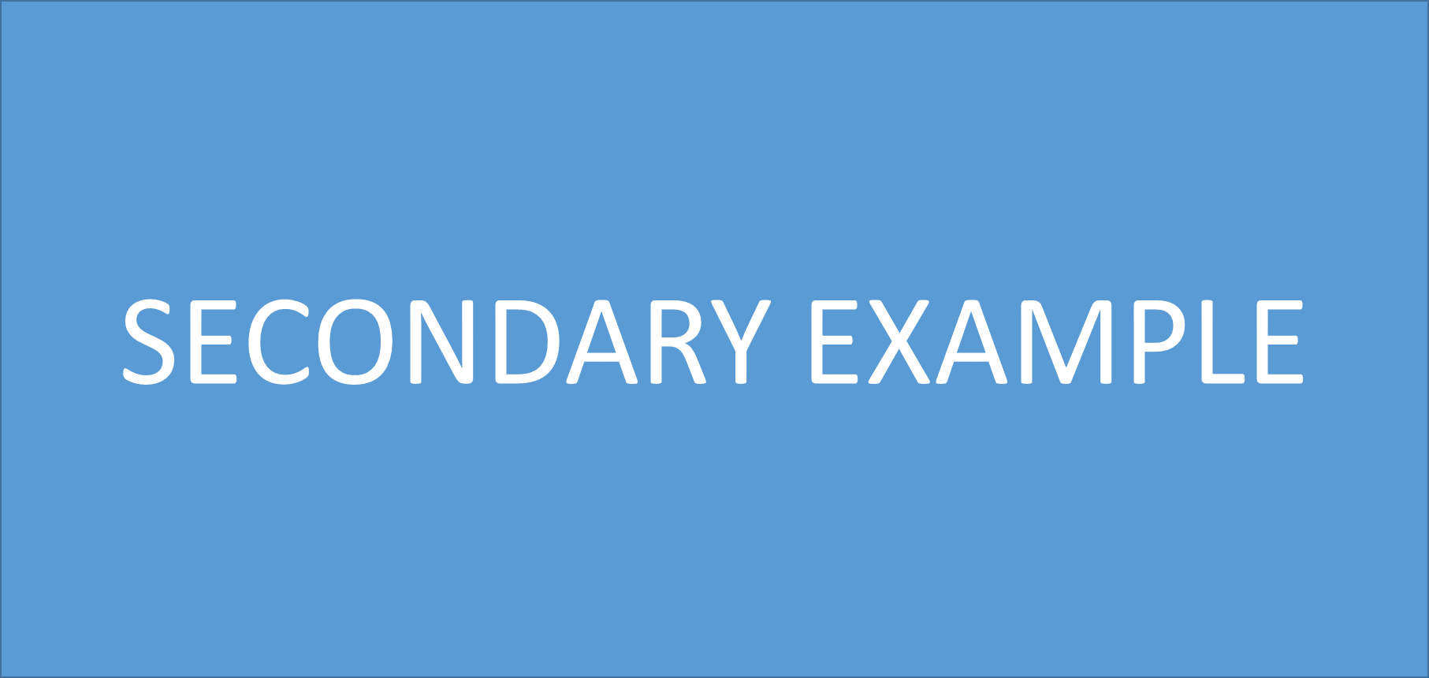
District Mission
RepMO is preparing each student for future excellence through a safe educational environment
District Vision
RepMO will be a model community dedicated to education without limitation that empowers learners to create their own success.
School Mission
Creating a safe place to learn and lead.
School Vision
Our vision for RMS is to become an exemplary school where students learn at high levels in an engaging and positive environment

Collective Commitments
Build and sustain an environment where all team members feel safe, cared for, valued, and celebrated.
Cultivate leadership and responsibility in students and staff to foster productivity and self-motivation.
Promote a school wide growth mindset that is future-focused.
Foster opportunities for collaboration, critical thinking, creativity, and communication amongst all staff and students.
Create an atmosphere where students, staff, families, and community stakeholders believe in their ability to positively contribute to our school.
Norms
We will begin and end on time.
We will consider the positive possibilities.
We will have a clear purpose and stay on task.
We will have opportunities for questions and feedback.
We agree to hold each other accountable to all norms.
Guiding Coalition
Tracy Williams - Principal
Bret Gallion, Miranda Schaefer, Shane Pierce - Assistant Principals
Sam Baugh - Music
Justin Bennett - ELA
Jackie Coskey - Art
Kyle Crouch - SpEd
Malinda Little - Science
Carrie Jones - PE
Madison Neves - Counseling
Heather Replogle - Social Studies
Stacey Robinett - Math
Rochelle Shumaker - PLTW

ACADEMICS
Literacy
Literacy Data Analysis What are your key successes? Key gaps? How do you know?
Key Successes:
- In the 2022/2023 school year the department increased the number of students achieving mastery on quarterly pretest to post-test assessments by 12%.
- The department had 13% growth in the amount of students that scored proficient/advanced on the SRI test.
- Over the course of the school year, the ELA department increased the number of grade-level readers by 9%.
- Each grade-level scored above the state average on the 2022 MAP test.
---------------------------------------------------------------------------------------------------------------------------
Key Gaps:
- At the end of the school year, 38% of students were reading below grade level.
- The department had 11 standards below mastery on quarterly common assessments.
- The department MAP scores went down compared to the 2022 MAP test (6th Grade -7.07%, 7th Grade -1.95%, 8th Grade -2.40%).

Plan: What are our goals for the year? | Do: What will we DO to accomplish these goals? | Measures: How will we measure that we are on our way to accomplishing these goals?
- 75% of students reading lexile scores will be at proficient or advanced by the end of the 2023/2024 school year.  - SRI lexile scores will grow 17% from the start of the year. | - ELA teachers will commit to 10-15 minutes of daily reading in every class, as well as encourage outside reading, create individualized reading goals to meet each student’s needs, and conference with students over what they are reading.  - ELA teachers will utilize the district literacy specialist to develop classroom reading goals, individual reading goals, and conferencing strategies with students.  - ELA teachers will give the SRI test the weeks of August 21st-September 1st (BOY), October 16th-26th (optional), December 4th-19th (MOY), March 4th-22nd (optional), and May 1st-22nd (EOY).  - ELA teachers will analyze SRI test data on the following dates; September 8th, November 3rd, January 5th, and May 17th.  - Communicate with parents after each SRI test regarding the progress students are making.  - After each SRI test, teachers will celebrate growth goals with their classes.  - ELA teachers will employ strategies to increase reading stamina.  - ELA teachers will embed critical thinking activities and accountability measures when students are reading. | - All ELA teachers will be tracking their students SRI scores to measure student growth and identify and provide opportunities for remediation and enrichment.  - SRI growth goals will be tracked after each SRI test by grade level and department.
- 80% of students will score proficient or advanced on quarterly common assessments. | - ELA teachers will refine their priority goals based on the 11 standards that were not above the state average.  - ELA teachers will create and implement common assessments for each quarter targeting priority goals.  - Grade level teams will complete the Response to Data document, then teams will meet with administrators to discuss data during PLC.  - All priority standards that are tracked on BSIP data will be taught and assessed until 80% of students have achieved mastery..  - Grade level teams will meet for a half day each quarter with content curriculum specialists for professional development and to discuss next steps from their common assessment.  - Develop response to data protocols  - Share and implement high yielding strategies based upon the data each week during PLC. Strategies will be implemented within the following unit of instruction.  - Develop tier two instructional plan | - Common Assessment data will be tracked quarterly to determine if 80% of students achieved mastery on the post-test.
- 80% of students in an RTI cycle will achieve mastery. | - Teachers will develop checkpoints.  - RTI interventions will be developed to help the students that did not meet the proficient criteria on the first checkpoint. | - Checkpoint #2 results will be recorded in the Know thy Calculator spreadsheet to show the level of mastery.
- 100% of students have experiences in the 4C focus area of: collaboration, communication, critical thinking, or creativity. | - Teachers will assess a specific skill within the 4C focus area of: collaboration, communication, critical thinking, or creativity.  - Teachers will provide learning opportunities within their intended curriculum targeting the specific 4C focus area.  - Course-level teams will collaborate with learning specialists to analyze 4C learning data to identify successes and opportunities for improvement. | - Teachers will update one unit of instruction per quarter to include student learning opportunities that target the 4C focus area.  - Teachers will document student achievement once per quarter within the specific 4C focus area.
- 85% public speaking students will be proficient or advanced in verbal and nonverbal by the end of the semester. | - The speech teacher will scaffold speaking skills throughout the semester in order to gradually build well rounded speaking skills.  - Speech Students will have multiple opportunities throughout the week to practice and develop each specific skill outlined on the standard rubric. | - Students will be measured on a standardized rubric that is used for each speech. Growth in each category will be tracked via the teacher graded rubric. This will be completed every three weeks.  - Students will also self-reflect through writing pieces after each speech delivery.

Professional Learning:
Professional Learning: What professional learning might be needed to support the “DO?”
- Teachers will engage in literacy training with the Secondary Literacy Specialist.
- Teachers will utilize SI Days and Early Release Collaboration time to share best reading and writing practices in order to help address the learning needs of all RMS students.
- Teachers will utilize SI Days and Early Release Collaboration time to develop and refine curriculum to support our students.
- On SI Days teachers will vertically align priority standards utilizing common assessments.
- Teachers will utilize SI Days and Early Release Collaboration time to develop checkpoints and lessons to be used for RTI time.
STUDY/ACT:
Study/Act: Checkpoint:
- ELA teachers will analyze SRI test scores to differentiate and enrich the curriculum on September 8th, November 3rd, January 5th, and May 17th.
- Grade level teams will complete the Response to Data document. Teams will meet with administrators to discuss post-test data at the end of each quarter.
- Continue to work as an ELA team to develop high-quality assessments.
- Aug. SRI Completed Nov. Feb. May
- Sept. Analyze SRI Scores Completed Dec. Mar.
- Oct. Jan. Apr.

ACADEMICS
Numeracy
Numeracy Data Analysis What are your key successes? Key gaps? How do you know?
Key Successes
- All grade levels completed a book study of Building Thinking Classrooms and began implementing some of the extensive research-based practices.
- A committee was formed including teachers, building leaders, and learning specialists to develop a 4C framework, including a scoring guide and data tracking and response system.
- All Grade Levels were above the state averages in all domains.
- 6th grade completed their curriculum audit.
- 7th grade focused on an increase in our Geometry domain, this showed growth in our overall data for our 2022 MAP test. (2021 we were 6% below the state average & in 2022 we were 5% above the state average)
- 8th grade was 18% higher in students who scored Proficient and Advanced in number sense than the state.

Key Gaps
- Student learning data for 4Cs is not tracked and systems of response are not in place.
- 8th grade’s lowest domain of the 4 domains was in Geometry and Measurement based on MAP item analysis..
- 7th grade’s standard that shows there is room for growth is NS.A.1.c. based on MAP item analysis.
- 6th grade students received only 50% of the points in the EEI domain based on MAP item analysis..
PLAN: What is the school numeracy goal and its success criteria? | DO: What will the school (teachers, students, and leaders) do to accomplish the plan? | Measures: How will you measure each step in the “DO”?
- At least 80% of students meet target on math common assessment (summative) | - Grade level teams will reflect and analyze the data from at least 2 Common Formative Assessments to drive instruction during each unit.  - Math teachers will create and implement common assessments for each unit targeting priority standards.  - One Curriculum Work Day each semester for each team to continue to work on refining their common formative assessments and common assessments.  - Common assessment data will be analyzed to determine intervention and extension activities. | - All math teachers will be tracking their students’ common formative assessment scores to measure student growth.  - Common Assessment data posted on the quarterly BSIP spreadsheets (and all other common assessments not on the spreadsheets) will be used to monitor student achievement/growth.  - Standards will be tagged on all common assessments.  - A Curriculum Work Day reflection will be shared with Mr. Gallion at the end of the day.  - Grade level teams will complete the Response to Data document using common assessment data. Teams will meet with dept. administrator to discuss pre-test/mid-unit Formative data/post-test data and action steps.
The math department will use high quality thinking tasks during Tier 1 instruction.  - Curriculum Overview Doc | - Math teachers will use at least one high quality thinking task during each unit of instruction. | - Teachers will link the task and the rubric in their grade-level curriculum and reflect with their team on student performance.
Specific DOK goals are set for designing common assessments. | - Teachers will design assessments that contain questions at varying DOK levels that align with state testing/blueprints.  5-15% DOK1  60-80% DOK2  10-25% DOK3 | - Teachers will track the percentage of questions on the DOK Tracking Document. This will be completed at least a week before instruction begins for each unit.
Successfully implement a full-scale RTI Initiative  - 80% of students in an RTI cycle will achieve mastery. | - Teachers will identify 6-8 priority standards to target for RTI.  - Core teachers will administer Checkpoint #1 to determine the students with the highest need for intervention.  - Teachers will group students based on need (level of understanding) and those who are placed in the RTI rotation will receive further instruction during the math rotation.  - RTI teachers will administer Checkpoint #2 to monitor the progress of students who received intervention.  - Teachers will add striving students to their roster during RTI cycles that are ELA designated. | - Checkpoint #2 results will be recorded in the Know thy Impact Calculator spreadsheet to show the level of mastery.
- 100% of students have experiences in the 4C focus area of: collaboration, communication, critical thinking, or creativity. | - Course level teams will select a specific skill within the 4C focus area of: collaboration, communication, critical thinking, or creativity.  - Teachers will provide learning opportunities within their intended curriculum targeting the specific 4C focus area.  - Course-level teams will collaborate with learning specialists to analyze 4C learning data to identify successes and opportunities for improvement. | - Teachers will update one unit of instruction per quarter to include student learning opportunities that target the 4C focus area.  - Teachers will document student achievement once per quarter within the specific 4C focus area.
Professional Learning:
- Teachers will attend two District Curriculum Work Days with the district Math Specialist to update grade-level curriculum and assessments.
  - PD will be provided based on student data and grade-level needs.
- Teachers will utilize SI Days and Early Release Collaboration time to share best practices in order to help address the learning needs of all RMS students.
- Teachers who attend conferences in or out of the district will share any new learning about teaching strategies or best practices with all math teachers whose students might benefit from their new learning.
- Instructional strategies aligned to 4C focus area to embed within content instruction.
- Check-list of look-fors when assessing 4C focus area and opportunity to calibrate when scoring student performance.
- Teachers will partner with ETS in the development of the look-fors and calibration of scoring.
STUDY/ACT:
- At the end of each quarter, the math department will meet vertically in mixed grade level groups. Teachers will share feedback about DOK levels and Priority Standards based on the needs of the grade level above and the grade level below, based on their observations during mixed grade level assessment sharing.
- After the common formative assessment is given, the Math team will meet to create differentiation and enrichment opportunities in response to the data being tracked on the See, Get, Do document.
- After each math RTI cycle, the math department will meet to discuss the results of RTI/Checkpoint 2 and how to respond to the data to create opportunities for remediation and enrichment moving forward through each cycle.

Culture
Attendance
Attendance Data Analysis What are your key successes? Key gaps? How do you know?
Key Successes
- The number of students on the ADLN list at the end of the 2022-23 school year decreased by 50% compared to the 2021-22 school year.
- 345 students qualified for the Great 98 attendance celebration following the first semester.
Key Gaps
- The building 90/90 proportional attendance rate was 84.51%.
- The building ADA was 93.24%.
- 17 students remained on the ADLN report at the conclusion of the 2022-23 school year, 3 students were in the eighth grade.
PLAN: What is the school attendance goal and its success criteria? | DO: What will the school (teachers, students, and leaders) do to accomplish the plan? | Measures: How will you measure each step in the “DO”?
- Improve our ADA from 93.24% (22-23) to 95% or higher  - Maintain a Proportional Attendance of 90% or higher for the 2023-24 school year  - Decrease the number of students found on the ADLN report by 20%  - Students will track their personal attendance data each month during Advisory time to remain above 95% | - Weekly admin meeting with System Support Counselor to review students who have missed 5 days or more and plan next steps  - Great 98 attendance recognition will take place each semester during events.  - Monthly random drawings for prizes for students with 98% or higher attendance at each monthly school-wide assembly.  - Display weekly grade level student attendance data in the building  - Dismiss students at the end of each day according to previous weeks winning grade level attendance  - Monthly monitor ADLN list of students to ensure they are placed in a Core class for each RTI cycle to ensure all students identified on the ADLN are placed in a Core class for each RTI cycle, the ADLN will be monitored monthly.  - Implement daily a 3 Tier process to address student attendance concerns  - Communication campaign to push out the importance of attendance and data via newsletters, social media, and announcements (verbal/visual).  - Monthly parent newsletters and weekly staff newsletters will provide attendance data | - The administration and counseling team will utilize weekly attendance intervention spreadsheet for tracking student attendance  - Weekly monitored PULSE grade level attendance reports  - Analyze data from monthly ADLN, ADA and 90/90 attendance report generated from PULSE in the monthly meetings for administration, counseling, and faculty meetings  - Students will measure and track their individual attendance data monthly during Advisory.
Professional Learning:
- Positive parent phone conversations
- Attendance Pyramid of Interventions for all staff
- Student Intervention Team (S.I.T.) process
STUDY/ACT:
- Monitor Attendance data monthly
  - Sept. complete ⃞ Jan. complete
  - Oct. complete ⃞ Feb. complete
  - Nov. complete ⃞ March complete
  - Dec. complete ⃞ April complete
- Discuss all attendance and low classroom student achievement data each progress during monthly administration and counseling team meetings
- Discuss all attendance and low classroom student achievement data each progress during monthly team meetings
- Monitoring of Tier 3 attendance was adjusted to bi-weekly to maintain fidelity of the process
- Conduct home visits as required by our Pyramid of Interventions

Culture
Trusting Relationships
Staff Satisfaction Data Analysis What are your key successes? Key gaps? How do you know?
Key Successes
- Nov. 2022 Student Survey: “I feel that my school is a good place to learn” score of 4.01 (highest of all 5 questions) in baseline year
- 2023 Climate & Culture Survey (MRA): School Belonging - “Students believe that they are cared about and understood by the people in their building” (greatest increase in Culture section +5; 69)
Key Gaps
- 2023 Climate & Culture Survey (MRA): Trusting Relationships - “Students have a high trust relationship with at least 1 teacher” (increase of only 1 point - 66.
- Nov. 2022 Student Survey: “I believe adults in my school care about me” score of 3.91 in baseline year
PLAN: How will you address this identified gap? What is the goal and its success criteria? | DO: What will the school (teachers, students, and leaders) do to accomplish the plan? | Measures: How will you measure each step in the “DO”?
- Establish a reflection protocol using RMS check-in survey data, while establishing baseline data for future use.  - Our goal on the Culture and Climate Survey is to increase our score from 66 to 68 by the Spring of 2024. | - Create a staff Action Team to focus on increasing Trusting Relationships with all students.  - The Counseling Team will provide supports to all, including classroom lessons, individualized counseling, and conflict resolution to address the social and emotional learning.  - Create and provide standardized script to be read to all students prior to Climate and Culture survey.  - Our building focus is going to be, “Be the One!”  - Protocol to recognize outstanding students focused on the word of the month.  - All teachers will greet their students at the beginning of each hour at the beginning of the door. | - Survey sample questions (RMS check-in survey) from MRA will be given throughout the school year (October & February) to check for growth and adjust learning as necessary.  - District provided Culture Survey will be given in November (Q2, Q4 emphasis)  - 2024 Climate & Culture Survey results
Professional Learning:
- Participate in summer Professional Learning focused on social emotional learning.
- An all staff presentation of building wide expectations during School Improvement days.
- Continuous implementation of Leader In Me.
STUDY/ACT:
- Trusting Relationships Staff Action Team will use their monthly meetings to monitor, reflect and adjust our plan.
- Survey created by the Trusting Relationships Action Team using questions from MRA will be given in October and February during Advisory.
- Students will also complete the district provided student survey and the Culture and Climate Survey.

LEADERSHIP
Family Engagement
Data Analysis What are your key successes? Key gaps? How do you know?
Key Successes
- Our goal for the 2022-2023 school year was to increase positive well-being from 63 to 65. Following our Climate & Culture Survey (MRA), we had an ending score of 69, this is a 6% growth!
Key Gaps
- 2023 Climate & Culture Survey (MRA): Family Engagement - “Students’ caregivers are satisfied with the way the school includes them in their child’s learning through inclusive opportunities, communication and support for learning at home.”
PLAN: What is the school goal and its success criteria? | DO: What will the school (teachers, students, and leaders) do to accomplish the plan? | Measures: How will you measure each step in the “DO”?
- Our goal is to increase our MRA Culture & Climate survey from a 65 to a 68 by Spring 2024.  - 70% of our RMS parents will be viewed as an Observer in Canvas Courses. | - Create a staff Action Team to focus on increasing Family Engagement with all students.  - Monthly review the percentage of parent observers in our Class Of courses.  - Teachers will be provided with tools to use to increase Family Engagement.  - Administration will provide instructions to parents on how to sign-up for Canvas via social media.  - Teachers will email all parents who are not enrolled in Canvas to encourage them to sign-up.  - We will use our social media platform to promote our word of the month.  - Teachers will use Canvas Announcements to communicate upcoming events, projects, assessments, etc. | - Teachers will complete a self-assessment on Family Engagement at the August and February SI Day.  - Monitor the parent observer enrollment on the Class Of courses.  - 70% of our RMS parents will be viewed as an Observer in Canvas Courses.  - District provided Culture Survey will be given in November.  - 2024 Climate & Culture Survey results (Q4, Q6-7 emphasis)
Professional Learning:
- Family Engagement impact journey training takes place on August 16th for all staff.
STUDY/ACT:
- Family Engagement Staff Action Team will use their monthly meetings to monitor, reflect and adjust our plan.
- RMS families will complete the district provided Culture Survey (November) and Climate and Culture Survey (February).

LEADERSHIP
Student Leadership (Personal Development)
Student Leadership (Engagement) Data Analysis What are your key successes? Key gaps? How do you know?
Key Successes
- In the 2023 Climate & Culture Survey (MRA) Self Advocacy we increased our score from a 66 to a 70, 4% growth.
Key Gaps
- 2023 Climate & Culture Survey (MRA): “Students take responsibility for their actions and emotions and prioritize the things that are most important to their future. (increased from a 68-71, this was a 3% growth)
PLAN: What is the school discipline goal and its success criteria? | DO: What will the school (teachers, students, and leaders) do to accomplish the plan? | Measures: How will you measure each step in the “DO”?
- All students will develop and monitor an attendance goal and reading goal within Advisory class.  - Student goals will be monitored for growth and celebrated within Advisory class.  - Implement effective and engaging Advisory lessons and LEAD Teams. | - Students will work with an Advisory class teacher to develop and monitor goals using a goal development document.  - Teachers will develop a process for student celebrations within their Advisory class.  - Staff Lighthouse Team will ensure student voice is heard when being placed in LEAD Teams. | - All students will meet with their Advisory class teacher monthly to review and document goal progress.  - Feedback on Advisory lessons will be created and given to students and teachers to determine engagement and effectiveness in February (SI day and April (faculty meeting).  - Staff Lighthouse Team will place 95% of students within their top 5 choices of LEAD Teams.
Professional Learning:
- Lighthouse Team Retreat Summer 2024
- All staff training in 7 Habits, Core 1 and Core 2
- Teacher Action Team met with their team members as part of the School Improvement day.(August 16 & October 6)
STUDY/ACT:
- Monthly faculty meeting with Teacher Action Teams
  - Sept. All Action Teams met ⃞ Jan. All Action Teams met
  - Oct. All Action Teams met ⃞ Feb. All Action Teams met
  - Nov. All Action Teams met ⃞ March All Action Teams met
  - Dec. All Action Teams met ⃞ April
- As of September 18, 2023 100% of students will have created goals. Students will revisit goals monthly to monitor progress.
- April Review of 2024 Student MRA Survey Results

