This system of Google Sheets has been utilized by our district’s middle and high schools to monitor priority goals.

Teachers input data each quarter into this teacher-level spreadsheet.
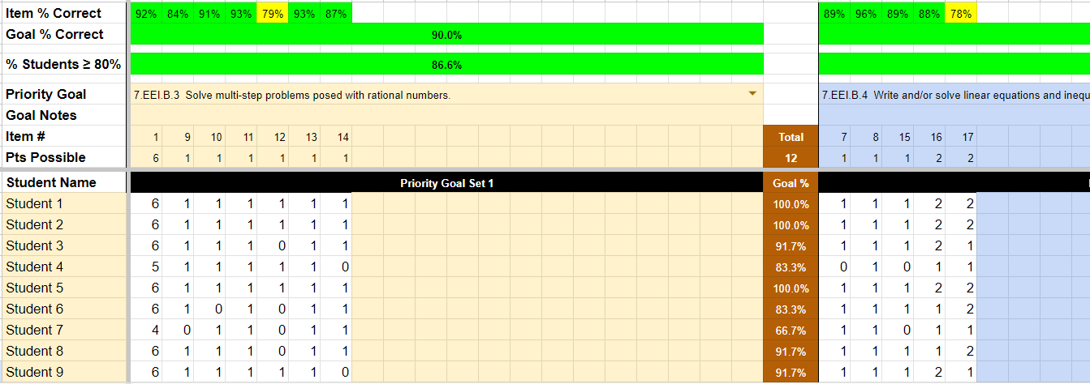
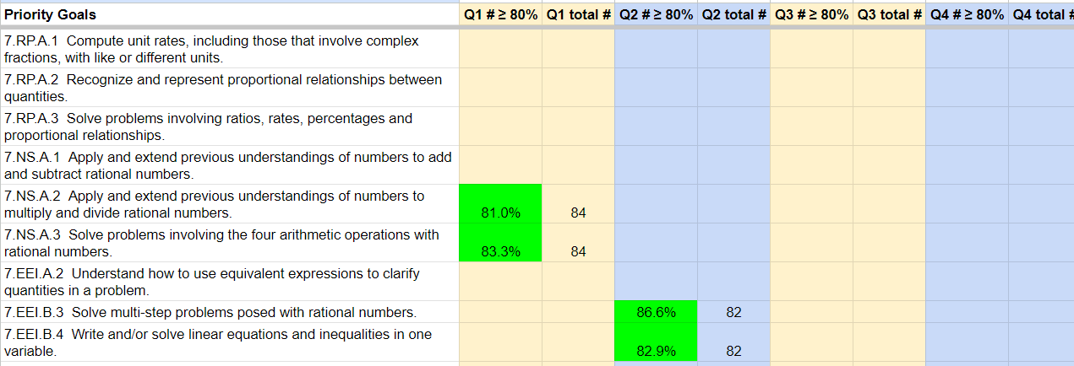

The data teachers input feeds into a content-level spreadsheet, which is used during team collaboration time to monitor progress on priority standards.
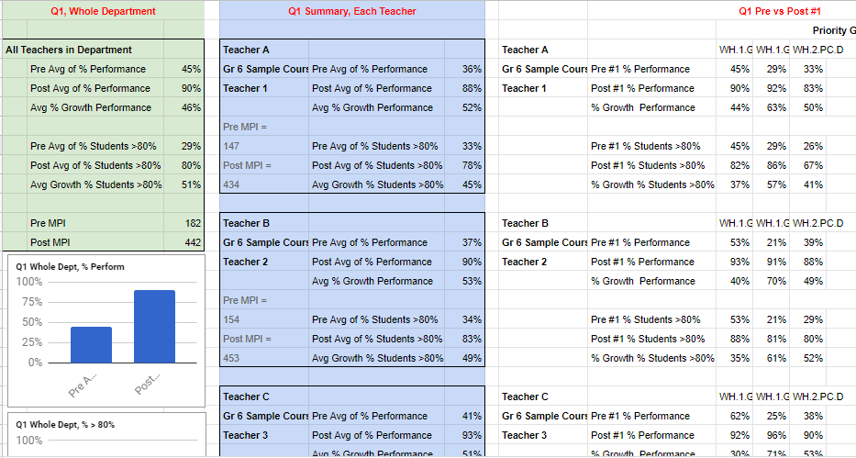

The principal-level sheets allow principals and instructional support staff to monitor, as well.
