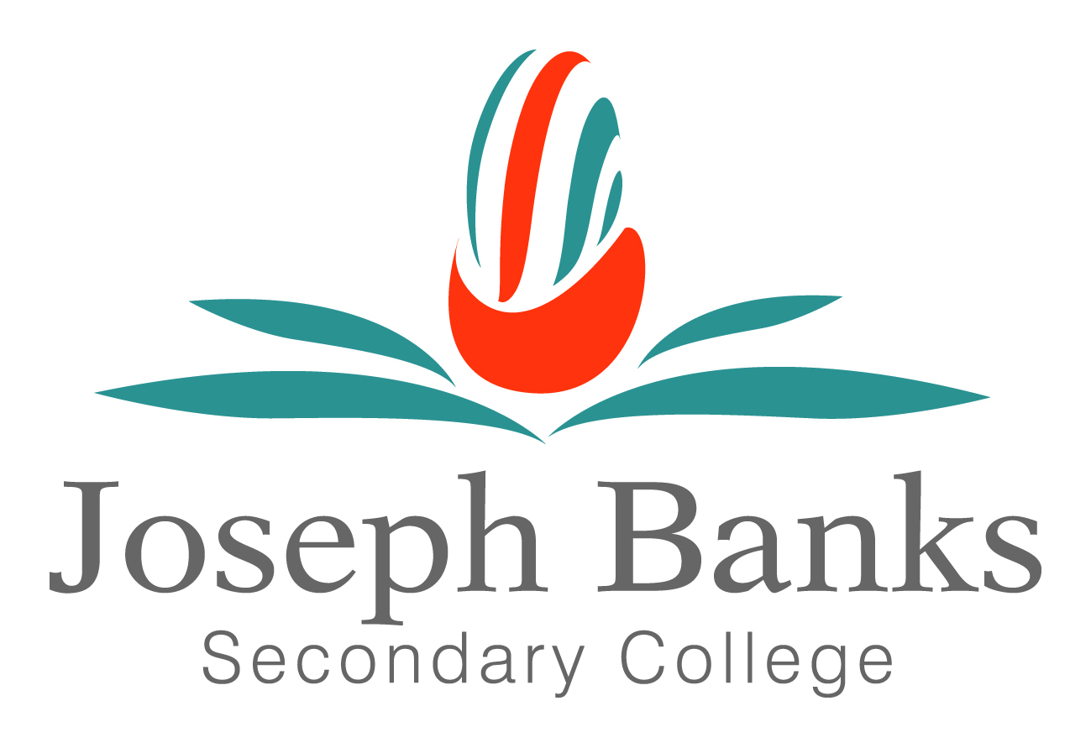

Joseph Banks Secondary College

2018-2019 Literacy Plan

Vision
The vision for our college is to create a vibrant culture of excellence, opportunity and success for students, staff and their community. Our goal is for all students to be literate, numerate and curious through the provision of a broad-based 21st century curriculum.

Why is a whole school literacy plan required?

Writing
In 2018, our students demonstrated both high progress and high achievement, when compared to the WA Public School data and have also shown positive growth in comparison to our like schools in both 2017 and 2018. This improvement is partly due to our focus on domain specific vocabulary, words walls, paragraphing and specific feedback on writing and punctuation. . However, our target is to ensure that our students are demonstrating high progress and achievement in comparison for our like schools for Writing, Spelling and Grammar & Punctuation. The data below shows positive trends in students who are operating at Bands 9 and 10, particularly when being compared to lour like schools. However, it is clear from the graphical data sets that as a College we require to continue to focus on students receiving regular feedback on their written work in all domain areas.
Band | College (Year 9) |  |  | Like School | % difference  2018
 | 2016 | 2017 | 2018 | 2018 | 2018
10 | 1% | 3% | 3% | 4% | -1%
9 | 3% | 7% | 7% | 8% | -1%
8 | 17% | 18% | 19% | 22% | +1%
7 | 34% | 25% | 22% | 24% | +3%
6 | 28% | 27% | 21% | 24% | - 3%
5 | 16% | 21% | 27% | 18% | -6%
Pre-qualify OLNA | 21% | 28% | 29% | 34% | -5%

Band | College (Year 7) |  |  | Like School | % difference  2018
 | 2016 | 2017 | 2018 | 2018 | 2018
9 | 2% | 2% | 3% | 2% | +1%
8 | 10% | 7% | 9% | 10% | -1%
7 | 17% | 15% | 17% | 21% | -4%
6 | 33% | 30% | 24% | 28% | -4%
5 | 27% | 34% | 35% | 28% | +7%
4 | 11% | 12% | 12% | 10% | +2%
Band 8+ | 19% | 24% | 29% | 33% | -4%

Reading
Our data illustrates that our students are in the expected range for reading in comparison to our like schools. When identifying trends in our reading data from 2016-2018, our students are continuing to move towards both high achievement and high progress, particularly when comparing our data to the WA Public School Data. The data below illustrates a substantial shift in the percentage of students who have pre-qualified for OLNA through NAPLAN testing in Year 9.

To continue to make positive growth in student progress and achievement, it is essential that reading strategies are embedded into lesson design in every lesson, every classroom, every day to ensure that our students are continuing to make considerable improvements in their reading comprehension.

Band | Joseph Banks Data  (Year 9) |  |  | Like School | % difference  2018
 | 2016 | 2017 | 2018 | 2018 | 2018
10 | 1% | 2% | 2% | 5% | -3%
9 | 10% | 10% | 9% | 15% | -6%
8 | 24% | 27% | 36% | 33% | +3%
7 | 34% | 27% | 38% | 30% | +8%
6 | 23% | 21% | 12% | 13% | - 1%
5 | 7% | 9% | 3% | 4% | -1%
Pre-qualify fOLNA | 35% | 39% | 47% | 53% | -6%

Band | Joseph Banks Data  (Year 7) |  |  | Like School (yr9) | % difference  2018
 | 2016 | 2017 | 2018 | 2018 | 2018
9 | 5% | 1% | 3% | 7% | -4%
8 | 12% | 11% | 11% | 16% | -5%
7 | 24% | 35% | 28% | 29% | -1%
6 | 32% | 30% | 31% | 30% | +1%
5 | 22% | 15% | 20% | 14% | +6%
4 | 5% | 8% | 8% | 4% | 0%
Band 8+ | 41% | 47% | 42% | 52% | -10%

Aim of literacy plan:
- Raise awareness of staff to the literacy plan
- Connect literacy strategies to Classroom Instruction that Works and Curiosity and Powerful Learning
- Embed literacy strategies into lesson design

Literacy Definition:
According to ACARA, students become literate as they develop the knowledge, skills and dispositions to interpret and use language confidently for learning, communicating in and out of school, and for participating effectively in society. Literacy involves students listening to, reading, viewing, speaking, writing and creating oral, print, visual and digital texts, and using and modifying language for different purposes in a range of contexts.
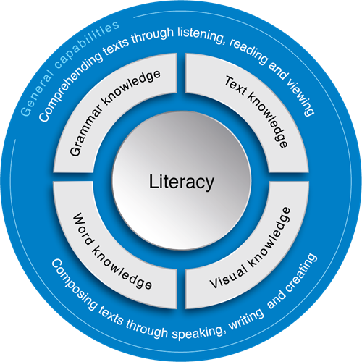
Literacy encompasses the knowledge and skills students need to access, understand, analyse and evaluate information, make meaning, express thoughts and emotions, present ideas and opinions, interact with others and participate in activities at school and in their lives beyond school. Success in any learning area depends on being able to use the significant, identifiable and distinctive literacy that is important for learning and representative of the content of that learning area. The development of literacy skills explicitly links to the Australian Qualifications Framework (AQF) generic learning outcomes. This supports individuals’ lifelong learning goals through the development of fundamental literacy skills involved in written, oral and technical communication, when undertaking defined routine work related activities to present information in employment, study and life.

Overview of promotion of literacy
All Teachers | English Teachers | Students | Parents
- Embed literacy into lesson design and planning documents (every classroom, every lesson, every day.) | - Support teachers in improving the literacy of our students, in both oral language, reading and writing. | - Upskill students to become reflective learners and edit their own work.  - Students are encouraged to watch/listen/read news and current affairs. | - Encourage students to read a variety of texts including fiction and non- newspaper/magazine articles, fiction. For example, novels, short stories,
Joseph Banks Secondary College Literacy Plan 2019
 | Reading | Writing | Oral Language | Language Conventions | 2019 Focus
Whole School | Creating the Environment for Learning:  - Use prompts such as visual images, captions, icons, headings etc. to stimulate curiosity (i.e. link to real life context/activate prior knowledge).  Help students to develop understanding:  - Chunk texts  - Use Cues, Questions and Advanced/graphic organisers. E.g. a retrieval chart, reading maps  Extending and applying knowledge:  - Reflection/evaluation of reading using Venn diagrams or Thinking Bridges | Creating the Environment for Learning:  - Vocabulary Walls  - Sentence Starters  - Brainstorming  Help students to develop understanding:  - Cues, Questions and Advanced/graphic Organisers  - Exemplars, scaffolding and templates, rubrics and exemplars.  - Frameworks for writing (paragraph structure, essay/persuasive/narrative).  - CUPS Editing checklist.  Extending and applying knowledge:  - Identify similarities and differences  - Explore different points of view.  Editing:  - CUPS Editing checklist. | Creating the Environment for Learning:  - Think,pair,share  - Quiz, quiz, trade  Help students to develop understanding:  - Roles in co-operative groups  - Discussion and debate of topics  Extending and applying knowledge:  - Explore ways to present information orally e.g. interview, peer teaching, filming | - Students should be encouraged to write in full sentences.  - Correct and edit student punctuation, for example; capital letters, full stops, apostrophes and semi-colons in written work.  - Provide feedback using standardised editing symbols  - Use placemat in the classroom to support the literacy of all students | Reading  - Develop Reading Comprehension skills  - Access and process information, using a range of strategies  Writing  - To extend student’s vocabulary and embed into their writing  - Students to write with purpose and use effective punctuation when constructing sentences  - Students to present their ideas through well-developed paragraphs
Professional Learning Community | - Leading Teachers/2IC working alongside Domain areas to support integration of reading strategies  - Planning for the modelling of reading strategies in meetings  - Using expert staff to deliver professional learning to the PLC  - Collaboration about exemplars of work and its impact on students learning.  - Upskill staff on the requirements for NAPLAN/OLNA | - Leading Teachers/2IC working alongside Domain areas to support integration of writing strategies  - Planning for the modelling of writing strategies in meetings  - Using expert staff to deliver professional learning to the PLC  - Collaboration about exemplars of work and its impact on students learning.  - Upskill staff on the requirements for NAPLAN/OLNA |  | - Evidence brought to meetings of progress from students via editing checklist.  - Upskill staff on the requirements for NAPLAN/OLNA  - Raise awareness of OLNA/NAPLAN Marking key/rubrics.
Domain | - Embed a range of text types into their planning.  - Consider complexity of texts which challenge students.  - Texts that are relevant to age and real life experiences.  - Upskill staff on the requirements for NAPLAN/OLNA | - Focus for planning of literacy strategies in the curriculum.  - Embedding effective literacy strategies into teaching and learning programs.  - Supporting staff across domain and PLC’s through professional learning and/or observation.  - Upskill staff on the requirements for NAPLAN/OLNA |  | - Embed spelling words into vocabulary walls and planning.  - Use editing checklists to encourage students to proof their work and receive feedback.  - Identify key subject specific words as part of their planning.

