Template
Mission

Vision

Collective Commitments

SIP Team

Lyon Elementary Schools’ Objectives and Data Analysis

Data Analysis What are your key successes? Key gaps? How do you know?
Success:

Gaps:

Grade Level Plan: What is the grade level literacy goal and its success criteria? | Do: What will the grade level (teacher, students and leaders) do to accomplish the plan? | Measures: How will you measure each step in the “Do”?
Professional Learning: What professional learning might be needed to support the “Do”?

Study/Act: Checkpoint: Based on the results of your measures, what ‘s working? What adjustments are suggested by the data?

Quarter 1:
Quarter 2:
Quarter 3:
Quarter 4:

Example
Mission
Lyon: Lifelong Leaders and Learners

Vision
Lead: I live the 7 habits in all areas of my life.
Love: I use my voice for good because change starts with me.
Learn: I set goals to grow.

Collective Commitments
The faculty and staff at Lyon Elementary are committed to fulfilling the district’s mission: preparing each student for a successful future.
As leaders within this school, we will do the following:
- Remain a positive role model and display work ethic and behavior we expect from our students.
- Do what is best for students, be reflective, and ask “why”.
- Make sure our goals are realistic and attainable.
- Be open-minded to new ideas and processes to enhance student learning.
- Make data driven decisions based on research and best practices.
- Support each individual by fostering an “in it together” attitude that will enhance the education of our students and keep our commitments the focus.
SIP Team
- Casey Mitchell, Principal  - Leanne Gove, Assistant Principal  - Jennifer Bowers, Counselor  - Michelle Peters, Counselor  - Julie Thompson, Kindergarten  - Lindsay Maynard, 1st Grade  - Emily Baker, 2nd Grade | - Stephanie Schmidt, 3rd Grade  - Whitney Hoodenpyle, 4th Grade  - Krista Boettler, 5th Grade  - Stacie Allen, Art  - Mallory Eoff, SpEd  - Christina Staeger, classified representative

Lyon Elementary Schools’ Objectives and Data Analysis

Writing Data Analysis What are your key successes? Key gaps? How do you know?
Success:
In 2018-2019:
- Lyon had 77.6% of students mastering grade level content in writing, an increase of 2% from 2017-18 school year
- 112 3rd through 5th grade students were proficient/advanced on 2019 ELA MAP assessment

Gaps:
In 2018-2019:
- Lyon did not meet the goal of 80% of students meeting writing grade level proficiency
- Two grade levels decreased proficiency from 3rd to 4th quarter
- 54.63% were proficient/advanced on the 2019 MAP test, this accounts to 93 3rd-5th grade students not meeting proficiency
Grade Level Plan: What is the grade level literacy goal and its success criteria? | Do: What will the grade level (teacher, students and leaders) do to accomplish the plan? | Measures: How will you measure each step in the “Do”?
80% of Lyon students will meet or exceed grade level standards in writing | - Phonics will be implemented in all K-3 classrooms  - Formative assessments and quick writes will continue to be used in weekly writing lessons | - PULSE data will be monitored for all priority standards  - Instructional rounds and classroom observations will support phonics implementation  - Individual classroom teachers will monitor writing action steps through monthly WIG calendars
Professional Learning: What professional learning might be needed to support the “Do”?
Grade levels will seek professional development in areas related to any DO step, based on current need or administrative suggestions. Lunch and Learns and book studies will be offered surrounding engagement, rigor, and critical thinking. All classroom teachers will receive Aligning Academic training from Leader In Me to support personal and academic goal setting
Study/Act: Checkpoint: Based on the results of your measures, what ‘s working? What adjustments are suggested by the data?
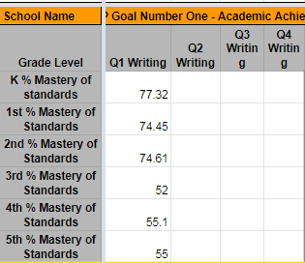

Quarter 1: Lyon’s overall percent of proficient students is 63.34%. Classroom goals (WIGS) will center on writing (Phonetic spelling and Quick writes). Multiple grades are struggling to meet proficiency in conventions so WIN time lessons and systematic strategies will be used to address low areas.
Quarter 2:
Quarter 3:
Quarter 4:

Lyon Elementary Schools’ Objectives and Data Analysis
Reading Data Analysis What are your key successes? Key gaps? How do you know?
Success:
In 2018-2019:
- 112 3rd through 5th graders were proficient/advanced on 2019 ELA MAP assessment
- 80.84%of students proficient with reading standards

Gaps:
In 2018-2019:
- 54.63% were proficient/advanced on the 2019 MAP test, this accounts to 93 3rd-5th grade students not meeting proficiency
- 12.5% of students were on Reading Proficiency Plans
Grade Level Plan: What is the grade level literacy goal and its success criteria? | Do: What will the grade level (teacher, students and leaders) do to accomplish the plan? | Measures: How will you measure each step in the “Do”?
82% of Lyon students will meet or exceed grade level standards in reading | - Phonics will be implemented in all K-3 classrooms  - Each classroom will implement time for volume reading and encourage goal setting surrounding reading  - Content will be spiraled to continue building knowledge around essential standards  - Staff learning will focus on rigor and text dependent questioning centered around grade level passages and non preferred topics | - PULSE data will be monitored for all priority standards  - Classroom WIGS will be implemented in each classroom  - Classroom walkthroughs of Literacy Stations will be conducted  - Agendas and lesson plans will act as artifacts for rigor and text dependent questions
Professional Learning: What professional learning might be needed to support the “Do”?
- RtI support through half day planning and conversations surround rigor will support use of MAP items to increase rigor.
- Professional development centered around engagement and critical thinking will be offered.
- A vertical team will be established to support vertical alignment of rigor.
- A plan to grow knowledge of text dependent questions will be created.
Study/Act: Checkpoint: Based on the results of your measures, what ‘s working? What adjustments are suggested by the data?
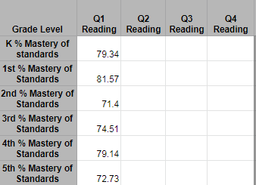
Quarter 1: Currently 75.71% of Lyon students are proficient with grade level reading standards. Students struggling in multiple areas within literacy have been identified and placed on reading proficiency plans (RPP). Collaboration will occur through goal sheets being shared and data being tracked for each student on an RPP.
Quarter 2:
Quarter 3:
Quarter 4:

Lyon Elementary Schools’ Objectives and Data Analysis
Numeracy Data Analysis What are your key successes? Key gaps? How do you know?
Success:
In 2018-2019:
- Lyon exceeded the goal with 82.3% of students meeting grade level math standards
- Three grade levels exceeded the goal of 80%
- 120 3rd through 5th grade students met proficiency on the 2019 MAP assessment

Gaps:
In 2018-2019:
- Three grade levels did not meet the goal of 80% of students meeting grade level expectations
- Lyon decreased their overall percentage by 3% when compared to the 2017-2018 school year
- 58.54% of 3rd-5th grade met proficiency on the 2019 MAP assessment, this means 85 3rd-5th grade students did not master grade level standards

Grade Level Plan: What is the grade level literacy goal and its success criteria? | Do: What will the grade level (teacher, students and leaders) do to accomplish the plan? | Measures: How will you measure each step in the “Do”?
85% of Lyon students will meet or exceed grade level standards in math. | - Utilize WIN time to focus on essential standards  - Classroom Wildly Important Goals (WIG) implemented in all classrooms  - Pre/post tests within RtI will align to MAP like rigor and test like questions  - Content will be spiraled to continue building knowledge around essential standards | - PULSE data will be monitored for all priority standards  - Weekly Release folder will house artifacts to show the following:  - Calendar to show spiraling of content  - pre/post tests aligned MAP item specifications and MAP practice tests  - Essential Standard Unit plan identifying DOK level and unwrapped standard  - Lesson plans aligned to unwrapped standard
Professional Learning: What professional learning might be needed to support the “Do”?
- Grade levels will seek professional development in areas related to any DO step, based on current need or administrative suggestions.
- Taking Action will be a resource teachers will use for protocols surrounding discussions on student achievement data and/or best practices within instruction.
- Mine the Gap, a book to support unwrapping of math standards was provided to each K-5 teacher to support the planning of WIN time instruction. Training was provided for all K-5 teachers on the utilization of tasks within this book.
Study/Act: Checkpoint: Based on the results of your measures, what ‘s working? What adjustments are suggested by the data?
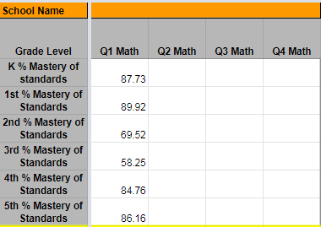
Quarter 1: Lyon has 78.17% of students proficient on grade level math standards. Skills groups will be embedded into WIN time. Adjustments will be made to WIN time calendars. Content will continue to be spiraled throughout the year.
Quarter 2:
Quarter 3:
Quarter 4:

Lyon Elementary Schools’ Objectives and Data Analysis
Attendance Data Analysis What are your key successes? Key gaps? How do you know?
Success:
In 2018-2019:
- Lyon ended the school year with proportional attendance of 96.46%

Gaps:
In 2018-2019:
- 3rd Quarter attendance was the lowest attendance for the year.
- 5th grade has a 2% decrease in attendance in the 4th quarter
Grade Level Plan: What is the grade level attendance goal and its success criteria? | Do: What will the grade level (teacher, students and leaders) do to accomplish the plan? | Measures: How will you measure each step in the “Do”?
Monthly attendance will remain at or above 95.2% with an overall proportional attendance at 96.5% | - Identify all students who have less than 90% attendance each month  - Utilize pyramid of interventions with all students falling below 90%  - Implement an attendance spirit week to raise awareness of the importance of attendance  - Implement Great 98 celebrations for students’ who have 98% or greater attendance each month | - Pulse attendance analyzed monthly  - Tiered interventions will be communicated to both teacher and administration monthly  - Attendance spreadsheet will show the number of students in each of the tiers of intervention
Professional Learning: What professional learning might be needed to support the “Do”?

Study/Act: Checkpoint: Based on the results of your measures, what ‘s working? What adjustments are suggested by the data?

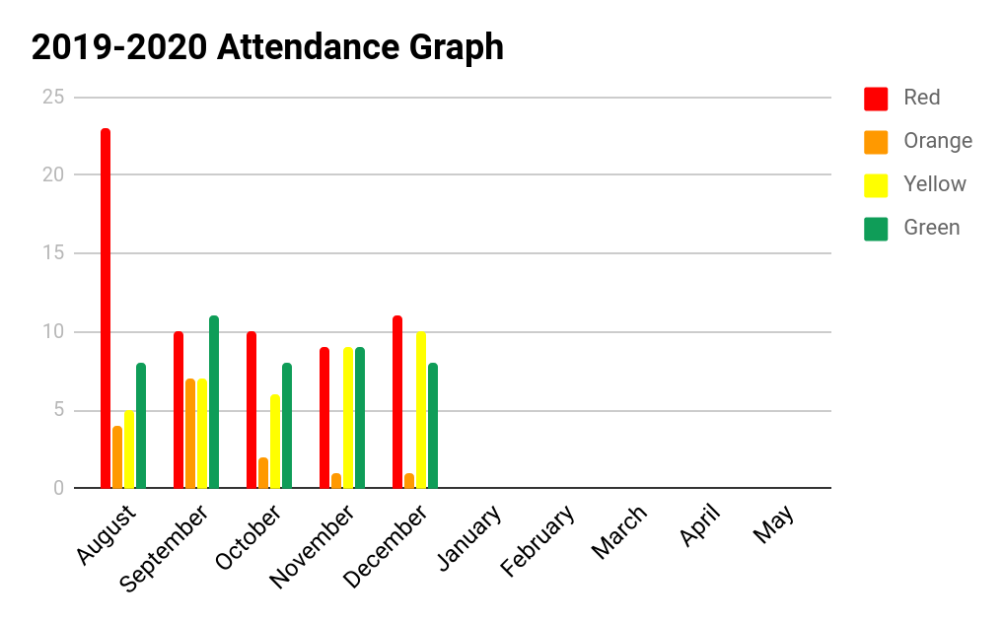
Quarter 1: Currently 16 students have graduated off the attendance pyramid with 90% of attendance or greater. In August Lyon had 40 students on within our intervention tiers, and as of October Lyon has 26. Lyon has seen a decrease of students needing attendance interventions each month.
Quarter 2:
Quarter 3:
Quarter 4:

Lyon Elementary Schools’ Objectives and Data Analysis
Discipline Data Analysis What are your key successes? Key gaps? How do you know?
Success:
In 2018-2019:
- Decrease of 27% from the 2017-2018 school year, with only 140 ODRs for the year.
- 2nd Quarter: There were a total of 67 ODRs in the first semester, which is just over halfway to the overall goal of 126 or less.
- 2nd Quarter: Lyon 2nd grade students currently have a total of only 3ODRs.

Gaps:
In 2018-2019:
- 3 months (October, February, and April) with 20+ ODRs exceeding the goal of 19 or less per month
- 2nd Quarter: The monthly goal of 12 or less ODRs was only met one month out of 5. In order to meet the overall goal of 126 or less total ODRs,
Grade Level Plan: What is the office discipline goal and its success criteria? | Do: What will the grade level (teacher, students and leaders) do to accomplish the plan? | Measures: How will you measure each step in the “Do”?
The goal is to have 126 ODRs, or  12 or less ODRs per month which would result in a 10% reduction of 10% when compared to the 2018-2019 school year. | - 100% of Lyon students have leadership roles in the classroom and on Student Leadership Teams.  - Discipline data will be shared monthly with the Lighthouse Team. The Lighthouse team will develop additional “DO” steps based on data and those will be communicated to staff monthly.  - The Lighthouse Team will analyze past office referral data to find trends, and will create a proactive plan based on that data.  - Positive Office Referrals and Leaders of the Month will be utilized to recognize students  - Professional development will be offered on Tier 1 and Tier 2 behavior interventions.  - The Student Intervention Team will support teachers with gathering data and implementing Tier 2 interventions. | - Lead team agendas  - Lighthouse Team agendas  - PULSE ODR data will be analyzed and communicated to staff monthly  - Facebook posts and building newsletters will showcase positive behavior recognition  - Agendas and presentations regarding professional development on behavior interventions  - SIT agendas
Professional Learning: What professional learning might be needed to support the “Do”?
- New staff members will participate in CHAMPS training.
- CHAMPS II training will be recommended to all staff.
- Professional development will be offered on Tier 1 and Tier 2 behavior interventions.
Study/Act: Checkpoint: Based on the results of your measures, what ‘s working? What adjustments are suggested by the data?
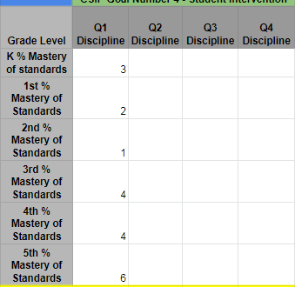
Quarter 1: Lighthouse Team embed Tiger Tickets for the week of 10/28-11/1 due to consistently high referrals this week. The team will continue to share out expectations, reminders, and reteach as necessary based on monthly monitoring of data.
Quarter 2: The current total of ODRs, 67, is just over half of the overall goal. A Lunch and Learn will be offered in March for continued support with gathering data and using Tier I interventions. The Lyon Lighthouse Team will continue to analyze past and current data, creating action steps to reduce ODRs. All Lyon students will continue to serve in leadership roles, with ODR data being shared with 4th and 5th grade students. Lyon SIT will continue to support teachers with Tier 2 interventions with the goal of decreasing the number of students with multiple ODRs.
Quarter 3:
Quarter 4:

