Supplemental Data Report for
Riverton Elementary School

Figure 1
2021-2022 Mid-Year Growth Data
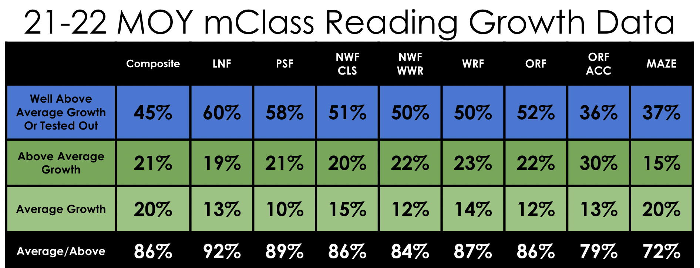
Figure 1: This data chart depicts the growth in reading taking place this school year (21-22) as a result of the changes listed above. While 100% of all our students made growth on the mClass Reading Assessment, we felt it was more important to determine the level of growth made, so we could adjust interventions and enrichments for students who did not grow at the rate we would expect them to grow. This data not only shows that over 85% of our students made Average Growth or greater in almost every assessed area, it also shows that over 50% of our students made Well-Above Average growth in six out of 9 assessed areas.

Figure 2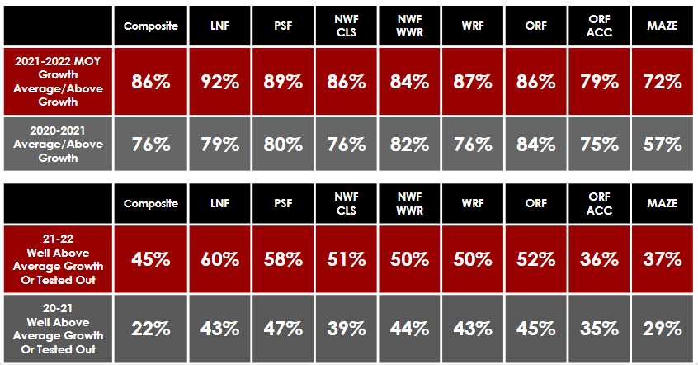
Figure 2: This data chart compares the growth of our students at mid-year last year (20-21) to the growth of our students mid-year this year (21-22) in all reading assessment areas. The first chart in Figure 2 compares the percentage of students who had AVERAGE growth or higher both last year and this year on the mid-year assessment. As you can see, we increased the percentage of students making average growth or higher in 100% of all assessment areas. The second part of this chart shows the percentage of students who made WELL-ABOVE AVERAGE growth in each reading area. As you can see, we increased the percentage of students falling in the well-above average growth in 100% of all tested areas.

Figure 3
Comparing Kindergarten Mid-Year Data Across 5 Years
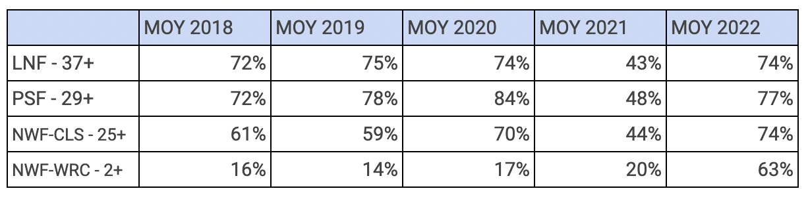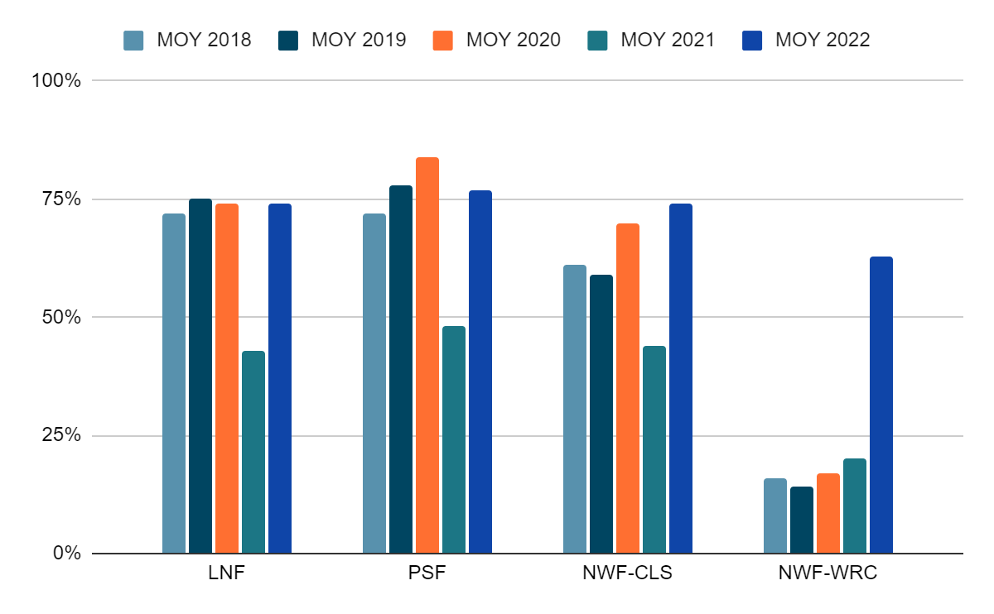
Figure 3: From 2018-2022, our reading assessment benchmarks have changed and all benchmarks are currently higher now than they were in the 2018-2020 school year. Due to these increases, we used raw data from the 2018, 2019, and 2020 school years against CURRENT benchmarks to see how our students are performing compared to previous years. It was important to use this raw data to the CURRENT benchmark levels because these levels are substantially higher now than they were in previous years, meaning students have to score higher now in every category to be considered proficient. So, this data reflects how many students would have benchmarked mid-year in the 2018-2020 school years if held to the same standard we currently use for mid-year data. We particularly wanted to know this information for our Kindergarten students, because this grade level sets the foundations for all future learning.
As you can see, there was a dip in the year of COVID (MOY 2021), due to students learning virtually for the first part of the semester (MOY 2021) and most PreK programs being suspended the previous year. However, our current Kindergarteners are not only on track to perform as well or better than previous years, our data shows that huge growth has occurred in the area of Nonsense Word Fluency, Words Read Correct (NWF-WRC) which means our students are blending words now better than ever before. This one indicator shows that our students are ready to read now more than ever before.

Figure 4
Tracking our Current 3rd Grade Students Through a Pandemic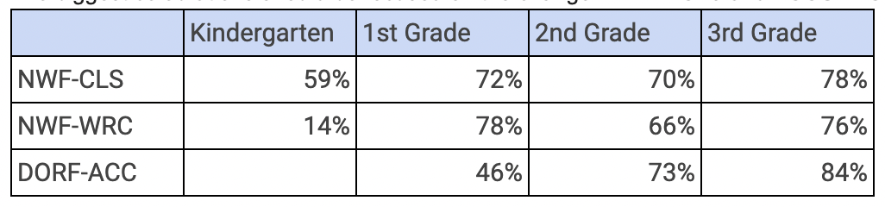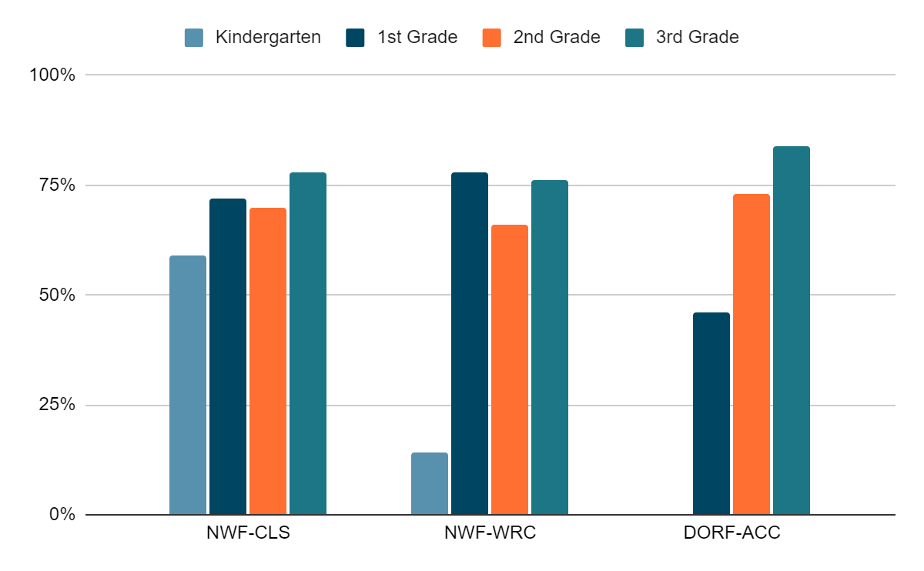
Figure 4: This data chart tracks our current 3rd graders from a pre-pandemic Kindergarten year through the pandemic to their current 3rd grade performance. All data reflects mid-year data proficiency levels set at CURRENT benchmarks, so the data reflects consistency in what is currently expected. During the Kindergarten and 1st grade years, the benchmarks for proficiency were lower than what is currently expected from Kindergarten and 1st grade students. So, we used raw data to extract out the number of proficient students using the current benchmarks for Kindergarten and 1st grade students.
As you can see from this data, our proficiency levels of this cohort of students show consistent growth, and the current level of 84% proficient in accuracy shows that students are able to apply their early literacy skills despite the disruptions to learning that occurred during the pandemic.

Figure 5
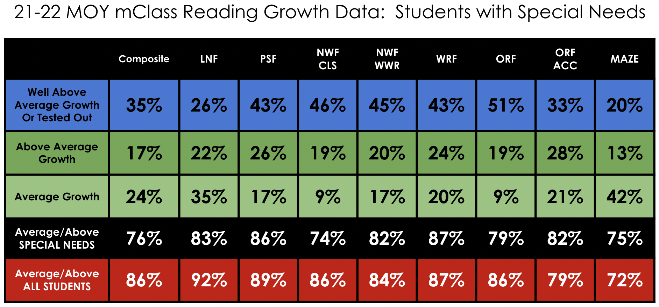
Figure 5: This data chart shows the mid-year growth of our students who have special needs. This data reflects their reading growth in each assessed area from beginning of the year to mid-year for the current school year. 100% of our students in this subgroup made growth, however, this chart reflects growth at high levels. While the high level of growth is below the growth level of all students in some areas, there are other areas where the growth level is at or above that of all students.

Figure 6
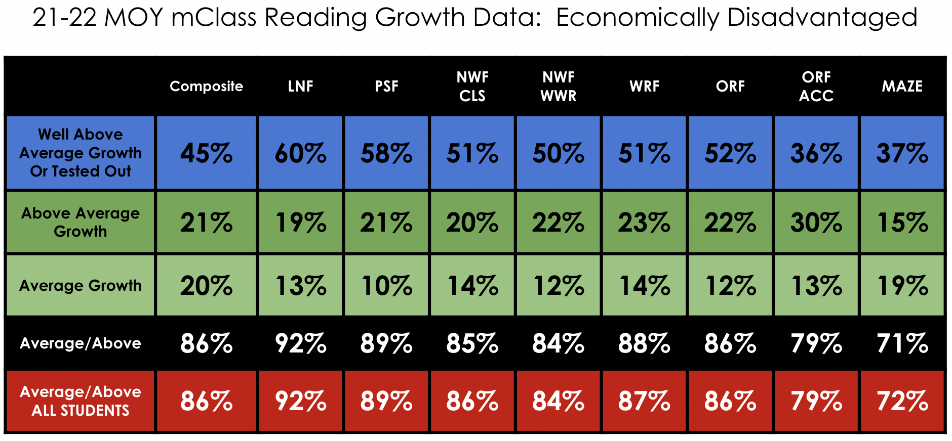
Figure 6: This data reflects that our students who are economically disadvantaged had average and above growth rates comparable to those of all students. This data, along with the data in Figure 5, shows that we are implementing high-quality instruction to close gaps and remove learning barriers.

