In 2019 we worked hard to increase the growth in all student groups. The below screenshots illustrate the success of our teacher teams.
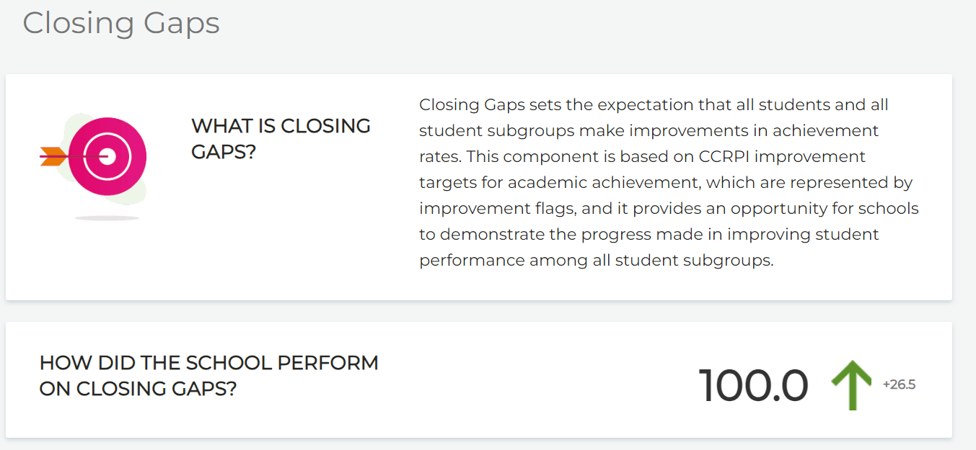
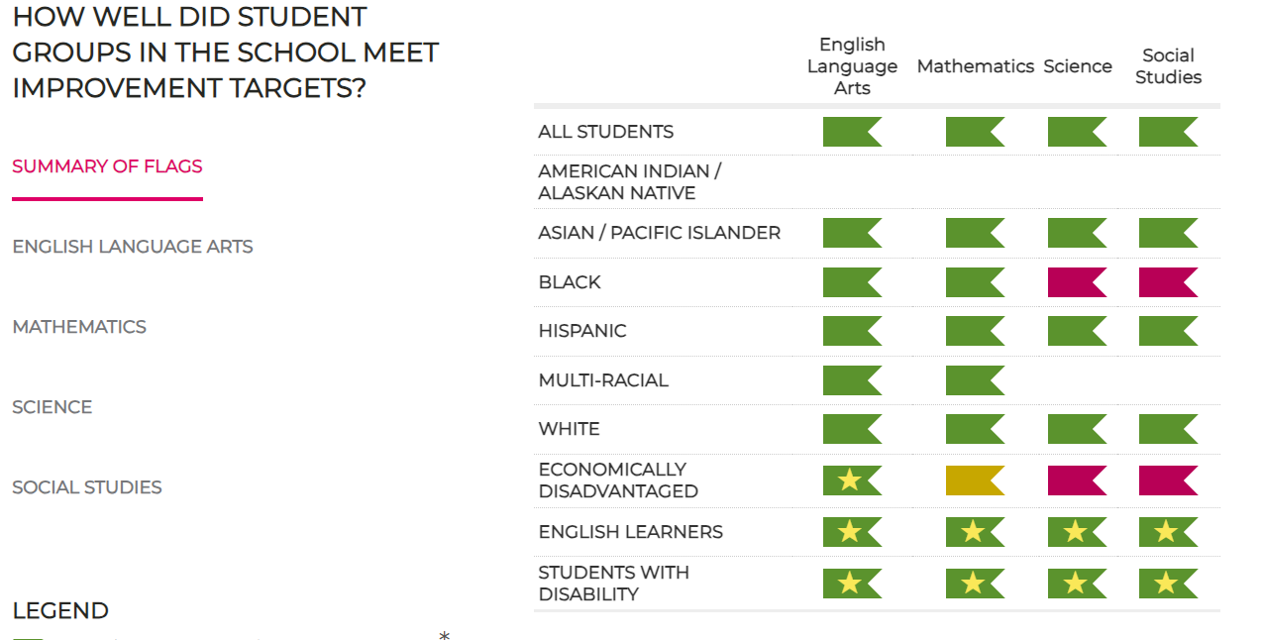
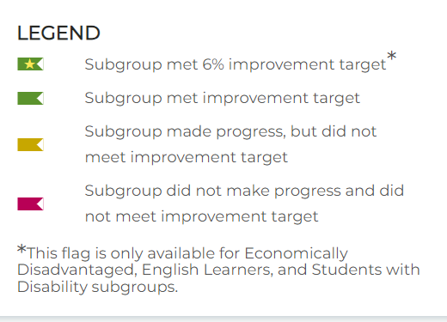
We have not had access to this growth data since 2019, but we will see it again this fall once it is released and will add it to our application as soon as it is available.

