Standards Based Assessments (SBA) Performance English Language Arts
This data set represents a comparison of performance from 2019 to 2023 with the available data. The 2019 scores represent student performance prior to COVID and the learning recovery process since COVID by grade level. Student performance overall is approaching pre-COVID performance and exceeded pre-COVID achievement in some areas.
Overall School Proficiency (2019, 2022, 2023)  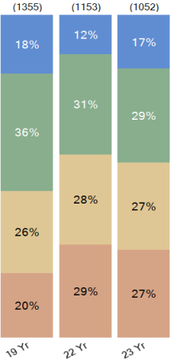 | 6th Grade Proficiency  (2019, 2022, 2023)  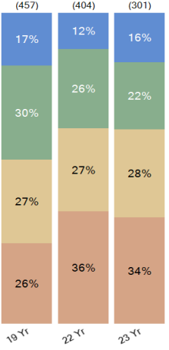 | 7th Grade Proficiency  (2019, 2022, 2023)  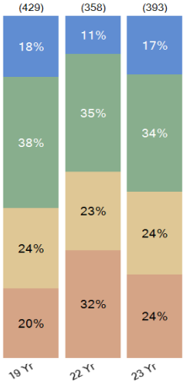 | 8th Grade Proficiency  (2019, 2022, 2023)  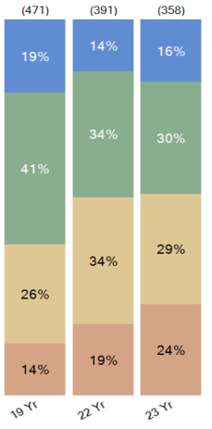
English Language Arts

Standards Based Assessments (SBA) Performance Math
Overall School Proficiency (2019, 2022, 2023)  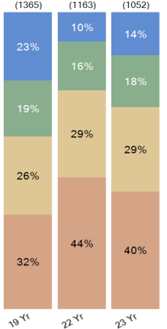 | 6th Grade Proficiency  (2019, 2022, 2023)  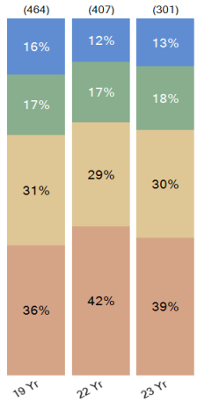 | 7th Grade Proficiency  (2019, 2022, 2023)  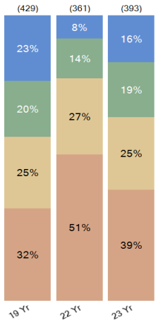 | 8th Grade Proficiency  (2019, 2022, 2023)  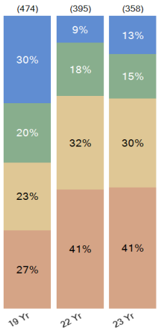

Growth/Achievement Comparisons SBA 2022 compared to SBA 2023
English Language Arts
The data in this chart represents cohort growth and achievement for all subgroups. This data indicates that all significant subgroup cohorts have shown improvement in both Math and ELA over the past year. Notice that the highest growth was demonstrated by Students with Disabilities in math. Our teams have had a target focus on providing intervention for students with disabilities in math with a robust co-teaching model. Each math team has a math teaching partner who has specialized training in supporting students with disabilities.

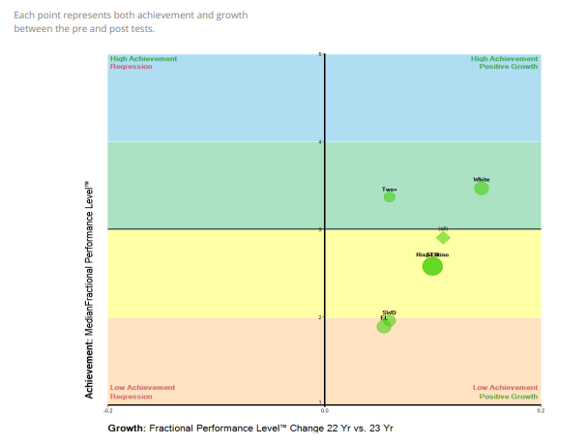
Growth/Achievement Comparisons SBA 2022 compared to SBA 2023
Math

