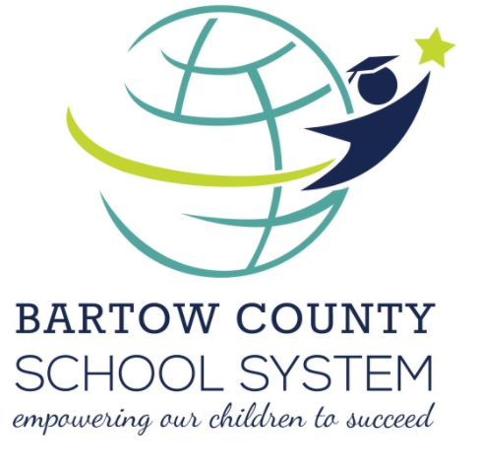
Cass High School/Site
Intervention Team

The School/Site Intervention Team is responsible for coordinating, monitoring, and identifying students in need of Tier 3 interventions. The team will focus on the individual needs of the most at-risk students, working to intervene and offer solutions to complex cases to increase student success. The team should be composed of diverse expertise to offer the best individualized course of action for each identified student.

Use the following to build a school intervention team with the Guided Coalition. Remember, when you don’t have access to someone with the exact title or role in the first column, ask yourself, “Which staff member is best trained to meet this need?”

Essential Role | Recommended | Staff Members Best Trained to Meet This Need
Administration | Principal, Assistant Principal | Jennifer Suarez
System Oversight | Learning Support Specialist | Carey Hory
Reading | Reading Specialist | Sarah Turner
Writing | English Language Arts Specialist | Jandy Fowler
Mathematics | Mathematics Specialist | Audrey Ellison
English Language | English Learner Specialist | Katherine Walraven
Language | Speech and Language Pathologist | Marialyce Lewis
Teaching Differentiation | Exceptional Education Teacher, LSS | Kimberly Schlabach
Behavior | Psychologist | Grace Krize
Social-Family | Counselor | Andrew Griffin
Instructional Resources | Librarian, ILT | Kayla Jackson
Community Resources | Community Resource Officer, Social Worker, Counselor | Andrew Griffin

Once team members have been selected and invited to participate, please have the team navigate the School Intervention Team Initial Meeting Protocol to establish necessary elements to guarantee a successful start to their work.

