2019-2020 MS ELA PLC Agenda
Date: 12/4/19

PLC GOAL: By 04/20/2020, students will identify the strongest evidence and apply it in formal paragraph format using explicit facts and as well as generalized inferences to support textual analysis with at least 80% accuracy as seen in formal and informal writing as well as teacher observations.

Agenda Items | Minutes
Last PLC Agenda
Dunlap Staff Development Calendar
ELA Middle School Meeting  TEAM LEAD  Prepare the agenda and lead PLC discussions.  MINUTE TAKE  Transcribe important discussion points throughout the meeting.  TIMEKEEPER  Transcribe the notes for data evaluation and keep the meeting moving along. | TEAM LEAD: Daniel Parichan  MINUTE KEEPER: Stacy Densmore  TIME KEEPER: Callie Ferraro
Establish Norms | - Be punctual (start & end time)  - Coming prepared  - Stay on topic  - No grading unless part of PLC  - Equal participation  - Respectful collaboration
FOCUS STUDENTS (RSP & ELD) | 6TH GRADE  - RSP - Olivia Mk, Sammy P, Raquel P, Angelica G, Megan O, Olivia Md*push in support provided - no formal IEP  - EL - Lismarin S., Chelsea E.  7TH GRADE  - RSP - Bryce C., Joseph T., Andrew S.  - EL - Aiden, Andrew, Julian, Tomas  8TH GRADE  - RSP - Gage R., Ray W., James S., Mia V.  - EL - Abraham X., Randy F.
Celebrations | RSP:  - OUT ON MED LEAVE  6th:  - Students are making good progress no WFBB essay about lying.  - Behavior hasn’t been that bad since returning from break.  7th:  - Although the overall scores weren’t great on the benchmark, the SCRs were amazing!  - My students are currently working on their first essay and have done a fantastic job on their flee maps, talking through their maps with a partner (after getting over the initial embarrassment), and now have a great foundation for their essays.  8th:  - Students are working well in their new assigned seats - have seen some improvement in behavior for history.  - There was a change in overall class behavior upon returning back from break and many students realized that they need to start taking it serious.
Pedagogical Discussion:Team engages in discussion around pedagogy, teaching practices. This can happen as part of a CFA or other agreed upon method. Try to keep discussions based upon evidence of student learning whenever possible. Possible methods for discussion may include common work sample, lesson study, and peer observations  - Writing Focus | WRITING FORMAT (after using thinking map)  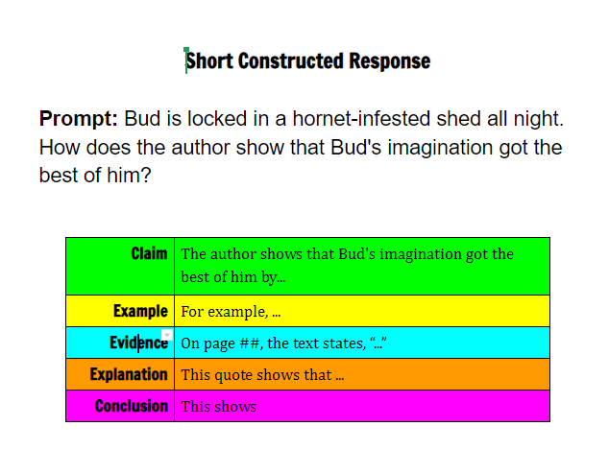  What Is A Short Constructed Response
Data Based Team Action Plan  - Identify the number of blue, green, yellow and red scores each grade level had for the District Benchmark (identify the corresponding scores for RSP and ELD students).  - Discuss strengths/struggles each grade level had.  - Attach 2-3 frequently missed questions w/ corresponding standard  - Attach 2-3 top scoring answers  - Writing strengths/weaknesses  - Any concerns? | DATA ANALYSIS  *Recent FALL 2019 District Benchmark Data  6th GRADE 4 3 2 1  ALL - 11 12 11  RSP - - 4 2  ELD - 1 - 1  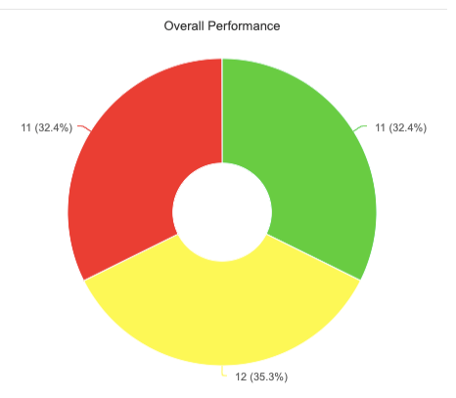  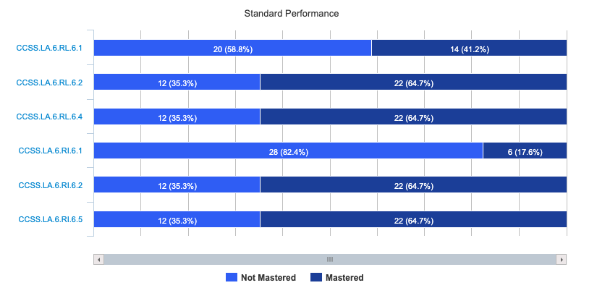  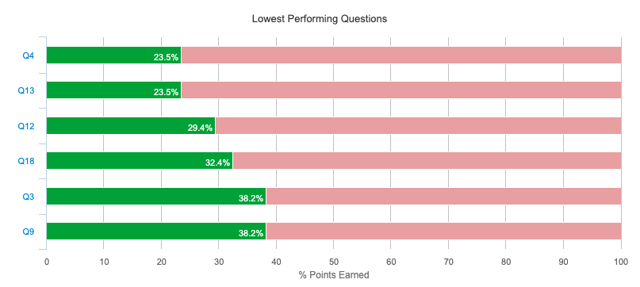  6TH GRADE  OVERALL THOUGHTS  *No writing in 6th grade test  *Text were run through a Grade level analyzer by Riverview 6th grade and she discovered that the text weren’t in a 6th grade reading level.  TESTING STRENGTHS  *Great focus on all students - took their time.  *Test taking strategies used when close reading text and crossing out answers.  *Held students accountable by working towards doughnuts if students scored a blue or green - knew about it at least a week in advance.  TESTING WEAKNESSES  *Few students took little to no care in test despite providing plenty of time.  *1 students took 10 minutes to answer 10 questions (that includes reading 2 passages)  *Students unaware about test taking strategy of double/triple checking their work.  QUESTIONS MISSED  Question #4 - RI 6.2 (missed by 26 students)  Question #13 - RI 6.1 (missed by 26 students)  Question #12 - RI 6.1 (missed by 24 students)  QUESTIONS CORRECT  Question #17 - RL 6.4 (missed by 2 students)  Question #14 - RI 6.2 (missed by 5 students)  Questions #8 - RL 6.2 (missed by 9 students)  INTERVENTION STRATEGIES  7th GRADE 4 3 2 1  ALL - 7 10 20  RSP - - - 3  ELD - - 1 3  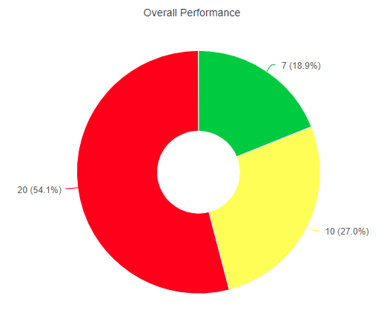  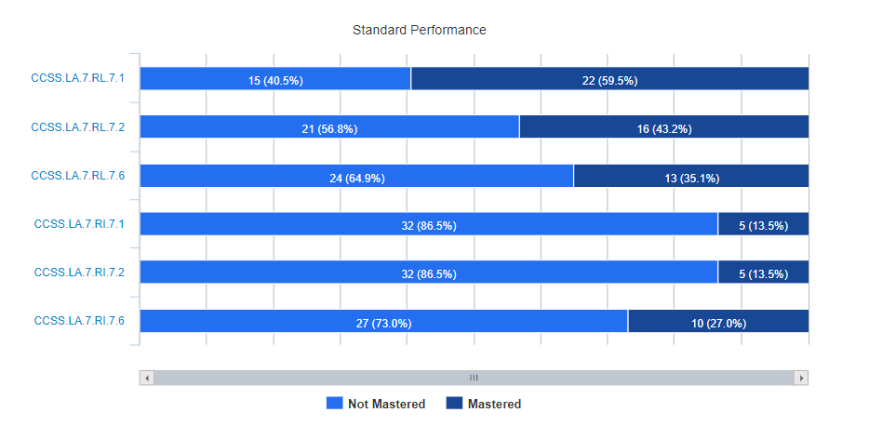  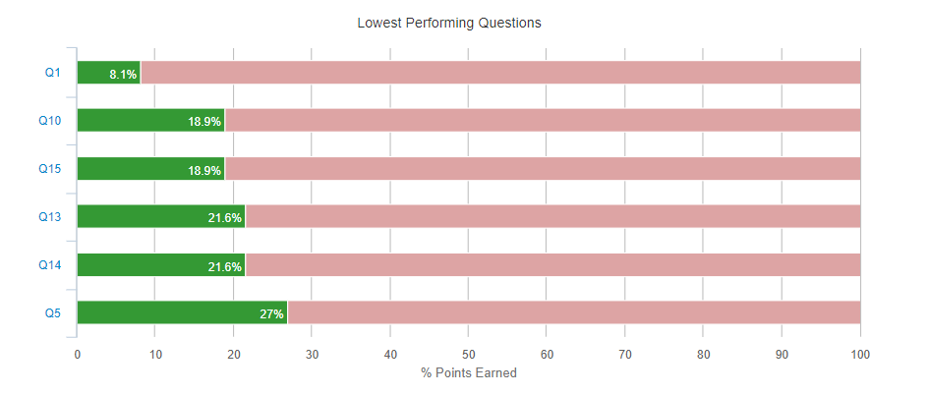  7TH GRADE  OVERALL THOUGHTS  *The wording on the test was confusing to some students. This can be addressed in intervention by making sure words, phrases or ideas are expressed in multiple ways.  *Many questions used the word “summary” or “summarize”. Although this was part of the curriculum, it was not the emphasis, but seemed to encompass the majority of the test.  *The questions were worded very similar to the way SBA questions are, but the format confused students.(Click on two sentences that…, Use part A to answer part B, etc. ) I need to incorporate IABs, and more assessments that included these types of responses.  TESTING STRENGTHS  * Most students were using the close reading strategies and test strategies we’ve discussed. For example, they were highlighting text, annotating when needed, and eliminating obvious incorrect answer choices.  TESTING WEAKNESSES  *Some students did not take the test seriously.  *Students did not read the questions carefully. After they reviewed their answers post submission, many realized this error.  QUESTIONS MISSED  Question #? - STANDARD  Question #? - STANDARD  Question #? - STANDARD  7th Grade SCR Examples:  INTERVENTION STRATEGIES  8th GRADE 4 3 2 1  ALL 1 8 4 20  RSP - - 4  ELD - - 1 1  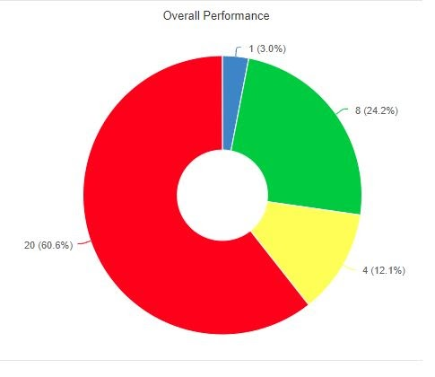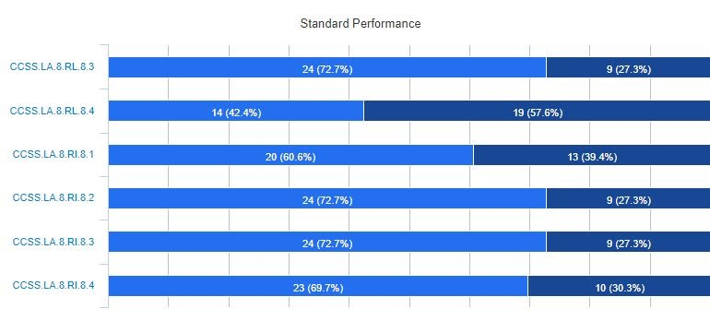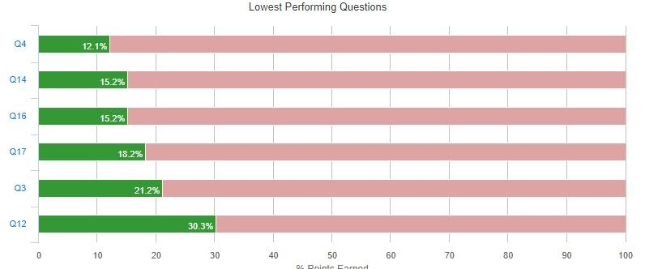  8TH GRADE  OVERALL THOUGHTS  - The students focused while taking the test.  - Some of the wording on the problems were hard for the students to understand.  TESTING STRENGTHS  *Students were trying their best in most cases.  Even though they did not score the best on their written responses their formatting was there!  TESTING WEAKNESSES  - #6 on the benchmark was their written response which had students infer based on the information provided. They answered the prompt in most cases incorrectly.  - Rushing through the test, or not taking the time to do their close reading routine.  QUESTIONS MISSED  Question #4 - STANDARD (missed by ## students)  Question #14 - STANDARD (missed by ## students)  Question #16 - STANDARD (missed by ## students)  #16  QUESTIONS CORRECT  Question #? - STANDARD (missed by ## students)  SNIP QUESTION  Question #? - STANDARD (missed by ## students)  SNIP QUESTION  Question #? - STANDARD (missed by ## students)  SNIP QUESTION  INTERVENTION STRATEGIES  *Focus on author’s purpose aiming toward the goal of information that needs to be inferred rather than the “black and white” that is printed on the page.  *Implementing IXL strategies to help them practice certain areas.(ex. Citing evidence, tone, informational text.)  *Types of language
ENRICHMENT T2
*Discuss the future of AR, reading logs and other variety of enrichment lessons.
DISTRICT WFBB ESSAY/PROMPT
*Discuss the current process of essay that is due (final draft and graded) by next Wednesday.
Next Meeting Preparation  What do we need to discuss at our next meeting? | *DECEMBER  https://contentexplorer.smarterbalanced.org/

.

