Gladys Polk Elementary
Faculty Newsletter
July 31, 2017
From Tara-
- Hope your summer has been great!
- Thank you to PLC Leads and Grade Level Leads for meeting with Alicia and me on July 21st to go through our August PD plans!
- Please click here to view the Polk 2017-2018 Master Schedule.
- Please click here to view the Polk Campus Teams/PLC’s list.
From Alicia

Building a Collaborative Culture….One Team, One Vision!
Gone are the days of “my classroom,” “my school,” “my students,” and “my business” within educational institutions. From classroom teachers to school principals, issues of personal turf and ownership reigned commonplace in practice and in conversations in school communities. Creating a school culture that ensures positive outcomes for all students requires an “all hands on deck” approach to meeting the needs of the learners. Like any form of collaborative scholarship, successful collaborative teaching integrates the strengths of multiple viewpoints in a synthetic endeavor that no single member of the project could have completed independently. It also provides an expanded number of teaching styles that may connect with more student learning preferences. At its best, collaborative teaching allows students and faculty to benefit from the healthy exchange of ideas in a setting defined by mutual respect and a shared interest in a topic. Collaborative teaching also cultivates educational conversations between teachers and students.
Calendar
August
- 1-3: Teacher Induction Program for all new to BISD teachers
- 7: Staff Returns Please click here to view the August Staff Development Schedule.
- 15: Meet the Teacher 12:30-3:30 p.m.
- 17: First day of school
Polk PLC
Our Mission: To ensure all students learn at high levels and are future ready.

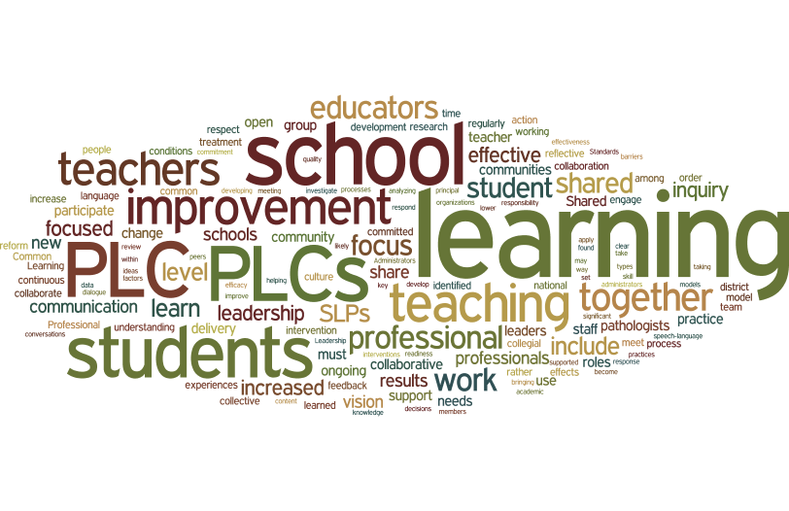
Our Vision: A culture of collaboration focusing on results.

Our Campus Improvement Plan Goals:
- Attendance Goal - 96.7% Last year’s attendance - 95.8%
- Discipline Goal - Less than 37 referrals Total for last year: 47

STAAR 2017 Preliminary Data:
% Approaches Grade Level
- 3rd Grade Reading - 83% (10 point growth)
- 3rd Grade Math - 93% (13 point growth)
- 4th Grade Reading - 83% (sustained)
- 4th Grade Math - 83% (3 point growth)
- 4th Grade Writing - 81% (8 point growth)
PD of the Month
Article: Educators Must Accept the Challenge to Be Professional by Anthony Muhammad
Repeat from last month, just in case you were not able to read it.
Quote of the Month

Building high levels of learning together!

