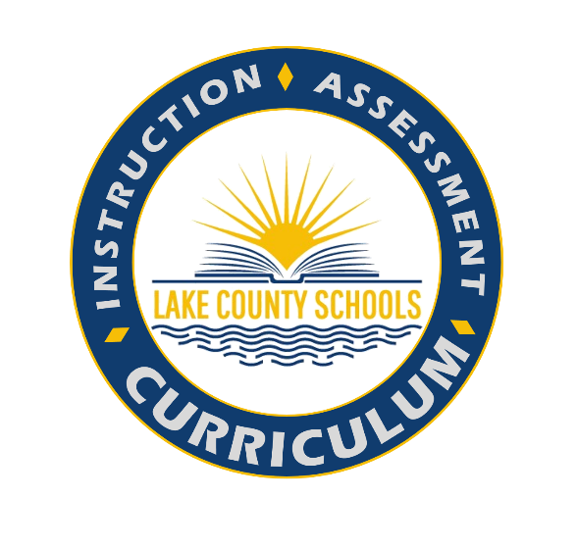
4th Grade Great Minds
2021-2022 English Language Arts (ELA) Scope and Sequence
4th Grade Lake County ELA Blueprints, Roadmap to Success
Wit & Wisdom Florida is a comprehensive Grades K–5 English language arts curriculum developed by and for teachers. Each Wit & Wisdom Florida module centers on the study of rich and engaging texts, curated to build student knowledge of important ideas in the liberal arts and the sciences. The approach to learning is integrated and text-based: daily reading, communications, grammar, and vocabulary study is rooted in—and draws on evidence from—exceptional texts.

The B.E.S.T standards are the foundation on which a robust curriculum will be built with a full appreciation of history, art, music, and other disciplines that were sidelined in favor of a focus on abstract reading strategies. These standards encourage a broader view of literacy that promotes knowledge-building across varied domains and subjects, making the integration of content and collaboration among teachers much easier to achieve.

Assessment Calendar | Authentic Literacy Block | B.E.S.T Standards | Vertical Progression of Standards

Suggested Pacing | Module/Essential Question | Focusing Questions | Spotlight Benchmarks | Integrated Benchmarks | Social Studies Integration with Required Supports
First week of School | Module 0 | How does reading help us build knowledge?  This is an introduction to Wit and Wisdom Curriculum. | Wit and Wisdom leads students to learn reading, writing, speaking, and listening vocabulary, and language skills in concert. Instead of addressing and assessing standards one by one, in isolation, students learn all skills in the context of module content.
Quarter 1  August 10-  October 7  Pacing calendar | “A Great Heart”  What does it mean to have a great heart, literally and figuratively? | **32 Lessons Module Map**  - Focus Question 1: How does someone show a great heart, figuratively?  - Focus Question 2: What is a great heart, literally?  - Focus Question 3: How do the characters in Love That Dog show characteristics of great heart?  - Focus Question 4: What does it mean to have a great heart, literally and figuratively? | Reading-Interpreting Figurative Language  ELA.4.R.3.1 Explain how figurative language contributes to meaning in text(s).  Informative Writing  ELA.4.C.1.4 Write expository texts about a topic, using multiple sources, elaboration, and an organizational structure with transitions | ELA.4.R.1.1 ELA.4.R.1.2 ELA.4.R.1.3 ELA.4.R.1.4 ELA.4.R.2.1 ELA.4.R.2.2 ELA.4.R.2.3 ELA.4.R.3.2 ELA.4.R.3.3 ELA.4.C.2.1 ELA.4.V.1.2 ELA.4.V.1.3 | Social Studies Integration Sheet  DBQ-Why is Freedom of the Press Essential to a Democracy?  DBQ-Cabeza De Vaca: How Did He Survive?  American Founder’s Month-  Constitution Day  Celebrate Freedom Week - Last full week of September  Hispanic Heritage Month-
Quarter 2  October 11 - December 16  Pacing calendar  4th Grade Modified Pacing Guide | “Extreme Settings”  How does a challenging setting or physical environment change a person? | **34 Lessons (Module Map)**  - Focus Question: 1: How does the setting affect the characters or speakers in the text?  - Focus Question 2: What makes a mountainous environment extreme?  - Focus Question: 3: How does setting influence character and plot development?  - Focus Question 4: How does a challenging setting or physical environment change a person? | Reading: Literary Elements  ELA.4.R.1.1 Explain how setting, events, conflict, and character development contribute to the plot in a literary text.  Narrative Writing  ELA.4.C.1.2 Write personal or fictional narratives using a logical sequence of events and demonstrating an effective use of techniques such as descriptions and transitional words and phrases. | ELA.4.R.1.2 ELA.4.C.1.4  ELA.4.R.1.3 ELA.4.C.2.1  ELA.4.R.1.4 ELA.4.C.5.1  ELA.4.R.2.1  ELA.4.R.2.2 ELA.4.V.1.2  ELA.4.R.2.3 ELA.4.V.1.3  ELA.4.R.3.2  ELA.4.R.3.3 | Social Studies Integration Sheet  Red Ribbon Week- Oct. 23-31  Holocaust Education Week -Second week in November
Quarter 3  January 4 - March 10  Pacing calendar | “The Redcoats Are Coming!”  Why is it important to understand all sides of a story? | 34 Lessons (Module Map)  - Focus Question 1: What were the perspectives of the two main sides of the American Revolution?  - Focus Question 2: How did different people’s experiences affect their perspectives on the American Revolution?  - Focus Question 3: How did different people’s perspectives affect their actions during the American Revolution?  - Focus Question 4: What drove the Patriots to fight for their independence from Britain? | Reading- Perspective and Point of View  ELA.4.RL.1.3-Identify the narrator’s point of view and explain the difference between a narrator’s point of view and character perspective in a literary text.  Purpose and Perspective  ELA.4.R.2.3- Explain an author's perspective toward a topic in an informational text.  Comparative Reading  ELA.4.R.3.3-Compare and contrast accounts of the same event using primary and/or secondary sources.  Argumentative Writing  ELA.4.C.1.3- Write to make a claim supporting a perspective with logical reasons, using evidence from multiple sources, elaboration, and an organizational structure with transitions  Researching and Using Information ELA.4.C.4.1-Conduct research to answer a question, organizing information about the topic, using multiple valid sources. | ELA.4.R.1.1 ELA.4.R.1.2 ELA.4.R.2.1 ELA.4.R.2.4 ELA.4.R.3.1 ELA.4.R.3.2 ELA.4.C.1.4 ELA.4.C.2.1 ELA.4.C.5.2 ELA.4.V.1.3 | Social Studies Integration Sheet  DBQ-How Free Were Free Blacks in the North?  DBQ-What Was Harriet Tubman’s Greatest Achievement?  Black History Month - Feb  African American History Task Force  Women’s History Month - Mar.
Quarter 4  March 21 -  May 27  Pacing calendar | “Myth Making”  What can we learn from myths and stories? | 34 Lessons (Module Map)  - Focus Question 1: What are myths, and why do people create them?  - FocusQuestion 2: What do myths and stories from different cultures have in common?  - Focus Question 3: How are Sal’s and Phoebe’s stories connected in Walk Two Moons?  - Focus Question 4: What does Sal learn in Walk Two Moons? | Reading -Theme  ELA.4.RL.1.2- Explain a stated or implied theme and how it develops, using details, in a literary text  Expository Writing  ELA.4.C.1.4-Write expository texts about a topic, using multiple sources, elaboration, and an organizational structure with transitions. | ELA.4.R.1.1 ELA.4.C.2.1  ELA.4.R.1.3 ELA.4.C.5.1  ELA.4.R.1.4  ELA.4.R.2.2 ELA.4.V.1.2  ELA.4.R.3.2 ELA.4.V.1.3  ELA.4.R.3.3 | Social Studies Integration Sheet  Medal of Honor Day - Mar. 25  Holocaust Education - May

