Reflective Questions
- Have we deconstructed the standard?

- How will we incorporate the targets from our deconstruction into our assessment?
  - Do our assessment questions align to the most rigorous targets in our deconstruction overall?

- Does our assessment align to the Item Specifications from Arizona Department of education:
Content Limits | Common Item Formats | Task Demands | Common Response Types
-Describes what content is tested | The AzMERIT Assessments are composed of item formats that include traditional multiple-choice response items and technology-enhanced response items (TEI) Each grade and standard can be assessed in varied TEI’s. See second page | -Describes the tasks that students will be asked to complete. | -Describes the most used test types that aligns to the standard.

- Have we looked at test items from various sources, for alignment?
  - Illuminate
  - PARCC
  - Smarter Balance
  - AZMERIT

- Have we analyzed the DOK levels of each question? Use the reference page(5) from the item specification document that indicates percent of points by DOK. Is this aligned to the percentage on your test?
Sample: 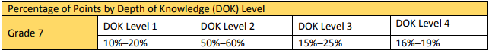
- What does mastery look like on each assessment item (create an answer key and show work)?
  - Does the mastery match the rigor of the deconstruction targets we created?
  - Do we have specific point values and/or rubrics with sample answers to what we expect the constructed responses to look like?

- How will our students earn “highly proficient” on the assessment*?
  - Demonstrates mastery, with excellence, of the grade-level standards with relative ease and consistency; OR
  - Applies and extends the key concepts, process and skills; OR
  - Is working at grade level but at a higher level of thinking.

