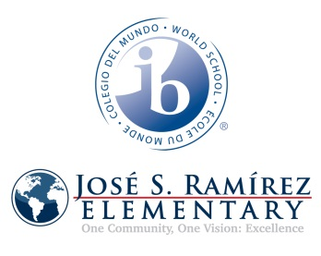

**Curriculum Questions**

**CALS Content**

Jazmin Torres-Math

Cassidy Balthrop-S.S.

Jennifer Valero-Science

Esther Caballero-Language Arts

Deanna Moore-Technology

Yu Kim-Johnson-Special Education

**Dual Language/SI**

PK-Lourdes Gutierrez

K-Juana Nunez

1st-Zintia Cervera

2nd-Eloisa Monsisvais

3rd-Nancy Vega-Clinich

4th-Karla DeLaGala

5th-Jazmin Torres

Brenda Jobes

**PLC Team**

Nancy Parker

Brenda Jobes

Karla DeLaGala

**Administration**

**N. Parker , B. Jobes**

**IB Pedagogy Team**

Pk-Lourdes Gutierrez

K- Cassidy Balthrop

1st-Laura Nettle

2nd Carolyn Williams

3rd Teresa Castro

4th- Karla DeLaGala

5th-Lucinda Hammons

Fine Arts-Ryanne Richardson

PYP Coordinator-Amber Faske

**Grade-level**