



**2016…**

**Investing in our people at Helensvale SHS.**

***The Compelling Why***

Teaching is complex and challenging. In order to make positive impacts upon the outcomes of student learning, teachers need knowledge and understanding of:

* the areas within which they teach
* how the students best learn the specific content given their diversities
* classroom environments that optimise learning

In order to do this, teachers need **targeted, ongoing professional learning opportunities**.

The Helensvale SHS community members view their own learning as fundamental to membership of the profession rather than something that is incidental or optional. We continue to build a culture of continuous learning and encourage all staff to reach their highest level of performance. Most importantly we believe that teachers who work together, learn from each other and share best practice are the keys to creating a true professional learning community where sustained school improvement can be secured.

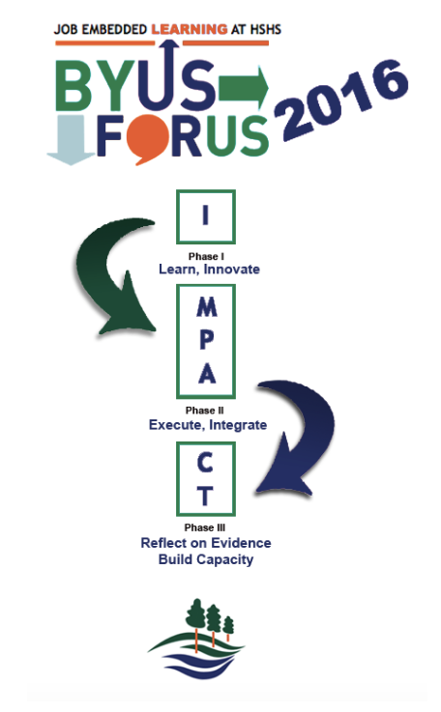

***Developing a Culture of Learning and Feedback***

**MODES OF LEARNING**

**How are we going to learn?**

* Professional Learning Teams

- Action Learning

- Study Groups

- Case discussion

- Professional conversations

* Peer observations
* Mentoring
* Coaching
* The IMPACT Lab
* On- site workshops
* External workshops
* Structured professional reading
* Personal professional reading
* Online learning

**PHASE 1: DELIVERY: INSPIRE!**

***What do we want to learn?***

* analysis of the environment, learning conditions and learning styles of the learner
* ‘what’ learners can expect to learn
* ‘how’ they will participate
* ‘what’ interactive supports will be in place to ensure knowledge transfer can occur through a variety of learning
* Links to be clear in transferring theoretical principles to classroom practice.
* Face to face component

**<**

**I**

**AITSL GOALS**

**Inspire**

**PHASE 2: ACTION:**

**Model, Practise, Apply**

***How will we know if we have learnt it?***

* Supported opportunities to integrate learning into teaching toolkits
* Gather evidence of impact upon student learning

**M**

**P**

**A**

**Model, Practise, Apply**

**PROFESSIONAL LEARNING TEAMS:** HSHS engine rooms for evidence sharing and support

**Connect, Transform**

**PHASE 3: Reflection:**

**Connect, Transform**

***What will we do if we haven’t learnt it yet?***

***What will we do if we already know it?***

* Reflection on new learnings
* Collaboration on evidence with colleagues
* Transform learning
* Opportunities to share new knowledge

**C**

**T**

**BUILDING CAPACITY**

**(Certification)**