Subject Line: Hastings Middle School has been redesignated as a Breakthrough School for 2017
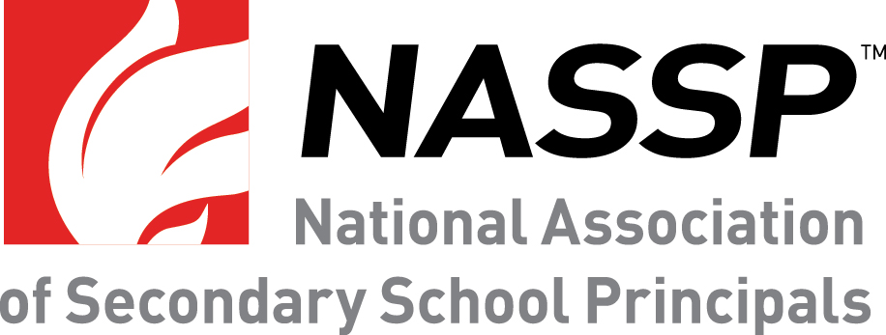

Hastings Middle School Continues to Excel as One of NASSP’s Breakthrough Schools
Named a Breakthrough School in 2014, HMS has been redesignated
FOR IMMEDIATE RELEASE
Contact:
David Essink, Principal, david.essink@hpstigers.org
Craig Kautz, Superintendent craig.kautz@hpstigers.org
Hastings, NE – Hastings Middle School joins 26 middle level and high schools redesignated as one of the National Association of Secondary School Principals’ (NASSP) 2017 Breakthrough Schools. NASSP recently evaluated each of these schools, originally recognized between 2011 and 2014, and determined that they have sustained their student achievement rates since their initial recognition.
Established in 2007, NASSP’s Breakthrough Schools program recognizes middle level and high schools that serve large numbers of students in poverty and are high achieving or demonstrate dramatically improving student achievement. Schools are selected based on documented success in implementing strategies aligned with the three core areas of Breaking Ranks II, including collaborative leadership; personalization; and curriculum, instruction, and assessment.
For more information on the Breakthrough Schools program, please visit: www.nassp.org/BTS.
Hastings Middle School is proud to be honored for the improvements our school continues to make. The most notable in the past three years include a focus on building positive relationships and developing a supportive and diverse culture. On a recent Gallup survey, a large majority of HMS students indicated they have adults at school who care about them and that they know they have a great future ahead of them.
About Hastings Middle School
Hastings Middle School follows the middle school philosophy. This includes breaking a larger school into smaller teams of students/teachers, having daily homeroom time, developing the whole child, building positive relationships, focusing on character education, providing lots of clubs and activities, and offering a large variety of exploratory classes. Hastings Middle School is made up of a 6th,7th, and 8th grade configuration with 830 students.

About NASSP
The National Association of Secondary School Principals (NASSP) is the leading organization of and voice for school principals, assistant principals, and school leaders from across the United States. The association connects and engages school leaders through advocacy, research, education, and student programs. NASSP advocates on behalf of all school leaders to ensure the success of each student and strengthens school leadership practices through the design and delivery of high-quality professional learning experiences. Reflecting its long-standing commitment to student leadership development, NASSP administers the National Honor Society, National Junior Honor Society, National Elementary Honor Society, and National Association of Student Councils.

