PRE-UNIT PLC MEETING TOOL

Name of Unit | R/S
Dates of Unit | # of Days in Unit
Morris EO’s addressed  All supporting | SE’s (Readiness and Supporting)
Formative Test Dates: Check for understanding | EO Test:
Guiding Questions:

What does a proficient student need to know:

Misconceptions:

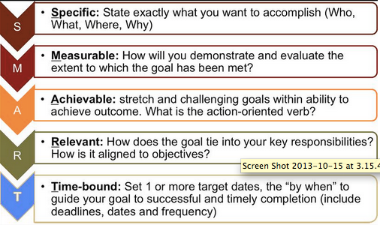

Smart Goal:
___% of students will be proficient in/at common assessment with a score of at least ____ on the next assessment to be given on ______________________.

DATA FORM
5th Science Data Sheet

Campus  year | Baseline  4th Reading STAAR  Approaching | Landform  Common Assessment | +/- | Advanced
2019
2018

Teacher | Baseline | EO | +/- | Advanced
Teacher (SF)
Teacher
Teacher
Teacher (Co-teach)
Teacher (bilingual)
Teacher (Pre-AP)
Spiral EOs | EO | EO
Teacher (SF)
Teacher
Teacher
Teacher (Co-teach)
Teacher (Bilingual)
Teacher (Pre-AP)

EO
+/-

Special Populations:
Special Populations | Baseline | EO | +/-
SPED
LEP

What is our area of celebration? _________________________________________
What are our areas of concern? __________________________________________
How did we teach this? ________________________________________________
___________________________________________________________________
Which SEs will we tutor on during class? __________________________________
Which SEs will we refer for intervention? __________________________________
Tier 2 will look like __________________________________________________
__________________________________________________________________
Additional thoughts/questions: ___________________________________________
____________________________________________________________________
____________________________________________________________________
____________________________________________________________________
____________________________________________________________________

CONTENT TEAM DASHBOARD PLANNER
GUARANTEED AND VIABLE CURRICLUM

 | Monday | Tuesday | Wednesday | Thursday | Friday
SE’s:
(Kid friendly language)

Tier 1 (Initial instruction strategies)

Tier 2 (Skill tutoring by Essential Outcome, by student)

Tier 3 (Substantial skill deficit, in-depth intervention)

Content Specific Expectations:

