A LEAD Teacher uses the PLT process to:  HELENSVALE STATE HIGH SCHOOL: A PLC AT WORK | A HIGHLY ACCOMPLISHED Teacher uses the PLT process to:
- Leads and models an understanding regarding the four critical questions of a PLC to colleagues within the team:  *Commitment to clarity and implementation consistency within the team regarding what learning ALL students will receive and when they will receive it. (Question 1)  *Agreement and commitment to deliver and lead collaborative responses to the common formative assessments. (Question 2)  *Lead data driven, explicit intervention strategies that respond to the formative data when students have not yet learnt it or already know it. (Questions 3 and 4)  *Models exemplary practice in analysing teaching deficits to seek appropriate professional learning for themselves and team members to assist in responding to questions 3 and 4 and uses verifiable learning outcomes evidence to evaluate the impact of this.  - Proactively and consistently leads by example to reinforce and model team agreed norms that promote trust, sharing and respect.  - Leads and develops an understanding in colleagues regarding the three big ideas of a PLC:  * reinforces a commitment to action that there is collective ownership over each and every student and their success within the PLT. (Big Idea 1)  * leads collaborative enquiry beyond cooperation to support and evaluate the ongoing cycle of implementation, reflection and improvement of teaching strategies (Big Idea 2)  *drives and evaluates highly effective common formative data processes incorporating feedback to measure teacher effectiveness of themselves and others in improving learning outcomes (Big Idea 3) | - Supports others to develop a greater understanding regarding the four critical questions of a PLC:  *Models and shares a continued focus on gaining clarity and consistency within the team regarding what learning ALL students will receive and when they will receive it. (Question 1)  *Initiate and ensure the delivery of common formative assessments and the subsequent collaborative discussions. (Question 2)  *Define and model explicit intervention strategies that respond to the formative data when students have not yet learnt it or already know it. (Questions 3 and 4)  *Seeks appropriate professional learning for themselves and team members to assist in responding to questions 3 and 4 and uses verifiable learning outcomes evidence to evaluate the impact of this.  - Proactively and consistently reinforces and models team agreed norms that promote trust, sharing and respect.  - Expands understanding of how the three big ideas underpin a PLC :  *Commits to the success of each and every student within their own classes and actively supports colleagues to engage with student data to ensure success. (Big Idea 1)  * Models collaborative enquiry to support the ongoing cycle of implementation, reflection and innovative teaching practice for themselves and others (Big Idea 2)  *Active in developing a culture of highly effective common formative data processes to measure teaching effectiveness in improving learning outcomes (Big Idea 3)
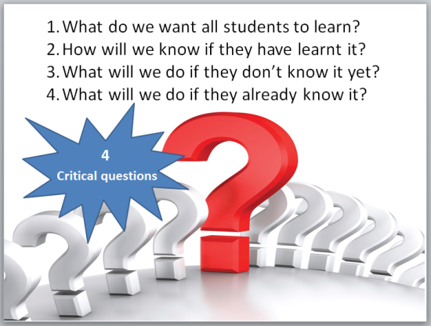  A PROFICIENT Teacher uses the PLT process to: | A Graduate Teacher uses the PLT process to:
- Applies a greater understanding regarding the implications of the four critical questions of a PLC:  *Clarity about what learning ALL students will receive and when they will receive it to support consistency across all classes. (Question 1)  *Establish and maintain ongoing common formative assessments throughout the unit. (Question 2)  *Implements intervention strategies incorporating team feedback that respond to the formative data when students have not yet learnt it or already know it. (Questions 3 and 4)  *Uses student data to seek appropriate professional learning to assist in responding to questions 3 and 4.  - Consistently follows team agreed norms that promote trust, sharing and respect  - Applies a greater understanding of the three big ideas of a PLC:  *Commits to the success of each and every student within their own classes and actively engages with the student data of colleagues. (Big Idea 1)  *contributes to collegial discussions by focusing on the impact of their own teaching strategies and that of their colleagues on student learning (Big Idea 2)  *uses effective common formative data processes to measure their effectiveness in improving learning outcomes and applies constructive feedback to improve knowledge and practice. (Big Idea 3) | - Demonstrates an understanding of the three big ideas of a PLC:  *Commits to the success of each and every student within their own classes. (Big Idea 1)  - contributes to collegial discussions by focusing on the impact of their teaching strategies on student learning (Big Idea 2)  - uses effective common formative data processes to measure their effectiveness in improving learning outcomes (Big Idea 3)  - Demonstrates an understanding regarding the four critical questions of a PLC:  *Clarity about what learning ALL students will receive and when they will receive it. (Question 1)  *Responds to the common formative assessments. (Question 2)  *Implements intervention strategies that respond to the formative data when students have not yet learnt it or already know it. (Questions 3 and 4)  *Seeks appropriate professional learning to assist in responding to questions 3 and 4.  - Consistently follows team agreed norms that promote trust, sharing and respect

