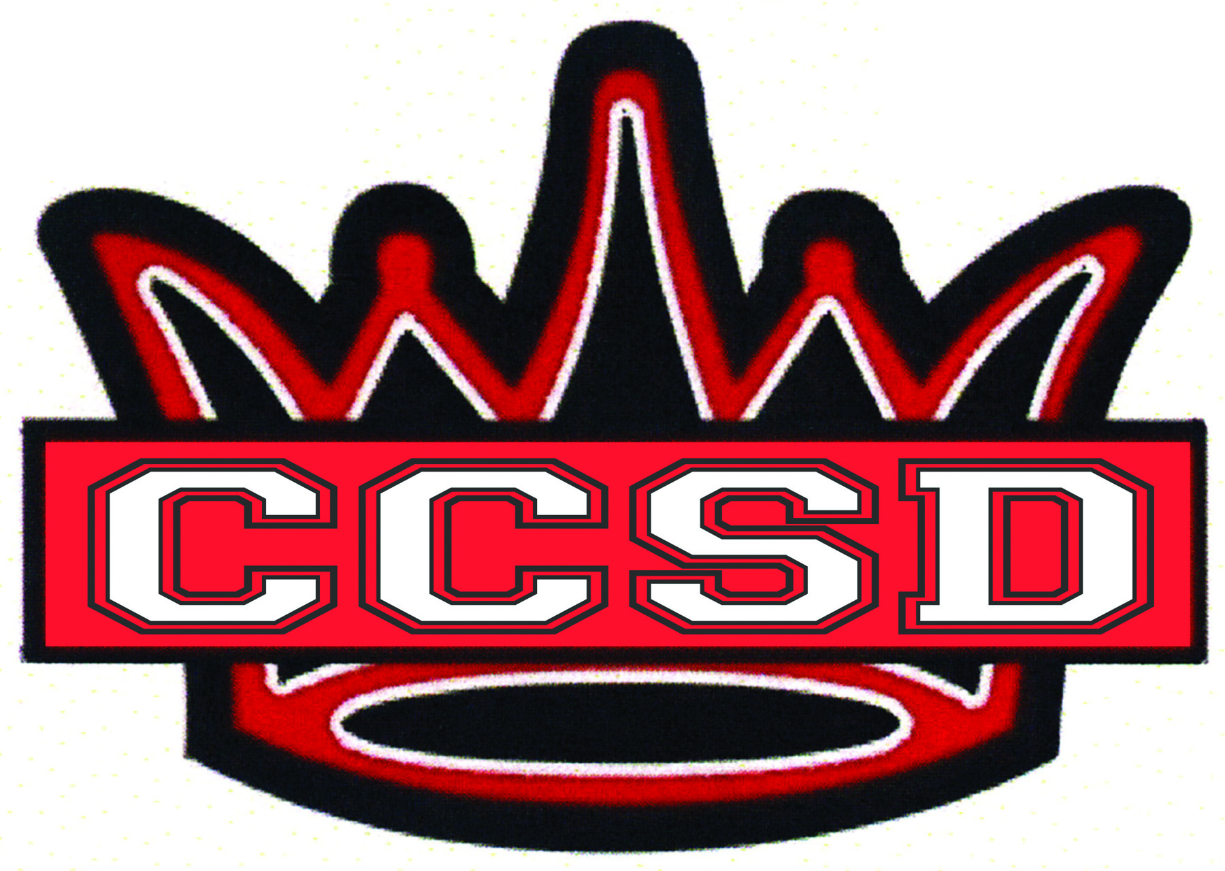
CCSD District Level
Professional Development GOALS
2015-2016

Tier I – Effective Core Instruction

Iowa Core Curriculum and Instructional Strategies
NEW!

- Increase technology utilized to deliver instruction.
Continued Focus

- Apply Iowa Common Core Standards of ELA, Literacy and Math.

Professional Learning Teams (PLC’s)
NEW!

- Monitor individual student learning of Promise Standards via team-developed common formative and summative assessments.
Continued Focus

- Refine and align Promise Standards.
- Use common formative assessment results to improve instructional practice and provide intervention and extension supports to student learning.

Gradual Release
NEW!

- Learning Targets are directly aligned with common formative assessments.
Continued Focus

- Components of Gradual Release are evident to observers.
- Consistently and clearly share learning targets with students.

MTSS/RtI
Continued Focus

- Tier II, Tier III

