Building Level
FOCUS and Expectations
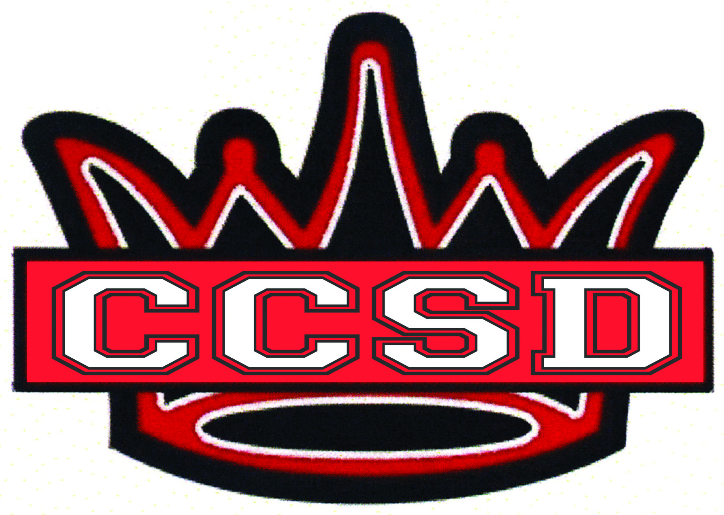
for Professional Development
2015-2016

TIER I
PLC Process
- Evidence students have mastered Promise Standards
- Evidence CFA results are used to improve instructional practice
- Evidence CFA results guide instruction
- Evidence CFA results are used to intervene and extend student learning

Effective Core Instruction
- Iowa Core Curriculum and Instruction
- Gradual Release – evidence of collaboration*
- Teacher Leadership*
- Integration of Technology*

*Evidence of Collaboration – “When we share our thinking, ask questions, and attempt to complete a complex task with others, we learn more.” @Unstoppable Learning by Fisher and Frey, 2015, p. 77

*Teacher Leadership – The ultimate goal of the Teacher Leadership program is to increase student achievement through improved classroom instruction. This is to be accomplished by adults working together to determine what is taught, how it will be taught, measuring the effectiveness of their instruction by monitoring student results, and responding to those results.

*Integration of Technology – Students today live totally submersed in technology. Therefore, as a relevant tool, technology should be used each day in the delivery of instruction and for student practice.

Tier II

Core PLUS Supplemental Interventions
- Led by PLC teams and individual classroom teachers, supplemental interventions are for students with some risk of not learning Promise Standards in spite of effective classroom instruction.

Tier III

Intensive Interventions
- Led by School-Wide Intervention/Data Teams, intensive interventions are for individual students at risk of not learning Promise Standards because of skill deficit or issues related to motivation, attendance and/or behavior concerns.

