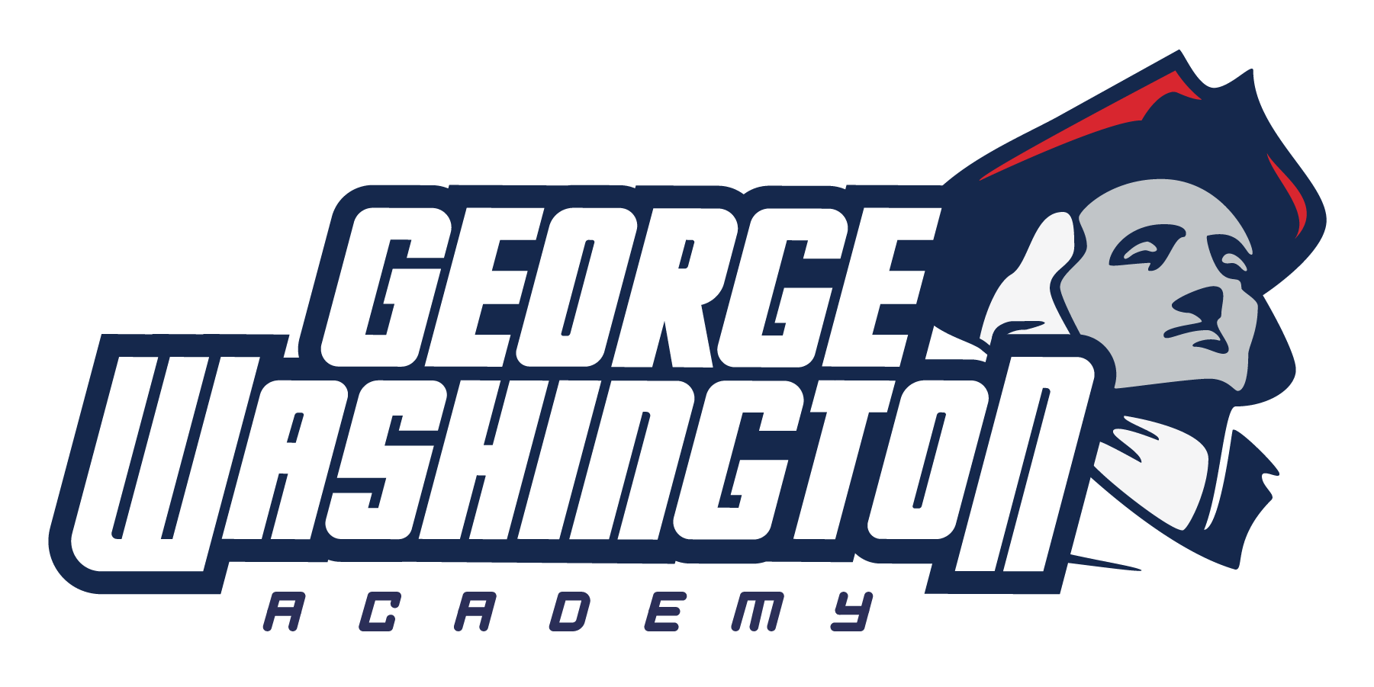
Multi Tier System of Support Framework

George Washington Academy is committed to our fundamental mission statement of “We are a Community of Learners”. To make sure that ALL students are learning at high levels we must develop a Multi-Tiered System of Support. This support system will focus on the four key areas of learners; Below Level Learners, Above Level Learners, Learners with Behavioral Concerns, and English Language Learners. Professional Learning Communities should be dedicated to making sure that the four fundamental questions of effective learning communities are being met.

- What do we want students to learn?
- How will we know if they learned the information?
- What will we do with students that are struggling to learn the information?
- What will we do with students that already know the information?

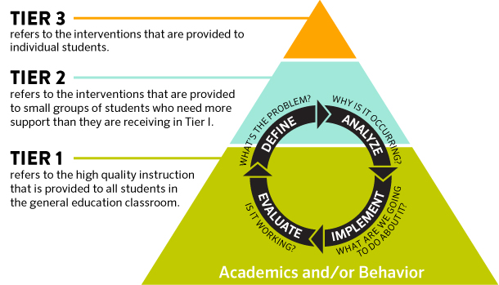

An integrated MTSS model consists of two effective innovations:

(1) Positive Behavior Intervention Supports (PBIS); which includes SEL (Social and Emotional Learners)
(2) School-Wide Academic Curriculum Model: Core Knowledge; ELA (CKLA and Collections) Math: (Saxon) for use in elementary and middle school settings (Tier 1 Text and Writing Model)

Each core component of the effective innovations are aligned with one another for the purpose of demonstrating how each will compliment one another if the components are used concurrently.

As we follow the cycle of the MTSS framework as well as answer the 4 questions of effective PLCs we will see that our actions will become more preventative instead of reactive.

George Washington Academy put in place a School Wide Positive Behavior Intervention System in October of 2018. This system provides instruction and meaning to teachers and students to know the expectations of the school as a whole. Administrators and Teachers explicitly train the students in how to follow the PBIS model. As part of the PBIS framework, training is provided for Social and Emotional Learners to assist them and their needs.

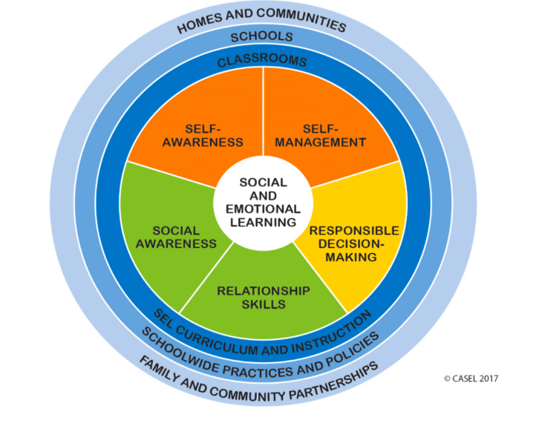

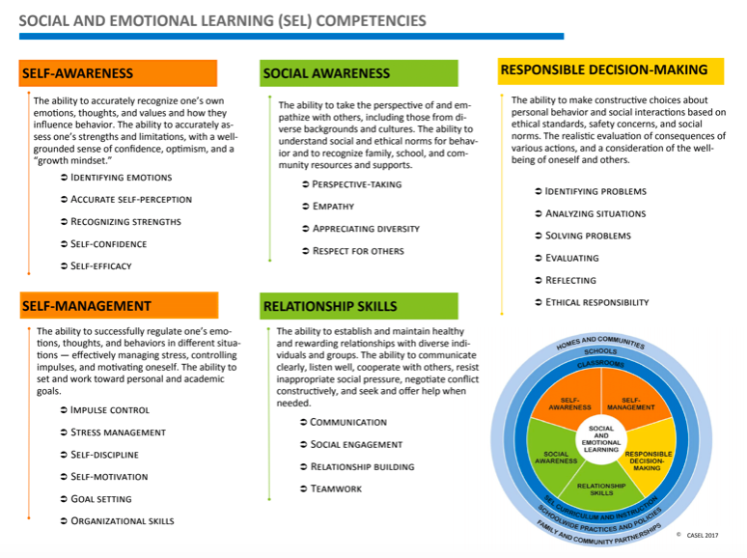

George Washington Academy has put in place a common Tier 2 time- Patriot Time in K-7. This support will range from emergent support to advanced enrichment in grade level specific content areas. This model will provide assistance and support to all students at all levels so that the specific needs of our students can be met.

A Reading Specialist oversees reading interventionists which are available to support students in a small group setting. These groups are fluid in nature and are put together based on common skill proficiencies and/or deficiencies.

In all MTSS tiers, GWA uses Recommended Evidence Based Strategies for Closing the Achievement Gap which is founded on current research-based best practices.
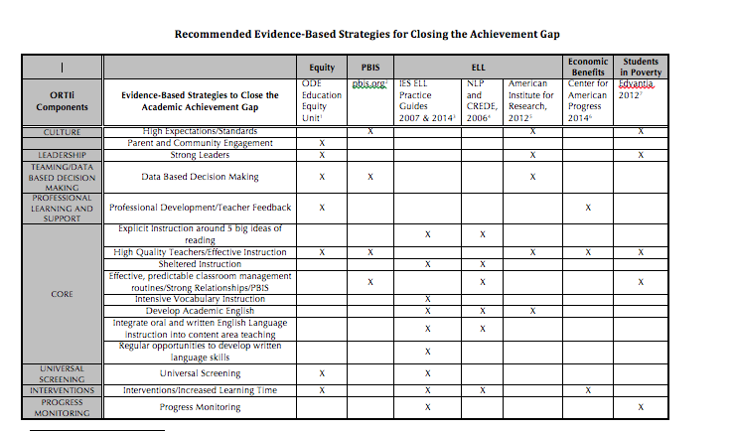
In order to support the recommended evidence-based strategy of “High Quality Teachers/Effective Instruction,” an Instructional Coach has been put in place at GWA.
An Instructional Coach is “... one who helps teachers recognize what they know and can do, assists teachers as they strengthen their ability to make more effective use of what they know and do, and support teachers as they learn more and do more.”
~Cathy Toll, The Literacy Coach’s Survival Guide

The Role of an Instructional Coach:

“Instructional coaches are partners with teachers and administrators, working alongside them as equals who first listen and learn; then assist in goal setting, action planning, and implementation.” ~Jim Knight

At GWA, Administration and the Instructional Coaches work together to set a school-wide instructional goal for student learning and outcomes for Tier 1 instruction. To support teachers in meeting the goal, the Coaching Cycle is implemented for every teacher K-7. Research has shown that when a teacher is coached, 95% of what has been learned is implemented. All coaching cycles relate to the school-wide instructional goal. If a teacher needs foundational support, professional development is provided to develop knowledge/skills. If a teacher has a foundational knowledge of reaching the goal, coaching is put into place to refine knowledge/skills. The first step is having a conference with the teacher to determine the teacher’s need in relation to the goal. From there, coaching in the classroom and the use of the debriefing cycle as needed will be implemented in order to move closer to the goal.

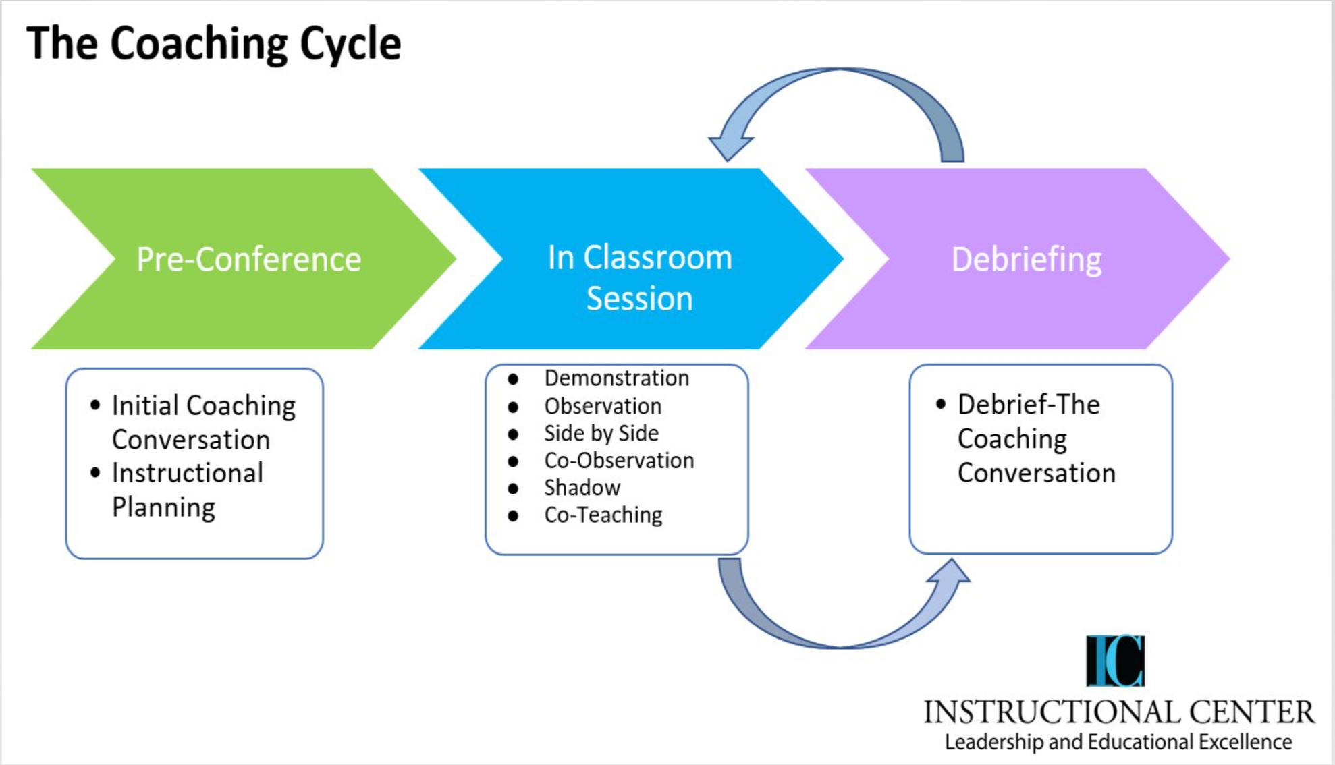

Data-Driven Decision Making within MTSS:

George Washington Academy strives to ensure that all students are learning at high levels by utilizing data-driven decision making.

A Data-Driven approach involves: (Pearson Education)
- Measuring what matters
- Collecting valid, reliable data
- Accurately interpreting data
- Making appropriate instructional changes for each student based on the data
- Tracking intervention effectiveness to confirm a student’s plan

Teachers analyze student results using data collection software to identify Tiered learning. GWA will know if Tier 1 is working based upon state benchmark, summative, and curriculum assessments, such as CKLA, Saxon Math, etc. We will know if Tier 2/ Tier 3 are working based upon progress monitoring data within Acadience and SRI as well as other assessments that pertain to the specific intervention. We will look at the data regularly to improve our instruction in the various tiers.

George Washington Academy teams will consistently discuss student data on a weekly basis during grade-level collaborative meetings.

