Historical Student Achievement Data Report
Use this template as an organizer to share your data regarding positive student achievement.

School Annual Performance Report State Historical Data
School Name |  | Milan Elementary School
 | 2013 |  | 2014 |  | 2015 |  | 2016
 | % Prof or Adv | MPI | % Prof or Adv | MPI | % Prof or Adv | MPI | % Prof or Adv | MPI
ELA Total | 29.3 | 306.7 | 17.7 | 302.1 | 46.2 | 310.8 | 58.1 | 336.2
Math Total | 34.7 | 328.0 | 24.7 | 314.4 | 31.6 | 295.8 | 48.1 | 332.1
ELA Subgroup | 25.8 | 295.2 | 17.5 | 301.3 | 46.2 | 306.4 | 52.5 | 326.3
Math Subgroup | 30.6 | 322.6 | 23.5 | 311.1 | 32.5 | 302.5 | 48.1 | 329.6

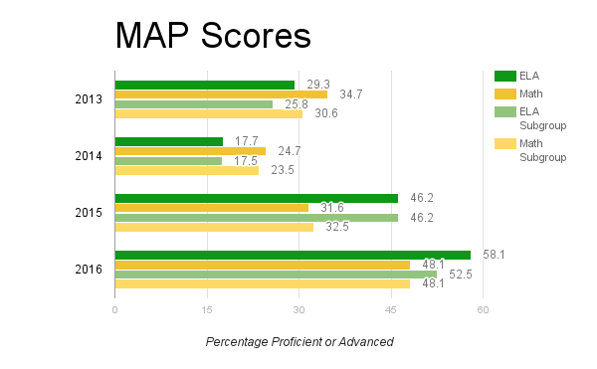

Additional Positive Student Academic Achievement Evidence
The state assessment results on the Annual Performance Report listed above serve as a preliminary screener for positive achievement in your school. Please provide three pieces of non-state assessed data demonstrating positive academic achievement as a result of your PLC work over the past three years. For schools not state-assessed (K-2, preschools, alternative schools, etc.), two additional sources of data is requested in lieu of state assessment results.

Data Source #1 (graph/charts/tables/etc.)
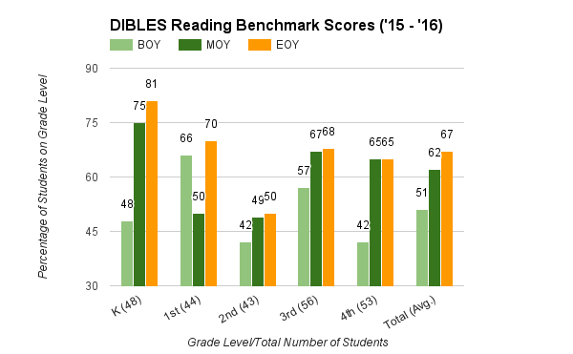
Dibel Reading Scores.
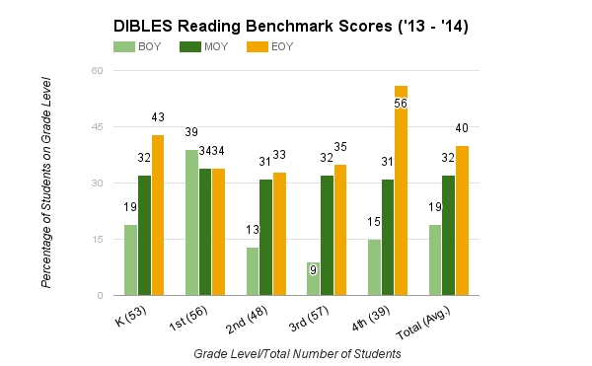

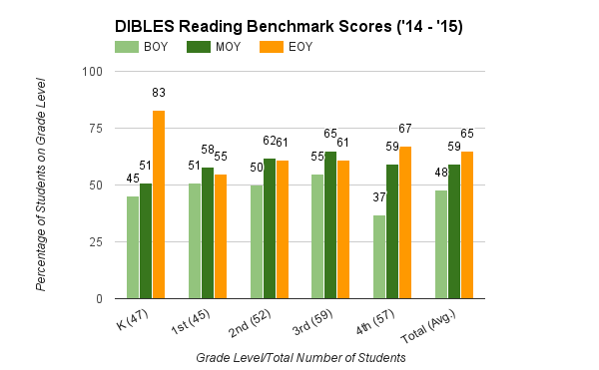

Brief explanation of data source #1
This data is used to monitor fluency at the district level.
Data Source #2 (graph/charts/tables/etc.)
PBS Behavior Report

Brief explanation of data source #2
This data is used to monitor referrals at the district level biweekly/quarterly and monthly.
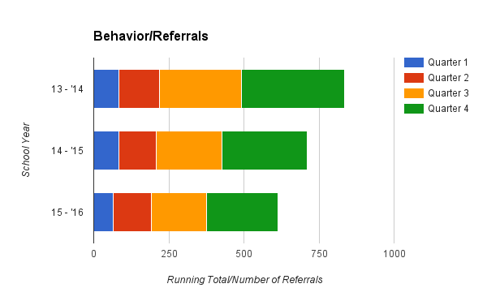
Data Source #3 (graph/charts/tables/etc.)
Star Reading Scores

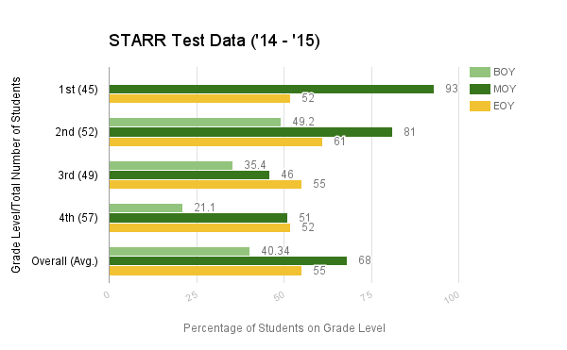

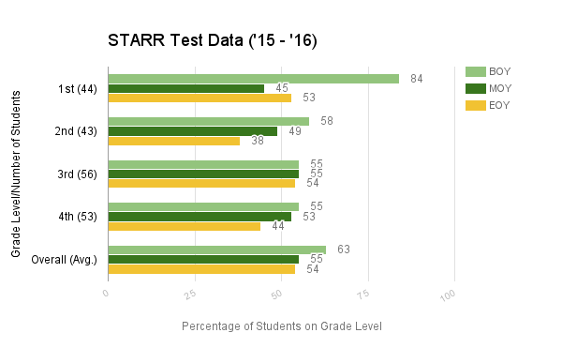

Brief explanation of data source #3
This data is used to monitor comprehension at the district level monthly.
Data Source #4 (Non-State Assessed Schools Only) graph/charts/tables/etc.
Math Benchmark Scores

Brief explanation of data source #4
This data is used to monitor math skills at the district level biweekly/quarterly and monthly.
Data Source #5 (Non-State Assessed Schools Only) graph/charts/tables/etc.
Brief explanation of data source #5

