**NAME:_________________________________________**

**Show What You Know!**



**Quarter 1**



* I know to read a book left to right and can show it.
* I know to read a book top to bottom and can show it.
* I know words are separated by spaces and can show it.

I can name and make the initial sound of the following letters:

|  |  |  |  |  |  |
| --- | --- | --- | --- | --- | --- |
| A | R | j | E | m | Z |
| o | g | v | q | c | t |
| i | S | B | x | U | N |
| d | p | L | K | w | f |
| Y | h |  |  |  |  |

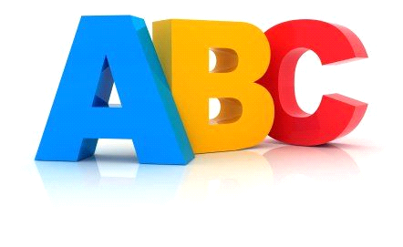

I can read this many sight words:



|  |  |  |  |  |
| --- | --- | --- | --- | --- |
| 25 |  |  |  |  |
| 24 |  |  |  |  |
| 23 |  |  |  |  |
| 22 |  |  |  |  |
| 21 |  |  |  |  |
| 20 |  |  |  |  |
| 19 |  |  |  |  |
| 18 |  |  |  |  |
| 17 |  |  |  |  |
| 16 |  |  |  |  |
| 15 |  |  |  |  |
| 14 |  |  |  |  |
| 13 |  |  |  |  |
| 12 |  |  |  |  |
| 11 |  |  |  |  |
| 10 |  |  |  |  |
| 9 |  |  |  |  |
| 8 |  |  |  |  |
| 7 |  |  |  |  |
| 6 |  |  |  |  |
| 5 |  |  |  |  |
| 4 |  |  |  |  |
| 3 |  |  |  |  |
| 2 |  |  |  |  |
| 1 |  |  |  |  |
| 0 |  |  |  |  |
|  | Quarter 1 | Quarter 2 | Quarter 3 | Quarter 4 |

After being read a story and text, I can do the following:



* Tell who the characters are.
* Retell the first event of the story.
* Identify 1 key detail from an expository text.

I can recognize this many rhyming words:

|  |  |  |  |  |
| --- | --- | --- | --- | --- |
| 25 |  |  |  |  |
| 24 |  |  |  |  |
| 23 |  |  |  |  |
| 22 |  |  |  |  |
| 21 |  |  |  |  |
| 20 |  |  |  |  |
| 19 |  |  |  |  |
| 18 |  |  |  |  |
| 17 |  |  |  |  |
| 16 |  |  |  |  |
| 15 |  |  |  |  |
| 14 |  |  |  |  |
| 13 |  |  |  |  |
| 12 |  |  |  |  |
| 11 |  |  |  |  |
| 10 |  |  |  |  |
| 9 |  |  |  |  |
| 8 |  |  |  |  |
| 7 |  |  |  |  |
| 6 |  |  |  |  |
| 5 |  |  |  |  |
| 4 |  |  |  |  |
| 3 |  |  |  |  |
| 2 |  |  |  |  |
| 1 |  |  |  |  |
| 0 |  |  |  |  |
|  | Quarter 1 | Quarter 2 | Quarter 3 | Quarter 4 |

I can write my first name:



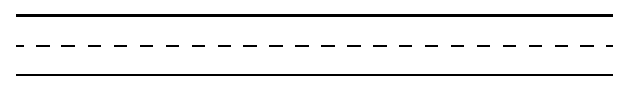

I can write the following lowercase letters:

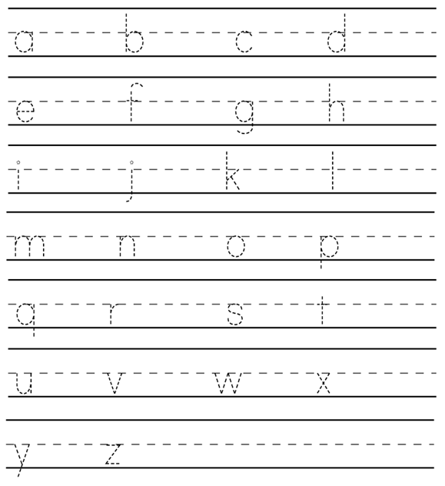

I can write the following uppercase letters:

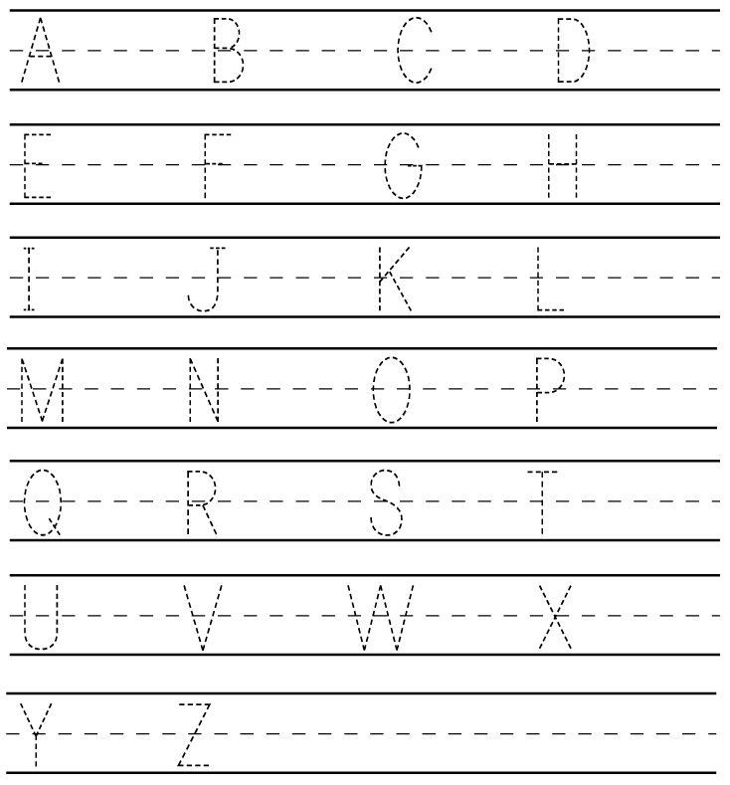

I can name, write, say, and read the following numbers

|  |  |  |  |  |
| --- | --- | --- | --- | --- |
| 1 | 2 | 3 | 4 | 5 |
| 6 | 7 | 8 | 9 | 10 |
| 11 | 12 | 13 | 14 | 15 |
| 16 | 17 | 18 | 19 | 20 |

I can count to 20 by 1s.

|  |  |  |  |  |
| --- | --- | --- | --- | --- |
| 1 | 2 | 3 | 4 | 5 |
| 6 | 7 | 8 | 9 | 10 |
| 11 | 12 | 13 | 14 | 15 |
| 16 | 17 | 18 | 19 | 20 |



I can count forward from any number to 20.

|  |  |  |  |  |
| --- | --- | --- | --- | --- |
| 1 | 2 | 3 | 4 | 5 |
| 6 | 7 | 8 | 9 | 10 |
| 11 | 12 | 13 | 14 | 15 |
| 16 | 17 | 18 | 19 | 20 |

I can name the following 2D shapes and describe the positionality: