PAW Meeting (Kinder) March 22, 2021
Alicia Sanchez | Leticia Cantu
Rocio Garcia Rios
Lissette Fernandez
Marcela Ibarra

*Kinder Dyslexia Screener
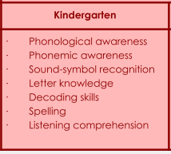
*April Istation  What can we do to help ensure valid data? | *Talk to students and explain that it is important that they do their best.  *Do it first thing in the morning when students arrive.  *Contact parents of virtual students and stress the importance of having them complete the assessment on their own.  *Small group testing for students that may need to be monitored more closely.  Keep in mind that higher students may take longer to complete the assessment...Students will need to have something to do if they finish early.
*Small Group Instruction
How do we ensure students are growing?
Phonemic Awareness
Analyzing Student Errors

*Participation Log and Progress Monitoring Documentation
*Kinder IAT | Students that are still working on mastering letter ID and sounds.
*PAW Grouping and Planning

