The ISIP assessment is a diagnostic tool given throughout the year measuring student progress in the following areas: letter knowledge, phonemic awareness, alphabetic decoding, comprehension, vocabulary, and spelling. This assessment is critical in the identification of specific areas of need for each child. ISIP supports staff members in making directive, timely, and research based Tier 1 and Tier 2 intervention plans.
2017-2018
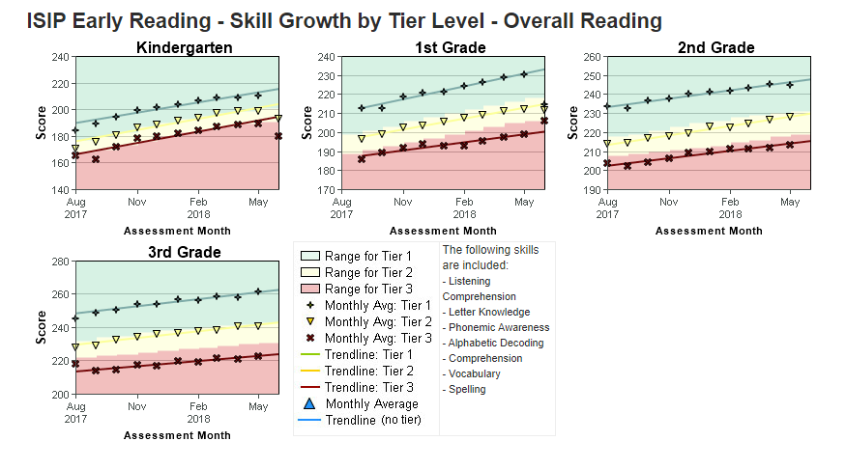
2016-2017
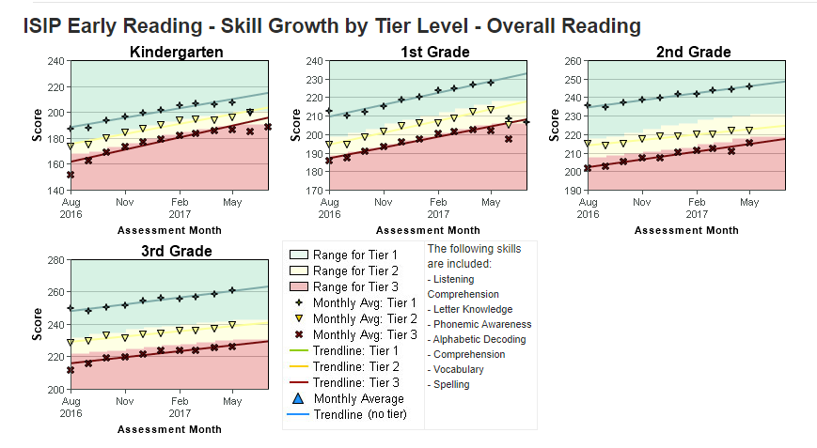

2015-2016
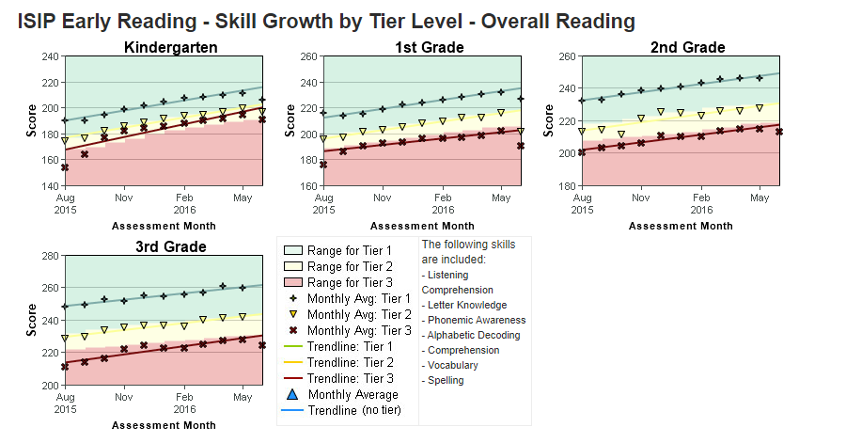

2014-2015
