Initial RTI Planning meeting
July 20th, 2020 http://www.rtinetwork.org/getstarted/develop/developingplan
1st Planning meeting with Dr. Williams, Lacee Wald, Melissa Lewis, & Karina Cole

IMPLEMENTATION BLUEPRINT--3-5 year PLANNING 2020-2025

⇨PHASE #1: The STAFF...Building Support
Implementing RTI requires a broadening in focus. To implement this innovation in a school setting, one has to pay attention not only to research about effective instruction, but also to the change management process. For too long education has underestimated what it will take for the adults in a school setting to change their practices and behaviors. The benefit of RTI is for our students, and success will be measured in how much their achievement scores improve. However, when it comes to implementation planning, the focus has to be on the adults—the teachers who will use the new practices.

BUILDING SUPPORT & CONSENSUS
Building support for the implementation of a Response-to-Intervention (RTI) model must first occur at the district and building administrator levels. When the district embraces and promotes the use of RTI as the primary method for determining the instructional and behavioral needs of all students—not just those experiencing difficulties learning—implementation proceeds more smoothly and is more likely to be successful. It is very difficult for a building principal to support implementation of this initiative if support is not apparent at the district level. In such a case, the particular building can operate as a “pilot” school. However, that building will not progress beyond the pilot stage unless district policies support RTI.

Similarly, the building administrator must support RTI. Implementation of the Three-Tier Approach to service delivery requires flexibility in roles and resources (both financial and instructional). Decisions regarding distribution of building-level resources are the primary responsibility of the building administrator. Because these decisions are critical to the implementation of RTI, the participation and support of the building administration is necessary to ensure successful implementation.

Educators are receptive to change when two conditions exist: first, they understand the need for the change and, second, they believe that they either possess the skills necessary to implement the change or have the support for acquiring the skills necessary to implement the change. In addition, developing an understanding of the need for RTI depends on two key things: information dissemination and interpretation of school-based data.

First, the need for RTI can be made quite clear when information on the “why” of RTI is presented, along with information on the impact this model has on student performance. The following are the typical areas where information can be provided in support of the need to change to an RTI approach:

- The adequate yearly progress (AYP) requirements of No Child Left Behind and state departments of education.
- The inclusion of RTI in the regulations for the implementation of the Individuals with Disabilities Education Improvement Act of 2004.
- The research evidence that supports the positive impact of RTI on student performance, particularly in reducing disproportionality (overrepresentation) and improving the academic and behavioral performance of students.
- The positive effects of having a consistent model and procedures that are used to make educational decisions for all students.

Second, the district and/or building leadership team can provide data on student performance and ask the question, “Are we happy with the data?” It is difficult to rationalize the continuation of business as usual when student data do not indicate that the current strategies are effective. The presentation and interpretation of district and/or building data is the most effective method of achieving support.

Staff and Roles and Responsibilities

A frequently asked question is, “How do the roles and responsibilities of educators change when RTI is implemented?” The answer is that roles and responsibilities are likely to flex rather than change dramatically. Here are some guidelines for staff roles and responsibilities in this model.

District Leaders
- Give “permission” for the model
- Provide a vision for outcome-based service delivery
- Reinforce effective practices
- Expect accountability
- Provide tangible support for the effort
  - Training
  - Coaching
  - Technology
  - Policies

Building Principal
- Sets a vision for the problem-solving process
- Supports development of expectations
- Responsible for allocation of resources
- Facilitates priority setting
- Ensures follow-up
- Supports program evaluation
- Monitors staff support/climate

Leadership Team Facilitators
- Ensures pre-meeting preparation
- Reviews steps in the process and desired outcomes
- Facilitates movement through steps
- Facilitates consensus building
- Sets follow-up schedule/communication
- Creates evaluation criteria/protocol
- Ensures parent involvement

Team Participants (Teachers, Student Services, Instructional Support)
- Review Request for Assistance forms prior to meeting
- Complete individual problem solving
- Maintain attitude of consensus building
- Understand and interpret data
- Research interventions for problem area

Parent
- Review Request for Assistance form prior to meeting
- Provide student information and participate in individual problem solving
- Prioritize concerns
- Maintain attitude of consensus building
- Participate in intervention development, implementation, and evaluation

Student
- Participate in problem solving and development of interventions (adjusted for age)
- Participate in goal setting and monitoring of progress toward the goal (or goals)

SUMMARY

Building support for the RTI process is essential prior to initiating any changes or activities related to the delivery of instructional and support services for students. Ensuring that all staff understand the rationale for the process (i.e., the need for it) is critical. Take as much time as is necessary to achieve this support before proceeding with any infrastructure development. This will pay off in the long run.

Here are several “indicators” that the building support phase is successfully proceeding:

- A district leadership team is in place to shepherd this process.
- Implementation buildings have been identified.
- Building administrators involved in implementation work closely with the district leadership team and hold regular meetings to assess progress.
- A district blueprint has been developed (or is being developed) and the district leadership team is working with the building administrators to outline the process for building-level plans.
- District and building data have been reviewed to assess need.
- Building administrators have identified staff to serve on the school-based leadership team.
- The district infrastructure is in place to begin the building support phase at the school level.

⇨PHASE #2: DEVELOPING A PLAN

A brief overview of the six stages of implementation is provided below with more details provided in the related articles. The stage names are those of Fixsen and his colleagues; the details about the activities that occur in an implementation of RTI are those of Susan Hall.

- Exploration—a small team does research to learn as much as they can about RTI in determining whether to implement such an approach
- Installation——begins when the decision to implement is made and continues until the first use of the innovation (may include planning, assigning job responsibilities, determining how it will be organized, initial team building)
- Initial implementation—where the “rubber meets the road” as many teachers try to use new practices in their day
- Full Implementation—practices have been installed and most professionals are comfortable, with practices operating smoothly
- Innovation—after implementing the innovation the way it was laid out, this is the time to try to make improvements
- Sustainability—in which the focus is on figuring out how to sustain the innovation over the long term

General Guidelines

- Follow the steps of consensus building, then infrastructure development, and then implementation. Developing an infrastructure for a setting in which consensus to implement has not been achieved is wasted energy. By the same token, attempting to implement the model in a setting in which there is little infrastructure is futile and frustrating.
- A handbook of policies and procedures should be developed to guide practice and promote consistency of implementation.
- Only bite off what you can chew! There is no blueprint for how expansive your implementation plan should be. Some buildings choose to limit the focus of implementation by grade level (e.g., start with just kindergarten) or content area (e.g., reading, biology). An implementation checklist is provided in this section. Use that checklist to determine where to start (phases-consensus, infrastructure, or implementation). Once you determine the phase that aligns with your readiness, identify a subject area or group (e.g., kindergarten, 6th grade) that has achieved consensus and for which you have the greatest amount of infrastructure in place already.
- The plan should cover a timeline of at least 3 years. It is important that the school staff understands how long this will take (it’s a marathon, not a sprint) and how what they are doing now fits with what will happen next.
- Professional development is the fuel that runs this engine. Knowing what skills will be needed and the existing skills of the staff will inform professional development needs. Professional development must precede implementation in order to ensure that the staff has the skills necessary to be successful with this initiative.

Creating the Infrastructure

Implementation of an RTI model requires specific resources, and it is important to reiterate that implementation without the essential components of the infrastructure is futile. The essential components of the infrastructure are as follows:

School-Based Leadership Team

The school-based leadership team (SBLT) must work in a collaborative way to achieve the common mission of implementation. Roles and responsibilities must be defined clearly and agreed upon. The SBLT must meet frequently to monitor the progress of implementation, assess the need for professional development, and provide technical assistance and support for implementation. Tools have been developed to monitor the progress of RTI implementation. The Self-Assessment of Problem Solving Implementation, a needs assessment survey, is one such measure. It is the responsibility of the SBLT to complete this survey at least twice a year, and preferably three to four times each year during the first 3 years of the Implementation Plan.

Data Coach

The functions of the data coach include the following:

- Gathers and organizes Tier 1 and Tier 2 Data
- Supports staff for small group and individual data collection
- Provides coaching for data interpretation
- Facilitates regular data meetings for building and grade levels

Problem-Solving Process

A step-by-step, problem-solving method must be used in the RTI process. This process should be used when making decisions about core instruction (Tier 1), supplemental instruction (Tier 2), and/or intensive instruction (Tier 3). A procedures handbook should be provided to guide the SBLT through this process. An explanation of the problem-solving method and resources for professional development exist elsewhere on this Web site.

Decision Rules Regarding RTI

When using data to make instructional and intervention decisions, clear rules guiding the interpretation of those data are required. Criteria for positive and negative responses to intervention must be developed so that a consistent set of decisions are made for students (based on those data) across buildings within the district. This critical component will be a high priority for professional development.

Data Sources and Decision Making

The building must ensure that data on which to base interpretations of students’ response to an intervention are available and accessible to teachers and the SBLT. Obviously, it would not be possible to determine a “response” to intervention without student-centered data. Data sources include:

- Universal screening measures
- Progress-monitoring measures
- Classroom assessments
- Diagnostic assessments
- Districtwide assessments
- High-stakes testing (accountability) assessments

Data from different sources are used to make decisions at different levels of instruction. For example, accountability assessment and universal screening measures may be used to assess the effectiveness of core instruction. Progress-monitoring measures may be used to assess a student response to supplemental instruction.

Intervention Map

It is important that all educators in the building understand the full range of instruction and interventions available in a building. This is important information that is used to ensure that core instruction and more intensive interventions are integrated across the tiers. If the general education classroom teacher does not know the nature and extent of the curriculum/strategies used in supplemental or intensive instruction, then that teacher will be unable to integrate the supplemental/intensive instruction into the general education classroom. Conversely, if the individuals providing supplemental and intensive instruction are not aware of the task demands of the core instruction, it is likely that the supplemental and/or intensive instruction will be fragmented and difficult for the student to use in the general education classroom. An example of an intervention map appears below:

Figure 1:

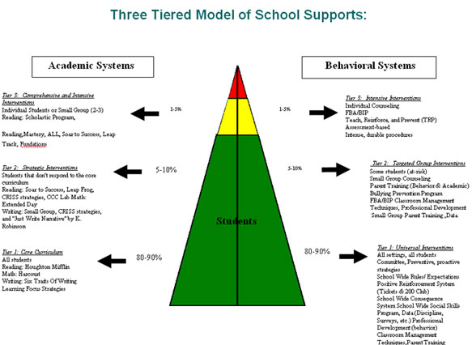

Intervention Support and Fidelity

Perhaps the most important letter in RTI is the I. Unless the instruction/intervention is implemented the way it was supposed to be implemented (i.e, intervention integrity), then any data collected will only reflect the fact that the student(s) did not actually get the instruction/intervention. Therefore, no conclusions about a student response to (non)intervention can be made.

Two strategies can be used to support intervention integrity. First, intervention integrity is enhanced when appropriate intervention support is provided. Second, intervention integrity is enhanced when intervention implementation is documented.

A useful protocol for intervention support has been developed. Intervention support strategies are provided for up to 10 weeks and include both the frequency of support and the content of the support.

Frequency -- Support meetings should occur two to three times per week for the first 2 weeks, two times per week for the next 2 weeks, and one time per week for the remaining 6 weeks.

Content -- The duration of support meetings ranges from 15 minutes to 30–45 minutes. During each meeting, three agenda items are covered. First, the student data are reviewed with the teacher. Second, the intervention support person determines if any barriers to intervention implementation exist and, if they do, attempts to resolve those barriers (e.g., time, method). Finally, the steps for the intervention are reviewed.

An intervention implementation log documents three aspects of the intervention integrity: the time (each day) that the student received the intervention, the program or strategy selected for the intervention, and the focus of the intervention. Download the Intervention Documentation to see an example of an intervention documentation form.

Technology Support

Technology support is, perhaps, the most critical element of the infrastructure. The primary form of technology support is a computerized database that stores, calculates, and displays student data. The SBLT uses this technology support to provide the data necessary for conducting instructional decision making.

⇨PHASE #3: INITIAL INSTALLATION

The installation stage starts when the decision is made to implement a Response-to-Intervention (RTI) approach , and it ends when the innovation process is first used. This stage is often referred to as the “start-up stage,” when you develop your plan. Fixsen, Naoom, Blase, and Wallace (2007) suggested that this stage may take between 2 and 6 months.

According to Fixsen and colleagues (2007), the installation stage has too often been ignored in human services. This comment is consistent with my observation that schools so often spend almost no time planning how they will accomplish a new practice—they just launch into it and hope to figure it out along the way. Although a healthy amount of action rather than analysis paralysis is a good thing, it’s as if schools sometimes fail to see what type of planning is possible.

Consensus Building

Consensus building is a critical part of implementation that is frequently overlooked. Don’t skip it. Getting buy-in is a process that can be planned—it doesn’t just happen. It starts with a discussion among the RTI team about who needs to be on board for success. There are key opinion leaders in every school and district. These key opinion leaders typically buy into something more fully if they are involved from the start. Sometimes it’s wise to identify key influencers who may be negative and place them on a carefully selected committee to try to bring them around from the beginning. Other times it’s better to figure out who is the best person to convince the naysayers and plan for that person to address the naysayers’ questions and concerns in private meetings rather than at committee meetings.

What processes will help staff embrace the initiative? There are certain decisions that are district based and others that are building based. For example, typically the district determines that RTI will be implemented and they select common assessment instruments. It isn’t effective to have schools selecting different curriculum-based measurements (CBMs), because building data must be rolled up to the district level to measure the progress of the RTI initiative. Yet, RTI happens at the school building level, and many of the critical decisions about how to implement it are left to the school.

For example, the district requires that the assessments be given, but the schools decide whether they will use an assessment team or classroom teachers to administer the screener. The district requires each building to provide 30 minutes of intervention to all students receiving Tier 2 services, but the building typically determines when intervention groups will occur and who will teach the groups. I recommend that decisions about how are made by grade-level teams to the extent possible to allow teachers to have maximum input into what they want to do. Commitment will be stronger if they design the delivery approach.

Team Building

Because of the wide variety of staff involved in RTI, team building is a critical ingredient for successful implementation. There are two dimensions of team building to consider. First, there is the necessity to facilitate collaboration among many different staff members who provide reading instruction to students who are struggling. This can include classroom teachers, special education teachers, Title I teachers, speech-language pathologists, English as a second language (ESL) teachers, and so on. The second dimension of team building is among teachers within a grade-level.

Collaboration between general and special education is critical for the successful implementation of RTI. But it’s more than just general and special education—it is also critical that Title I, ESL, and Reading Resource teachers all actively participate in this process. Every staff member who deals with a struggling reader needs to participate in decisions about which instruction the student will receive, whether it’s working, and what else to try if the student’s rate of progress is insufficient. RTI provides a golden opportunity to align staff who traditionally have worked with limited collaboration.

Consideration of special education placement should be a seamless process between general and special education. Documentation of the extra help provided while the student is in general education is critical in determining if it’s time to refer a student for child study. Collaboration up-front between general and special education staff is crucial for designing data collection procedures that will serve all purposes. In most states, data about the types and amount of intervention provided to a student will be considered when a child study team determines whether to test a student for a possible specific learning disability. Important data to consider include the following:

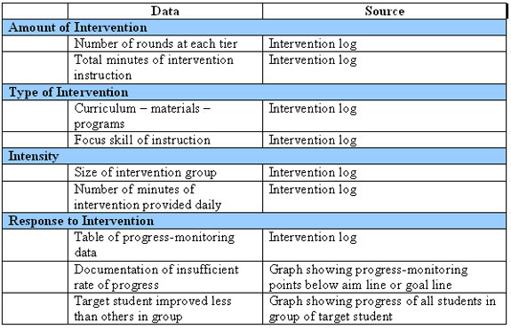

As evident from the table above, much of the data can be captured in an intervention log. It is difficult, or impossible, to recreate the history of interventions after the fact. At the outset it’s impossible to know which students will make insufficient progress. Data must be collected throughout the process on all students so that it will be available for the few students who show an insufficient rate of improvement and are referred for further study.

One positive outcome of RTI is that often the collaboration within a grade-level team improves as a result of the dialogue that transpired in implementing these new practices. This is especially the case when they use the “walk-to-intervention” model to group across the grade level, whereby students might receive intervention instruction from a teacher other than his or her homeroom teacher. Another impetus for improved grade-level collaboration is when the focus of team meetings is on how teachers are grouping their students, what instructional strategies or materials have led to successes with students, or how teachers seek input and advice from their colleagues about individual students who are not improving. It’s significant when teachers refer to students as "our kids" instead of "my kids."

Resource Inventory

During the installation stage, schools often take time for a self-assessment focused on analyzing the achievement scores of the students served by the school and on how to articulate a motivation for implementation of RTI. In this stage, RTI teams inventory what the school already has in place, as well as what resources will be needed for the implementation. Some common topics to explore include the following:

- Staffing—who will provide the intervention instruction?
- Assessment tools—do we need to purchase or license any?
- Curriculum inventory—what do we have, and what will we need?
- Administrative leadership—what steps do the leaders need to take to support this initiative?
- Teacher training—what kind of support, coaching, or professional development (PD) will be needed?
- Teacher background knowledge—what exists and what will we need to provide?
- Budget/funding—how much may be needed, and what are the potential funding sources?

Activities During the Installation Stage

Activity 1: Determine Service Delivery Model and Scheduling

One of the first in a set of decisions involved in planning an RTI implementation involves how to organize what may be called the “service delivery model.” This term is used to encompass decisions about who, where, and when, meaning who will teach the groups, where they will be taught, and when will intervention groups occur? These decisions need to be made before considering the staffing and training needs, which are covered in Activity 2. Discussion about how to organize a delivery model for Tiers 2 and 3 is sometimes a missing part of training about RTI. Many teachers report that often what regional offices of education offer is PD to disseminate information about what RTI is, but those sessions sometimes don’t include practical tips on how to get started. Too often the content remains at the overview level and misses getting down to the nitty-gritty details that have to be addressed to start the installation. As noted by Fixsen and colleagues (2007), “Thus, diffusion and dissemination play an important role in starting the implementation process but should not be confused with implementation itself” (p. 5).

Who Teaches Intervention Groups? Selecting who delivers the intervention instruction depends on the school’s staffing. There are several typical options. Administrators need to determine which staff can assist classroom teachers. Are there curriculum specialists who dedicate their day to working with small groups of students who are struggling with reading or math? In most schools that have Title I funding, the teachers and aides align their groups with the intervention groups.

When there are no instructional aides, Title I teachers, or curriculum specialists to help, then the classroom teacher teaches the intervention groups. When there is additional support staff to help, sometimes all groups are taught by interventionists (reading or math specialists). Many times a combination of support personnel and classroom teachers teach the intervention groups.

Where Do Intervention Groups Meet? There are many location options for intervention instruction. Some schools have multiple groups in the classroom, while in other schools an interventionist may pull her group from the classroom and take them to a quieter room. There is no research that says that one is more effective than another. Many times it depends on the school’s layout. If there is a room where an intervention group can meet, it may be much quieter and the separate space will allow the intervention teacher to have all of his or her materials organized for easy access. If the reading specialist’s room is too far from the classroom, then the advantages of quiet and materials accessibility may be offset by the loss of time in walking students to another location.

When Do Intervention Groups Meet? The “who” and the “where” are easier to determine because they are a function of the school’s staffing and facilities. Typically, the hardest decision of the three (who, where, and when) is to determine when to provide intervention instruction. Teachers already feel that their day is completely scheduled and there is no time to squeeze in one additional thing. Solving the scheduling issue is critical if teachers are to dedicate time to teaching intervention groups. Should the intervention block be taught as one activity during the content area block time? The “gold standard” recommended by experts is that Tier 2 and Tier 3 intervention should occur outside of the core content block. The reason for this recommendation is that students who are behind in an area need more time in instruction, not the same amount of time. Additionally intervention typically focuses on only a few skill areas and, therefore, pulling a student for intervention during the regular instruction in that content area means he or she will miss out on other important components. For example, if a student’s reading intervention happens during the 90-minute reading block, he or she may be pulled out during vocabulary and comprehension instruction for intervention in decoding. This gap in instruction may contribute to the student losing ground overall even if he or she is making progress in the skill area targeted by the intervention.

Many schools add 30–45 minute intervention blocks to the daily master schedule. Each grade level has a designated time for intervention groups that is outside their core content instruction, PE, lunch, music or other “specials.” It is recommended that intervention be scheduled at different times for each grade level. For example, kindergarten intervention might be from 9:00 to 9:30, 3rd grade from 9:40 to 10:10, 1st grade from 10:30 to 11:00, and 2nd grade from 11:10 to 11:40. Staggering the times of the grade-level blocks enables support staff to be available to assist each grade level during intervention. Usually, Title I and reading specialists go into all the classrooms to work with one intervention group while the classroom teacher takes another intervention group during the same time slot.

Based on observation of hundreds of schools attempting to implement RTI, schools that add an implementation block to their master schedule make earlier progress in their implementation than those that don’t. There may be a host of reasons for this. When the principal or administrative team adds intervention to the master schedule, there is a level of commitment and a statement of the importance of this instructional time. It also enables the sharing of students between teachers. What is on the schedule is more likely to get done rather than leaving it to each teacher to decide how to fit intervention time into her own daily schedule.

Activity 2: Creating an RTI Implementation Plan

As part of the team’s plan, a number of other decisions will need to be made.

- Staffing
Sometimes there is funding to hire new staff to assist with RTI. This could include either an RTI coordinator or intervention teachers to teach the small groups. If staff is added, a number of activities will occur, including writing job descriptions, recruiting and interviewing applicants, and hiring and training new staff. Most schools don’t add any staff when they launch RTI but they may redeploy existing staff and restructure responsibilities slightly. For example, it may be helpful to free up one afternoon per week for a reading specialist to serve as a part-time RTI coordinator.
- Assessment Planning and Training
The RTI team will need to plan the assessment functions, which include administering assessments, collecting and analyzing data, and determining how to interpret data to place below-benchmark students in small groups. Who will do these functions? The most available person is not necessarily the best choice—instructional aides might be able to give the assessments but will not always able to bring other teachers around to understanding what the data say about their students’ skill deficits.

⇨PHASE #4: FULL IMPLEMENTATION
Full implementation is reached when at least 50% of the teachers are performing their new functions acceptably (Fixsen, Naoom, Blase, and Wallace 2007). It generally takes the first academic year for teachers to learn how to administer the assessments, interpret the data, place students in groups, and begin to learn how to provide targeted and effective intervention instruction. Learning to interpret the assessment data and form tight groups takes the first couple of months, and then learning to plan and deliver effective intervention instruction generally takes even longer. (Possible year 1 GOAL)

A checklist of processes that are observable when the school is in the full implementation stage is provided below. Schools can use this checklist of characteristics to evaluate whether they are in the full implementation stage, and identify any areas requiring more attention.
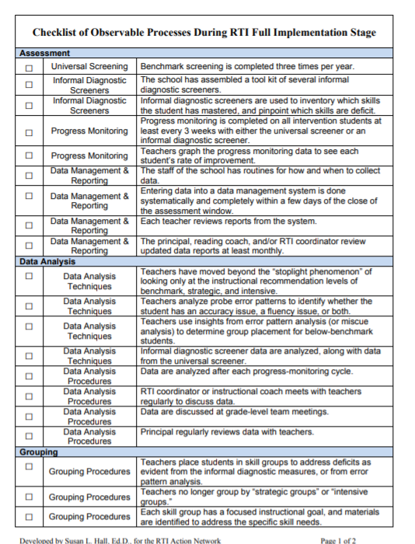

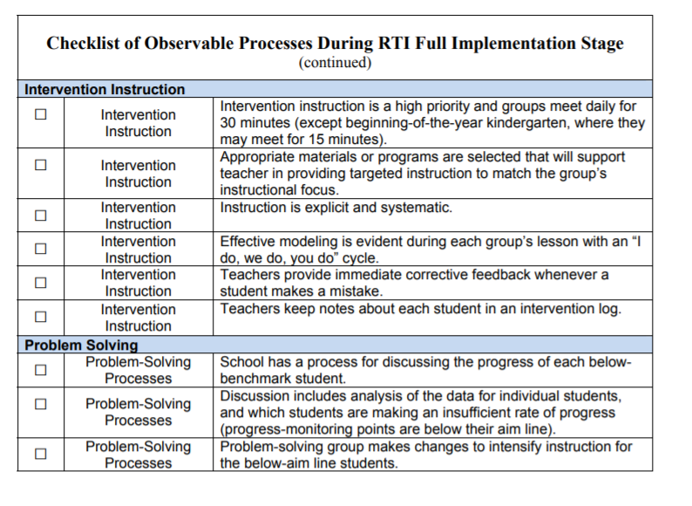

ACTIVITIES DURING THE FULL IMPLEMENTATION STAGE

Activity 1: Teachers Receive Ongoing Professional Development and Coaching
The focus of professional development during full implementation shifts from teachers learning data analysis techniques to coaching teachers in how to deliver the most effective intervention instruction possible. There is a sequence to the new processes that teachers must learn. Administering assessments comes first and is followed by interpreting the data. Then, once the data analysis techniques are mastered, it’s possible to place students in groups by targeted skill area. Only after groups are well constructed is it possible to look at the quality of instruction; it’s difficult to focus on the characteristics of high quality intervention instruction when students in a group have diverse needs such that the skills one student needs to develop are not at all what another student needs.

Why does it take teachers so long to reach proficiency in Response-to-Intervention (RTI) practices? Teachers are often not accustomed to teaching small groups and may find this transition very difficult. But it’s more complicated than merely learning classroom management techniques to keep the other students well occupied at independent work stations while the teacher works with three to five students at a table. Intervention instruction is explicit and systematic, and it is likely quite different from the type of instruction the teacher has a great deal of experience in providing. Students in intervention groups receive immediate corrective feedback, so the teacher has to observe each student and differentiate the reteaching to meet each student’s needs. The intensity and individualization of intervention instruction is not something very many teachers know how to do before they see it modeled. Professional development is critical because this instruction is different from whole-class instruction.

At the earlier stages of implementation some of the professional development can be structured in a workshop format. For example, workshops are effective for providing an overview of what RTI is, as well as the historical and research underpinnings supporting its use. Also workshops are effective for learning to administer new assessments and how to interpret the data reports. However, when it comes to learning new instructional strategies, modeling and coaching are more effective than a workshop format. Many of the topics effectively covered in a workshop setting are appropriate during the exploration, installation, and initial implementation stages. By the time the school reaches the full implementation stage, the most effective format of professional development is grade-level team meetings and individual coaching and modeling.

Activity 2: Develop a Problem-Solving Process
Although the school may initiate problem-solving processes in an earlier stage, this process is most needed during full implementation. The problem-solving meetings are relevant after intervention instruction has been provided for a reasonable time period and enough progress monitoring data have been collected to merit discussing whether the rate of improvement is insufficient. This often means that the student has participated in a couple of 10-week rounds of intervention, with at least one round where the instruction was intensified, commonly referred to as Tier 3.

Once the school begins regularly discussing students in a problem-solving approach, it is common to increase the frequency of progress monitoring assessment during this stage. This occurs at this point because the data are now actively used in decision making and teachers see that it is easier to draw conclusions about a student’s rate of progress with more data points.

When a problem-solving process is used, a team of staff members meets to discuss the rate of progress of an individual student. The problem-solving process may have some characteristics of a child study team meeting in some schools, depending on how that process is done. It’s important to outline a process in general education that is linked to the referral process; these processes should be cohesive and connected, not two different processes. That way the information collected before referral is used for the referral decision. This is at the heart of RTI.

Activity 3: Develop a Tier 3 Instruction Layer
When schools first implement RTI, there is a great deal of uncertainty about the difference between Tier 2 and Tier 3 instruction. Does more time in an intervention group automatically mean the instruction is Tier 3? What does it mean to “intensify” instruction? Does the instruction need to include a more systematic program or instructional approach? How is the instruction provided in Tier 3 different from that in Tier 2, but also different from what a student will receive if qualified for special education services? All these questions, and many more, need to be answered.

Many schools spend their first year just getting a solid Tier 2 system in place. Only after the data show that their Tier 2 instruction is effective for nearly all students will the staff begin to question what Tier 3 is. The transition happens naturally once teachers can identify the outliers—students not progressing as much as peers. I observed this natural evolution toward Tier 3 while participating in a 5th grade team meeting at a middle school in New York with many students reading below grade-level. The team met monthly to move students from one skill group to another. Before the meeting, each teacher gave the students in his or her current group a progress monitoring assessment using an informal phonics screener or an oral reading fluency probe (this school used the Dynamic Indicators of Basic Early Literacy Skills), depending on the group’s focus. The names of the skill groups were written across a whiteboard and each teacher posted sticky notes to place students in the appropriate skill group for the next month. In December, the third month the team had met, there was a cluster of five students who had hovered in the bottom skill group since September. All other students were moving up the skills continuum. The team decided to place those five students in a group with a teacher who had prior training in delivering explicit, systematic, multisensory instruction so that she could keep that group together for several months and increase the intervention time. Before Tier 2 was up and running, it would have been difficult for this team to know what Tier 3 should be and which students should be placed in this increasingly intensive tier.

⇨Phase #5: INNOVATION
There is no “RTI in a Box.” Instead, it will have to be customized to fit the context of each individual school. For example, whether it is better for an interventionist to “push-in” to a classroom or for teachers to group across an entire grade level depends upon staffing, level of teacher cooperation, and even facility layout. There is no single right way to organize the delivery model for intervention groups. Yet, it is important to implement with practices that have been proven to be effective in schools similar to yours. Only after fully understanding what you are trying to do and successfully getting results with the proven process should you then make changes. As Fixsen, Naoom, Blase, and Wallace (2007) said, “learn the intervention, learn how to do it with fidelity, do it long enough to learn the nuances of its applications, and then work on how to improve the intervention itself” (p. 7). Success and student results during the first full year of implementation are crucial to getting complete staff buy-in, so it’s better not to allow teachers to create their own way until after they have implemented the district’s selected approach first.

During the innovation stage, schools typically make improvements to their assessment calendar, data analysis practices, grouping practices, timing of intervention in the master schedule, and model for the delivery of the groups. During this stage, RTI may be added to upper grade levels or to the rest of the schools now that the process and practices are fully understood and working well at the lower grade levels or pilot buildings.

⇨PHASE #6: SUSTAINABILITY

Sustainability is critical and should be the goal during each earlier stage. The manner in which RTI is implemented in earlier stages will determine the level of sustainability. To a great extent, securing teacher buy-in is critical to the long-term sustainability of this innovation. That’s why it is critical to provide teachers with professional development and coaching that leads to support and commitment, not just compliance. Teachers need time to fully understand the why and the how, and to have the opportunity to learn data analysis, grouping, and instructional techniques.

Some people search for the silver bullet of intervention programs that will produce results, as if the program teaches rather than the teacher. In RTI, perhaps even more than with a core program, the data-informed decision making is critical to success. The data analysis processes must be taught to the classroom teachers so that they can experience why focused groups enable targeted instruction; teachers need to experience that the success in the student’s progress monitoring scores resulted from decisions they participated in and practices they implemented. If someone else administers all the assessments and places students in groups and just hands over a list of students and a program to teach, the success cannot be experienced in the same way. In RTI there is an integral connection between making instructional decisions for a student and the assessment data that led to those choices. Teachers must be taught to understand and use the data.

Many times schools are in a hurry to implement RTI. Fixsen, Naoom, Blase, and Wallace (2007) said the following with regard to the benefit of hiring an outside expert to advise during the process: “Early decisions about how to access external expertise to assure a quick and successful start-up, and how to make use of that external expertise to build local capacity, will impact sustainability over the long term” (p. 7). Educational consultants can indeed help with the implementation process; however, careful selection of a consultant is encouraged. Ask about the depth of the consultant’s experience in helping schools implement RTI. Ask for referrals and talk with staff or administrators at other schools the consultant has assisted. While a consultant can help the district or school implement RTI more quickly and the consultant’s advice may improve the probability of sustainability, schools can be just as successful without a consultant if they have a dedicated RTI team that researches extensively and is given the time to lead this innovation.

⇨EXTRA SUPPORT IDEAS…..

Preparing for a Progress Monitoring Review Process

Engaging in Reflection for Productive Decision Making
One of the most powerful practices included in an RtI framework is using data to guide decision making. During early stages of RtI planning and implementation, teams are making decisions about what tools will be used for progress monitoring, how frequently progress will be monitored, what decision rules will be used to prompt when changes may be warranted,· when will these data discussions take place, and who will be involved.· Make no mistake, these decisions usually require a significant amount of time and spirited discussion to arrive at consensus for district or building level teams.· Once made, actually launching the data teams and using the decision rules are important milestones in the RtI journey. I emphasize” important milestones” because, to me, they are initial steps in the process and require the group to engage in reflection on the process so it can be properly matured over time.· This is where many of the teams I work with are in the process and, for this blog, I want to share what realizations we are coming to as we work to make the process more efficient and effective.
Our discussions have focused on how to properly prepare for a progress monitoring review. The key components we find ourselves discussing include:

1. Clear Purpose

We find that revisiting the purpose of the review process is essential. The purpose of the review process is to determine whether or not to change something about what we are doing during core instruction and intervention in order to better meet the student’s needs. While we have team norms, this mantra needs to be repeated in order to “undo” decades of our spoken or unspoken purpose being that we determine whether the data suggest that we go to an initial evaluation, or whether the student continues to “need help” from the reading or math specialist.

2. Understand Student Strengths and Needs

The general education teacher is the student’s primary teacher. As such, we need to ensure they are comfortable and confident leading the discussion regarding each student’s specific strengths and need areas. For example, in reading, it is important that they understand which big ideas are strengths and which are need areas. This sounds very straightforward, but even my very veteran and strong teaching colleagues have indicated that thinking about reading by the big ideas was not emphasized in their preservice programs and usually is not provided adequate coverage in staff development beyond the knowledge level.

3. Clear Articulation of Intervention Match to Need

Using screening data and a validation process to determine who may warrant additional support has been an easy transition for most all teams I work with. The more challenging component has been for the team to clearly understand and be able to match or create an intervention to the student’s specific need. While reading and math specialists may feel comfortable with this process, it is important that the child’s classroom teacher understand both the match of intervention and the scope of skills that will be covered.

4. Reflection on Student Progress Monitoring Data

While a first step for a team is to be able to accurately describe student progress monitoring data in terms of level and slope of performance, the next step is to use this summary as a springboard to the reflections on the student’s performance in the core curriculum and during intervention time. We are finding that “on the spot” reflections are not sufficient to engage in problem solving when a change is warranted, so we are working to provide a reflection guide in advance. We anticipate that the advance reflection will allow for (1) more meaningful problem solving and (2) curtail the “quick fixes” that I find us going to – “add x number of minutes of sight word review,” “add fluency opportunities.” It isn’t that these may not be appropriate, but for students experiencing the most significant time learning to read, I’m not sure we have really created the most thoughtful change.

Given what I’ve been sharing, we’ve created a “story script” that we’ve been using to guide each of us through the process. We created this because we find that a team of 6 people will have six different ways to “share the story.” This makes it inefficient for a team to wrap their head around the details of the student. (For those of you who have had Ruby Payne training, showing the “Did you hear about Jack” video is a fun way to emphasize how difficult it can be to follow people’s stories). The script, therefore, allows us to practice articulating all the essentials to ensure we have a collective understanding. One way to practice this is to have teachers rotate being the facilitator so they are also in the position of listening for the essentials and checking for understanding. In my next blog, I’ll share two case studies of how this has resulted in problem solving.

Bigger than the Details: Topics to Build into Faculty Discussions
In the district I serve, we’ve made considerable advancements with our RtI practices. We have a district protocol that has served us well for several years. We are expanding our protocol into our preschool settings and we continue to work hard to integrate our academic and behavior structures. We have a multi-year approach to growing our skills around evidence-based practices, data-based decision making, and the application of the problem-solving process. Yet, while every building in the district could make the list of particular practices they want to improve and strengthen, there are some important topics that deserve some conversation and acknowledgement among our faculties.

For those colleagues who like to outline topics for faculty meetings for the year, I thought I’d offer a couple of topics and references that would be worthy of pause and conversations. They are areas that, at the core, can create your “tipping point.” They are topics that ensure we are individually, and collectively, focused on making the most difference we can in children’s lives. They get at who we are as educators, and as a faculty. The evidence-based practices involved with RtI are powerful – but can be even more powerful when implemented in an overall healthy and focused system of educators who know what they do, why they do it, and use each other in important ways for the betterment of important outcomes for children. It is my hope that these conversations can be overt demonstrations of leadership that illustrate the “mortar between the bricks” with the practices.

Growth Mind-Set vs. Fixed Mind-Set
One of the key assumptions with RtI is that all kids can learn (Batsche et al., 2005). The purpose of early identification, teaching core with powerful instructional techniques, putting in place a strong and focused intervention, and monitoring student progress is with the expectation that we will change learning outcomes for students. We use the problem-solving process to help us make judicious decisions about next instructional moves with students for whom we haven’t found an instructional match. We must be astute to how they are interacting with our instructional materials and teaching strategies so that we can develop a plan that is customized to each student’s learning needs. This approach could be considered a perfect match for those educators who have, what Carol Dweck calls, a “growth mindset”. On the other hand, having a “fixed mind set” creates dissonance during RtI planning and data review processes. The Mind-Sets and Equitable Education article from the National Association of Secondary School Principals will generate discussion important to a faculty as they think about the impact that their belief system has on student achievement, as well as generating discussion about how they can create classrooms that promote students learning to have a “growth mindset.”

Discussion Questions:

- In what ways does this message resonate with you as an educator?
- Dr. Dweck states on page 28 “Teachers with a growth mind-set don’t just mouth the belief that every student can learn; they are committed to finding a way to make that happen.” Discuss the changes that have been put in place with RtI. What do you see as the connection?
- Discuss in what ways having a growth mindset is of heightened importance for students who have a history of difficulty in school (academic or social).
- Compare what it would be like to be in a classroom with a teacher who had a growth mind-set versus a fixed mind-set. What would the differences sound like and look like?

Food for thought….
The RTI process begins with high-quality instruction and universal screening of all children in the general education classroom. ... RTI is designed for use when making decisions in both general education and special education, creating a well-integrated system of instruction and intervention guided by child outcome data.

Universal Screening The first step of the RTI process is a Universal Screening. Purpose: The only purpose of a Universal Screener is to identify which students you want to monitor more closely during Tier 1.

