ICS Elementary Essential Literacy Agreements

Definition of Learning
Learning is an ongoing process in which learners acquire, develop and apply knowledge, skills, and dispositions essential to thrive in, and contribute to, an ever-changing world.
Learning is optimized when it is:
meaningful authentic reflective collaborative conceptual transdisciplinary active personalized blended
ICS learners have agency through the ICS Learning Process:

Inquiry--What do I want to know and be able to do?
Action—How will I demonstrate that I know it?
Reflection-What will I do if I’m not learning and what will I do if I already know it?

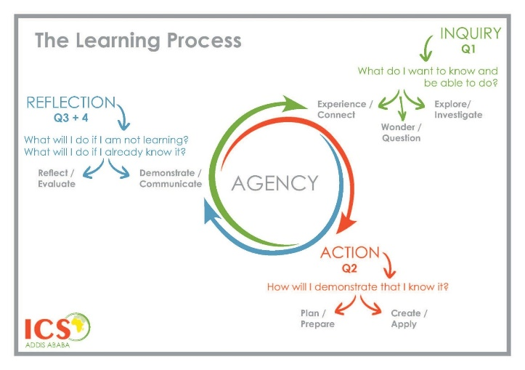

The fundamental interrelatedness of literacy with the process of inquiry provides for rich, connected, contextual learning critical to our changing world. The literacy program at ICS is focused on ensuring that all students achieve personal excellence. Through a developmentally appropriate, differentiated and interdisciplinary approach, the balanced literacy program at ICS guides students in the life-long process of acquiring knowledge and understandings, learning attributes, and communication skills that will allow for their fullest participation in the world. While literacy instruction is direct and explicit within the English Language Arts program, it is taught as part of the PYP Units of Study, as it is essential that the skills and understandings gained through a conceptual lens will empower understandings and communication skills in all content areas.

Curriculum at ICS

- The Common Core English Language Arts Standards will be the foundation for the ELA curriculum (CCSSELA), and the ES ELA Power Standards, drawn from the CCSS, comprise the most essential standards for each grade level. Teachers will use this to support students in moving toward proficiency.
- The ICS Language Scope and Sequence will be used to guide instruction for teaching reading and writing, and to clarify the power standards.
- Literacy standards will be connected to the UOI through the grade level yearly overview which show these connections and will be reflected on before the unit and at the end of the unit.
- The Workshop Model of instruction is used for reading and writing, and student learning will be supported by using parts of the TCRWP Units of Study in Reading and Writing as a resource, and for providing guidance for large, small, and individual instruction within a transdisciplinary framework.
- The sequencing and integration of these units will be discussed within grade level PLCs in order to best fit the developmental needs of the students and the ICS Program of Inquiry

Instruction at ICS
General
- Based on inquiry
- Facilitated through a workshop model
- Focused on conceptual understandings and meaningful authentic connections
- Student centered and hands-on
- Emphasis on concrete and pictorial representations
- Focused on collaboration
- Differentiated to meet the needs of all students
- Learning targets explicitly stated to students in student-friendly language
- Use of flexible groupings
- Personalized
- Use of conferring

Literacy specific

- Daily Instruction will be embedded into the framework of the Transdisciplinary Nature of the Program of Inquiry as much as possible.
- Explicit Reading and Writing instruction/ practice will occur every day using a workshop model and within the transdisciplinary scope of our PYP Units of Inquiry
- Explicit and personalized Handwriting, Cursive and Keyboarding instruction will occur in grades EY–5 as demonstrated by student interest and need. Handwriting in EY will begin with lower-case letters then continue to upper case. The learning target will be that students are proficient in both cursive and keyboarding by the time they leave fifth grade.
- **Explicit Word Study instruction will occur and Vocabulary will be developed within the context of the UOI.** (**Currently in conversation, October 2020)

Resources
(These resources are not intended to be used “page by page” or scripted, and should be tailored to ICS’s context, students, and Units of Inquiry.)
- The TCRWP Units of Study in Reading and Writing - resource for teaching ELA
- Classroom libraries are an essential part of a reading workshop. Classroom library Guidelines
- ICS Leveled Book Room, located in the elementary library, maintains book sets that can be used for guided reading instruction. Checkout through Elementary Library.
- Handwriting Without Tears is used to teach handwriting in grades K-5.
- Typing Club is used in grades 3, 4, and 5 to teach keyboarding skills,
- *Words Their Way - core resource for teaching word study in grades 1-5. (Being looked at- Oct. 2020)
- ICS POI, PYP planners (Yearlong overviews, UOIs) all on Toddle
- Additional resources can be found in the Library and the OL

