Helper Middle School Improvement Plan 2017-2018
Purpose: All students at Helper Middle School will learn and grow at high levels.
School-Centered Focus | - Academics: Development and implementation of essential skills in all grades, for all courses..  - Behavior: Development, implementation, and reteaching of expected school-wide behavior.  - Attendance: Development and implementation of attendance expectations and incentive program.
Problem of Practice (Things we are doing or NOT doing that contribute to to the problem) | - Academics  - Not all essential skills have been identified and/or adjusted for every course.  - Principal has not been consistent in checking on progress as essential skills were adjusted.  - Learning targets have not been defined for every essential skill.  - Interventions during RAMS time are not always used for essential skills.  - PLC time is not always student-centered, data is not always used.  - Behavior  - Adjustments need to be made on the reflection sheets.  - Students do not always understand the ramifications of receiving/completing reflection sheets.  - Teachers are not reminded of agreed upon standards for non-negotiables and tardies.  - Teachers/staff are not always consistent with distribution of green sheets.  - Attendance  - There has been no consistent effort made to increase and/or sustain attendance.  - Students and parents are not specifically educated on the importance of good attendance.  - No incentive program has been developed for consistent attendance.

SMART Goals | - Academics  - Students will master essential skills and the learning targets therein by scoring 75% or higher on formative assessments.  - Behavior  - Disciplinary referrals will be reduced to 5 or less per quarter.  - Attendance  - Helper Middle School total attendance will be 95% or higher each quarter.
Evidence-Based Strategies to Address the Problems of Practice | Simplifying Response to Intervention Four Essential Guiding Practices (Austin Buffum, Mike Mattos, Chris Weber, 2012)  Visible Learning for Teachers (John Hattie, 2012) and the Visible Learning Plus Foundation Workbook (John Hattie)  Bridges Out of Poverty (Payne, DeVol, Smith, 2009)  ASPEN Training, Managing Aggressive Behavior in the School Setting (Ben Springer: Ph.D., NCSP, 2013)  Bully-ology (Ben Springer, Ph.D., NCSP and Ben Belnap, Ph.D., 2013)
Budget/Resources | TrustLand budget is used to pay teachers for extra hours to develop the learning targets and formative assessments. Teachers are given 41.5 hours this year to work on school goals outside of contract time.

Evidence-Based Strategy # 1: Academics Mental Model
What will it look like when essential skill mastery is implemented at an acceptable level?
Tier I
- All students receive grade level instruction with a focus on essential skills in every course.
  - Essential Skills: Essential skills have been identified for every course taught at HMS. These skills are considered essential because they have endurance (skills valuable beyond a single test date), leverage (skills valuable in multiple disciplines), and/or readiness (skills essential for success in the next grade).
  - Learning Targets: Essential skills have been “unwrapped” into learning targets. Learning targets are specific skills within the more broad essential standard, and those learning targets are what teachers formatively assess. Teachers intervene only on learning targets during RAMS time.
- Teachers will use formative assessments to determine mastery level for each essential skill and/or learning target.
  - Formative assessments will be specific to a learning target or essential skill
  - Teachers will adjust instruction based on results from formative assessment (80% or more of the students should master specific concepts at this time)
Tier II
- Teachers will meet during PLCs and use data from formative assessments to determine which students need extra help to master concepts.
  - RAMS time will be used to pull students for intervention Tuesday - Friday
  - RAMS time is prioritized by course and grade
  - Intervention groups are organized by concept keeping groups focus specific to one standard or target
- Intervention time will be required ONLY for essential skills and learning targets.
  - “Important” and “nice to know” concepts may be assessed in class, however teachers are not expected to intervene on non-mastery of these concepts
  - Students who need help with non-essential concepts or those failing classes will be pulled into SAW (student achievement workshop)
  - IEP goals
- After intervention has taken place, formative assessments are used again to determine mastery level of students (15 - 20% of the students should reach mastery at this time)
  - For students who have not yet mastered the concept, teachers will work together to pull students during RAMS time until student has mastered concept
  - Teachers who did not assess an essential skill that week may give up their day of priority to help a teacher who did
  - Teachers will consider
    - Using special education teacher to help explain concepts in a different way
    - Use peer tutors to help explain concepts in a different way
    - Lower DOK (depth of knowledge) while still maintaining grade level concept
    - Paraprofessional aides

Tuesday | Wednesday | Thursday | Friday
Math 6  ELA 7  Science 8/US History  SpEd (if not science)  SAW | Math 7  ELA 8  Science 6  SpEd (if not science)  SAW | Math 8  ELA 6  Science 7  SpEd (if not science)  SAW | Electives  CCA  Social Studies (6th and 7th)  SAW

Tier III
- Students who are significantly behind in reading and/or basic math skills will be placed in a basic skills class.
  - Additional in the schedule to grade-level language arts and math (ALL students ALWAYS have grade-level instruction)
- Identifying students for basic skills
  - Teacher recommendation from Sally Mauro Elementary (feeder school) and/or Helper Middle School
  - QRI reading assessment
  - WEI reading assessment
  - Brigance math assessment
- Students will track their own progress during basic skills. When they reach the goal(s), they are allowed to exit basic skills.
  - Reading Requirements
    - Students must read a minimum of 90 words per minute
    - Students must be at an “Independent” 5th grade reading level
    - Students must answer comprehension questions correctly with a minimum of 80% proficiency from both stories and text
How will we know if/when essential skills mastery is being implemented at an acceptable level?
- 80% of students master concepts during Tier I instruction.
- 95 - 100% of students will master the concept after Tier II instruction is provided
  - RAMS intervention is used for essential skills and/or learning targets that were not mastered in Tier I
  - Student Achievement Workshop (SAW) will be used for all students failing classes
  - Basic Math Skills taught the first few weeks of school
    - Add, subtract, multiply, and divide whole numbers (up to 3 digits)
    - Add, subtract, multiply, and divide fractions (positive only)
    - Add, subtract, multiply, and divide decimals (2 places only)
  - Extensions will be provided for those students who have already mastered concepts
- Additional time during interventions will be used as many times as necessary until 100% of students have mastered essential skills.
- Students will improve 3% in proficiency and 5% in growth on SAGE assessment in math, science, and language arts.
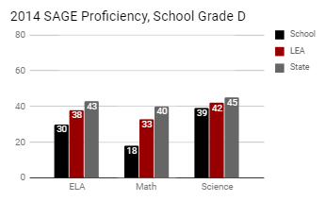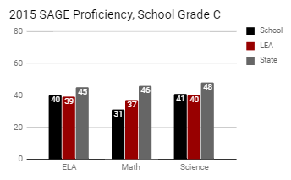
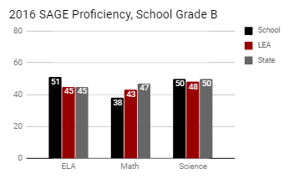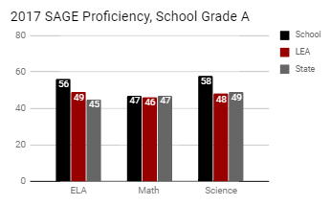

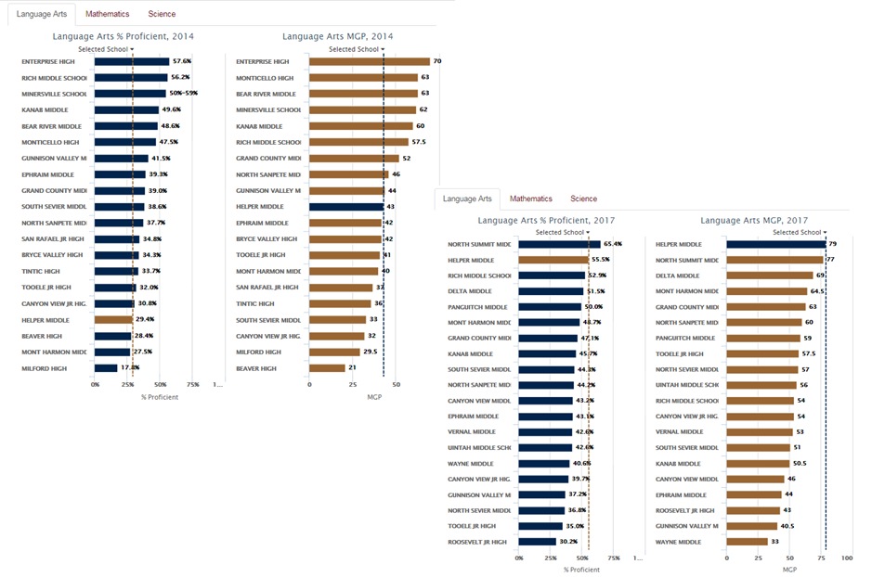
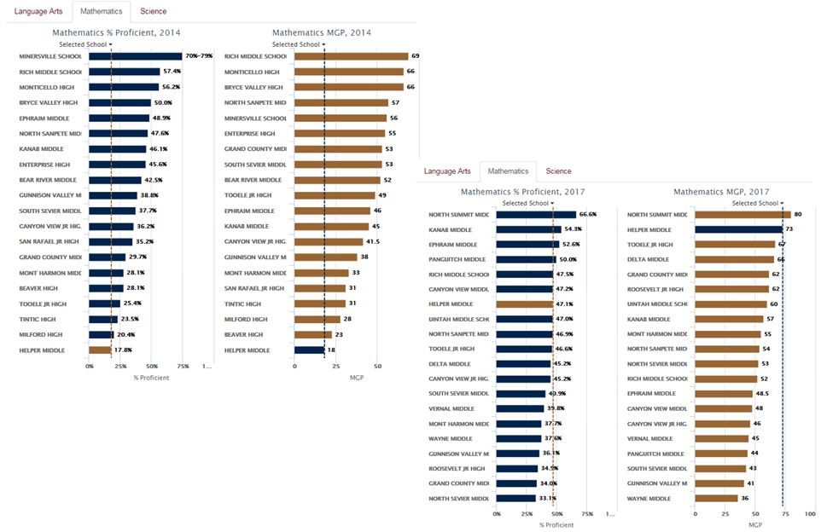
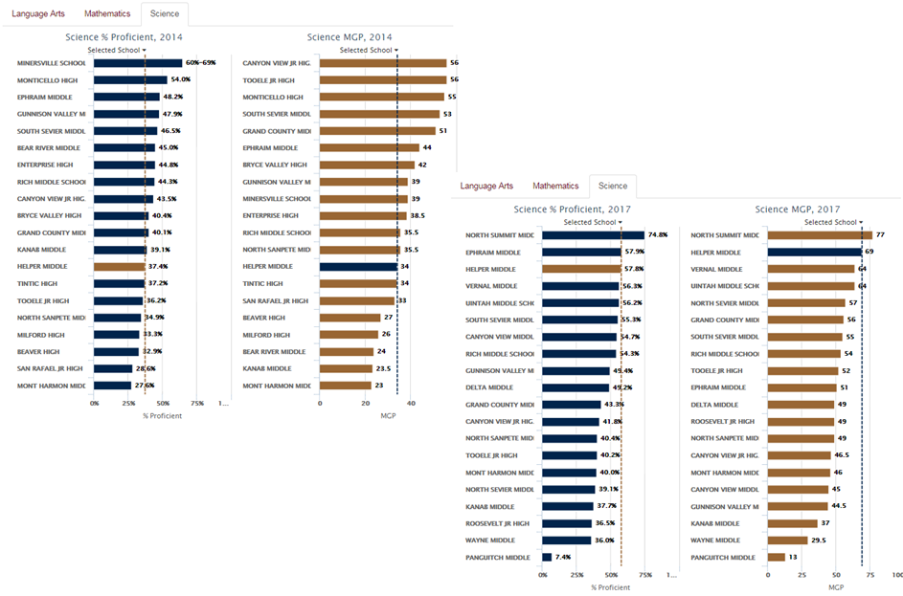

Evidence-Based Strategy # 1 Tasks to Support Mastery of Essential Skills
What?  (Task) | When?  (Date) | Who is Responsible?
- Essential skills will be reviewed and adjusted for ALL courses.  - Learning targets will be reviewed and/or completed for ALL courses.  - PLCs will be used to identify students who did not master concepts and pulled for specific, targeted intervention time.  - Principal will use walk-throughs, facilitation of PLCs, and School City reports to ensure mastery learning is taking place. | August 24  August 24  Sept. 5 (ongoing during PLCs)  Sept. 5 (ongoing) | Teachers  Teachers  Teachers  Principal

Evidence-Based Strategy # 2: Behavior - Mental Model
What will it look like when tiered behavior plan is implemented at an acceptable level?
Tier I

PBIS (Positive Behavior Intervention and Support)
- Clear expectations are provided for students consistently
  - Fall and winter assemblies explaining behaviors
  - Reminders during the first period of class after every 3-day or longer break from school
  - Use of warning and green reflection sheet when expectations are not followed
- Congratulations Tickets
  - Given to 3 students (one high achieving, one average achieving, and one low achieving student) per day by each teacher and principal
  - Eligible for daily, weekly, and yearly drawings
- House Assignments
  - Students randomly assigned to red, white, or black house
  - Students are provided shirts of the corresponding house colors
  - Points are given for special activities
  - Award activity for winning house each quarter
- Quarterly Honor Roll and Citizenship Activities
- Quarterly “Breakfast of Champions” for all those with 4.0 GPAs

Second Step Lessons
- Counselor presents Second Step lessons during social studies and health classes the first several weeks of school. The lessons chosen for students are:
  - Active Listening
  - Empathy
  - Considering Perspectives
  - Respectful Disagreement Skills/Communication Skills
  - Responsible Decision Making
  - Bullying
    - 6th grade - verbal and written bullying
    - 7th grade - cyber bullying
    - 8th grade - bullying in relationships
- Students take assessments on the skills taught and are remediated if necessary during RAMS time until 100% mastery is achieved.

Tier II
Reflection Sheets (Green Sheets)
- Students are warned when demonstrating unwanted behaviors
- Students are asked to complete a green sheet to teacher’s standard when they have continued the unwanted behavior
- Teachers turn in green sheet as soon as possible to counseling secretary who tracks the data
  - Students are asked to complete a behavior packet with behavior aide when they have 2 green sheets from the same teacher in one week or 3 green sheets from any combination of teachers in one week. Behavior packets are aligned with the problem behavior.
  - Students will be called out of the next free time to complete the behavior packet (RAMS time, lunch, before school, etc).
  - Packet must be completed to behavior aide’s standards
- Meeting will be scheduled with principal, counselor, student, and parent/guardian upon completion of 10th behavior packet.
  - Discussion of extenuating circumstances
  - Problem solving steps planned to improve behavior
  - Consider outside mentoring options
  - Behavior contract signed with goals and incentives specific to student
    - Included informal observation
  - Consideration for Tier III behavior intervention

Bullying Prevention
- Parent will be contacted when student is demonstrating bullying behavior. Bullying will be considered when there is:
  - Imbalance of power or social class
  - Intent is to cause physical or emotional harm
  - Incidents happen on multiple occasions
- Parent, student, counselor, and principal will meet to introduce the Bullyology program and begin working with student during agreed upon time.
Tier III

Individual Behavior Plan
- Identify:
  - Antecedents - triggering event, setting event, what happened just before, can we manipulate the setting to prevent the behavior
  - Behavior - target behavior, replacement behavior
  - Consequences - reduce problem behavior with consequences, increase replacement behavior with consequences
  - Function - escape, attention, tangible, stimulation
- Meet with student, parent/guardian, teachers, counselor, and principal to write BIP (behavior intervention plan).
- Student will choose from the reinforcement menu and create graduated scale of reinforcement with counselor.
- BIP team (teachers, counselor, principal, parents, and student) will meet every 2 weeks (10 school days) to discuss progress toward goals of replacing problem behaviors. Adjustment(s) to BIP will be made and communicated each meeting.
- After 3 meetings, team will discuss further actions to pursue or begin removing BIP restrictions fostering self-regulation in student.

Bullying Prevention
- Student will be expected to teach Bullyology lessons to appropriate audience.
- Criminal charges will be considered.
How will we know if/when tiered behavior plan is being implemented at an acceptable level?
- 5 or fewer disciplinary referrals are written each quarter.
- Number of green sheets reduces each quarter.
- Number of behavior packets reduces each quarter.
- Number of students in individual behavior plans is less than 2% of total students.

2016-17 Disciplinary Referrals (Tiered behavior program implemented at semester break)

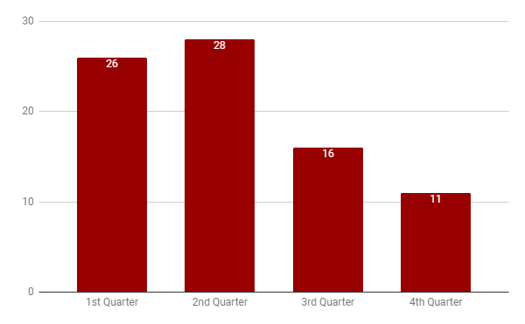

Number of Green Sheets (Tiered behavior program implemented at semester break)
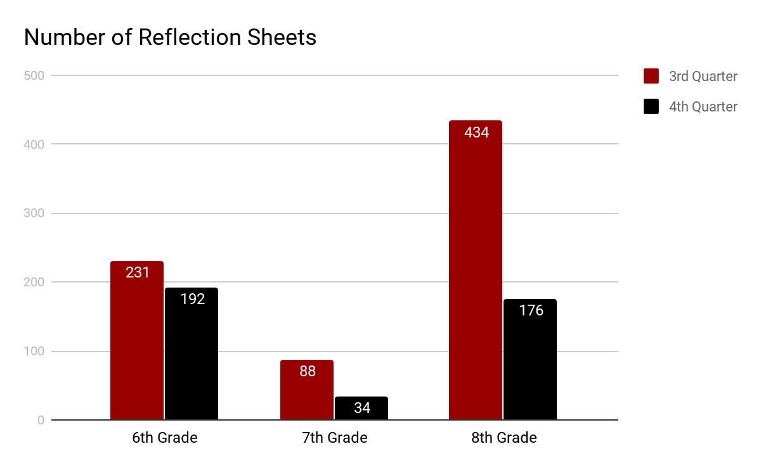

Evidence-Based Strategy # 2: Tiered Behavior Plan
What?  (Task) | When?  (Date) | Who is Responsible?
- Explicit instruction describing expected behaviors and green sheet program.  - Reteaching of expectations after every 3-day or longer break from school during first class of day.  - Warning of unwanted expectation, distribution of green sheet, quality check of student response, turning in green sheet to be entered in spreadsheet.  - Entering green sheet data, flagging when students have 2 from one teacher or 3 from a combination of teachers.  - Assign behavior packet based on need gathered from green sheet data.  - Flag students who have completed 10 behavior packets, notify counselor that student is moved to Tier II.  - Meet with parents, student, begin Tier II behavior interventions.  - Track students in Tier II, determine their movement back to Tier I or forward to Tier III.  - Write Tier III behavior plan as necessary, meet with behavior team and follow through with Tier III expectations. | Aug. 25, Jan. 2  Sept. 5  August 24  August 24  September 5  September 5  September 5  September 5  September 5 | Counselor  Teachers  Teachers  Counseling Secretary  Behavior Aide  Counseling Secretary  Counselor and Principal  Counselor and Principal  Counselor, Principal, Teachers, Parent/Guardian, Student

Evidence-Based Strategy # 3: Attendance Mental Model
What will it look like when essential skill mastery is implemented at an acceptable level?
Tier I (All students who have 10 days of absences or less)
- Educate students and their parents on importance of attendance
  - Remind 101, emails, FaceBook, etc.
- Incentives for all students who meet attendance standards
  - Group contingency rewards (by grade, house, or school)
  - Send positive notes or postcards home when students attend well
- Consequences
  - Attendance letter sent at 5 days of unexcused absences
  - Multiple excused absences letter sent when excessive
- New student transition

Tier II (Students who have more than 10 unexcused absences before semester break)
- Attendance contract written during meeting with parent/guardian, student, principal, and counselor
  - Informal observation
  - Individualized goals written (includes timeline and progress monitoring)
  - Incentive for improvement (includes school personnel tracking progress monitoring)
- Mentor/advocate possibly assigned
- Possibly begin to pull in outside resources

Tier III (Students who have more than 10 absences and have not successfully completed Tier II expectations)
- New contract written including additional resources for student AND family
- Formal FBA (Functional Behavioral Assessment)
  - Possibly including educational psychologist
- Mentor/Advocate Assigned
  - Formal assignment with specific tasks
  - Plan to help the transition out of the Tier III
  - Possible request to attend multi-agency meeting to help address family needs
How will we know if/when essential skills mastery is being implemented at an acceptable level?
- All students and parents will be instructed on the importance of regular school attendance.
- Students will earn incentives as they regularly attend and achieve attendance standards.
- 98% of students will maintain 95% or higher attendance rate.
- 2% or less of students will need Tier III intervention for attendance.

Evidence-Based Strategy # 3 Tasks to Support Mastery of Attendance
What?  (Task) | When?  (Date) | Who is Responsible?
- Students will be instructed on the importance of attendance and expectation that they will attend 95% or more days of school.  - Accurate attendance is taken in every class, every day.  - Parents will be regularly reminded about importance of attendance via email, FaceBook, Remind 101, and the school website.  - Students will be flagged and principal will be notified when they begin moving from Tier I to Tier II.  - Attendance meeting scheduled, contract signed.  - Attendance followed and principal notified when contract breached.  - Tier III contract signed, formal mentor assigned, multi-agency meeting arranged. | August 24  August 24  September 5  September 5  September 5  September 5  October 15 | Principal  Teachers  Principal, Technology Specialist  Counseling Secretary  Principal, Counselor, Parent/Guardian, Student,  JJS Mentor  Principal, Counselor  Principal, Counselor, Parent/Guardian, Student,  JJS Mentor

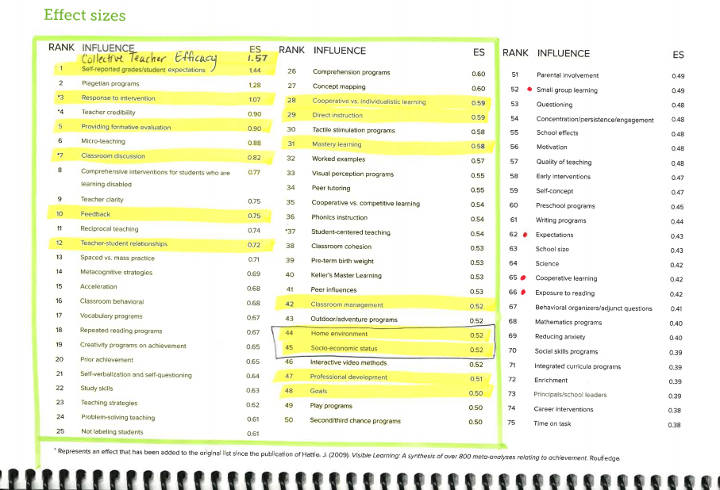

Lunch Schedules
Regular Schedule (Tuesday - Friday)

First Lunch 11:11 - 11:41  (According to 5th/6th Period) | Second Lunch 12:22 - 12:52  (According to 5th/6th Period)
Fausett (evens) | Cartwright
Fidell | Ison
Arrieta (evens) | Arrieta (odds)
Butler (odds) | Butler (evens)
Daniels
Ovard (odds) | Ovard (evens)
Howa (odds) | Howa (evens)

Early Out Schedule (Mondays - or first day of week)

First Lunch 10:30 - 11:00  (According to 7th/8th Period) | Second Lunch 11:15 - 11:45  (According to 7th/8th Period)
Arrieta (evens) | Cartwright
Butler (odds) | Butler (evens)
Daniels | Fausett
Oliver | Fidell (odds)
Howa (odds) | Howa (evens)
Black | Ison
Ovard (odds) | Ovard (evens)

Bell Schedules

Regular Schedule |  |  | Early Out Schedule
67 Minute Classes |  |  | 41 Minute Classes
8:15 | First Bell |  | 8:15 | First Bell
8:19 - 9:26 | 1st/2nd Period |  | 8:19 - 9:00 | 1st/2nd Period
9:30 - 10:37 | 3rd/4th Periods |  | 9:04 - 9:45 | 3rd/4th Periods
10:41 - 11:11 | RAMS |  | 9:49 - 10:30 | 5th/6th Periods
11:11 - 11:41 | 1st Lunch |  | 10:30 - 11:00 | 1st Lunch
11:15 - 12:22 | 5th /6th (2nd Lunch) |  | 10:34 - 11:15 | 7th/8th (2nd Lunch)
11:45 - 12:52 | 5th/6th (1st Lunch) |  | 11:04 - 11:45 | 7th/8th (1st Lunch)
12:22 - 12:52 | 2nd Lunch |  | 11:15 - 11:45 | 2nd Lunch
12:56 - 2:03 | 7th/8th Periods |  | 11:49 - 12:30 | 9th/10th Periods
2:07 - 3:14 | 9th/10th Periods

