Healthcare Credentials
At the BCCCA, students in the healthcare pathway can take national certification exams through the National Healthcareer Association (NHA) to obtain healthcare credentials. These credentials allow students to go directly to work in the healthcare industry during or after high school. The credentials the BCCCA offers include:
CCMA – Certified Medical Assisting
CPT – Certified Phlebotomy Technician
CET – Certified EKG Technician
The data below shows aggregate data on student performance on these exams.
Year | Winter 2018 | Spring 2019 | Winter  2019 | Spring 2020 | Winter 2020 | Spring 2021 | Winter 2021 | Spring 2022 | Winter 2022 | Spring  2023
Percentage of Students Earning Credential | 27.27% | 68.42% | 55.56% | 83.33%*  Few testers due to Covid | 81.25% | 75.00% | 79.41% | 83.33% | 74.07% | 83.4%
 | No collaborative teams | No collaborative teams; Guiding Coalition began | Collaborative Teams began; focus only on essential standards, CFAs, and prevention | Collaborative Teams continued; focus only on essential standards, CFAs, and prevention | Collaborative Teams; added focus on CSA and Tier 2 | Continued collaborative teams with focus on Tier 1 and Tier 2 | Continued collaborative teams with focus on Tier 1 and Tier 2 | Continued collaborative teams with focus on Tier 1 and Tier 2 | Continued collaborative teams with focus on Tier 1 and Tier 2 | Continued collaborative teams with focus on Tier 1 and Tier 2
*Due to Covid, students tested during the summer of 2020. Not all students were tested. This group represents a small group of highly motivated students who were determined to earn their credentials.

Healthcare Credentials – Exceptional Education Trends
Achievement Level | Spring 2021 |  | Winter 2021 |  | Spring 2022 |  | Winter 2022 |  | Spring 2023
 | Total | 24 | Total | 34 | Total | 80 | Total | 27 | Total | 49
 | Ex Ed Total | 2 | Ex Ed Total | 1 | Ex Ed Total | 4 | Ex Ed Total | 2 | Ex Ed Total | 1
 | Number | Percentage | Number | Percentage | Number | Percentage | Number | Percentage | Number | Percentage
Pass | 1 | 50% | 1 | 100% | 3 | 75% | 1 | 50% | 1 | 100%
Fail | 1 | 50% | 0 | 0% | 1 | 25% | 1 | 50% | 0 | 0%

Healthcare Credentials – Economically Disadvantaged Trends
Achievement Level | Spring 2021 |  | Winter 2021 |  | Spring 2022 |  | Winter 2022 |  | Spring 2023
 | Total | 24 | Total | 34 | Total | 80 | Total | 27 | Total | 49
 | ED Total | 4 | ED Total | 6 | ED Total | 33 | ED Total | 5 | ED Total | 14
 | Number | Percentage | Number | Percentage | Number | Percentage | Number | Percentage | Number | Percentage
Pass | 2 | 50% | 4 | 67% | 24 | 73% | 4 | 80% | 12 | 86%
Fail | 2 | 50% | 2 | 33% | 9 | 27% | 1 | 20% | 2 | 14%

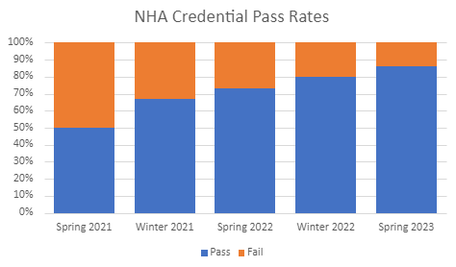
Though the number of students testing changes significantly from semester to semester, the data shows that economically disadvantaged students are doing better than before in healthcare credentialing classes.

