ELA ESSENTIAL STANDARDS GRADE 1
RL.1.1  Ask and answer questions about key details in a text. | RL 1.2  Retell stories, including key details, and demonstrate understanding of their central message or lesson. | RI 1.1  Ask and answer questions about key details in a text. | RF 1.3  Know and apply grade-level phonics  and word analysis skills in decoding words.  a. Know the spelling-sound correspondences  for common consonant digraphs (two letters  that represent one sound).  b. Decode regularly spelled one-syllable words.  c. Know final-e and common vowel team  conventions for representing long vowel  sounds.  d. Distinguish long and short vowels when  reading regularly spelled one-syllable words.  e. Decode two-syllable words following basic  patterns by breaking the words into syllables  using knowledge that every syllable must  have a vowel sound.
Student-Friendly Version | Student-Friendly Version | Student-Friendly Version | Student-Friendly Version
I can ask and answer questions about important information (key details) in a fiction text. | I can retell stories, including important information (key details), and understand the central message or lesson. | I can ask and answer questions about important facts (key details) in a non-fiction (informational) text. | I will understand and apply grade-level phonics and word analysis skills in decoding words.
Vocabulary | Vocabulary | Vocabulary | Vocabulary
Key details:  Main Idea (Plot)  Character  Setting  Problem & Solution  Narrative  Fiction | Retell  Sequence  (Beginning, Middle, End: First, Next, Then, After, Last, Finally)  Summary  (Who, When, What, Where, Why, How)  Central message (lesson learned) | Key details:  Topic (Main Idea)  Who, What, Why,  Where, When, How  Informational Text  Nonfiction | Decode  Digraph  Irregular  Vowels (short and long)  Final -e  Syllables  Blends
Learning Target #1 | Learning Target #1 | Learning Target #1 | Learning Target #1
I can ask questions about key details in a fiction story. | I can retell a story including key details, sequence and summary. | I can ask questions about key details in an informational text. | I will know the spelling-sound correspondences  for common consonant digraphs.
Objective 1 | Objective 1 | Objective 1 | Objective 1
Given a wordless picture book, students will orally ask questions about the story including key details such as;  What is the story about?  Who are characters? Where does the story take place?  What might the problem be?  How was the problem solved?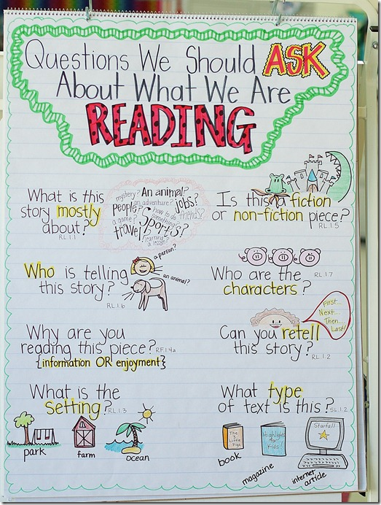 | Given a few photocopy pages from a wordless picture book, students will place the pages in sequence and describe what is happening in each picture and explain why the pictures go in a particular order, using sequence vocabulary.  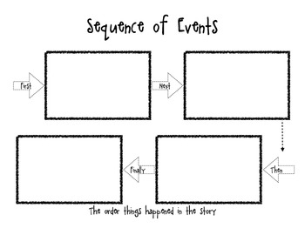 | Given photographs and pictures, students will develop kinds of questions to ask before, during and after a reading about key details.  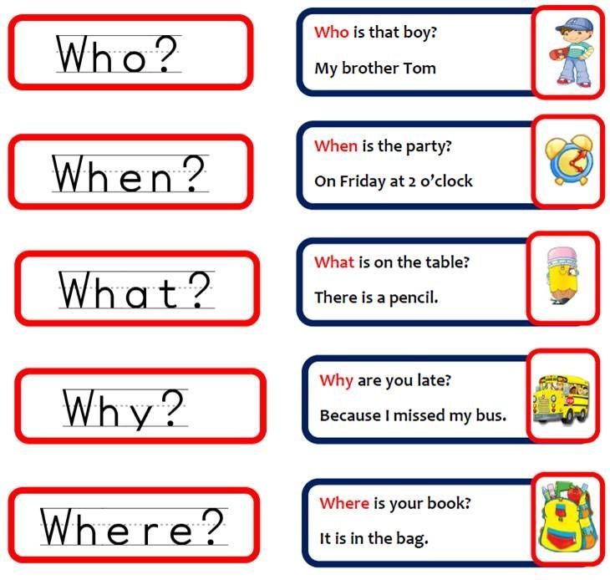 | Given pictures and a word bank, students will demonstrate their understanding of digraphs by matching the correct word to the picture.  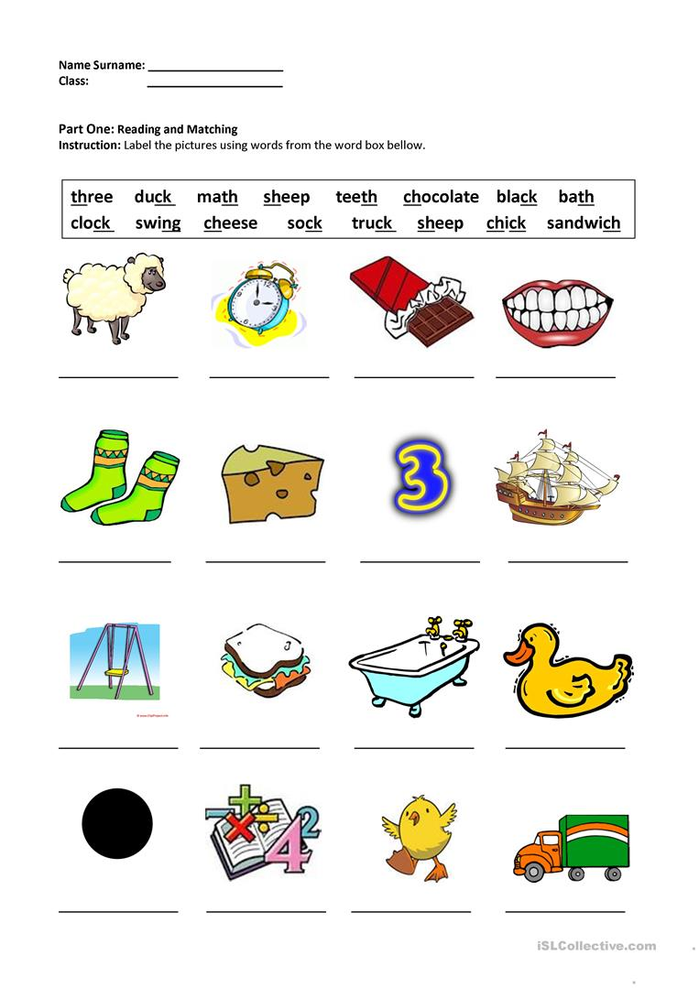
Objective 2 | Objective 2 | Objective 2 | Objective 2
Given a short story, students will orally ask questions about key details, before, during and after an interactive read aloud.  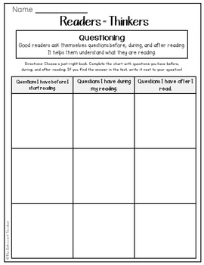 | After listening to the picture book, The Giving Tree students will cut out the pictures and paste them in the timeline in sequential order.  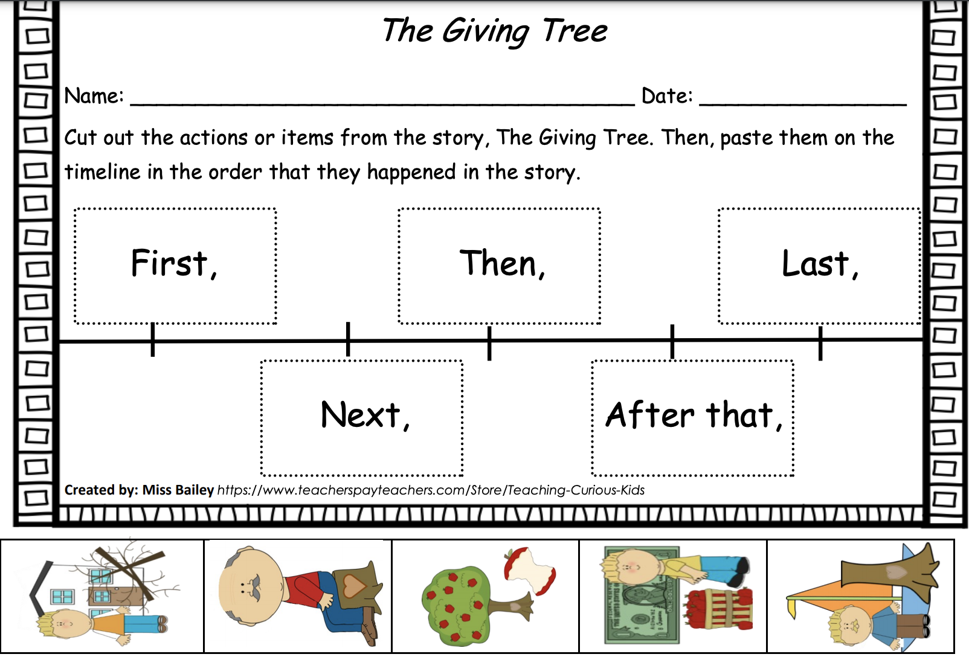 | Given an informational text, students will orally ask questions about key details, before, during and after an interactive read aloud.  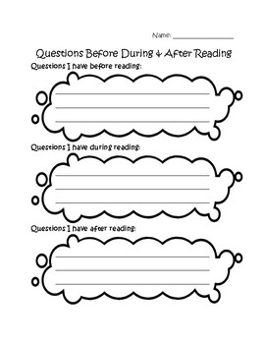 | Given pictures and parts of a word, students will demonstrate their understanding of digraphs by writing the correct digraph to finish the word.  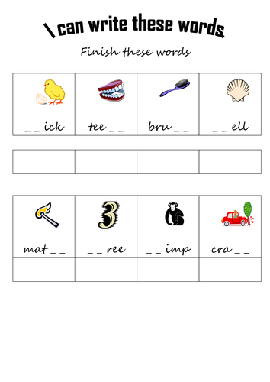
Objective 3 | Objective 3 | Objective 3
Given a short story, students will read and put sentence strips in the order of the story and draw a picture of the characters.
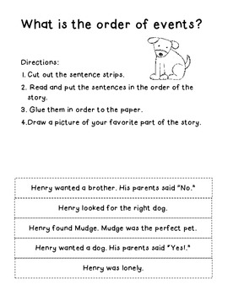

 | Objective 4
Given a story, retell the story including key details, sequence and summary.

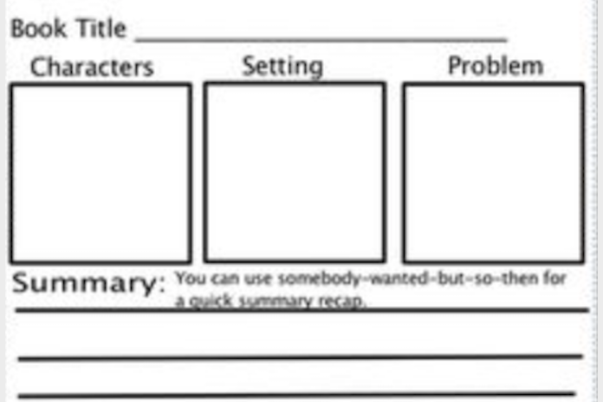

Learning Target #2 | Learning Target #2 | Learning Target #2 | Learning Target #2
I can answer questions about key details in a text. | I can demonstrate understanding of the central message or lesson in a text. | I can answer questions about key details in an informational text. | I will orally produce single-syllable words by blending sound.
Objective 1 | Objective 1 | Objective 1 | Objective 1
Given questions about a short video, students will orally answer questions about key details.  The Horse and The Snail  What is the main idea of this story? Who are the characters? | Given an illustrated narrative poem read aloud, students will participate in oral discussion to define and identify the central message of the poem.  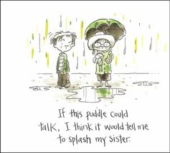 | Given questions about a short informational video, students will orally answer “Wh” questions about key details  All About Hippos for Kids: Hippopotamus for Children  What is this book mainly about? Where does this animal live? | Given words and pictures, students will practice putting their fingers on the first letter, saying the sound then moving on to the next letter. They will then blend the word then match it to the picture.
Objective 2 | Objective 2 | Objective 2 | Objective 2
Given a passage and questions, students will read the passage and answer questions about key details.  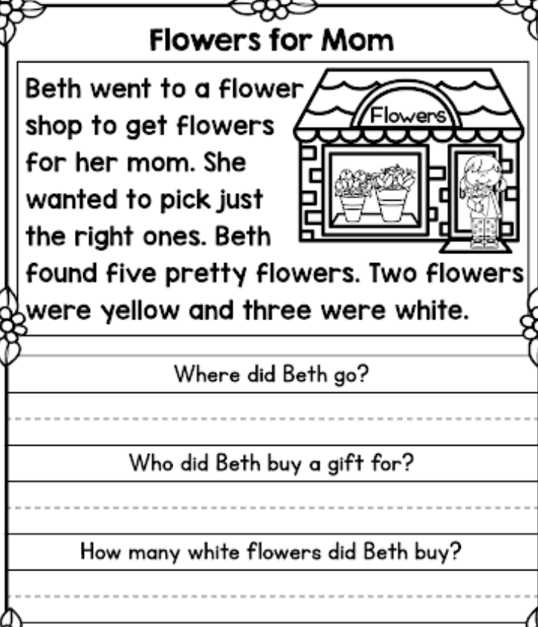 | Given a story, students will identify and write the key details and theme of the story.  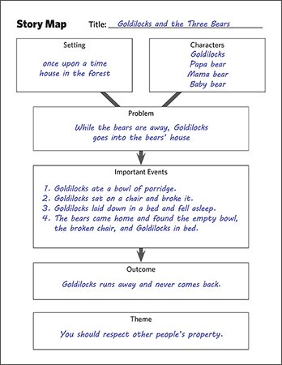 | Given questions about a short informational passage, students will read and answer questions about key details.  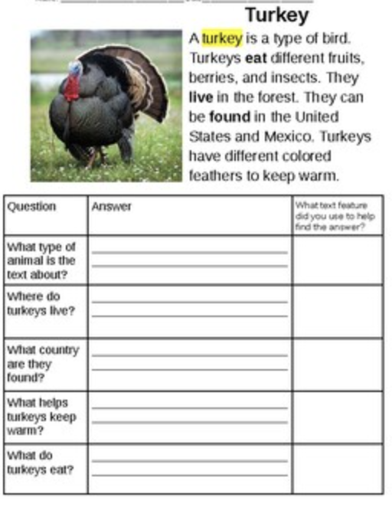 | Given a picture and missing blends for a word, students will look at the picture and write in the missing blends for the word. They will sound out a word then draw a line to match it to a picture.
Objective 3 | Objective 3 | Objective 3 | Objective 3
Given a story and questions, students will read the story and then refer to the story to locate and answer the questions about key details.  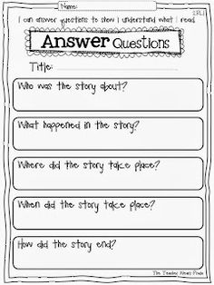 | Given a book, students will complete a book review that includes a detailed summary (beginning, middle and end), story elements and a central message or lesson.  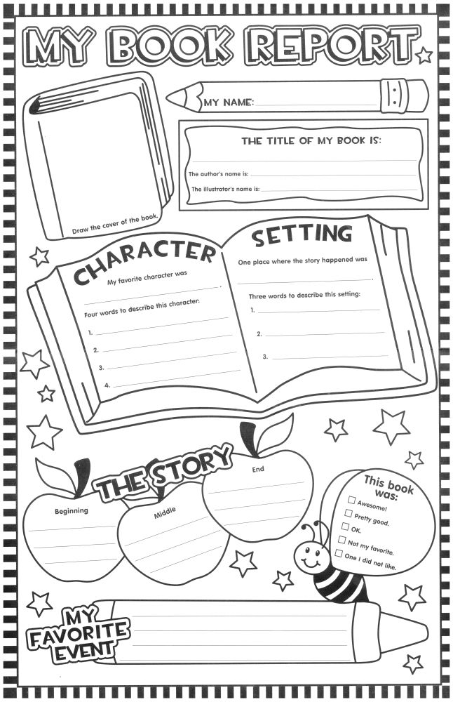 | Given two informational passages, students will construct a Venn Diagram to compare and contrast the key details.  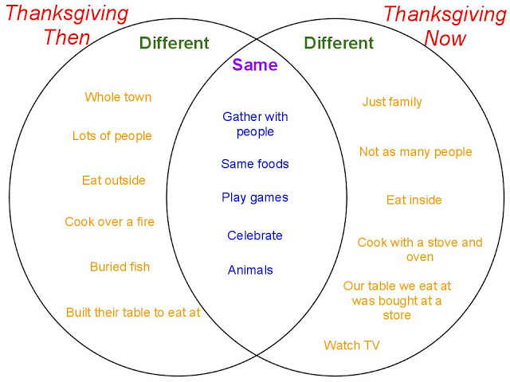 | Given a picture, students will look at a picture then say what it is, then write the blend for that sound.
 |  |  | Learning Target #3
 |  |  | I will know final -e and common vowel team conventions for representing long vowel sounds.
 |  |  | Objective 1
 |  |  | Given a list of three "ea" and “ee” words, students will create a story using the "ea" and “ee” words.
 |  |  | Objective 2
 |  |  | Given a list of three "ai" and “ay” words, students will create a story using the "ai" and “ay” words.
 |  |  | Learning Target #4
 |  |  | I can distinguish long and short vowels when reading regularly spelled one-syllable words.
 |  |  | Objective 1
Given pictures of one-syllable words, students will distinguish and sort the pictures into the correct column, long vowels or short vowels.

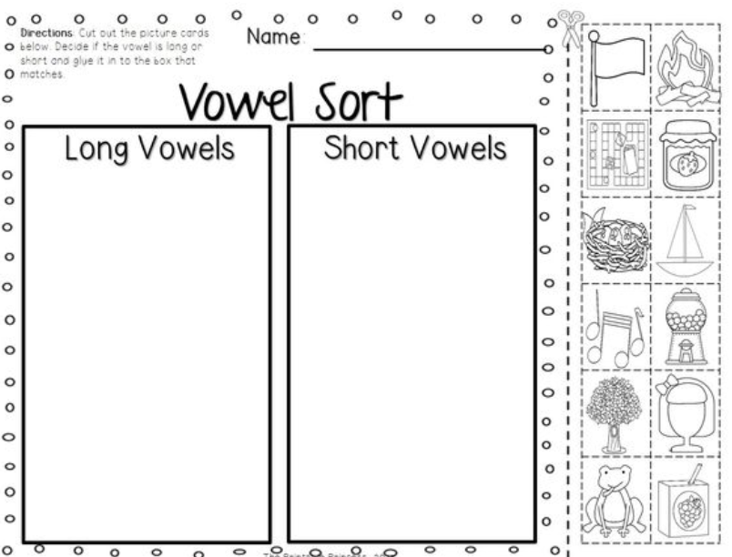

 |  |  | Learning Target #5
I can decode two-syllable words following
basic patterns by breaking the words into
syllables using knowledge that every syllable
must have a vowel sound.
 |  |  | Objective 1
Given a two-syllable word, students will decode the
word and choose the word that is correctly divided
into two syllables.

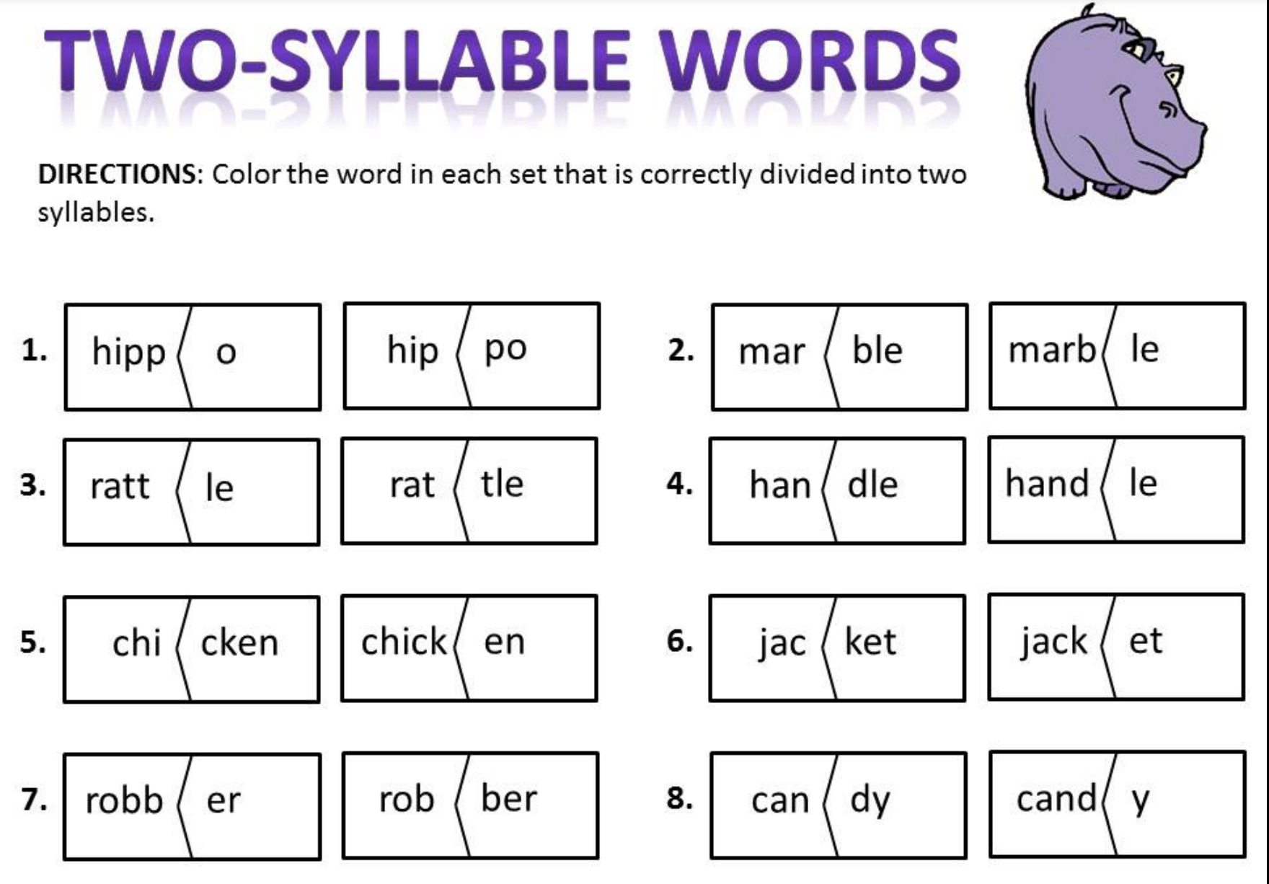

ELA ESSENTIAL STANDARDS GRADE 2
RI.2.1. Ask and answer such questions as who, what, where, when, why, and how to demonstrate understanding of key details in a text. | RL.2.1. Ask and answer such questions as who, what, where, when, why, and how to demonstrate understanding of key details in a text. | RL.2.2. Recount stories, including fables and folktales from diverse cultures, and determine their central message/theme, lesson, or moral. | RF.2.3. Know and apply grade-level phonics and word analysis skills in decoding words.  A. Know spelling-sound correspondences for common vowel teams.  B. Decode regularly spelled two-syllable words with long vowels.  C. Decode words with common prefixes and suffixes. D. Identify words with inconsistent but common spelling-sound correspondences.  E. Recognize and read grade-appropriate irregularly spelled words.
Student-Friendly Version | Student-Friendly Version | Student-Friendly Version | Student-Friendly Version
I can ask and answer “who, what, when, where, why, and how” questions to show that I understand the important details in a nonfiction text. | I can ask and answer “who, what, when, where, why, and how” questions to show that I understand the important details in a fictional story. | After reading stories, fables, or folktales from different cultures, I can put the important events in order and determine the central message (theme), lesson or moral. | I can decode words by using the different phonics skills, and I can also break down words by syllables, vowel teams, and/or prefixes and suffixes, and how a vowel sound can change when adding silent e, or (ed).
Vocabulary | Vocabulary | Vocabulary | Vocabulary
Non-Fiction/Informational Questions (The 5 W’s):  Who  What  When  Where  Why  How  Key Details | Fiction Questions (The 5 W’s):  Who  What  When  Where  Why  How  Key Details | Fiction  Recount  Fables  Folktales  Diversity  Cultures  Central Message  Theme  Lesson  Moral | Decode  Sound Correspondences  Long and Short Vowels  Vowel Teams  Syllables  Prefixes  Suffixes  Irregularly spelled words
Learning Target #1 | Learning Target #1 | Learning Target #1 | Learning Target #1
I can ask questions before, during, and after reading that help me understand the meaning of the text (e.g. who, what, where, when, why, and how) | I can ask questions before reading that help me understand the meaning of the text(e.g. who, what, where, when, why, and how) | I can retell a story/fable/folktale from diverse cultures. | I can decode spelling-sound correspondences for common vowel teams.
Objective 1 | Objective 1 | Objective 1 | Objective 1
Given an informational text, students will ASK questions BEFORE they read to understand what the text is about.  Activity:  Completing a chart to prepare the students for questions to ask before they read an informational text.  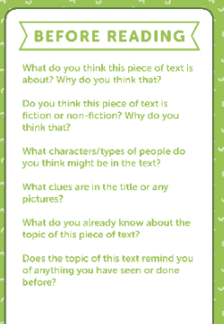 | Given a fictional text, students will ASK questions BEFORE they read to understand what the text is about.  Activity:  Completing a chart to prepare the students for questions to ask before they read a fictional text.  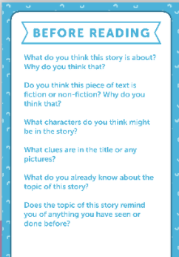 | Given a story/fable/folktale, students can summarize the important events in sequence.  Activity:  Students will complete a sequence chart to summarize the story/fable/folktale using key words to indicate sequence (first, next, then, after that, finally).  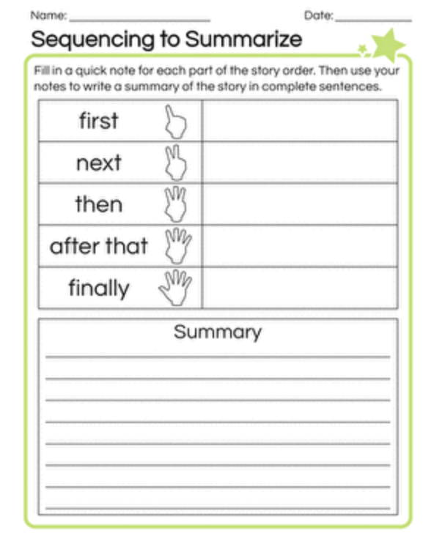 | Students can hear sounds and associate the vowel teams (dipthongs).  Activity: Using Elkonin Boxes to represent letter-sound relationships and number of  letters each sound makes.  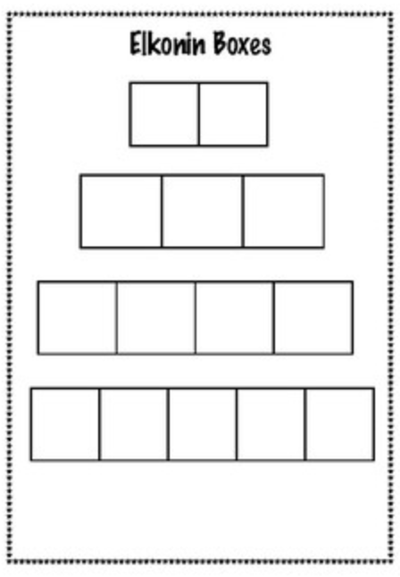
Objective 2 | Objective 2 | Objective 2 | Objective 2
Given an informational text, students will ASK questions DURING they read to understand what the text is about.  Activity: Questions for students to respond to in writing are listed below:  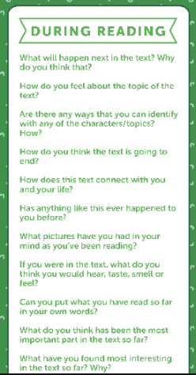 | Given a fictional text, students will ASK questions DURING they read to understand what the text is about.  Activity: Questions for students to respond to in writing are listed below:  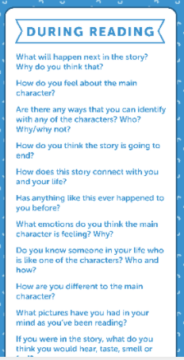 | Can recognize the cultural differences of various versions of the same folktale/fable/story.  Activity: Students will complete a Venn diagram referring to two folktales/fables/stories from different cultures, noting what is similar and different between the folktales/fables/stories.  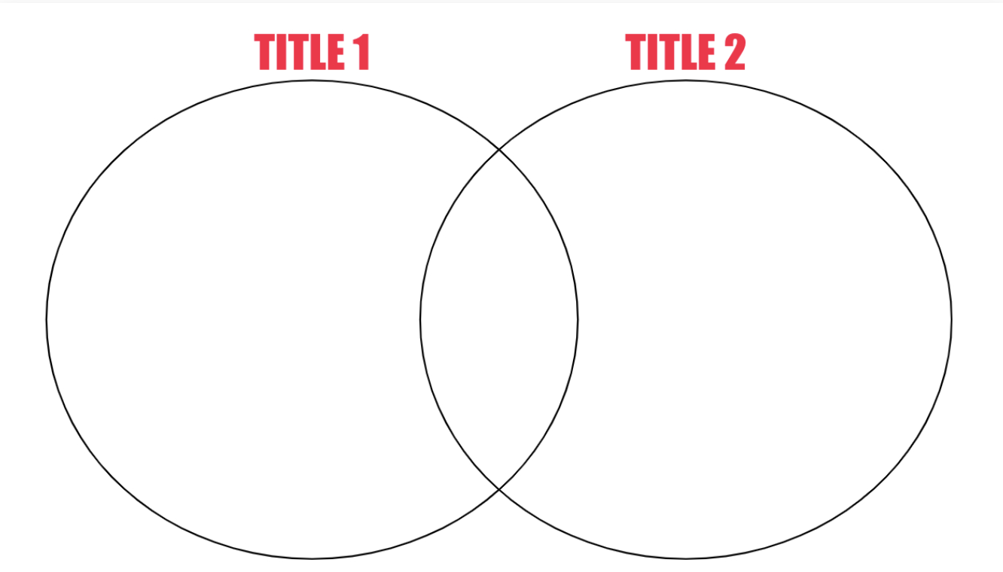 | Recognize two vowels working together (vowel team) makes one sound.  Activity: Sort vowel teams and identify the vowel sound that they make.  Example:  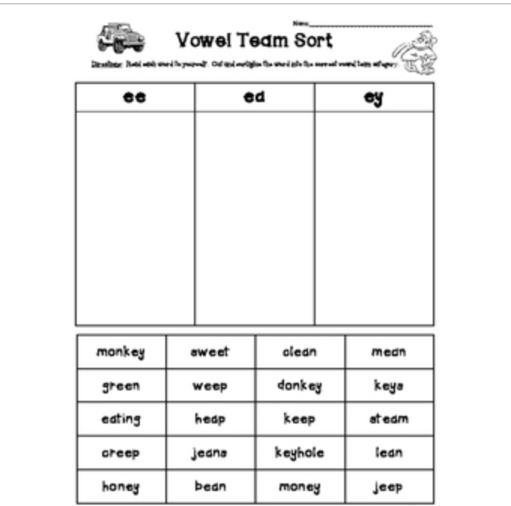
Objective 3 | Objective 3 (if needed) | Objective 3 (if needed) | Objective 3 (if needed)
Given an informational text, students will ASK questions AFTER they read to understand what the text is about.  Activity: Questions for students to respond to in writing are listed below:  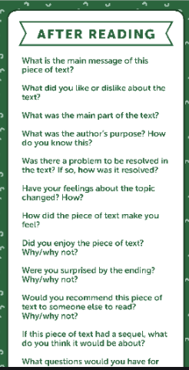 | Given a fictional text, students will ASK questions AFTER they read to understand what the text is about.  Activity: Questions for students to respond to in writing are listed below:  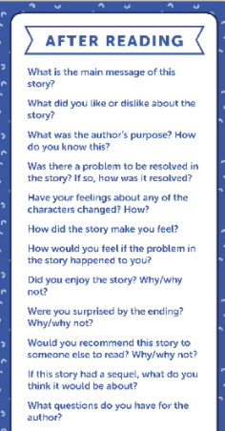
Learning Target #2 | Learning Target #2 | Learning Target #2 | Learning Target #2
I can answer questions DURING and AFTER reading to show my understanding of the text. | I can answer questions during reading to show my understanding of the text. | I can determine the central message, lesson, and/or moral of a story. | I can decode regularly spelled two-syllable words with long vowels.
Objective 1 | Objective 1 | Objective 1 | Objective 1
Recognize the purpose of a text and tell what the author is trying to explain or answer.  Activity: Using an Author’s Purpose Chart, students will explain the purpose of the text and cite examples to support responses.  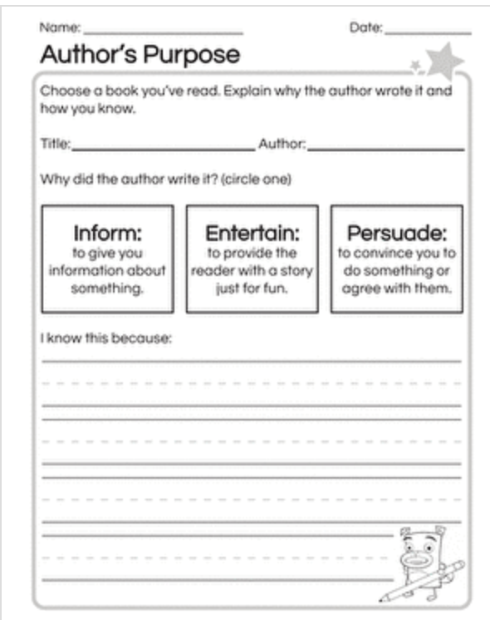 | Recognize story elements and identify the genre of the text to understand text structure.  Activity: Using a graphic organizer, event chain, timeline, retelling rubric after a shared reading of text.  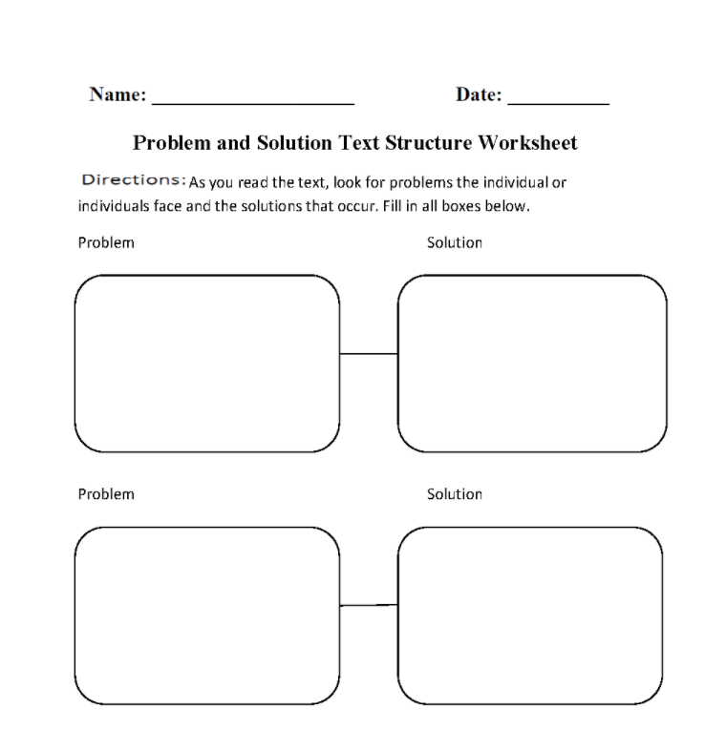 | Interpret the central message of a story and determine that a central message is found in fictional text.  Activity:  Students will utilize a narrative story to identify the central message and support with evidence from the text using a table.  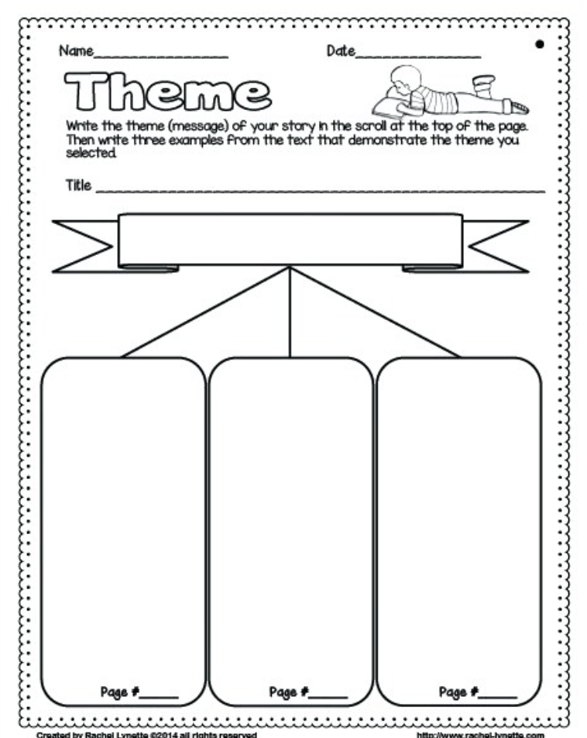 | Students can decipher the number of syllables in a word.  Activity: Students will categorize one and two syllable words.  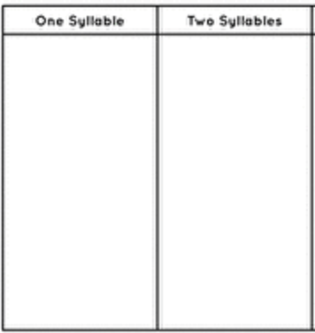
Objective 2 | Objective 2 | Objective 2 | Objective 2
Identify the main topic of a multiparagraph text as well as the focus of specific paragraphs within the text.  Activity: Use a Main Idea Chart and have students Think-Pair-Share their results after independent reading of text.  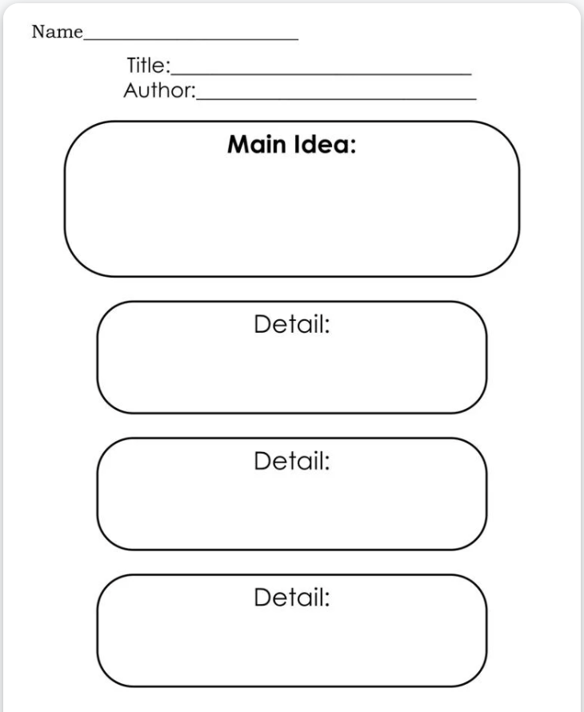 | Determine key story elements in a text to answer and defend the 5 W’s.  Activity: Use a Key Story Elements Chart to provide evidence from text to support responses.  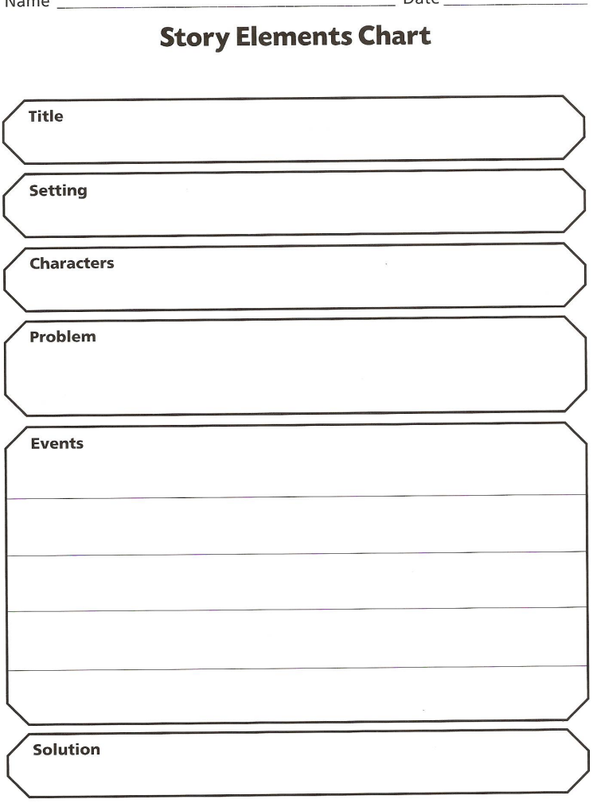 | Interpret the lesson/moral of a fable/folktale and determine that a lesson/moral are found in fables and folktales.  Activity: Students will interpret the lesson/moral of Aesop’s fables or folktales and support with evidence from the text utilizing a chart.  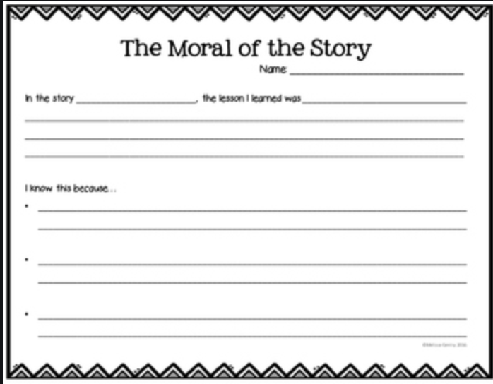 | The students will use the number of syllables in a word to distinguish the vowel sound (open syllable=long vowel sound, closed syllable = short vowel sound).  Activity: Use a Open and Closed Syllables Chart to classify words with open and closed syllables.  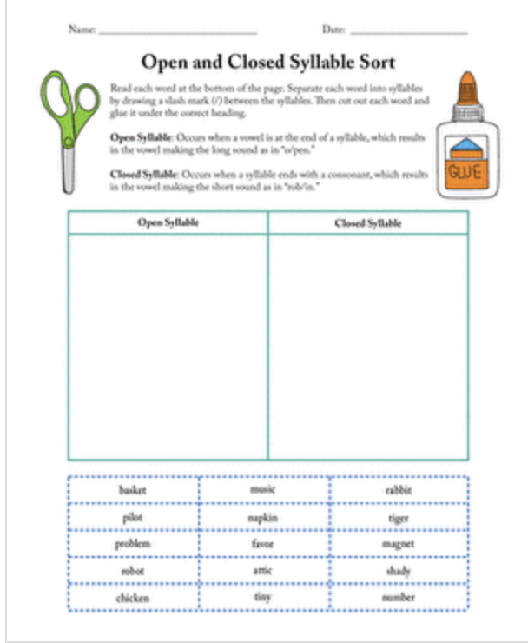
Objective 3 (if needed) | Objective 3 (if needed) | Objective 3 (if needed) | Objective 3 (if needed)
Learning Target #3  (if needed) | Learning Target #3  (if needed) | Learning Target #3  (if needed) | Learning Target #3
I can explain how specific images or illustrations (such as diagrams, charts, captions, headings, table of contents, index, and glossary) can help me answer the 5 W’s and demonstrate an understanding of key details in a text. | I can explain after reading how the 5 W’s can help me answer and demonstrate an understanding of key details in a text. |  | I can decode words with common prefixes and suffixes.
Objective 1 | Objective 1 | Objective 1 | Objective 1
Determine understanding of key details in a text and how the author uses text features for readers to locate key facts in a text efficiently.  Activity: Use a Text features Chart to include various text feature examples from informational text to promote deeper comprehension of the text.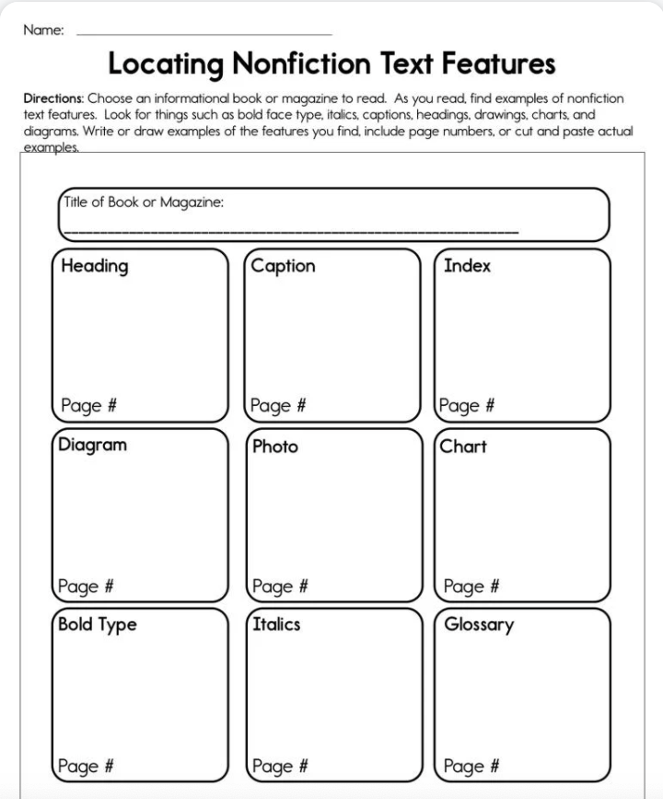 | Determine key story elements in a text to answer and defend the 5 W’s.  Activity: Use a Key Story Elements Chart to provide evidence from text to support responses.  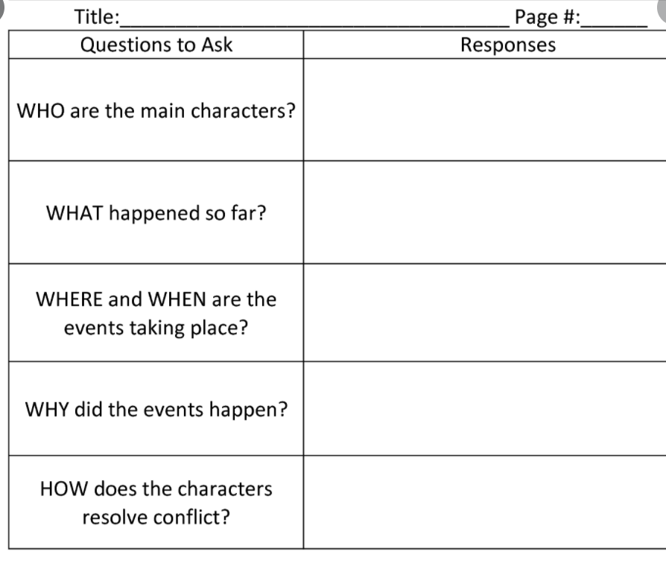 |  | Identify the base or root word in a multisyllabic word.  Activity: Use a Base Word/Root Word table to distinguish the the base word from prefix or suffix.  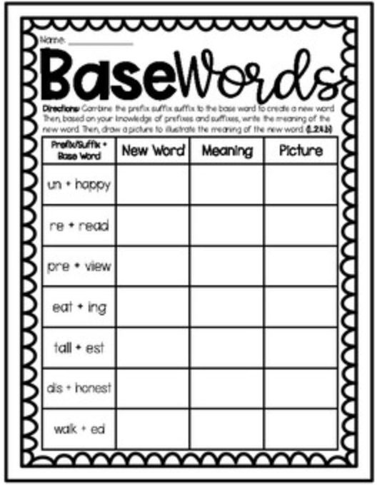
Objective 2 | Objective 2 | Objective 2 | Objective 2
Defend how text features are helpful in clarifying text.  Activity: Complete a Main Idea and Details Map with partners for a gallery walk.  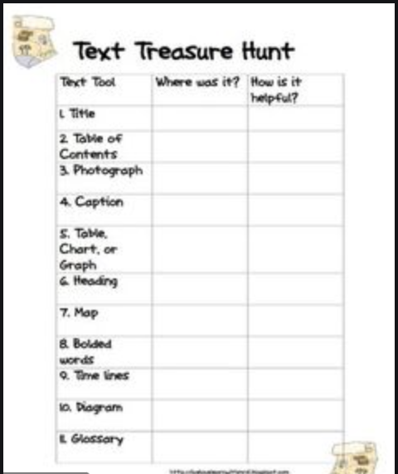 | Explain how the 5 W’s help readers recount the summary of the text.  Activity: Complete a 5W’s Table with partners for a gallery walk.  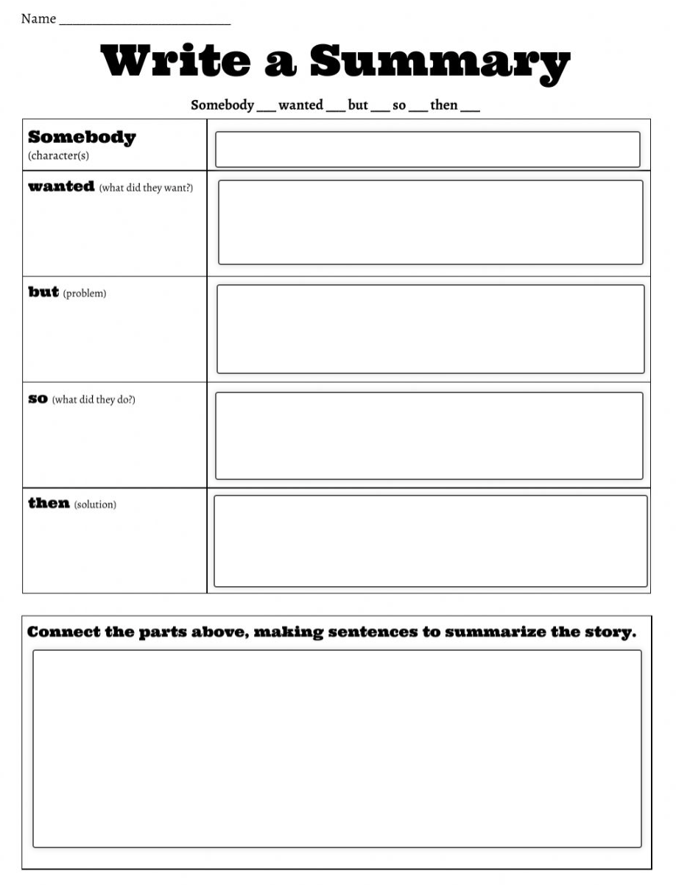 |  | Determine a prefix in a word and it’s meaning.  Activity: Complete a Prefixes Chart to identify the prefix and note the meaning of the word.  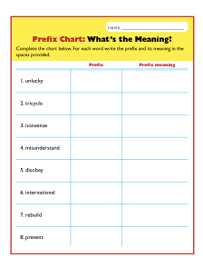
Objective 3 (if needed) | Objective 3 (if needed) | Objective 3 (if needed) | Objective 3
Identify the suffix in a word and it’s meaning.

Activity: Complete a Suffixes Chart to identify the suffix and note the meaning of the word.

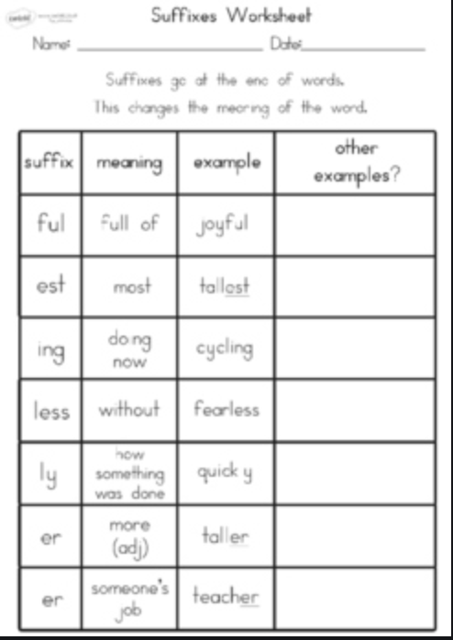
 |  |  | Learning Target #4
 |  |  | I can identify words with inconsistent but common spelling-sounds. correspondences.
 |  |  | Objective 1
Differentiate various inflections and sort them according to their sound ( add -ed)

Activity: Students will identify the three different sounds the ending -ed makes in a word.

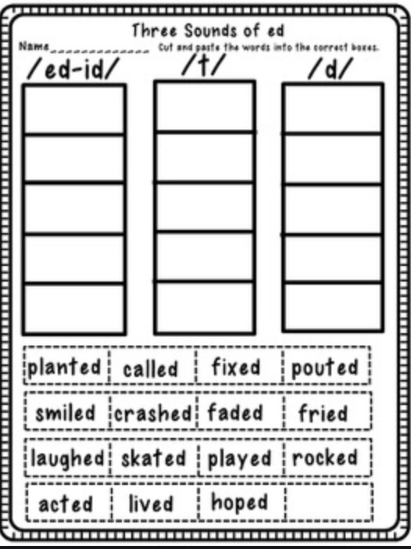

 |  |  | Objective 2
Apply the plural spelling principle to write the word correctly.

Activity: Students will differentiate single nouns and spell plural noun and list on Irregular Nouns Chart.

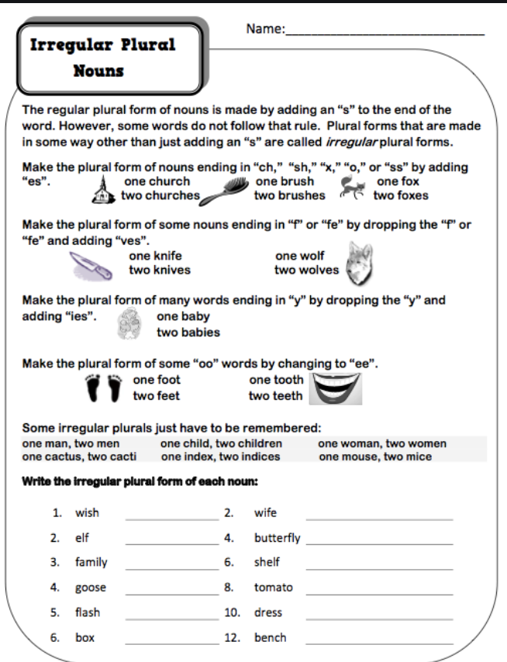
 |  |  | Objective 3 (if needed)
Learning Target #5
I can recognize and read grade-appropriate irregularly spelled words.
 |  |  | Objective 1
Decode and recognize irregularly spelled words when reading. (High Frequency Words-Grade 2 List)

Activity: Students will create an ongoing list of High Frequency Words to utilize when reading.

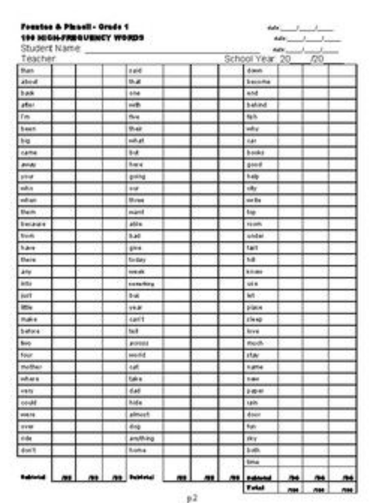

 |  |  | Objective 2
 |  |  | Objective 3

ELA ESSENTIAL STANDARDS Grade 3
Standard RL.3.1:  Ask and answer questions to demonstrate understanding of a text, referring explicitly to the text as the basis for the answers. |  | Standard RL.3.2. Recount stories, including fables, folktales, and myths from diverse cultures; determine the central message, lesson, or moral and explain how it is conveyed through key details in the text. |  |  | Standard RI.3.1.  Ask and answer questions to demonstrate understanding of a text, referring explicitly to the text as the basis for the answers. |  | Standard RF 3.3:  Know and apply grade-level phonics and word analysis skills in decoding words.  - Identify and know the meaning of the most common prefixes and derivational suffixes.  - Decode words with common Latin suffixes.  - Decode multi-syllable words.  - Read grade-appropriate irregularly spelled words.
Student-Friendly Version |  | Student-Friendly Version |  |  | Student-Friendly Version |  | Student-Friendly Version
I can ask and answer questions, using the text for support, to show that I understand the stories I am reading.. |  | I can remember and retell different kinds of stories from many cultures and figure out the lessons or morals of the stories. |  |  | I can ask and answer questions, using the text for support, to show that I understand the information that I am reading. |  | I will know and apply grade-level phonics and word analysis skills in decoding words.
Vocabulary |  | Vocabulary |  |  | Vocabulary |  | Vocabulary
Fiction  Narrative  Key details  Text  Main Idea  Character  Setting  Conflict  Problem & Solution  Thin Questions  Thick Questions |  | Theme  Author’s Message  Moral  Lesson Learned  Details  Summary  Opinions  Facts |  |  | Non-Fiction  Informational  Argumentative / Persuasive  Text Features  Key Details  Main Idea  Examples  Support  Fact / Opinion |  | Decoding  Prefix  Suffix  Multi syllable  Spelling patterns  Root words  Base words
Learning Target 1  I can ask questions to show that I understand the stories I am reading. |  | Learning Target 1  I can retell stories (including fables, folktales and myths) in my own words. |  |  | Learning Target 1  I can ask questions to demonstrate my understanding of an informational text. |  | Learning Target 1  I can identify and know the meaning of the most common prefixes and suffixes.
Objective 1  Given a class novel, students will ask appropriate questions following teacher read-aloud of book preview (front/back covers and teaser)  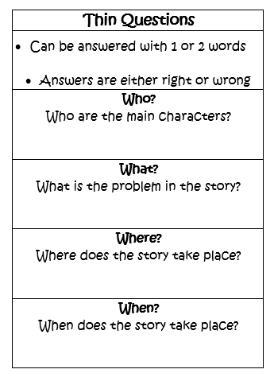 |  | Objective 1  Given a class novel, students will retell a small passage from a different character’s viewpoint.  Activity  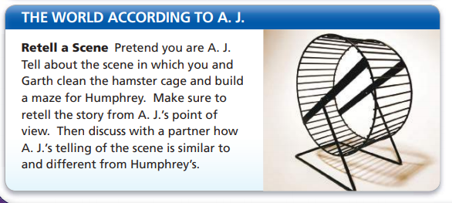 |  |  | Objective 1  Given a class novel and paired informational text, students will ask questions about a topic connected to the novel.  Activity  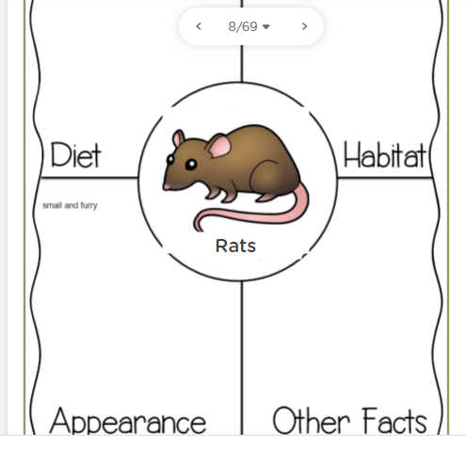 |  | Objective 1  Given a spelling principle, students will be able to define prefixes,
Learning Target 2  I can find the answers to specific questions within the stories that I read. |  | Learning Target 2  I can explain the central message, lesson, and/or moral, using key details from the story. |  |  | Learning Target 2  I can refer back to the text to answer questions using specific details from informational text. |  | Learning Target 2  I can decode words with common Latin suffixes.
Objective 1  Given a class novel and graphic organizer, students will cite similarities and differences between two characters.  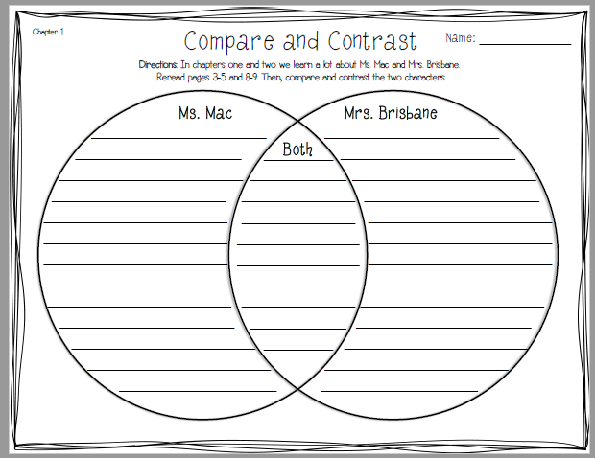 |  | Objective 1  Given a chapter from a class novel, students will identify the important lessons the main characters in the chapter learn.  Activity  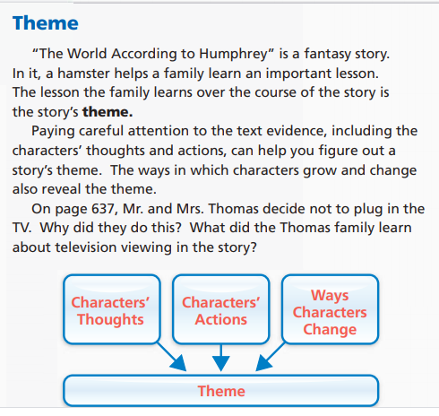 |  |  | Objective 1  Given a class novel and paired informational text, students will cite evidence to answer questions.  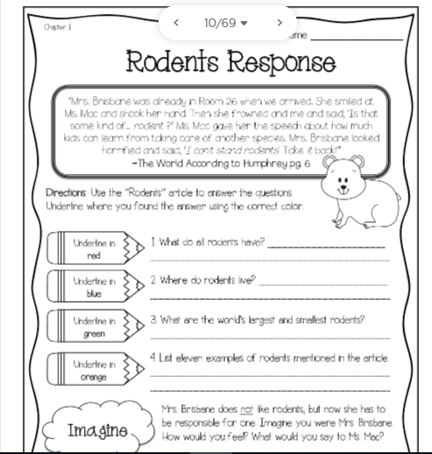 |  | Objective 1
Learning Target 3

I can decode multi-syllable words.

 |  |  |  |  |  |  | Objective 1
Learning Target 4

I can read grade-appropriate irregularly spelled words.
 | ELA Essential Standards Grade 4
 | RI 4.1 Refer to details and examples in a text when explaining what the text says explicitly and when drawing inferences from the text. |  | RL. 4.1 Refer to details and examples in a text and make relevant connections when explaining what the text says explicitly and when drawing inferences from the text. | RL 4.2 Determine a theme of a story, drama, or poem from details in the text; summarize the text. |  | RF 4.3 Know and apply grade-level phonics and word analysis skills in decoding and encoding words.  - Use combined knowledge of all letter-sound correspondences, syllabication patterns, and morphology (e.g., roots and affixes) to read accurately unfamiliar multisyllabic words in context and out of context.
 | Student-Friendly Version |  | Student-Friendly Version | Student-Friendly Version |  | Student-Friendly Version
 | I can refer (use) important details and examples in a text to support my answers when answering explicit (fact-based) questions and inferred (implied) questions. |  | I can refer (use) important details and examples in a text, and make logical connections to support my answers when answering explicit (fact-based) questions and inferred (implied) questions. | I can identify (determine) the theme of a story, drama, or poem from the key details in the text. I can also determine the theme through summarizing the text. |  | I can use my phonics skills and word analysis skills in order to correctly pronounce and understand unfamiliar words alone or in a text.
 | Vocabulary |  | Vocabulary | Vocabulary |  | Vocabulary
 | Refer  Key Details  Examples  Evidence  Infer  Background Knowledge  Explicit vs. Implicit  Fact-Based Questions  Explicit (Straight-Forward) Questions |  | Refer  Relevant Connections  Key Details  Examples  Evidence  Infer  Background Knowledge  Explicit vs. Implicit  Fact-Based Questions  Explicit (Straight-Forward) Questions | Identify  Determine  Theme  Moral  Central Message  Key Details  Evidence  Summary (Summarize)  Sequence of Events |  | Decoding  Encoding  Analysis  Syllables  Root words  Prefixes  Suffixes  Unfamiliar words  Context clues
 | Learning Target #1 |  | Learning Target #1 | Learning Target #1 |  | Learning Target #1
 | I can (locate) find details and examples to support my understanding of specific information from the text.  Vocabulary:  Refer  Key Details  Examples  Evidence |  | I can (locate) find details and examples to support my understanding of specific information from the text.  Vocabulary:  Refer  Key Details  Examples  Evidence  Relevant Connections | I can summarize a story through the sequence of events and determine the theme of a story through the summary.  Vocabulary:  Identify  Determine  Theme  Moral  Central Message  Key Details  Evidence  Summary (Summarize)  Sequence of Events |  | I can use prefixes and suffixes to understand the meaning of an unfamiliar word by itself, in a sentence, or in a paragraph.  Vocabulary:  Decoding  Encoding  Analysis  Syllables  Root words  Prefixes  Suffixes  Unfamiliar words  Context clues
 | Objective 1 |  | Objective 1 | Objective 1 |  | Objective 1
 | Given an anchor chart, video, and article, students will locate and list important details and examples from each paragraph.  Anchor Chart  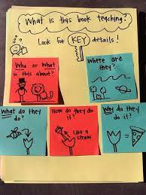  Video: Key Details / Nonfiction Text  https://www.youtube.com/watch?v=4LOXHIrkFJQ  Key Details Practice: Nonfiction  https://jamboard.google.com/d/1K4n71kjU8RpAX7AdwHL-I6NfF45rw6IUkjUtT26vIzg/viewer?f=0  NJ Released Test Items: Key Details / Nonfiction  https://jamboard.google.com/d/1Opi9LmmEXz68qOCFoj-4ZfHIMRTDFSQCmkEj8h_v0wQ/viewer?f=2 |  | Given an anchor chart, video, and text, students will locate and list important details and examples from each paragraph related to the following:  - Story (Literary) Elements  Anchor Chart  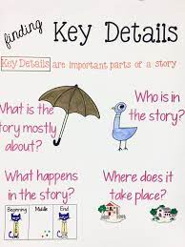  Video: Key Details / Fictional Text  https://www.youtube.com/watch?v=NUUvhxRfq0w  Key Details Practice:Fiction  https://jamboard.google.com/d/1mHJlfFGleJ8bzPnw8IbUcL1Eyhh6inH-jWy3lQVSVsE/viewer?f=1  NJ Released Test Items: Key Details / Fiction  https://nj.digitalitemlibrary.com/home?subject=ELA&grades=Grade%204&view=CCSS&itemUIN=VF925509_TTS | Given an anchor chart, video, and a short story, students will summarize the text, and determine the theme based on the events in the summary.  Anchor Chart 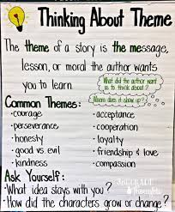  Video: Theme  https://www.youtube.com/watch?v=MAu3e5GZo4k&t=33s  Theme Practice  https://jamboard.google.com/d/1dA0ucqYS3kONdkxtx3p1tgzD0tHtldpjuCYdgoy03WE/viewer?f=1  RL.4.2: NJ Released Test Item: Theme  https://nj.digitalitemlibrary.com/home?subject=ELA&grades=Grade%204&view=CCSS&itemUIN=1829  NJ Released Test Items:  https://nj.digitalitemlibrary.com/home?subject=ELA&grades=Grade%204&view=CCSS |  | Given an anchor chart, and weekly interactive vocabulary slides, students will identify the clues in the text to determine the meaning of unfamiliar words.  Anchor Chart  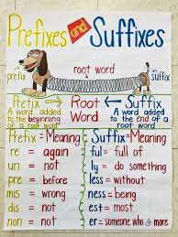  Video: Prefixes and Suffixes  https://www.youtube.com/watch?v=WYSnf6qy4WA  Weekly Interactive Vocabulary  https://docs.google.com/presentation/d/1S9LGzifvuH51OUFnvmHg3bf4l2tATrA4Aob-Biq3ME8/edit#slide=id.p  Prefix and Suffix Practice  https://jamboard.google.com/d/1e3SnZkYx0nK-eclZtursW3frd5sqk2MgezAmF58khbs/viewer?f=2  NJ Released Test Item: Prefixes/Suffixes  https://jamboard.google.com/d/1e3SnZkYx0nK-eclZtursW3frd5sqk2MgezAmF58khbs/viewer?f=2  NJ Released Test Items:  https://nj.digitalitemlibrary.com/home?subject=ELA&grades=Grade%204&view=CCSS
 | Objective 2  Given an anchor chart, video, and a nonfiction article, students will refer to key details in a text to use as supporting evidence in their answers. |  | Objective 2  Given an anchor chart, video, and a fictional story, students will refer to key details in a text to use as supporting evidence in their answers. | Objective 2  Given an anchor chart, video, and a short story, students will summarize the text, determine the theme based on the events in the summary, and refer to the events to support the theme. |  | Objective 2
 | Anchor Chart  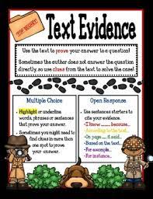  Video: Text Evidence  https://www.youtube.com/watch?v=fXgb21vRWYY  Text Evidence (Nonfiction) Practice  https://jamboard.google.com/d/17jyBne4uWBlOAm5TI4VhhSevxFq66eBHscZ7UH2MSvY/viewer?f=0  RI.4.1: NJ Released Item: Text Evidence (Nonfiction)  https://nj.digitalitemlibrary.com/home?subject=ELA&grades=Grade%204&view=CCSS&itemUIN=1740_A_TTS  NJ Released Test Items  https://nj.digitalitemlibrary.com/home?subject=ELA&grades=Grade%204&view=CCSS |  | Anchor Chart  Video: Text Evidence Fictional Text  https://www.youtube.com/watch?v=nD5kvFd0L7s  Text Evidence (Fiction) Practice:  https://jamboard.google.com/d/1s5M2CHsvQ-UTI7SzvWzquJI62yxb-40Im0HJ530UPc0/viewer?f=0  RL.4.1: NJ Released Item: Text Evidence (Fiction)  https://nj.digitalitemlibrary.com/home?subject=ELA&grades=Grade%204&view=CCSS&itemUIN=1710_A  NJ Released Test Items  https://nj.digitalitemlibrary.com/home?subject=ELA&grades=Grade%204&view=CCSS | Anchor Chart  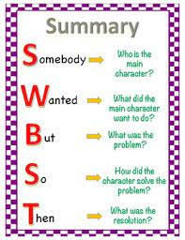  Video: Summary  https://www.youtube.com/watch?v=w33-m8-geuM  https://www.youtube.com/watch?v=THOVem7nRkA&t=1s  Summary Practice:  NJ Released Test Items  https://nj.digitalitemlibrary.com/home?subject=ELA&grades=Grade%204&view=CCSS
 | Objective 3 (if needed) |  | Objective 3 (if needed) | Objective 3 (if needed) |  | Objective 3 (if needed)
 | Learning Target #2 |  | Learning Target #2 | Learning Target #2 |  | Learning Target #2
 | I can make inferences from nonfiction texts using my background knowledge and evidence from the text.  Vocabulary:  Infer  Key Details  Evidence  Clues  Background Knowledge |  | I can make inferences from fiction texts using my background knowledge and evidence from the text.  Vocabulary:  Infer  Key Details  Evidence  Clues  Background Knowledge  Relevant Connections | I can summarize a story through the sequence of events and determine the theme of a drama through the summary.  Vocabulary:  Drama  Identify  Determine  Theme  Moral  Central Message  Key Details  Evidence  Summary (Summarize)  Sequence of Events |  | I can use context clues to understand the meaning of an unfamiliar word by itself, in a sentence, or in a paragraph.  Vocabulary:  Decoding  Encoding  Analysis  Syllables  Root words  Prefixes  Suffixes  Unfamiliar words  Context clues
 | Objective 1 |  | Objective 1 | Objective 1 |  | Objective 1
 | Given an anchor chart, video, and pictures, students will infer the meaning of a picture by identifying and listing the clues from the picture to support their inference.  Anchor Chart: Inference  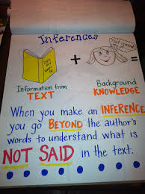  Video: Making Inferences Non-Fiction  https://www.youtube.com/watch?v=i_hbzv2EacM  Picture: Inference / Non-Fiction  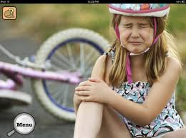  Chart: Making Inferences: Non-Fiction  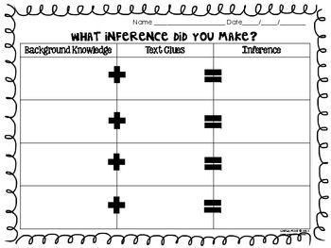  NJ Test Released Items: Making Inferences:  https://nj.digitalitemlibrary.com/home?subject=ELA&grades=Grade%204&view=CCSS&itemUIN=1046_A |  | Given an anchor chart, video, and pictures, students will infer the meaning of a picture by identifying and listing the clues from the picture to support their inference.  Anchor Chart: Inference  Video: Making Inferences Fiction  https://www.youtube.com/watch?v=INFWXZ_tl4M  Picture: Inference / Fiction  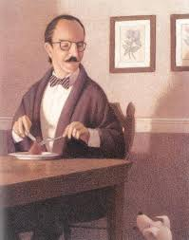  Chart: Making Inferences: Fiction  https://jamboard.google.com/d/1oZIHSoK2rP23MXzoEg9LXmP_o_gM4jiDssBNXIDGFOc/viewer?f=0  NJ Test Released Items: Making Inferences  https://nj.digitalitemlibrary.com/home?subject=ELA&grades=Grade%204&view=CCSS&itemUIN=1225_A | Given an anchor chart, video, and a short drama, students will summarize the text, and determine the theme based on the events in the summary.  Anchor Chart: Theme  Video: What is Drama?  https://www.youtube.com/watch?v=imlwmNO9xlY  Drama and Theme Practice  https://jamboard.google.com/d/1np43TMi7NQU94blIZQoEJfyCKU3zymWSxxV1zrYZ0Gg/viewer?f=0  NJ Test Released Items: Drama and Theme  https://jamboard.google.com/d/1LOfLgKi_EiKYBBHd7Kqit6UocsLazZKI9lrJnNutyPk/viewer?f=0  https://nj.digitalitemlibrary.com/home?subject=ELA&grades=Grade%204&view=CCSS |  | Given an anchor chart, and weekly interactive vocabulary slides, students will identify the clues in the text to determine the meaning of unfamiliar words.  Anchor Chart: Context Clues  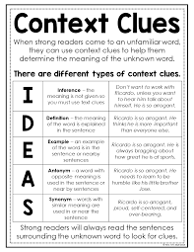  Video: Context Clues  https://www.youtube.com/watch?v=eHCpJ86XDY4  Weekly Interactive Vocabulary  https://docs.google.com/presentation/d/1S9LGzifvuH51OUFnvmHg3bf4l2tATrA4Aob-Biq3ME8/edit#slide=id.p  Context Clues Practice  https://jamboard.google.com/d/1X-h6xW2sVe3A_wtj236Cu4Ff0Y4iizpnyNowfUwocuc/viewer?f=0  NJ Released Item: Vocabulary/Context Clues  https://jamboard.google.com/d/1dhYX2Afd2oLHrwX5s6Zik6v5l3SP8ecwLF0s4B4zUcQ/viewer?f=0  NJ Released Items  https://nj.digitalitemlibrary.com/home?subject=ELA&grades=Grade%204&view=CCSS
 | Objective 2 |  | Objective 2 | Objective 2 |  | Objective 2
 | Given an anchor chart, video, and nonfictional short excerpts, students will infer the meaning of an excerpt through the identification of key details (clues) from the text, and list their clues and background knowledge to support their inference.  Anchor Chart: Inference  Video: Making Inferences / Non-Fiction  https://www.youtube.com/watch?v=_mLc_SegREw  Making Inferences / Non-Fiction: Practice  https://jamboard.google.com/d/1BG7Qw79fIIJyfnadck6kyZQAkX_5nRqCNxIgHAhexMI/viewer?f=0  NJ Test Released Items: Making Inferences / Nonfiction:  https://nj.digitalitemlibrary.com/home?subject=ELA&grades=Grade%204&view=CCSS&itemUIN=VF561236 |  | Given an anchor chart, video, and fictional short excerpts, students will infer the meaning of an excerpt through the identification of key details (clues) from the text, and list their clues and background knowledge to support their inference.  Anchor Chart: Inference  Video: Making Inferences / Fiction  https://www.youtube.com/watch?v=to30AJm2epQ  Making Inferences / Fiction: Practice  https://jamboard.google.com/d/1y-Z9ZLb1jGnIW9xJWJaHhypZx7EeMTnpDcvnA84UAv4/viewer?f=0  NJ Test Released Items: Making Inferences / Fiction  https://nj.digitalitemlibrary.com/home?subject=ELA&grades=Grade%204&view=CCSS&itemUIN=1225_A | Given an anchor chart, video, and a poem, students will summarize the text, and determine the theme based on the events in the summary.  Anchor Chart: Poetry / Parts of a Poem  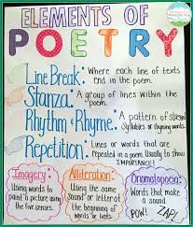  Video: Poetry  https://www.youtube.com/watch?v=zFNnbxCZPBU  Poetry and Theme Practice  https://jamboard.google.com/d/1oXkSHeyulMEsQjtcRXdDTtwZN8ezSjGANn-MRFhIasQ/viewer?f=0  NJ Test Released Item: Poetry and Theme Practice  https://jamboard.google.com/d/1WJ-P_TNWY_BZ3oJDETA_ohIhJi7uuotdFg96FOP5GiA/viewer?f=0  https://nj.digitalitemlibrary.com/home?subject=ELA&grades=Grade%204&view=CCSS
 | Objective 3 |  | Objective 3 (if needed) | Objective 3 (if needed) |  | Objective 3 (if needed)
 | Given an anchor chart, video, and an article, students will use their inference skills by identifying key details (clues) from the text and listing their clues and background knowledge to support their inference.  Inference Skills Practice: Non-Fiction  https://jamboard.google.com/d/1WkN8-CbwF-s0a4mwOmb85w7OrdIR64OE-GzB5-jeCgY/viewer?f=0  NJ Test Released Items:  https://nj.digitalitemlibrary.com/home?subject=ELA&grades=Grade%204&view=CCSS |  | Given an anchor chart and longer fictional text, students will use their inference skills by identifying key details (clues) from the text and listing their clues and background knowledge to support their inference.  Inference Skills Practice: Fiction  https://jamboard.google.com/d/14_EjTtpNCwqwJn1kJS0GWVAjBRduA6hUko6NwRk2BE0/viewer?f=0  NJ Test Released Items:  https://nj.digitalitemlibrary.com/home?subject=ELA&grades=Grade%204&view=CCSS
 | Learning Target #3  (if needed) |  | Learning Target #3  (if needed) | Learning Target #3  (if needed) |  | Learning Target #3  (if needed)
 | I can recognize and explain the differences between implicit (inferred) information and explicit (direct) information and how this helps me to explain and support my answers. |  | I can recognize and explain the differences between implicit (inferred) information and explicit (direct) information and how this helps me to explain and support my answers. | I can determine the theme of a poem through my knowledge of the parts of a poem and how it can connect to a lesson that I can apply to my own life.
 | Objective 1 |  | Objective 1 | Objective 1 |  | Objective 1
 | Given an anchor chart, video, informational text and graphic organizer, students will identify and distinguish the differences between implicit (inferred) and explicit (direct) information, and use that information to support their answers.  Anchor Chart: Inference  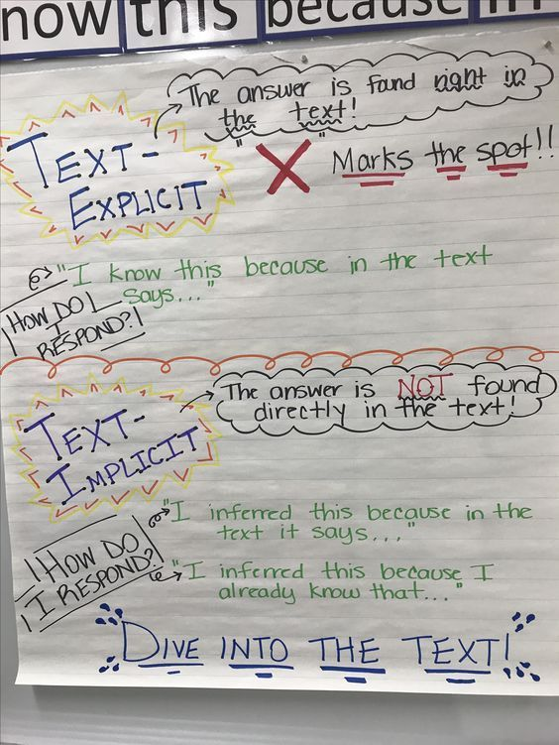  Video: Explicit vs. Implicit Information  https://www.youtube.com/watch?v=GfpOMHkYyeg  Explicit vs. Implicit: Practice  https://jamboard.google.com/d/19-1QXn9EfRajPbLKXCM-YbrpeA_DrhgNYlIF8zUSh0g/viewer?f=0  NJ Test Released Items: RI.4.1  https://nj.digitalitemlibrary.com/home?subject=ELA&grades=Grade%204&view=CCSS |  | Given an anchor chart, fictional text and graphic organizer, students will identify and distinguish the differences between implicit (inferred) and explicit (direct) information, and use that information to support their answers.  Anchor Chart: Inference  Video: Explicit vs. Implicit Information  https://www.youtube.com/watch?v=GfpOMHkYyeg  Explicit vs. Implicit: Practice  https://jamboard.google.com/d/1IxddigT5zS0KQb9m9hqUd5_9fGlHfUI1C2pvk-oI_ow/viewer?f=0  NJ Test Released Items: RL.4.1  https://nj.digitalitemlibrary.com/home?subject=ELA&grades=Grade%204&view=CCSS
 | Objective 2 |  | Objective 2 | Objective 2 |  | Objective 2
 | Objective 3 (if needed) |  | Objective 3 (if needed) | Objective 3 (if needed) |  | Objective 3 (if needed)

ELA ESSENTIAL STANDARDS Grade 5
Standard RL.5.1  Quote accurately from a text, and make relevant connections when explaining what the text says explicitly and when drawing inferences from the text. | Standard RL.5.2  Determine the key details in a story, drama or poem to identify the theme and to summarize the text. | Standard RI. 5. 1  Quote accurately from a text and make relevant connections when explaining what the text says explicitly and when drawing inferences from the text. | Standard RF 5.3  Know and apply grade-level phonics and word analysis skills in decoding and encoding words.  A. Use combined knowledge of all letter-sound correspondences, syllabication patterns, and morphology (e.g., roots and affixes) to read accurately unfamiliar multisyllabic words in context and out of context.
Student-Friendly Version | Student-Friendly Version | Student-Friendly Version | Student-Friendly Version
I can use my own knowledge and accurately quote from a fiction text when I am explaining what it says. | I can use details from the text to determine the theme and to summarize the text. | I can use my own knowledge to quote accurately from informational text when I am explaining what it says. | I can use what I have learned about letters, sounds, and words to help me read and write words and sentences.
Vocabulary | Vocabulary | Vocabulary | Vocabulary
evidence  examples  details  quote  explicit  implicit  inference  relevance  analyze | theme  author’s message  moral  lesson learned  details  summary  opinions  facts  support | evidence  examples  details  quote  explicit  implicit  inference  specific  analyze | phoneme  morpheme  syllable  phonics  decode  encode  multisyllabic  root  prefix  suffix
RL 5.1 Learning Target 1  I can make a guess and support it with examples, details or quotes from the text along with connections to my own knowledge. | RL 5.2 Learning Target 1  I can list key details while watching or reading a story, poem, or drama. | RI 5.1 Learning Target 1  I can identify the exact words the author uses in an informational text or video. | RF 5.3 Learning Target 1  I can sound out words I do not know when reading and writing.
Objective 1  Given a story, students will demonstrate understanding of the text by analyzing the author’s hidden meaning.  Activity  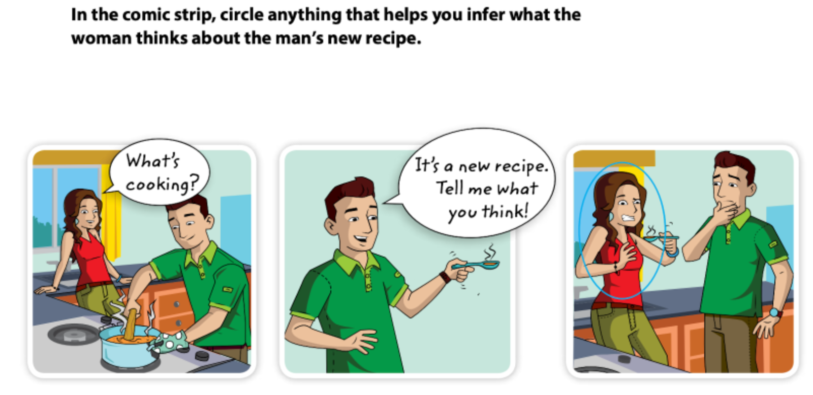 | Objective 1  Given a story, drama or poem in print or video, all containing the same theme, students will decide on the key details within the text. | Objective 1  While reading an informational article, list and collect examples of words, and direct quotations the author uses within the text that can be stated in an answer. | Objective 1  While reading, students will apply their grapheme-phoneme knowledge to decode unfamiliar words in isolation and in the context of a sentence or text.
Objective 2

While writing students will apply their grapheme-phoneme knowledge to encode unfamiliar words in isolation and in the context of a sentence or text.

RL 5.1 Learning Target 2  I can accurately quote from a fictional text to support inferences that I have made. | RL 5.2 Learning Target 2  I can explain how characters respond to challenges when discussing the theme of a story. | RI 5.1 Learning Target 2  I can identify relevant connections in a text or video. | RI 5.3 Learning Target 2  I can read and spell unfamiliar words that have more than one syllable.
Objective 1  Given a short story, students can demonstrate understanding of the text by analyzing the author’s hidden meaning.  Activity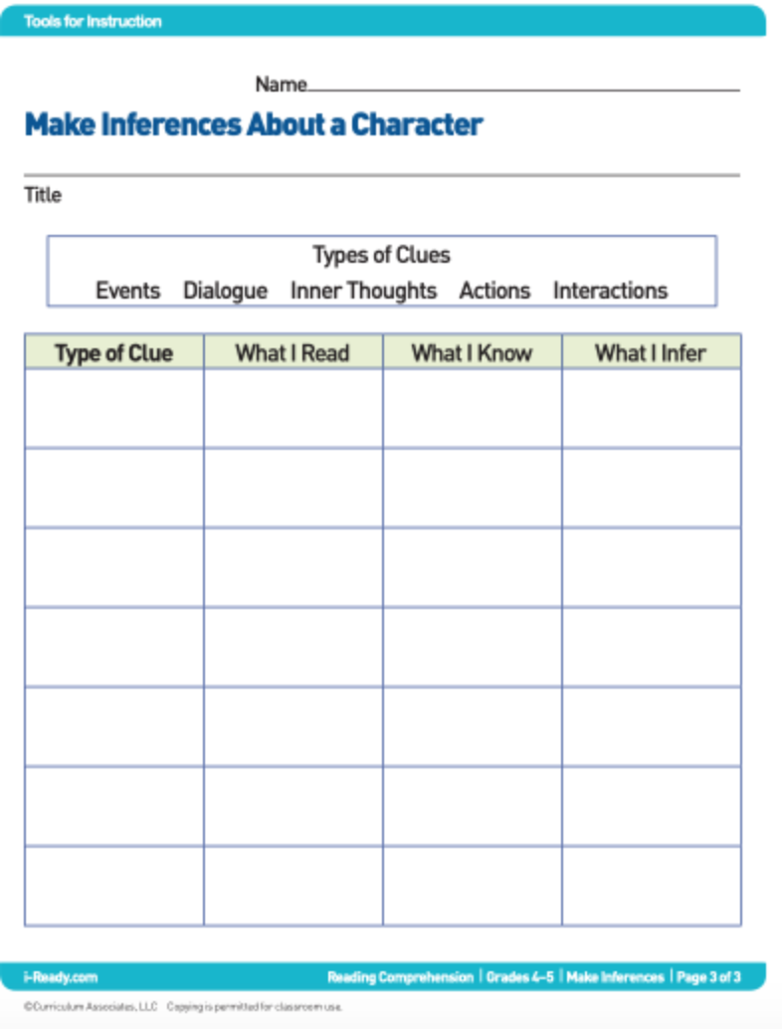 | Objective 1  Given a story, poem, and drama in print, or video, students will choose the overall theme. | Objective 1  Given an informational text, and video students will distinguish between relevant and irrelevant connections.  Activity  Relevant vs. Irrelevant Chart  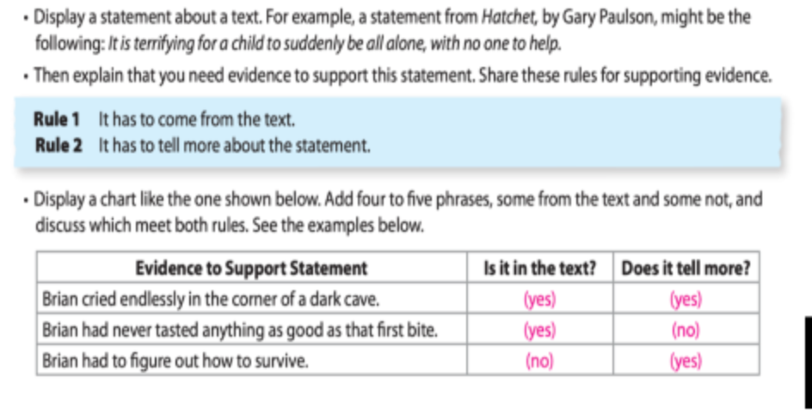 | Objective 1  Given 10 multisyllabic words, students will examine each word taking it apart by syllable type.  Activity  Identify syllable types  Closed, open, vce, vv, r-controlled, and -cle,
RL 5.1 Learning Target 3  I can identify the exact words the author uses in a fictional text. | RL 5.2 Learning Target 3  I can summarize a story, drama or poem by answering an open-ended response using key details and theme. | RI 5.1 Learning Target 3  I can restate the author’s words from an informational text in my own words. | RF 5.3 Learning Target 3  I can recognize root words, prefixes, and suffixes when reading and writing.
Objective 1  Given a short reading passage,  students will distinguish between paraphrasing and direct quotation and understand when to utilize each. | Objective 1  Given a story, poem, and video, students will summarize using key details and theme. | Objective 1  Given an informational text, students will demonstrate understanding of the text by analyzing the author’s hidden meaning | Objective 1  While reading students will determine the meaning of words based on the prefixes, roots, and suffixes in the word.
Activity  Direct Quote vs. Paraphrase  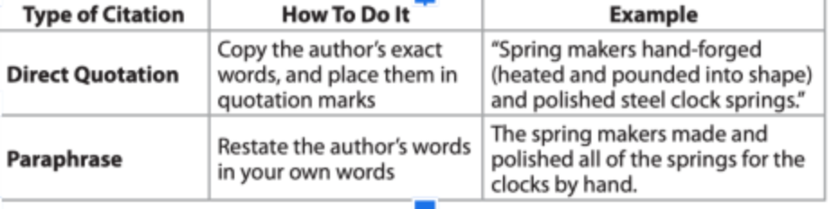 | Activity  After discussion, students will write an essay using key details and theme of the story, poem, and video. | Activity  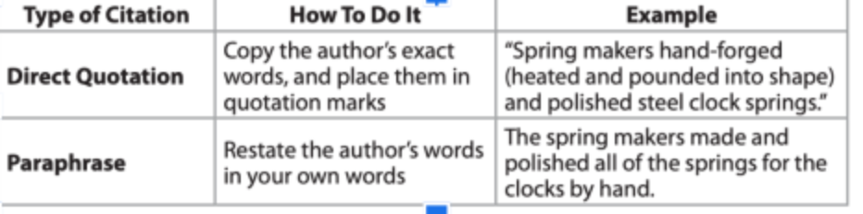

ELA ESSENTIAL STANDARDS Grade 6
Standard RL.6.1  Cite textual evidence and make relevant connections to support analysis of what the text says explicitly, as well as inferences drawn from the text. | Standard RL.6.2.  Determine a theme or central idea of a text and how it is conveyed through particular details; provide a summary of the text distinct from personal opinions or judgments. | Standard RI.6.1.  Cite textual evidence and make relevant connections to support analysis of what the text says  explicitly as well as inferences drawn from the text. | Standard RI.6.2.  Determine a theme or central idea of a text and how it is conveyed through particular details;  provide a summary of the text distinct from personal opinions or judgments.
Student-Friendly Version | Student-Friendly Version | Student-Friendly Version | Student-Friendly Version
I can cite and analyze textual evidence in literature to support what I think the text is stating. | I can determine how the theme is shown through key events in the story. I can also summarize the text. | I can locate and define textual evidence in the text. | I can determine the central idea and key details of an informational text.
Vocabulary | Vocabulary | Vocabulary | Vocabulary
Text, Textual Evidence, Analyze, Narration, Dialogue, Quotations, Explicit, Inference, Draw, Conclusion | Characters, Setting, Plot, Conflict, Theme, Narrative Perspective, Mood, Tone  Events, Summarize | Cite, Analyze, Draw, Explicit, Imply, Inference, Textual Evidence | Central Idea, Convey, Details, Summarize, Judgement, Fact, Opinion, Suggest, Sources, Objective
Learning Target 1  Locate and define textual evidence. | Learning Target 1  Identify and define the theme or central idea of a narrative text. | Learning Target 1  Locate and define textual evidence. | Learning Target 1  Identify the central idea and details of an informational text.
Objective 1  Given a narrative text, students will be able to identify and cite explicit evidence in the text that supports what the text is stating. | Objective 1  Given a narrative text, students will be able to identify and explain the theme of a narrative text by analyzing the key events and other details. | Objective 1  Students will be able to identify and cite explicit evidence in the text that supports what the text is stating. | Objective 1  Students will be able to recognize the central idea of a text by analyzing key details within the text.
Learning Target 2  Refer to evidence in the text to determine and support relevant inferences and predictions to reach a logical conclusion. | Learning Target 2  Determine the theme (or another element of fiction) based on the details within the text, and provide an objective summary of a narrative text. | Learning Target 2  Define an inference, and explain how inferring can help reach a conclusion about the text. | Learning Target 2  Objectively summarize an informational text by identifying the central idea and key details.
Objective 1  Given a narrative passage, students will be able to analyze and interpret textual evidence to make relevant inferences and make logical conclusions. | Objective 1  Given a narrative text, students will be able to identify and organize a sequence of key events and give an objective summary. | Objective 1  Students will be able to analyze an informational text and make a logical conclusion, based on the evidence or implied information in the text. | Objective 1  Students will be able to summarize significant information throughout a text with objectivity and without bias.
Learning Target 3  Cite explicit evidence from the text to support analysis of inferences drawn, and make relevant connections to the text | Learning Target 3  Analyze and explain how particular details within the text contribute to the theme (or another element of fiction). | Learning Target 3  Cite evidence from the text to support analysis, and make a relevant connection to the text.  . | Learning Target 3  Analyze relevant details and how they are conveyed and revealed as they develop in the text.
Objective 1  Given a narrative passage, students will be able to cite and interpret explicit evidence in a narrative text to make relevant connections and support their analysis. | Objective 1  Given a narrative text, students will be able to identify and explain how particular details (i.e. theme, characterization, plot development, setting, etc.) can be conveyed and expressed through key details in the text. | Objective 1  Students will be able to evaluate textual evidence and make a relevant connection to the text that supports their analysis. | Objective 1  Students will be able to distinguish how the central idea is conveyed and expressed in the text through particular details.  Objective 2  Students will be able to synthesize various main ideas to determine the overall central idea of multiple texts.

ELA ESSENTIAL STANDARDS Grade 7
Standard RL.7.1:  Cite several pieces of textual evidence and make relevant connections to support analysis of what the text says explicitly as well as inferences drawn from the text. | Standard RL.7.2. Determine a theme or central idea of a text and analyze its development over the course of the text; provide an objective summary of the text. | Standard RI.7.1.  Cite several pieces of textual evidence and make relevant connections to support analysis of what the text says explicitly as well as inferences drawn from the text. | Standard RI.7.2.  Determine two or more central ideas in a text and analyze their development over the course of the text; provide an objective summary of the text.
Student-Friendly Version | Student-Friendly Version | Student-Friendly Version | Student-Friendly Version
I can refer to the text to find several examples that strongly support my thoughts and inferences about a story. | I can use details from the text to determine the theme main idea of a story, and summarize a story without adding my own opinion. | I can refer to the text  several times to  support my thoughts  and inferences about a  piece of informational  text. | I can find more than  one central idea in a  text and explain how  the ideas develop  throughout the text..
Vocabulary | Vocabulary | Vocabulary | Vocabulary
Evidence Infer  Examples Connotation  Details Denotation  Analysis Specific  Explicit Vague  Implicit | Theme Details  Summary Facts  Lesson Learned Moral  Author’s Message | Evidence Infer  Examples Connotation  Details Denotation  Analysis Specific  Explicit Vague  Implicit | Topic  Main Idea  Supporting Details  Summary  Objective  Fact  Opinion
Learning Target 1  I can recognize and cite explicit (directly from the text) evidence from a narrative text. | Learning Target 1  I can define and determine the theme or central idea of a narrative text. | Learning Target 1  I can recognize and cite explicit (directly from the text) evidence from an informational text. | Learning Target 1  I can define and determine the theme or central idea of an informational text.
Objective 1  Given an excerpt from a short story, I can cite several details about the setting.  Activity  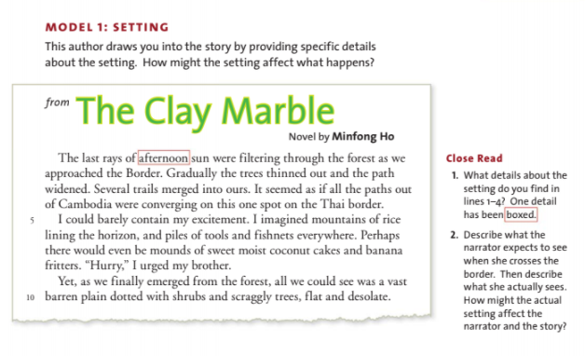 | Objective 1  Given a short story, students will use a plot diagram to determine the central conflict.  Activity:  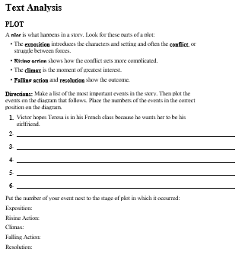 | Objective 1  Given an informational article, students will use directly stated proof to answer multiple choice questions.  Activity  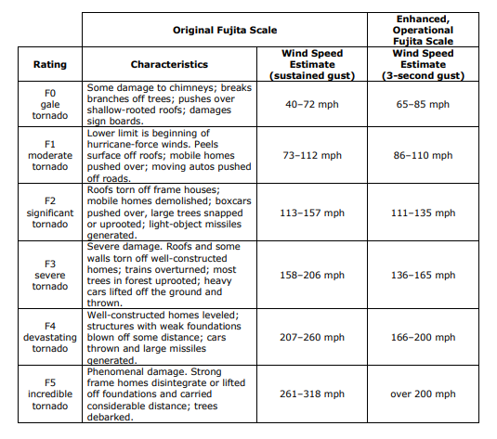  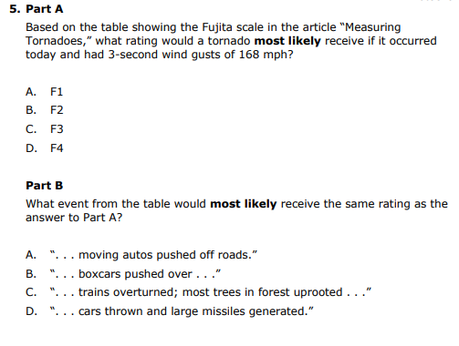 | Objective 1  Given a short informational passage, students will use note taking skills to determine the main idea of one subsection of the passage.  Activity  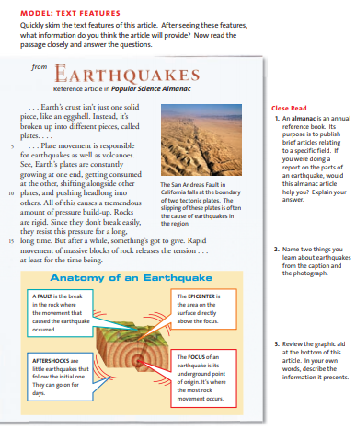  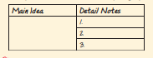
Learning Target 2  I can make inferences based on evidence from a narrative text to reach logical conclusions. | Learning Target 2  I can write a summary of a text, stating the key points of the text without adding my own opinions and feelings. | Learning Target 2  I can make inferences based on evidence from an informational text to reach logical conclusions. | Learning Target 2  I can find two or more central ideas in an informational text.
Objective 1  Given a short story, students can infer character personality traits associated with the actions of a character  Activity:  Thank You, M’am  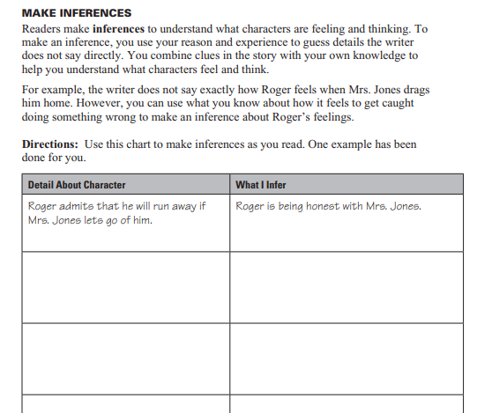 | Objective 1  Given a short story, I can complete a template to objectively summarize the story.  Activity:  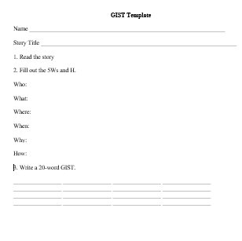 | Objective 1  Given a short informational passage, students will identify examples of author bias toward the subject matter.  Activity:.  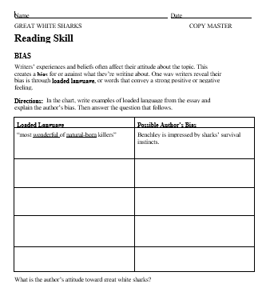 | Objective 1  Given a short informational passage, students will use outlining note taking skills to determine the main ideas of the passage.  Activity  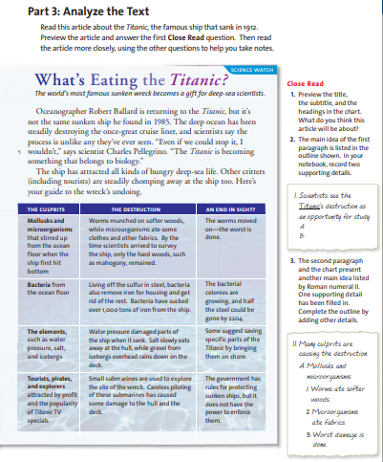
 |  | . | 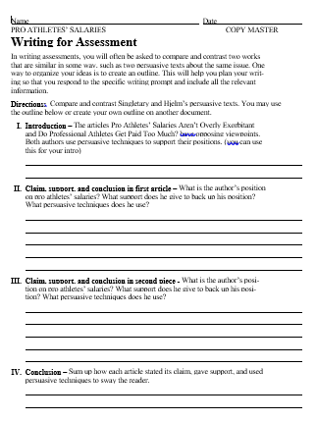
Learning Target 3
I can create a factual summary of an informational text, stating the key points of the text without adding my own opinions and feelings.
Objective
Given persuasive, informative article, students will cite examples that help the author emphasize his or her main point about a topic.
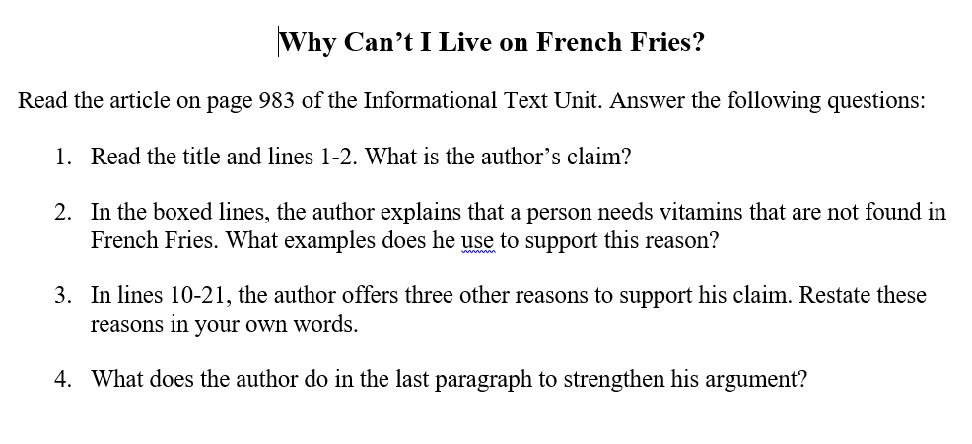
Learning Target 4
I can create a factual summary of an informational text, stating the key points of the text without adding my own opinions and feelings.
Objective
Given a newspaper article, students will identify journalism's "5 W’s and 1H" (who, what, when, where, why, and how) and complete a template with the corresponding information they have found in the article. Finally, students use their notes to write a 20-word summary called a GIST. Once students have mastered writing a GIST using newspaper articles, the strategy is then applied to content area texts to support comprehension and summarizing skills.

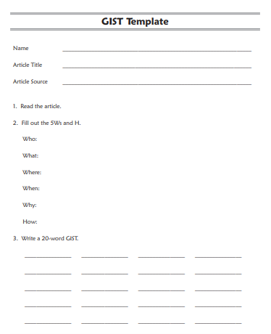

ELA ESSENTIAL STANDARDS Grade 8
Standard RL.8.1:  Cite the Textual evidence that most strongly supports an analysis of what the text says explicitly, as well as inferences drawn from the text. | Standard RL.8.2. Determine a theme or central idea of a text and analyze its development over the course of the text, including its relationship to the characters, setting, and plot; provide an objective summary of the text. | Standard RI.8.1.  Cite the textual evidence and make relevant connections that most strongly support an analysis of what the text says explicitly as well as inferences drawn from the text. | Standard RI.8.2.  Determine a central idea of a text and analyze its development over the course of the text, including its relationship to supporting ideas; provide an objective summary of the text.
Student-Friendly Version | Student-Friendly Version | Student-Friendly Version | Student-Friendly Version
I can refer to the text and find specific examples that strongly support my thoughts and inferences about a story. | I can use details from the text to determine the theme or message of a story. | I can give examples of  key pieces in a text that  support my thoughts  and inferences about a  piece of informational  text. | I can find more than one  central idea of a text  and explain how  the ideas develop  throughout the text.
Vocabulary | Vocabulary | Vocabulary | Vocabulary
Evidence Infer  Examples Connotation  Details Denotation  Analysis Specific  Explicit Vague  Implicit | Theme Details  Summary Facts  Lesson Learned Moral  Author’s Message | Evidence Infer  Examples Connotation  Details Denotation  Analysis Specific  Explicit Vague  Implicit | Topic  Main Idea  Supporting Details  Summary  Objective  Fact  Opinion
Learning Target 1  I can identify textual evidence in fictional text. | Learning Target 1  I can define and determine the theme or central idea of a narrative text. | Learning Target 1  I can identify textual evidence in informational text. | Learning Target 1  I can define and determine the theme or central idea of an informational text.
Objective 1  Given a paragraph from a novel, students can cite examples of a character’s advantages.  Activity  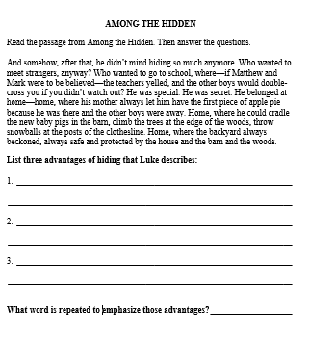 | Objective 1  Given a short fable, students will identify the lesson learned by the character(s) in the fable.  Activity:  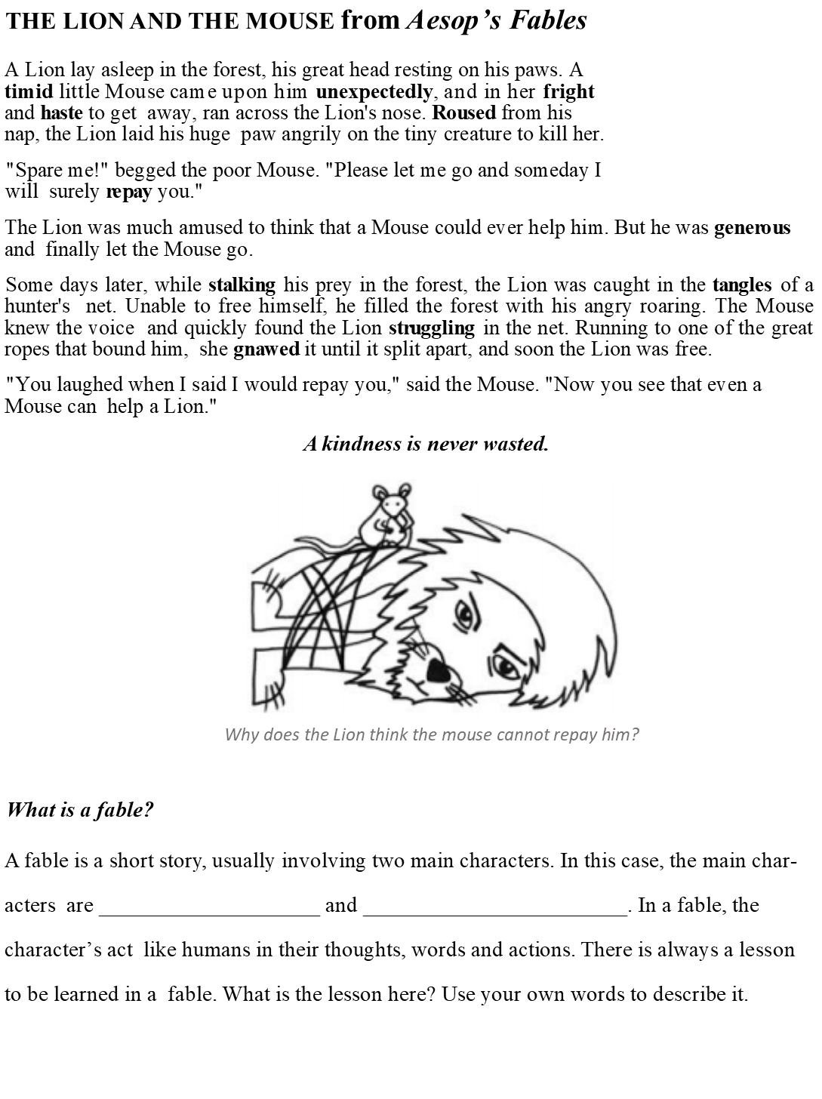 | Objective 1  Given a short informational paragraph, comprehension question, and highlighters, students will highlight directly stated proof for their answers within the text.  Activity  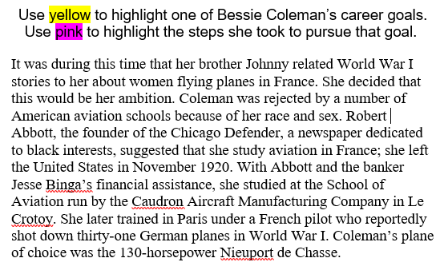 | Objective 1  Given a short informational passage, students will use outlining skills to determine the main idea of one subsection of the passage.  Activity  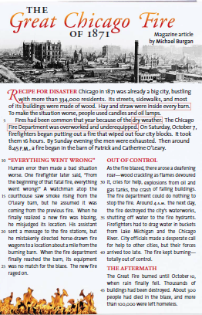
Objective 2  Given a short story, students can cite specific actions of a character  Activity:  Among the Hidden Short-Write  Revisit the end of chapter 12 to the beginning of chapter 14. Luke describes his plan to sneak into the Sports Family’s house. What actions does Luke take during the planning phase? Describe the route he takes to the house. What happened when he got to the screen door of the Sports Family’s house? What did Luke do about it? Write a paragraph that answers all questions. Be sure to use details from the story to support your answers. | Objective 2  Having read a novel narrated by three main characters, students will cite the common lesson learned by all three characters.  Activity:  Slumming Open-Ended Response Assessment  Students respond in writing to the following question: Was the experiment a success? Did the characters achieve their goals, or did they each learn something? You must answer this question separately for each character, using details and examples to support your answers.  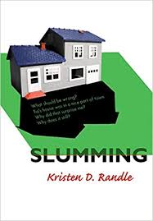 | Objective 2  Given a short informational paragraph and comprehension question, students will answer the question by writing a quote directly from the text  Activity:  How does the author organize the following paragraph? Cite evidence from the text to support your answer.  On 15 June 1921 Coleman received her pilot’s license, number 18310, the first awarded to an American woman by the French Federation Aeronautique Internationale, and she became the only licensed African American woman pilot in the world. She returned to the United States in September 1921 but went back to Europe to study in Germany, where she received the first flying license granted to an American woman. She returned to the United States in August 1922. | Objective 2  Given a short informational article, students will skim the title and subheading to predict the main idea, then read closely to state the main idea.  Activity:  Article about deadly poisons entitled, “Kill or Cure.”  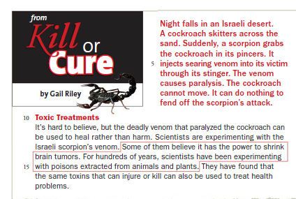
Learning Target 2  I can make inferences based on evidence from a narrative text, along with my own background knowledge, to reach logical conclusions. | Learning Target 2  I can follow the development of a theme or central idea throughout a narrative text. | Learning Target 2  I can infer what the text is saying by using specific evidence from the text. | Learning Target 2  I can determine how an author's use of details conveys two or more central ideas in an informational text.
Objective 1  Given a short story, students can infer character personality traits associated with the actions of a character  Activity: Among the Hidden Short-Write  Directions: Now that you have identified the actions Luke took to get into the Sports Family’s house, think about what those actions say about Luke’s personality. What character traits can you attribute to his actions? How are these actions and traits different from those he has displayed prior to this point in the novel? | Objective 1  Given fictional drama, I can quote characters’ dialogue and cite their actions that support my analysis of the story’s theme.  Activity: Anne Frank  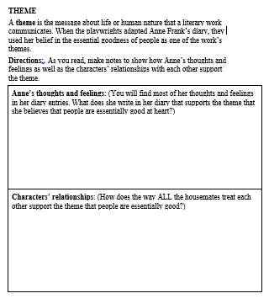 | Objective 1  Given a short excerpt from biographical text and personality traits word bank, students will identify personality traits and cite the evidence that supports them.  Activity: The Wright Brothers  How were Wilbur and Orville different? Use details from the text, as well as your own words, to support your answer.  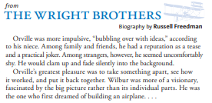 | Objective 1  Given a short informational passage, students will use a Y-Chart to determine the main ideas of two subsections of the passage.  Activity  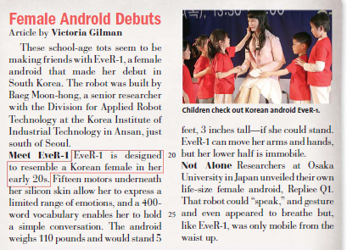  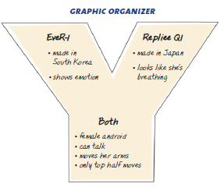
Objective 2  Given a fiction novel with two main characters who share similar circumstances, students can state the similarities and differences between the characters’ personalities, and cite the details that support their analyses.  Activity: Among the Hidden Y-Chart  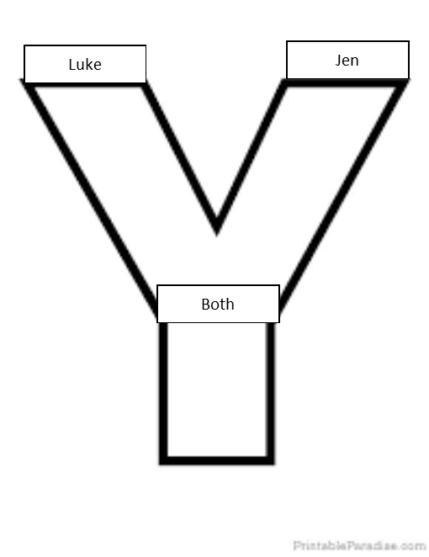 | Objective 2  Given a fictional novel, I can analyze the lesson learned by the main character through the course of the novel.  Activity: Monster, by  Walter Dean Myers  How has Steve changed because of the trial?  Inference: Why does O’Brien turn away at the end of the novel (276, 281)?  On page 207, O’Brien is not friendly to Steve when the trial is over even though he is found innocent. Why not? | Objective 2  Given a persuasive article, students will identify examples of author bias toward the subject matter.  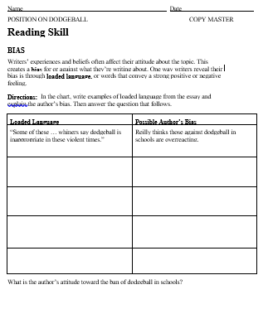. | Objective 2  Given two texts with opposing viewpoints, students will compare and contrast the claims, evidence and persuasive techniques in each text.
Learning Target 3
I can analyze how supporting ideas contribute to the development of central ideas throughout a text.
Objective
Given persuasive, informative article, students will cite examples that help the author emphasize his or her main point about a topic.
Learning Target 4
I can create a factual summary of an informational text, stating the key points of the text without adding my own opinions and feelings.
Objective
Given a newspaper article, students will identify journalism's "5 Ws and 1 H" (who, what, when, where, why, and how) and complete a template with the corresponding information they have found in the article. Finally, students use their notes to write a 20-word summary called a GIST. Once students have mastered writing a GIST using newspaper articles, the strategy is then applied to content area texts to support comprehension and summarizing skills.

