Fractions Strategy Ladder

1 | 2 | 3 | 4 | 5
 | Understands that the problem is asking him/her to distribute. | Can share fairly, but may not split the remainder into the correct number of pieces or into uneven pieces. | Can share fairly and divide remainder between 2 or 4 sharers.  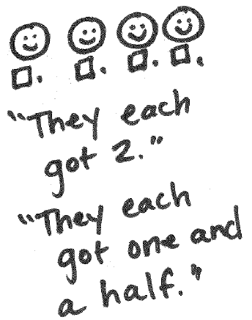 | Can share fairly and divide remainder between 2 or 4 sharers and are able to verbally name the amount each child has.  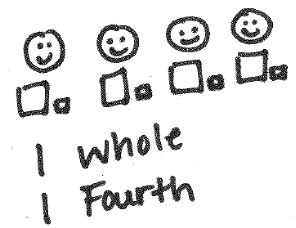
-Use only problems that result in whole numbers.  -Have students use manipulatives to act out the problem. | - “Is that fair/equal?”  - “How can you share the last cookie fairly?  - “Make sure you share everything!”  -Use manipulatives. If solving for a mixed fraction make sure the manipulatives can be divided. | - “How did you divide/split the last cookie? Why?”  - “Is that fair/equal?”  - “Will they be getting the same amount?”  -Use piece of paper and allow student to divide it and then compare the pieces to see if they are the same.  -Show the students how to appropriately split a unit. | - “How many cookies did each child get?”  - “How did you divide/split the last cookie? Why?”  - “What does it mean when we split something in half?”  -Use anchor chart  -Make sure students understand the concept of ‘whole’  -Use sentence frame to help students explain their thinking of. | - “How many cookies did each child get?”  - “How did you divide/split the last cookie? Why?”  - “How could we record our thinking so someone else will understand what’s in our picture?”  -Extend students thinking with 3 or 6 sharers.

Least Sophisticated <-------------------------------------------------------------------> Most Sophisticated

