Formative A
NBT.2.5a

Directions- When necessary- remember to fill in the bubble grid with your answer.
- 797 x 5 = _____________ 2.5b L2

- Select the equation that is represented by the base 10 models. (2.5a L2)
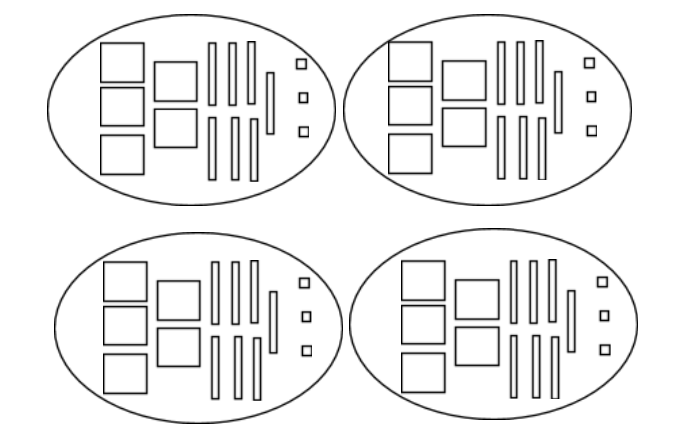
5,723 x 5
5,073 x 4
573 x 4
573 x 8

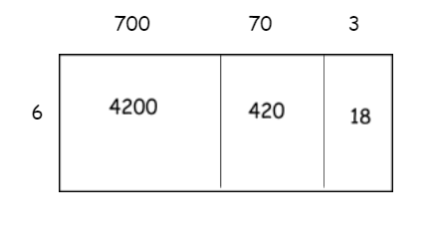
- Select the multiplication equation represented by the area model. (2.5a L2)
___ 4638 X 6
___ 700703 X 6
___ 7073 X 6
___ 773 X 6

- Decide if each expression can be used to solve 4,207 x 3. Choose Yes or No for each expression. 2.5a L3

  - (4,000 x 3) + (200 x 3) + (7 x 3) Yes No

  - (4,000 x 3) + (20 x 3) + (7 x 3) Yes No

  - (4,000 + 20 + 7) x 3 Yes No

  - (4,000 + 200 + 7) x 3 Yes No

- What is the product of 2316 and 8? 2.5a L3

- Select all the partial products for 8 x 3,321. (2.5a L3)

8
80

160

1600
2,400

24,000

- Complete the table by filling in the missing strategy. 2.5a L4
Equation | Partial Product | Distributive Property | Base 10 | Area Model
 | x  8  6 0  + 2 0 0  2 6 8 | x | x
 |  | (3x100) + (3x10) + (3x6) | 100  1  1  1  1  1  1  10  1  1  1  1  1  10  100  1  1  10  1  1  1  1  100  1 | 100 10 6  3 300 30 18
 | x  8  + 6 0 0  6 0 8 |  | 100  100  100  1  1  1  1  100  100  100  1  1  1  1 | 300 0 4  2 600 0 8

- Cassandra solves 3,412 x 7 using partial products as shown below. Explain the mistake and solve it correctly. 2.5a L5
3, 4 1 2 Correction:
X 7
1 4
7 0
2 8 0
+ 2 1 0 0 0
2 1, 3 6 4

Explain: __________________________________________________________

________________________________________________________________

Achievement Level Descriptions
Standard: NBT.2.5a
- (60%) | 2 (70%) | 3 (80%) | 4 (90%) | 5 (100%)
Not showing grade level understanding of this standard. | Multiplies a whole number (of up to three digits) by a single-digit whole number, including the use of strategies based on place value and visual models. | Multiplies a whole number up to 4 digits by a single-digit whole number using strategies based on place value; illustrates and explains calculations by using equations, rectangular arrays, and/or area models. | Determines the equation that represents a base-ten model; makes connections between different multiplication strategies. | Analyzes and describes an error in a strategy and shows the correct solution.

Name: _______________________________

Achievement : Level Descriptions
Standard: NBT.2.5a
- (60%) | 2 (70%) | 3 (80%) | 4 (90%) | 5 (100%)
Not showing grade level understanding of this standard. | Multiplies a whole number (of up to three digits) by a single-digit whole number, including the use of strategies based on place value and visual models. | Multiplies a whole number up to 4 digits by a single-digit whole number using strategies based on place value; illustrates and explains calculations by using equations, rectangular arrays, and/or area models. | Determines the equation that represents a base-ten model; makes connections between different multiplication strategies. | Analyzes and describes an error in a strategy and shows the correct solution.

