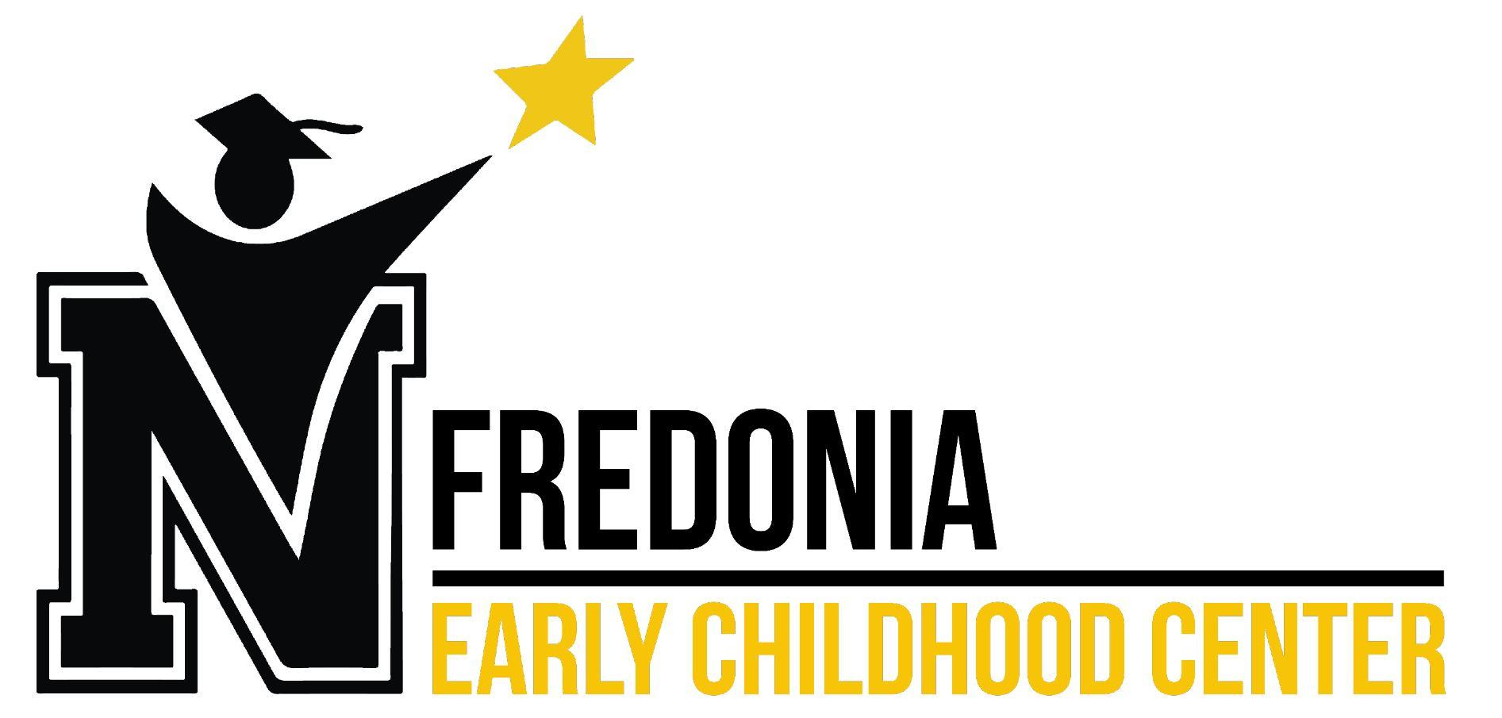

We exist to ensure high levels of learning for all students. This document outlines how we work and our team’s core beliefs. Compare yourself to our practices. Are we the right fit for you?

HOW WE WORK
Students First | Why do we put students first?  All staff have an obligation to those we serve. We are a critical factor in our students' success, and remain focused on their growth.  What it looks like at Fredonia Early Childhood Center (FECC).  Know every student by name and need. Come prepared to meetings. Work interdependently with a team to ensure best Tier I practices. Advocate for students. Remain solution- centered.
Move with Urgency and Focus | Why do we move with urgency and focus?  All staff must focus on what matters most - student outcomes. A bias for action hastens our learning, and increases the rate of positive outcomes for our students. They deserve it, the time is now.  What it looks like at FECC.  Complete assessments on time. Teach campus agreed upon learning targets. Use data to inform small groups. Provide timely feedback to all students at all levels. Come with targeted solutions to all meetings. Track and utilize performance data.
Seek Feedback from Stakeholders | Why do we seek feedback from stakeholders?  All staff value honesty and look for others to refine our ideas while challenging and building our capacity. No one person has all the answers. It takes our team to ensure high levels of learning for all students.  What it looks like at FECC.  Engage parents as partners in their child’s education. Work collaboratively with our campus teams and specialists. Use student data to confirm or alter Tier I practices.
Deliver Outstanding Results | Why do we deliver outstanding results?  All staff are high achievers. Our success means lasting impacts for our students. We take responsibility for seeing our work through and delivering on our mission.  What it looks like at FECC.  Set and work towards aspirational goals for yourself and students. Achieve goals for student growth and performance. Be responsive in teaching practices. Students own their success and track their achievements. Student progress monitoring and goal setting is present in the room.

OUR CORE BELIEFS
Accountable | All staff know that our actions have significant impacts on students. We complete tasks in a timely manner while upholding our commitments. We believe our students deserve the best.
Caring | All staff lead their classrooms with a genuine interest in people and ideas. We will ensure our students have access to every factor of success. We hold our students to high expectations while fostering their individual growth.
Driven | All staff have the audacity to set and work towards aspirational and achievable goals. We know that there will be challenges, but view these as opportunities to sharpen our skills. We are excited about our work and about delivering exceptional results for our students.
Optimistic | All staff embrace each day as a new day for our students and colleagues. We have positive intent in our interactions. We choose to see the best in ourselves, our peers, and our students and their parents.
Solution-Centered | All staff know that all problems and challenges can be solved with the right team and mindset. We understand that progress can be slow but through focused efforts, our long term goals can be achieved. We know that passing “the problem” off is not in the best interest of students. We are always willing to accept support and be honest in our feedback and efforts.

MISSION

Ensure high levels of learning for all students.

VISION

We are a model school that provides a best in class education to our students. Through interdependent collaborative teams, knowing our students by name and need, and relentlessly pursuing aspirational goals for learning we inspire to be a top tier educational facility.

