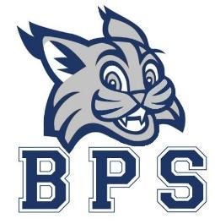
Faculty Meeting
February 21, 2023
Agenda
8:30 a.m.
- Bobcat Booyahs
- BPS Information
  - Pay Schedule for Next Year
  - Contracts Due 3/1
  - Allotments
  - Screener on DL Day- Parker

- BPS Data
  - Behavior data

- Instructional Spotlight
  - F and P Look-fors and Big Ideas
  - Social Studies Projects K-2
  - MAP Fluency Progress Monitoring

- Important Dates for February
  - 17^{th-} SPIRIT Day and Hat Day ($1)
  - 20th- President’s Day (no school)
  - 21st- Distance Learning Day
  - 22nd- PBIS Team (4:10-5:00)
  - 24th- PTO Fun Friday (chips) and Hat Day ($1)
  - 25th- Job Fair
  - 27th- Read Across America Week begins

