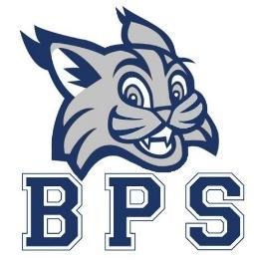
Faculty Meeting
November 9, 2022
Agenda
4:15 p.m.
- Bobcat Booyahs and Read Aloud
- BPS Information
  - Ms. Pinto as a substitute
  - Christmas Party
  - Attendance
  - PBIS Walkthrough
  - Safety Reminders and Scenario (lock doors, wear badges, severe weather drill)
  - Public Record

- BPS Data
  - Behavior data for the month of October

- Instructional Spotlight
  - Math Centers 1- Know, 2- Glows, 3- Grows and Supports
  - Collaborative Culture vs Collaboration Lite

- Important Dates for November
  - 10^{th-} Holiday Lunch for Pre-K
  - 10th- Progress reports go home
  - 14th-18th- HAEOP Jeans Week
  - 14th- Intervention Team Meeting
  - 14th- P BIS Walkthrough
  - 14th- PBIS Team (4:10-5:00)
  - 14th- BUILD Team (4:15-5:00)
  - 14th- Pre-K and Kinder release day
  - 16th- 1st and 2nd release day
  - 16th- 70’s Day
  - 18th- SPIRIT Day (Wear BPS Gear and concessions for sale)

