SO HOW
DID WE GO?
We provide feedback for students, but what about us? Should this not be the heart of true collaboration?

Step 1:
Each team member presents their common formative assessment data in an uninterrupted forum in ten minute slots to comment on:
1. Pre-assessment data and progress throughout the term
2. Strategies implemented and the level of success
3. Are SMART goals on track?
4. Teaching implications for remainder of the term.

Step 2:
Feedback is provided by the team after each presentation. This can be in the form of both warm and cool feedback. Examples of these are as follows:

Warm Feedback:

- Provides specific feedback to presenter/writer/designer
- NOT general statements of approval. Avoid statements such as: “I liked it.”, “This is good.”, “Great job!”, “Well done.”
- Highlights and recognizes the strengths of the unit and strategies. “Your results clearly align with...” “The ‘need to knows’ are clear and have been addressed” “I can see why you have chosen that level of intervention.”

Cool Feedback:

- Wonderings, questions, and dilemmas listeners find in the content
- NOT criticism. Cool feedback poses ideas that prompt the presenter to think about the content/strategies from a different perspective. “I” statements and the use of “might” rather than “should” promote an environment of respect and leave control in the hands of the presenter.
- Possible sentence starters for this area could be “I wonder …”, “What if …”, “I was confused by …”, “I’m curious …”, “Tell me about …”, “You might consider …”
Feel free to use the attached template to attach post it notes during the presentation to avoid interrupting the presenter. We have trialled this in some groups (including admin PLT’s with great success).

Have fun! Having time to collaborate, learn and grow is a real gift!

Term 3
Week 6
2.20pm-3.25pm
So how
did we go?
Here are some further refinements of warm and cool feedback processes if you would like to examine…
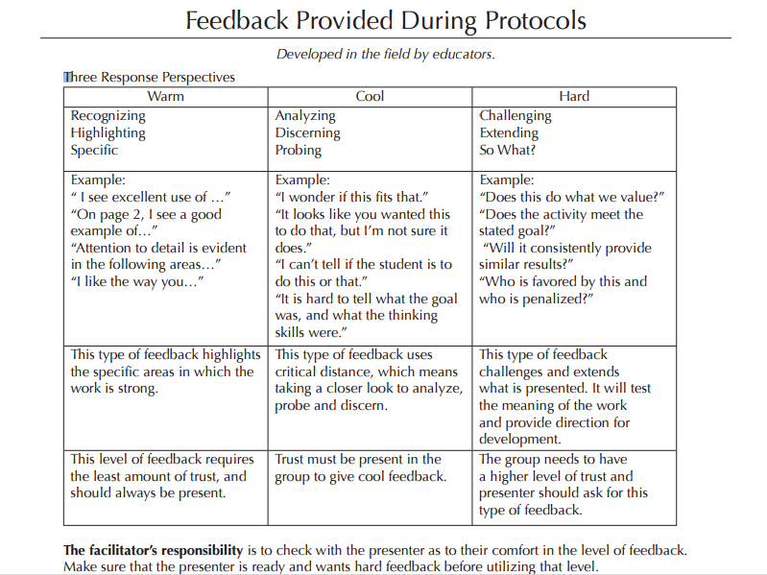
What actually is effective feedback? Here’s some of Hattie’s research for thought….
- Effective feedback requires that a person has a goal, and takes action to achieve it. The information becomes feedback if, and only if, I am trying to cause something to change and the information tells me whether I am on track or need to change the course of the goal, and receives goal-related information about his or her actions.
- Any useful feedback system involves not only a clear goal, but also tangible results related to the goal.
- Effective feedback is concrete, specific, and useful; it provides actionable information.
- It must be user friendly. Even if feedback is specific and accurate in the eyes of experts or bystanders, it is not of much value if the user cannot understand it or is overwhelmed by it.
- The feedback must be timely. In most cases, the sooner we get feedback, the better.
- Feedback within our teams must be ongoing. Adjusting our performance depends on not only receiving feedback but also having opportunities to use it.
- To be useful, feedback must be consistent. Clearly, performers can only adjust their performance successfully if the information fed back to them is stable, accurate, and trustworthy.

