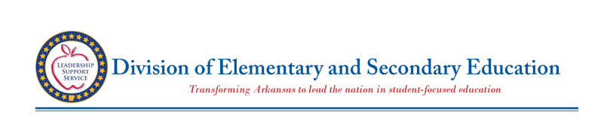

**Johnny Key**

Secretary

**Dr. Ivy Pfeffer**

Deputy Commissioner

**Stacy Smith**

Deputy Commissioner

**State Board of Education**

**Charisse Dean**

*Little Rock*

**Chair**

**Ouida Newton**

Poyen

**Vice Chair**

**Susan Chambers**

*Bella Vista*

**Dr. Fitz Hill**

*Little Rock*

**Kathy McFetridge**

*Springdale*

**Dr. Sarah Moore**

*Stuttgart*

**Steve Sutton**

*Marion*

**Adrienne Woods**

*Rogers*

Thank you for applying for a RISE School Award.

The Reading Initiative for Student Excellence, RISE Arkansas, fosters a culture of reading by coordinating a statewide reading campaign with community partners, parents, and teachers to establish the importance of reading in communities, homes, and schools.  The first goal of RISE Arkansas is to “sharpen the focus and strengthen instruction”. RISE training was developed in 2017 to bring evidence-based teaching practices to the classroom.

In an effort to promote the continued growth of RISE Arkansas, the Arkansas Department of Education recognizes schools who have successfully implemented these practices for their students.  In Spring of 2022, a team from the ADE used a rubric to score thirty-one submitted applications. The rubric was based on the three goals of RISE plus the minimum requirements from the application.  Of those that applied, twenty-two schools advanced to a second round which included a day-long visit from RISE specialists. The goal of the visit was to look for a schoolwide implementation of strategies and practices aligned with the science of reading.

Upon completion of the day-long visit, a second rubric was used to look more closely at instructional shifts in twelve different areas.  For schools to be chosen as RISE Award winners, the minimum rubric score was 36 out of 48 possible points. Your final rubric score was 48.   Based on your score, the Arkansas Department of Education is proud to announce Evening Star Elementary as a recipient of a 2022 RISE School Award. We have attached a copy of your rubric as feedback from our team, as we know each school will continue to grow in their instruction and practice that is aligned to the science of reading.

To recognize the work that is happening in your district, we would like to invite your team to come and celebrate with us during the 2022 ADE Summit this July at the Hot Springs Convention Center.  The award presentation will take place Tuesday, July 12 from 2:20 - 4:40 in Hall A of the Hot Springs Convention Center.  We would love for you to bring a team to celebrate this award.

From all the research studies and the data collected, we know reading is a fundamental skill that impacts all phases of our lives.  Teaching students to read is hard work and requires dedication and a deep understanding of the process. Your teachers are putting in the hours and effort needed to make an impact on your students, your school, your community, and our state.

On behalf of all of us at the Division of Elementary and Secondary Education, thank you to your entire team.  Keep up the great work!

Sandy Shepard

RISE Arkansas

Sandy Shepard, Lead RISE Specialist

(501)682-9961

sandy.shepard@ade.arkansas.gov

Begin typing here…