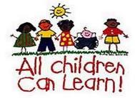
Sunset Elementary
Essential Standards & Unit Assessments
ELA-May 30, 2019
Math-May 31, 2019

Agenda

- Meeting expectations
- Purpose of our PLC work
- Use of interventionist
- Overview of essential standards development
- Review units created in January
- Build common assessments

