English Language Proficiency Assessment California (ELPAC)
Marco Forster Middle School Achievement Performance (2019, 2021, 2022, 2023)
At Marco Forster we have had a school-wide focus on improving outcomes for English Learners. The documents listed below illustrate English Learner progress on the ELPAC before COVID and how we have progressed as a site after COVID. You will notice that as of 2023 English Learners have a higher proficiency level (Level 4) than students in 2019. Specifically, English Learners have improved in Oral Language proficiency. Marco Forster has adopted a “Structured Interaction” school wide focus, where all teachers integrate peer to peer structured interactions daily to develop oral language for all students, but with intentionality for the 300 + English Learners on our campus. Additionally, as you look at each grade level, you will find that the students in each cohort improve dramatically year over year during their time at Marco Forster Middle School.

ELPAC Overall Achievement Scores

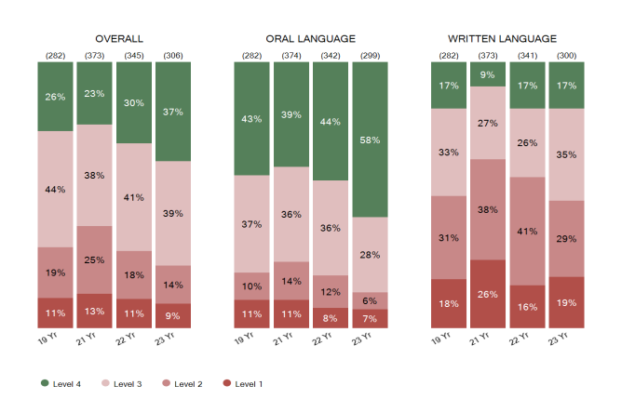

ELPAC 6th Grade Achievement Scores

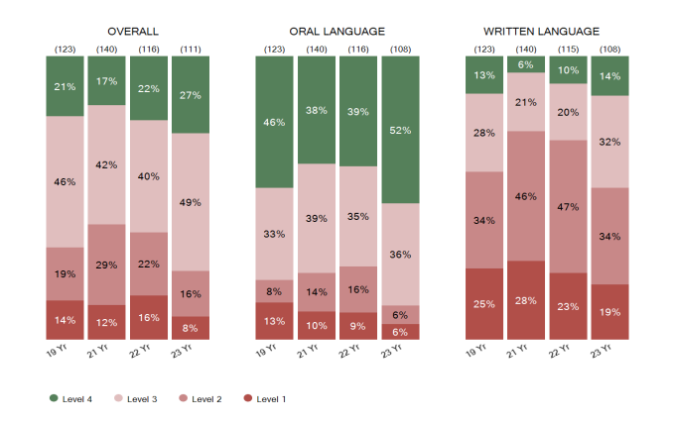

ELPAC 7th Grade Achievement Scores
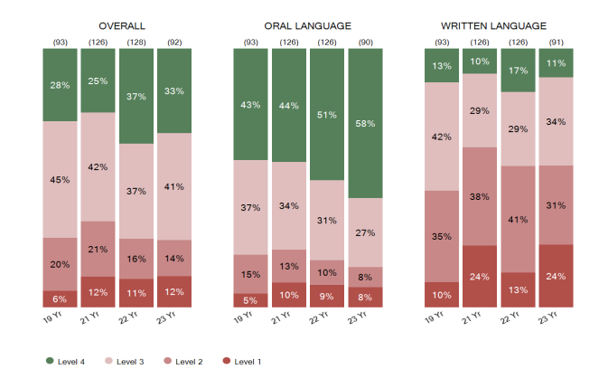

ELPAC 8th Grade Achievement Scores
