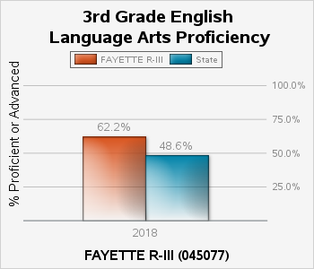

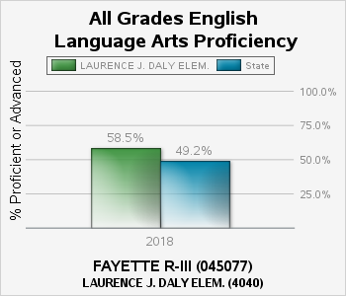

What is it?
English Proficiency represents the percentage of students who take the required English language arts assessment (grade level or End of Course Assessment) or MAP-Alternate Assessment and score Proficient or Advanced.

How is it calculated?
The total number of students scoring proficient or advanced on required MAP English language arts assessments/total number of students assessed on the MAP English Language Arts assessment (grade level, End of Course or MAP-Alternate)

How is it used?
Proficiency rates are required by federal law to be included in the building level Report Cards by the Every Student Succeeds Act (ESSA) and state law.

Why is it important?
English language arts proficiency is important as it allows students to be successful in other content areas. Proficiency in language arts is also critical to success in the workplace or post-secondary experiences.

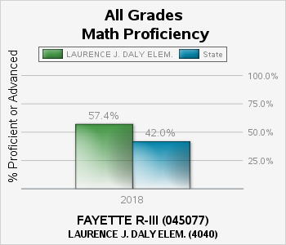

What is it?
Math Proficiency represents the percentage of students who take the required math assessment (grade level or End of Course Assessment) or MAP-Alternate Assessment and score Proficient or Advanced.

How is it calculated?
The total number of students scoring proficient or advanced on required MAP math assessments/total number of students assessed on the MAP math assessments (grade level, End of Course or MAP-Alternate).

How is it used?
Proficiency rates are required by federal law to be included in the building level Report Cards by the Every Student Succeeds Act (ESSA) and state law.

Why is it important?
Proficiency in math is important as it allows students to develop critical skills in problem solving, logical thinking and reasoning.

