**List of student and school accomplishments**

9/2019 HTMS – 2019 CCRPI score – 6th in the State of Georgia; Platinum level for achievement – 96.4

**Music Program**

2019 - Band, Orchestra, and Chorus receive all superiors in their LGPE performances.

2019 – HTMS Music Program declared top music middle school program in the State of Georgia

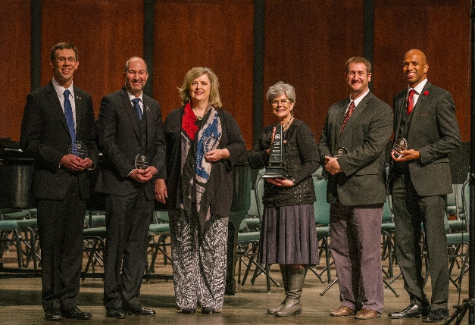

2/2020 – Orchestra receives all superiors in LGPE performances, others have not occurred

3/2020 – 3 orchestra students are named All State Orchestra participants

2/2020 – Honor Band – 25 students participated – most in Cobb County School District

3/2020 – 1 band student named to All State Band

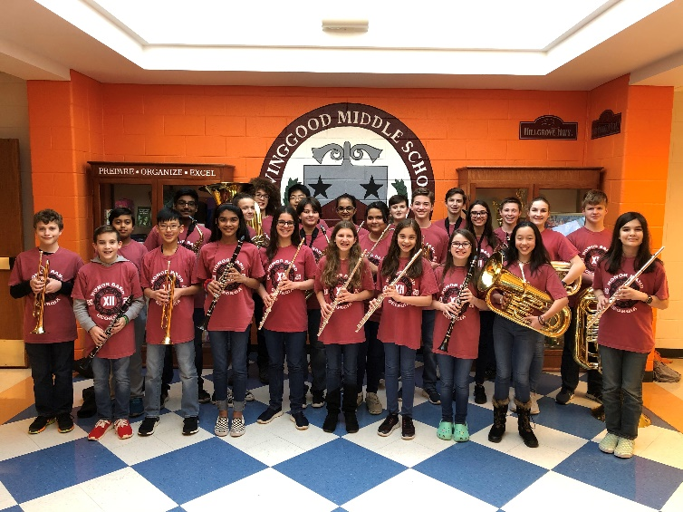

**Helen Ruffin Reading Bowl**

2019 – 1st place in local tournament and competed at State.

2020 – 6th place in county

**Science Olympiad**

3/2019 Science Olympiad: Placed 2nd at Regionals and 10th at State Tournament.

11/2019 The Science Olympiad team placed second in the Walton-Dodgen Invitational. They medaled in 14 out 23 events!

2/2020 Science Olympiad team takes third place in regionals and is headed to State Tournament.

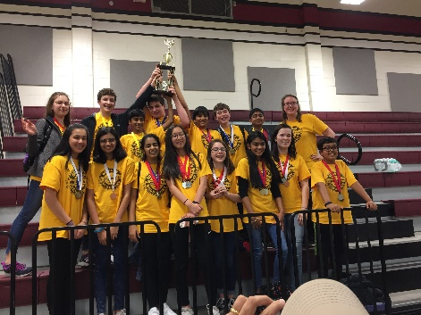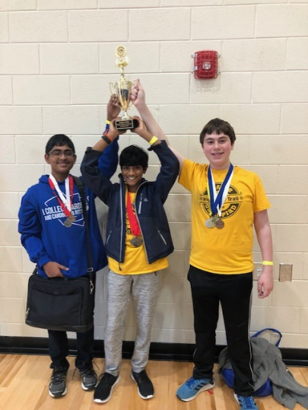

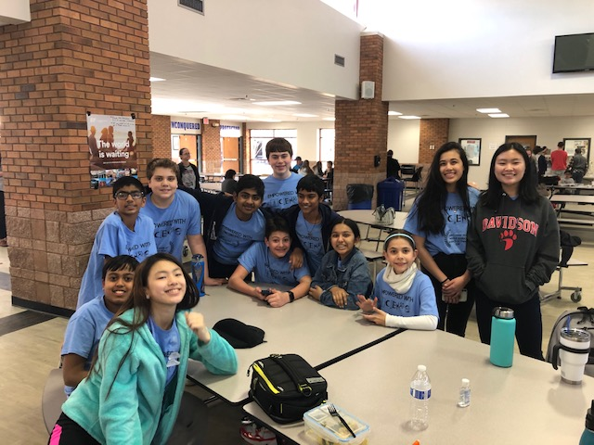

**Math Competition Team**

2/2018 – regional competition: 2nd place team

5/2018 – Cobb County Middle School Math Tournament: 1st Place Team

2/2019 – Regional competition: 2nd Place Team; 1st Place Individual

5/2019 – Cobb County Middle School Math Tournament 3rd Place Team; 2nd place individual

5/2019 – Cobb County 3-part math competition series: 3rd Place Team

2/2020 – MATHCOUNTS regional competition: 4th Place Team; 1st place Individual

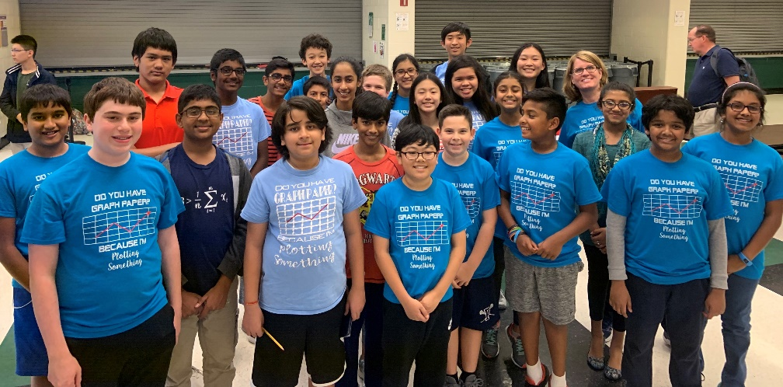

**Science Fair**

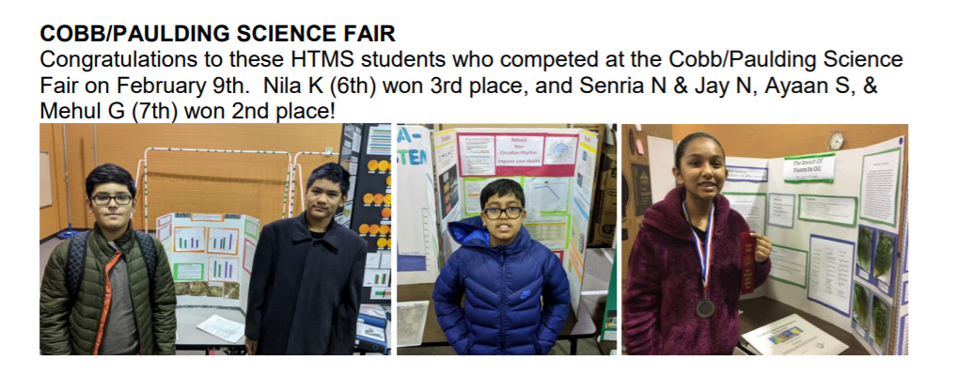

**Spelling Bee**

2/2020 – 6th grader wins 3rd place in CCSD Spelling Bee and will be competing in Regionals

**Cobb Regional Technology Competition**

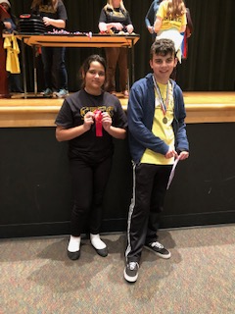

2019 Cobb Regional Technology Competition

**1st Place:**

Hogan M won 1st place in digital video game design.

**2nd Place:**

Ann R won 2nd place in Graphic Design.

Meghan P won 2nd place in digital photography

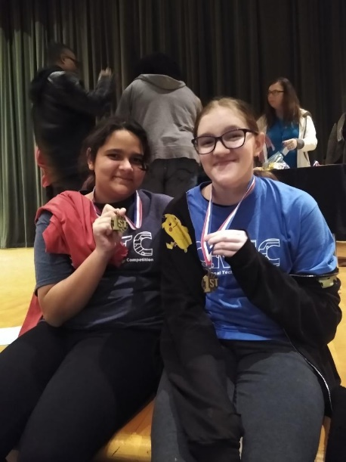

2020 Cobb Regional Technology Competition

**1st Place:**

Luke M | 7/8 Device Modification

Ann R and Kate D | 7/8 Animation

**2nd Place:**

Noa I and Cora AD | 5/6 Graphic Design

**Chess Club**

2020 – 1st place in Cobb County Middle Schools

2020 – 3rd place in Metro Regional Competition

**Cobb County Writing Fair**

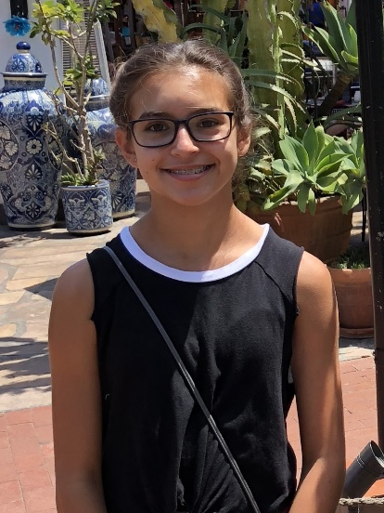The Cobb ELA Department is pleased to announce that the following student placed in the CCSD 2019-2020 Writing Fair:

*Seventh Grade-First Place*

*Maria Julia Seixas*

First place winners were submitted to the MRESA competition for consideration at the State competition.

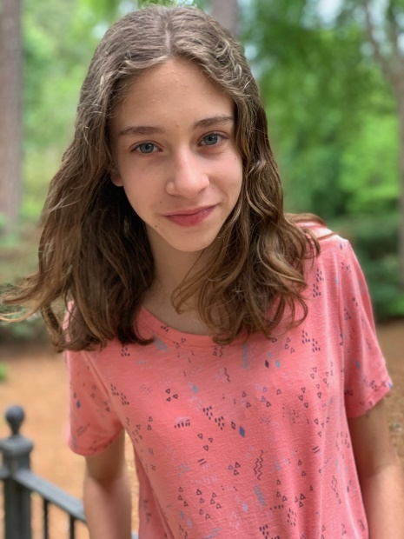**Cobb County’s First 100 Word Story Middle School Challenge 2019-2020**

Congratulations!  You have been selected as a winner of Cobb County’s first 100 Word Story Middle School Challenge.  Your story was selected from 156 stories entered by students from 19 Cobb County middle schools.