Discipline Data Summary 2017-2021
From the 2017-18 school year to present we have seen a steady decrease in the overall number of office referrals. The number of suspensions has fluctuated over the past three years but our most recent numbers show a significant decline. Our goal was to reduce the number of overall office referrals by 5%. We surpassed that goal all three years.
 | 17-18 | 18-19 | 19-20 | 20-21
Overall Suspensions | 292 | 348 | 299 | 25
ISS | 183 | 246 | 199 | 17
OSS | 109 | 102 | 100 | 8
Total Office Referrals | 830 | 727 | 694 | 65

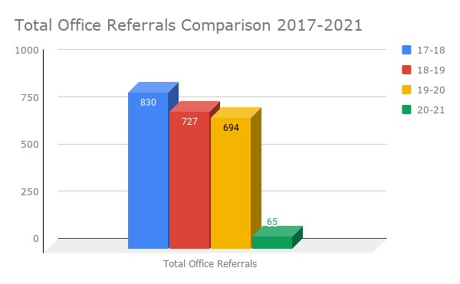

Reduction in Discipline by Cohort from 2017-2020
In the 2017-2018 school year our 6th grade cohort was responsible for receiving 46% of the overall number of office referrals for the entire school. We began implementing an SEL action plan that included hiring a behavior interventionist to work with students who received 3 or more office referrals in one school year on a regular basis. We followed and monitored their progress closely over the next two years. From 2017-2020 we saw a 64% decrease in overall office referrals from the 6th grade cohort. We also saw a 94% decrease in the number of office referrals among our Tier 3 behavior intervention students who had 7 or more office referrals in the 2017-18 school year.
Overall Office Referrals by Cohort
Year | # of  Referrals
17-18 (6) | 377
18-19 (7) | 284
19-20 (8) | 135

