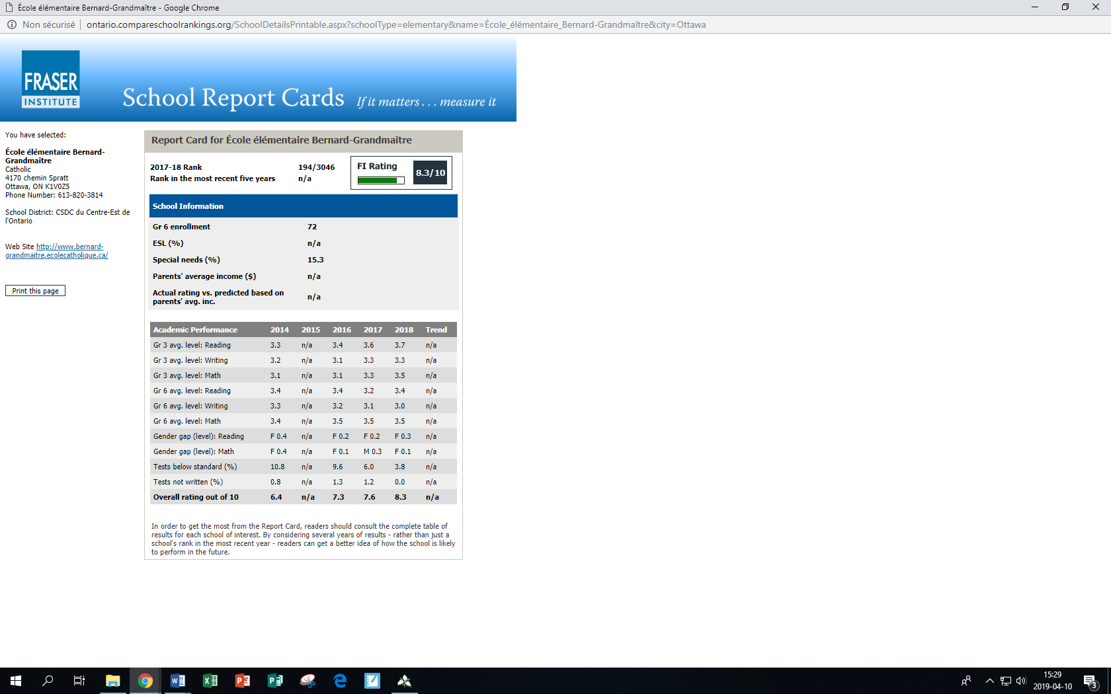

Canadian Fraser Institute

Report Card for École élémentaire Bernard-Grandmaître
2017-18 Rank 194/3046  Rank in the most recent five years n/a | 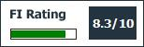

School Information
Gr 6 enrollment | 72
ESL (%) | n/a
Special needs (%) | 15.3
Parents' average income ($) | n/a
Actual rating vs. predicted based on parents' avg. inc. | n/a

Academic Performance | 2014 | 2015 | 2016 | 2017 | 2018 | Trend
Gr 3 avg. level: Reading | 3.3 | n/a | 3.4 | 3.6 | 3.7 | n/a
Gr 3 avg. level: Writing | 3.2 | n/a | 3.1 | 3.3 | 3.3 | n/a
Gr 3 avg. level: Math | 3.1 | n/a | 3.1 | 3.3 | 3.5 | n/a
Gr 6 avg. level: Reading | 3.4 | n/a | 3.4 | 3.2 | 3.4 | n/a
Gr 6 avg. level: Writing | 3.3 | n/a | 3.2 | 3.1 | 3.0 | n/a
Gr 6 avg. level: Math | 3.4 | n/a | 3.5 | 3.5 | 3.5 | n/a
Gender gap (level): Reading | F 0.4 | n/a | F 0.2 | F 0.2 | F 0.3 | n/a
Gender gap (level): Math | F 0.4 | n/a | F 0.1 | M 0.3 | F 0.1 | n/a
Tests below standard (%) | 10.8 | n/a | 9.6 | 6.0 | 3.8 | n/a
Tests not written (%) | 0.8 | n/a | 1.3 | 1.2 | 0.0 | n/a
Overall rating out of 10 | 6.4 | n/a | 7.3 | 7.6 | 8.3 | n/a

