FMS Data Cycle Directions
http://www.allthingsplc.info/files/uploads/DataProtocol.pdf
Step One  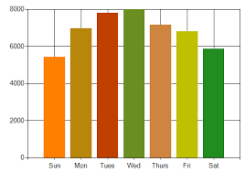 | Collect and chart your data HERE
Step Two  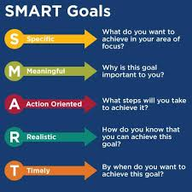 | Set a SMART Goal
Step Three, Four, and Five | Analyze to Prioritize Needs, Select Strategies, Determine Result Indicators  Using this form (be sure to make a copy and rename)  https://docs.google.com/document/d/1S_zPyk-lblDcAgZXBWNW1phvW1vZQD36jLYJFMx6wbw/edit?usp=sharing  analyze to prioritize student needs AND select strategies for areas of concern or misconception.
Step 6 | Monitor Progress: How is your plan working?

