BAM091L | 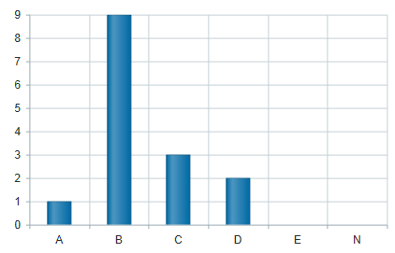  Level of Achievement:  Our Minimum Targets  Years 7 to 11 95% of students in all subjects receiving a grade of C or better  Year 12 100% of students in all subjects receiving grade of C or VET completion  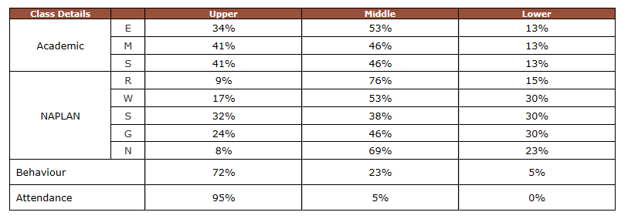
Whatever it takes! | Generalised class data conclusions | What specific WILL deficits are evident? | What specific SKILL deficits are evident from formative data? |  | Teaching Strategies
 | TERM 2: PLT WORKING CLASS DATA PLACEMAT | Name students- name WILL issues. | Name students- name SKILL issues? | What will we do for those who already have it?
 |  |  |  | What will we do for those who haven’t got it yet?
KIC:
ATSI:
ICP:
EALD:
MEDICAL:
SPECIAL PROVISIONS:

