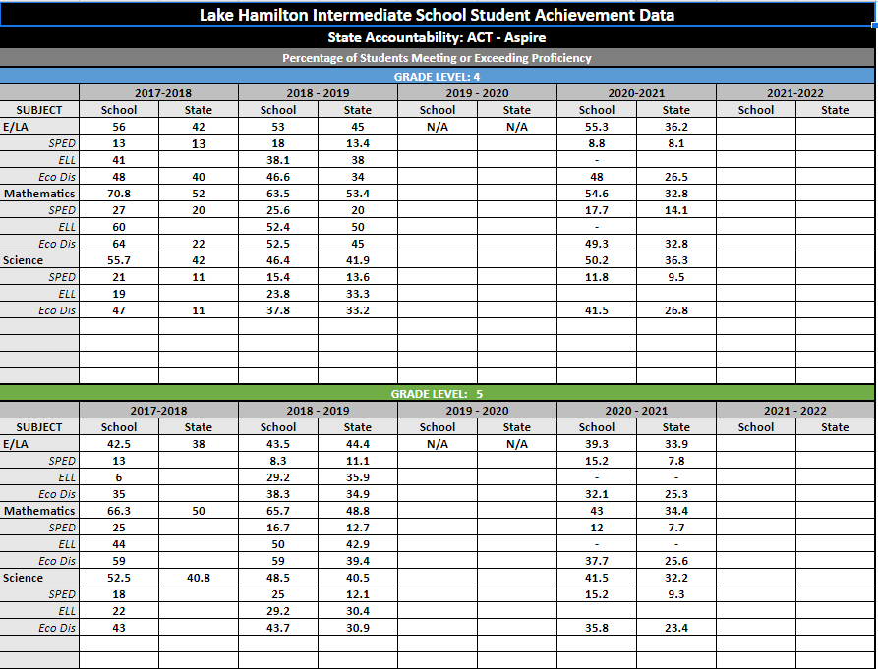
According to this data,4th grade ELA went down 3 points on the ACT Aspire in 2017-18; whereas we gained 2.3 points in 20-21 . 4th grade Math declined 7.3 points from the 2017-18 school year to 2018-19; then another 8.9 points in the 2020-21 school after returning from COVID. Science initially went down in the same time frame, but gained 3.8 points during the 2020-2021 school year.

5th grade gained 1 point between the 2017-18 and 2018-19 school year; then dropped 4,2 points in 2020-21. Math dropped .6 points between 2017-18 and 2018-19; then took a big hit in 2020-21. Science was very much the same as math dropping 4 points from the 2017-18 school year to 2018-19; then an additional 7 points in 2020-21.

Because this is a vertical study and not one of the same group of kids, the assumption would be that this was possibly due to the group of kids being different. At this time, there were not any staff or curriculum changes. Any time there is a curriculum change, there seems to be a change in test scores. In the 19-20 school year, we all experienced the global pandemic where our students were sent home in March. The following year, many did not return to school as we offered a virtual option. The pandemic affected many students in a variety of ways. Even though school resumed in August of 2020, academically many students had not participated in educational productivity from home since March. As a result, our students are, in many cases, still trying to fill gaps that were created by such a pandemic. In all, While our scores have been on the rise, and then fell some, are still consistently above our state average. We would also like to acknowledge that throughout this timeframe we are looking at, our teachers and students not only were working through the pandemic, many teaching hybrid and virtual only classes, but were continuing to put every effort forward with the new knowledge acquired by Solution Tree and learning to navigate a new grading system (standards based grading).In addition to these things, our school restructured our teaching assignments. We went from 3 teachers in a pod , teaching 90 minute class periods in reading/writing, science/social studies, and math to 4 teachers in a quad, teaching 60 minute classes in reading/writing, reading/social studies, science, and math.

