W8 Kindergarten Grade Alignment Document/Lesson Plans

**Attached you will find a document we call our alignment document. This document is a lesson plan that includes the four questions essential for learning, a daily schedule, an alignment document/scope and sequence, and resource document all in one. Our teachers created the template according to their preference. This document does not include “Guided Reading.” Our teachers turn in “Guided Reading Plans/Observations” after a week of lessons. Since decisions are made, in the moment, in guided reading groups, documentation of student progress and teaching strategies are maintained in Guided Reading Plans.

Readiness Standards:
Math: | Reading: | Writing:
K.7(B) compare two objects with a common measurable attribute to see which object has more of/less of the attribute and describe the difference | K.8(B)* describe characters in a story and the reasons for their actions K.8 Fig.19(D)* | K.15(A)* dictate or write information for lists, captions, or invitations
What do we want our students to learn? We want students to be able to give examples of measurable attributes in items including length, capacity and weight. | What do we want our students to learn?  The students will learn characters and setting in the story. | What do we want our students to learn?  We want our students to write legibly and use capitalization and punctuation conventions in their compositions.
How will we know that our students have learned it? We will know our students have learned it by observing them compare items, and also seeing the products they have created on our measurement activities. | How will we know that our students have learned it?  We will assess by having them draw the setting and characters on an index card. | How will we know that our students have learned it?  We will know from observations of writing activities: morning journals, writers workshop
What will we do if the student does not learn it? If the student does not learn it, we will practice one on one and in small group comparing items using different attributes such as a pencil is longer than a ____. We will also use manipulatives to prove that our comparison is true. | What will we do if the student does not learn it?  We will ask personal questions about personal events to identify character and setting. | What will we do if the student does not learn it?  If students are not learning it, we will do mini lessons on capitalization and punctuation. We will also work with students on writing conventions during small group time.
What will we do if the student has already learned it? If the student has already learned it, we will allow them to create their own way of measuring items and present their data to the class. For example, they may want to see how many paperclips long something is compared to another. | What will we do if the student has already learned it?  Ask them to pick their own setting and write a sentence about it. | What will we do if the student has already learned it?  We will encourage these students to write and illustrate their interests and share their work with the class.

 | Monday | Tuesday | Wednesday | Thursday | Friday
7:45-8:00  Unpack  Greeting  Morning Activities | Arrive , Move Name Card, Unpack, Make Commitments and begin working on  Fall student reader book or any student reader books that you need to finish | Arrive , Move Name Card, Unpack, Make Commitments and begin working on  Journal Writing:  My favorite color is _____________.  How many _________ things can you draw? | Arrive , Move Name Card, Unpack, Make Commitments and begin working on  Introduce Writing Reference Folders: have students write sight words that they know in their Writing Reference Folders  or  Sight word/color playdough writing with toothpicks or sight word rubbings  Extra: Color Word Puzzles | Arrive , Move Name Card, Unpack, Make Commitments and begin working on  Journal Writing:  In the fall I can see a _____..  Have students glue a picture of what they can see.  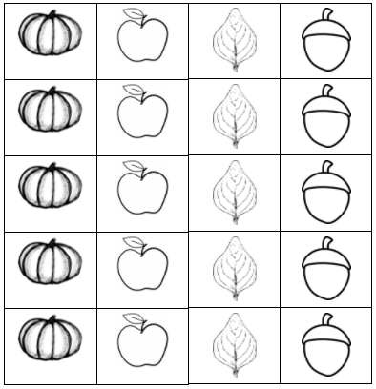 | Arrive , Move Name Card, Unpack, Make Commitments and begin working on:  Sight Word Bingo: students prepare bingo board by putting any sight words or color words on their board,
8:10-8:30  Announcements  8:10-8:30  Rituals  Morning Message | *Come to the Carpet SOng/Clean Up  *Play Good Morning Song *C. Discipline  I Love You Ritual (Humpty Dumpty)  Safekeeper Ritual,  *5 C. Discipline Rules  Wish well  Attendance:  Count Around the Circle, Attendance Stick, Counting Jar  Morning Message:  Numbers & Alphabet Practice  Write a number or letter on the chart, call on students to find the correct color word to make the statement true. Add to a center.  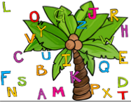  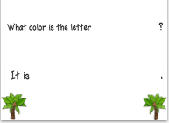 | *Come to the Carpet SOng/Clean Up  *Play Good Morning Song *C. Discipline  I Love You Ritual (Humpty Dumpty)  Safekeeper Ritual,  *5 C. Discipline Rules  Wish well  Attendance:  Count Around the Circle, Attendance Stick, Counting Jar  Morning Message: make a list of words that begin with K  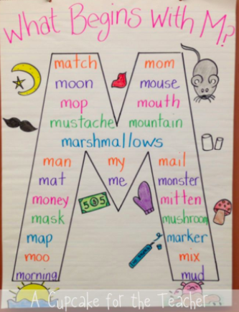  Movement songs:  https://www.youtube.com/watch?v=dD-dG-7yCJM If You’re a Kid Halloween  https://www.youtube.com/watch?v=QmoE8NSkK7s Born to Move | *Come to the Carpet SOng/Clean Up  *Play Good Morning Song *C. Discipline  I Love You Ritual (Humpty Dumpty)  Safekeeper Ritual,  *5 C. Discipline Rules  Wish well  Attendance:  Count Around the Circle, Attendance Stick, Counting Jar  Morning Message:  Write the missing letter (l) lion, leaf, lamb, ladybug  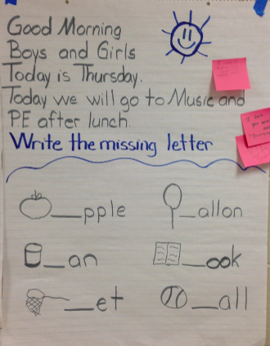  Tchart, write a lowercase l / write a capital L | *Come to the Carpet SOng/Clean Up  *Play Good Morning Song *C. Discipline  I Love You Ritual (Humpty Dumpty)  Safekeeper Ritual,  *5 C. Discipline Rules  Wish well  Attendance:  Count Around the Circle, Attendance Stick, Counting Jar  Morning Message: Fill in the missing words, match the numbers to tally marks, fix the sentence  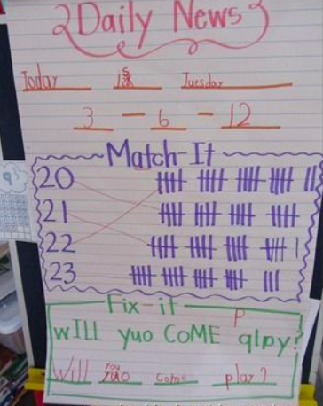  Movement songs:  https://www.youtube.com/watch?v=VFa0b_IIRac Move to the Letter Sounds  Movement songs:  https://www.youtube.com/watch?v=nAUdQZ8Xivw Rhyming | *Come to the Carpet SOng/Clean Up  *Play Good Morning Song *C. Discipline  I Love You Ritual (Humpty Dumpty)  Safekeeper Ritual,  *5 C. Discipline Rules  Wish well  Attendance:  Count Around the Circle, Attendance Stick, Counting Jar  Morning Message: Fill in the missing words, what is my sight word? Write the number word  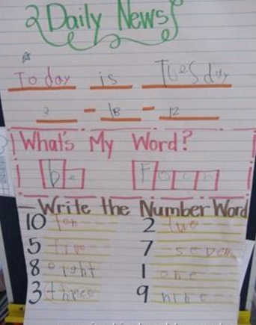
Writing TEKS:
Capitalization, and Punctuation. Students use appropriate capitalization and punctuation conventions in their compositions. Students are expected to: (A) form upper- and lower-case letters legibly using the basic conventions of print (left-toright and top-to-bottom progression); (B) capitalize the first letter in a sentence; and (C) use punctuation at the end of a sentence.
8:30-9:45  Sight Word Review/  Guided  Reading  Stations | Song: The word on the bus/Hickety Pickety  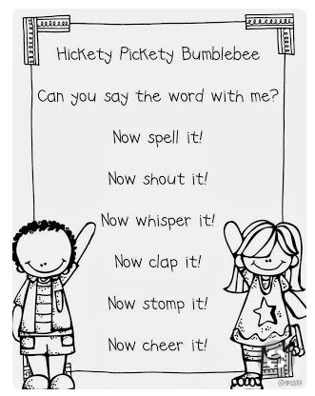  Busy Bee Stations | Song: The word on the bus/Hickety Pickety  Busy Bee Stations | Song: The word on the bus/Hickety Pickety  Busy Bee Stations | Song: The word on the bus/Hickety Pickety  Busy Bee Stations | Song: The word on the bus/Hickety Pickety  Busy Bee Stations
9:45-10:00  Interactive Writing | Senses  5 Senses Class Book Jaxon can touch ____. Kinsley can see ____. Etc. continue through week..  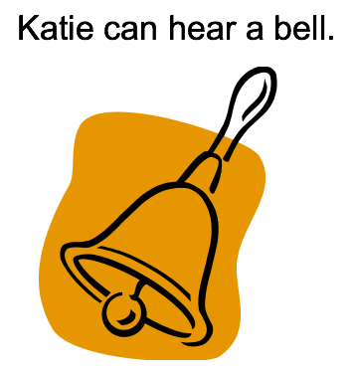 | Senses  5 Senses Class Book | Senses  5 Senses Class Book | Senses  5 Senses Class Book | Senses  5 Senses Class Book
10:00-10:20  10:30-11:00 | Recess  Lunch | Recess  Lunch | Recess  Lunch | Recess  Lunch | Recess  Lunch
11:00-11:30  11:00-11:30  Shared Reading  Mini Lesson  Poem  Review anchor charts from last week: characters, setting, making connections, Reading is Thinking, Readers Think with post-its. | Go Noodle: Unwind  Phonics TEKS: TEKS: K.7 (A): respond to rhythm and rhyme in poetry through identifying a regular beat and similarities in word sounds.  Poems: 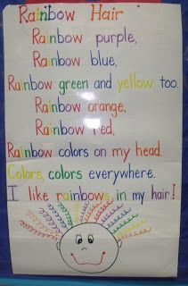  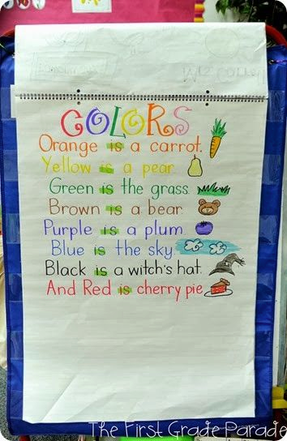  Reading TEKS:  K.6.A-identify story elements (setting)  K.4.B-ask and respond to questions about texts read aloud  Big Books: Mouse Paint, White Rabbit  Locate letter, word, sentence and color words.  Other big book options: Brown Bear, Brown Bear, what do you see?  Review Characters anchor chart. Have students draw a character that we have read about on a notecard. Make a characters anchor chart.  Phonics Lesson: Introduce sight words by doing color song. (youtube). Introduce new poems. | Go Noodle: rainbow breath  Phonics Lesson: ELC 3 Phonics Lesson- “Hearing Words in Sentences’  Reading Mini Lesson- Give each child an index card. Have them draw the main character and color it their favorite color and write the color word to label it.  Other Options: Brown Bear story elements activities, (highlighting color words and other sight words)  Or Feeling Buddies, pg. 53 Strong Emotions  Make Feelings Bottle (red food coloring with water)  Sing #15 In My Body  Talk about how strong emotions feel in our bodies  Looks like (face, hands, arms)  Sounds like (voice)  Review what angry says: I’ll rant and I’ll rave. Something’s bugging me! Nothing will change until I breathe. (show feelings bottle, shake up)  Review being a STAR  Repeat and discuss when feeling Scared  Sing #23 Solutions  Choose one activity:  Page 3.1A - students color bottles to represent calm Vs angry  Or  Practice breathing by smelling a flower and blowing out a pretend candle | Go Noodle: chillax  Phonics Lessons: Color word poems- highlight color words and other sight words  Reading Mini Lesson-  Review Setting Anchor Chart:  Give each child a notecard. Have them draw a picture of a story setting. Make a story setting anchor chart. | Go Noodle: Super Scooper  Phonics: Lessons: PA3 “Hearing Rhymes” ( I will have picture cards for you)  Reading MIni Lesson- Read big book and locate punctuation.  Or Feeling Buddies  Pg. 58 Belly Breathing  Sing Breathe #2  Discuss when a feeling gets ahold of your, 1st step is go to the safe place, then step #2 is to choose a way to calm down (breathing)  Today we are going to talk about belly breathing.  Put hands on bellies close to belly button, inhale through nose while belly goes out  Exhale through mouth and belly goies in  Pass out a small book for each child to use have student lay on floor in circle with feet out, place book on belly, then practice breathing so book rises up and down  Sing breathe #2  Create anchor chart  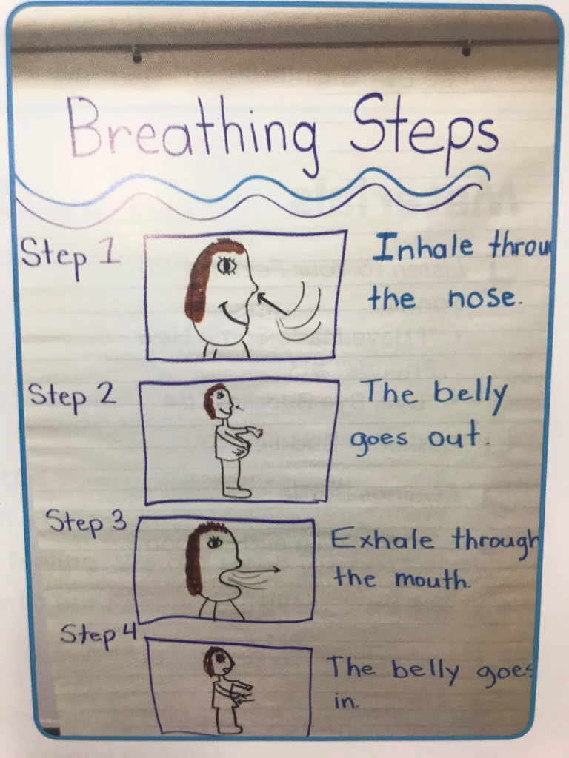  Have students create their own star wand to help them remember to be a STAR  Star cut out, popcicle stick and ribbon if you want | Go Noodle: Switch  During read aloud time, practice using post-its to think as we read. Reading is Thinking activity: Discuss how readers are always thinking as they read/asking questions about the story. Get a bowl and pour in some baking soda. Before pouring in the vinegar, talk about how our brains should be bubbling with questions like this: Pour in vinegar!
11:30-12:30  Number Talk  Problem Solving  Math  Small Groups | K.7 (A) Give an example of a measureable attribute of a given object, including length, capacity, and weight  Number Talk: Use a rekenrek today. Discuss that the ones you move over are “In play.” Those are the ones they need to count.  Ask: What do you see? How do you see it? Allow time for students to share strategies (counting on, counted by ones, grouping, any other strategy)  # of the day  Math Mini Lesson:  Measurement Anchor:  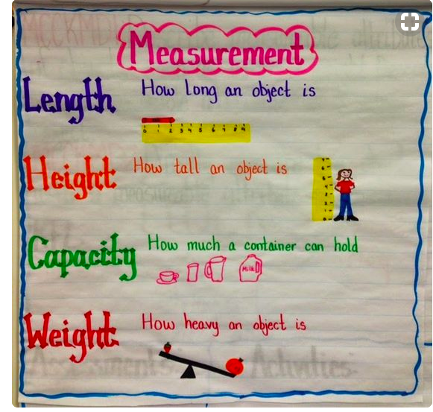  Explore math manipulatives (cubes, bears, blocks, etc…) Discuss/compare measurable attributes. Ex. The rectangular prism is bigger/longer than the cube. Allow students to draw things in their math journals comparing length or size.  Math by Myself:  -Halloween Centers  -Any Shape Games  -Any Number Sense Game Taught (five in a row, roll and build, etc….)  -Counting w/Play Doh  -QR Code Math  -Large #line game  -Magnetic Number Game  -Subitizing puzzles  -Make shapes with geoboards  Math with Someone:  Allow students to use square tiles to measure their feet. They can work in partners. Afterwards, complete the My foot is ____ squares long using cut out paper squares.  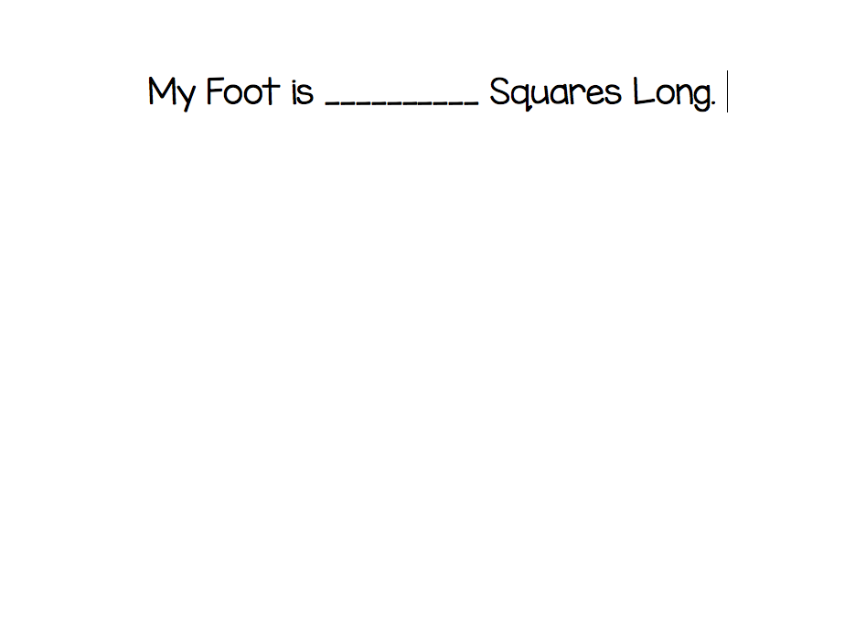  Students will trace their foot and glue paper squares across.  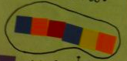  Math in Writing:  -Finish any Math Journals Needed:  -How many apples tall are you?  -Ten Frames from last week.  Math with Teacher:  Introduce Game:  Roll and Record 2 (#s 2-9)  -roll the dice. Whatever is rolled the student can write it in that correct column. Challenge them to write the # in different ways (numeral, tally marks, dots, objects, etc…)  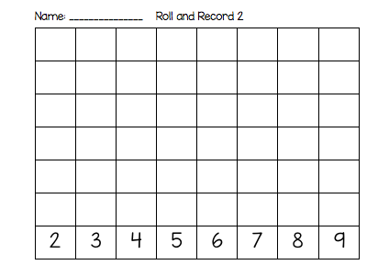 | Number Talk: PowerPoint: What Does Not Belong?  -Show slides  Ask: “What does not belong? Why does it not belong? There can be multiple answers.  # of the day  *Math Center Rotation: Reference Monday | Number Talk: Dot Cards Peek and Build (October)  Ask: “What do you see? How do you see it?” Allow time for students to share strategies (counting on, counted by ones, grouping, any other strategy)  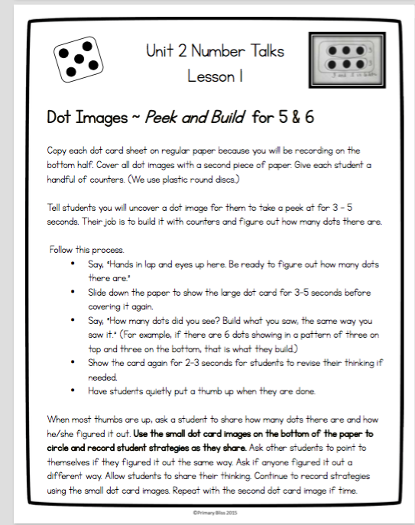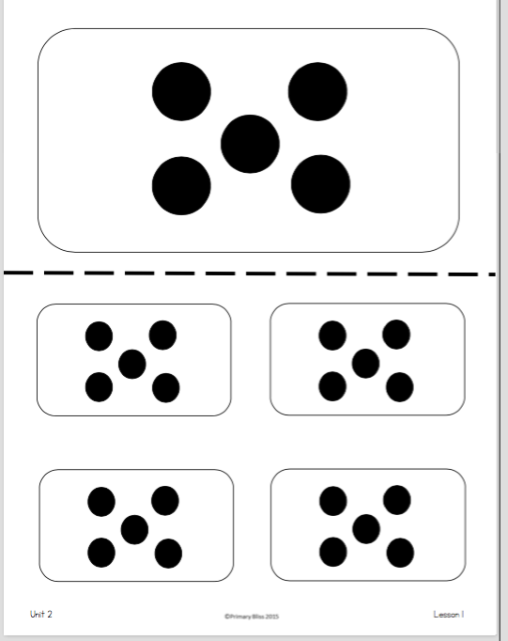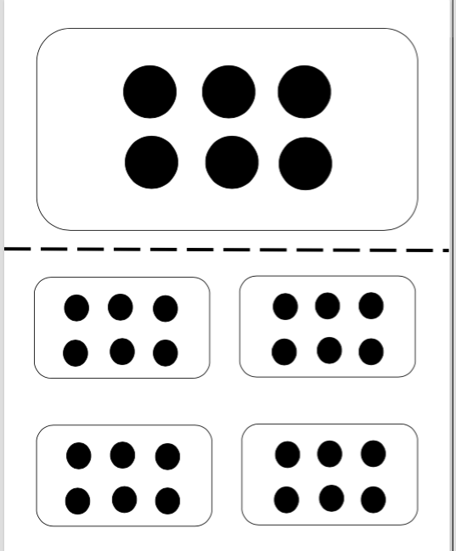  Whole Group Math Today due to Character Ed:  Teach Games: Race to Ten!/Race to Twenty (higher level learners)  -Roll the Dice (+1, +2, +3, -1, -2, -3) whatever is rolled, the students must put that me counters on or take that many away. The first to 10 or 20 wins!  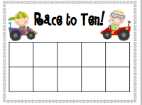  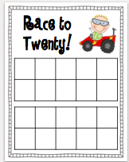  Math Lesson: Measuring with cubes. Show students some items that you are going to measure. Model how to measure a pencil using cubes. Allow students to help you measure. Do the same thing with other items around the classroom.  Activity: Have students use measuring tools to measure the measuring cards.  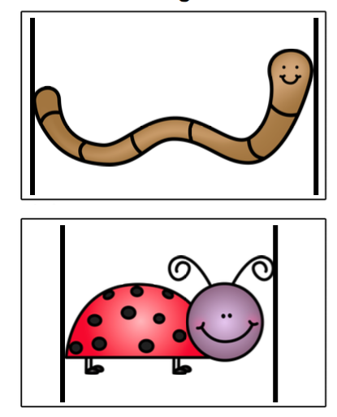  They can use cubes, square tiles, pom poms, etc…. To measure. Write recording in math journal with mini pictures of measuring cards.  Character Ed | Problem Solving:  Who Has More?  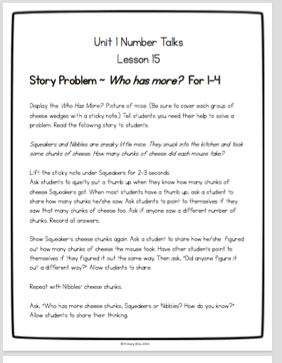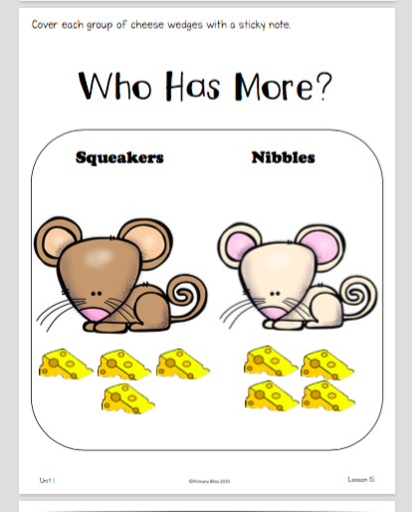  Whole Group : Using your balance, measure different items around the classroom to see what is heavier. Make a list of things that are heavier than us.  Then, complete:  A _____ is heavier than me.  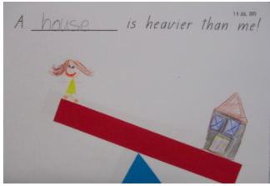  *Math Center Rotation: Reference Monday | # of the day  (Ways to Make a #)  Whole Group:  Allow several students to come up and grab a handful of cubes. Make a prediction of how many they might be able to grab. Discuss:  Mary Beth grabbed 12 and Jaxon grabbed 8. Why do you think they grabbed that many? Why weren’t they able to grab the same amount?  Activity: Using cups of different sizes, have students see which containers can hold the most beans, rice or whatever you have on hand.  *Math Center Rotation: Reference Monday
12:30-1:15  Peripherals | Bradley:  Busha:  Edwards:  Hoyt:  Stagner: R.Bodies  Wingo: | Bradley:  Busha:  Edwards:  Hoyt:  Stagner: Technology  Wingo: | Bradley:  Busha:  Edwards:  Hoyt:  Stagner: P.E.  Wingo: | Bradley:  Busha:  Edwards:  Hoyt:  Stagner: P.E.  Wingo: | Bradley:  Busha:  Edwards:  Hoyt:  Stagner: Music  Wingo:
1:15-1:40  Recess  Snack Time  Penmanship | Handwriting: catch up on any letters or numbers we have done so far  https://www.youtube.com/watch?v=liKBXp5kdL8 Dr. Jean Numeral Song  https://www.youtube.com/watch?v=2X-HAFPHBzg Harry Kindergarten Numeral Writing  https://www.youtube.com/watch?v=qfcbWmASibk Jack Hartman Number Writing Song  Writing TEKS:  Capitalization, and Punctuation. Students use appropriate capitalization and punctuation conventions in their compositions. Students are expected to: (A) form upper- and lower-case letters legibly using the basic conventions of print (left-toright and top-to-bottom progression); (B) capitalize the first letter in a sentence; and (C) use punctuation at the end of a sentence.
1:40-1:55  Calendar Routine/Number Corner  1:55-2:15  Writer’s Workshop | Number Corner:  October Song-Jack Hartmann  Youtube Counting Songs.  *Calendar: today, yesterday, tomorrow  Review: counting forward and backwards to 20, 1 more/1 less, Counting by Tens.  Review ways to make a number briefly.  *Attendance Stick Activities  (Investigations)/  Together come up with the date and write it on the board. Count the numbers aloud from 1 to today’s date.  ----------------------------  Mini lesson:  Introduce Writing Reference Folders: have students write sight words that dthey know in their folders, review halloween words in folder whole group  Mini lesson - Using sentence frames to help us write. Make a sentence frame poster (post in writing center after todays group lesson)  Review sight words we know, Make sentence frames using sight words we have learned. Model using sentence frames to write about Halloween Stickers. Have students write in journals using Halloween stickers.  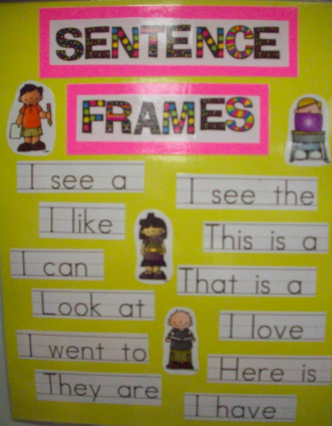  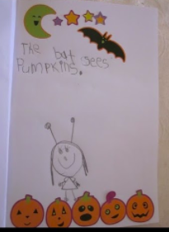 | Number Corner:  October Song-Jack Hartmann  Youtube Counting Songs.  *Calendar: today, yesterday, tomorrow  Review: counting forward and backwards to 20, 1 more/1 less, Counting by Tens.  Review ways to make a number briefly.  *Attendance Stick Activities  (Investigations  ------------------------------  Mini lesson:  Read the book, Library Mouse or watch it on youtube with this link  https://www.youtube.com/watch?v=qfyBT8BIUSI discuss: What is a writer? A writer is someone who shares stories or information. In the book, Sam wrote many stories. He was just a little library mouse, but he was a writer! Share some of the stories you have read already this year. The authors of these books got an idea in their head and decided to write it down. Explain to students that this year, THEY will be writers! Write on the top of a handheld mirror “I am a writer!” and pass it around so students can see their reflection.  Review the paper in Writer reference folder (I can spell color/number words) Have students draw and write about an idea they have in their head in their journals. | Number Corner:  October Song-Jack Hartmann  Youtube Counting Songs.  *Calendar: today, yesterday, tomorrow  Review: counting forward and backwards to 20, 1 more/1 less, Counting by Tens.  Review ways to make a number briefly.  *Attendance Stick Activities  (Investigations  --------------------------------  Mini lesson - How do authors get ideas about what to write? “Authors write about things they know a lot about or things they care about. Eric Carle writes about insects bc he knows a lot about insects. I’m going to make a heart map. This will remind me of things I can write about. Draw a large heart on chart paper. I’m going to divide my heart map into four parts. I’m thinking of things I love or know a lot about. Model. Now each of you can make your own heart map and draw pictures for your heart map.  Pass out heart map paper for students to draw and take dictation. Add students heart maps to their writing reference folder. | Number Corner:  October Song-Jack Hartmann  Youtube Counting Songs.  *Calendar: today, yesterday, tomorrow  Review: counting forward and backwards to 20, 1 more/1 less, Counting by Tens.  Review ways to make a number briefly.  *Attendance Stick Activities  (Investigations  ----------------------------  Mini lesson -  create an anchor chart for what writers do Discuss how writers follow these steps to create their stories.  Pass out the cut/paste activity to put the steps in order and trace the words. 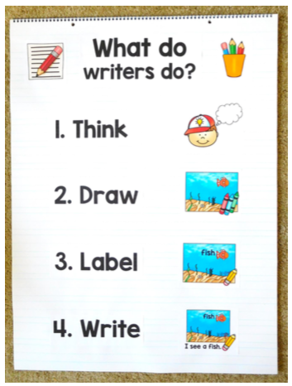  Add to their writing reference folder. | Early Release  Number Corner:  October Song-Jack Hartmann  Youtube Counting Songs.  *Calendar: today, yesterday, tomorrow  Review: counting forward and backwards to 20, 1 more/1 less, Counting by Tens.  Review ways to make a number briefly.  *Attendance Stick Activities  (Investigations  ---------------------------  This week we made our heart map. It reminds us of things we can write about. Discuss that our journal is what we can write in every day. Look at your heart map and decide what you want to write in your journal. Allow time for children to write in journal and take dictation as time allows but clean up in time for Author’s Chair  Mini lesson - Author’s Chair, Who remember what an author/illustrator do? We are all authors and illustrators. We are going to share our stories with each other. Choose 2-3 kids to show journal entry and describe what they wrote. Point out details in writing, offer suggestions if words do not match pictures, end with complement of sharing/writing.
2:15-2:40  Social Studies  Science | TEKS:  K.6A  use the five senses to explore different forms of energy such as light, heat, and sound;  Five Senses  Read My Five Senses  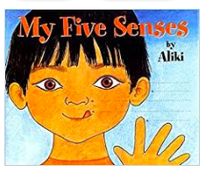  Brainpopjr.com: Senses  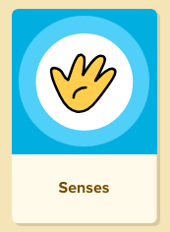  Five Senses Song:  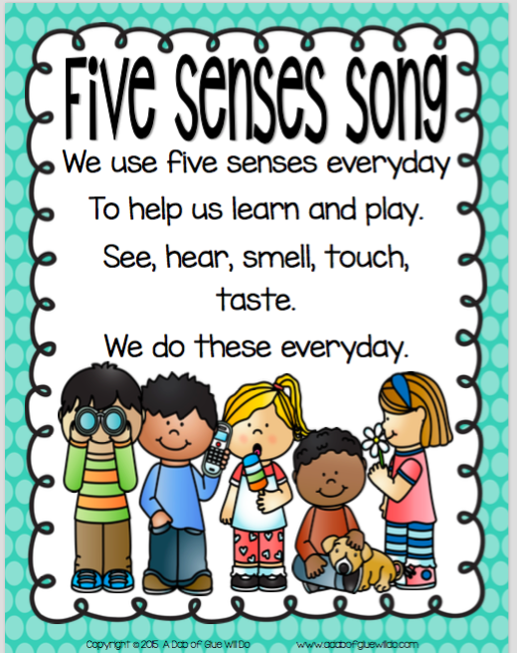  See: Chart: What did you see on our nature walk? Have kiddow draw a picture of what they saw on a notecard and label it. | TEKS:  Five Senses Song Jack Hartmann  https://www.youtube.com/watch?v=TtL11JXG1mc  Smell: Make a web/brainstorm list of things children can smell  Illustrate and write about something you can smell.  Smelling Jars:  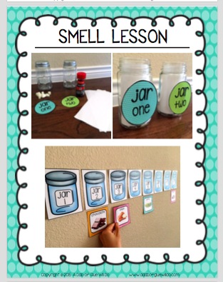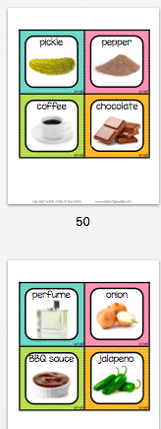 | TEKS:  Five Senses  Read The Listening Walk  https://www.youtube.com/watch?v=kzQOdEAIH5E  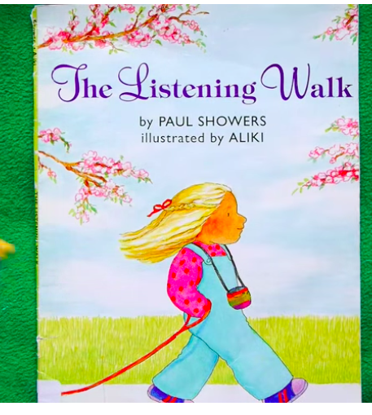  Hear: Go on a Listening Walk  Anchor Chart: What did you hear on our listening walk?  Have students draw a picture of what they saw on a notecard and label it.  Sound Shaker Game:  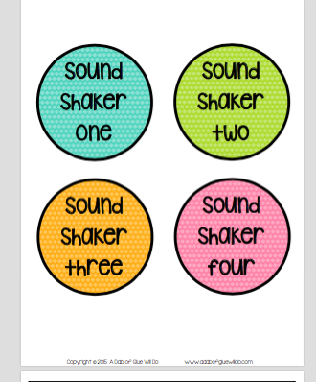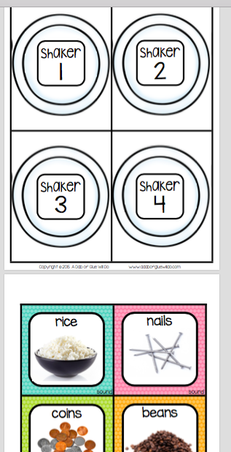 | TEKS  Five Senses  Touch:  Make a web/brainstorm list of things children can touch  Illustrate and write about something you can touch.:  Touch Bags:  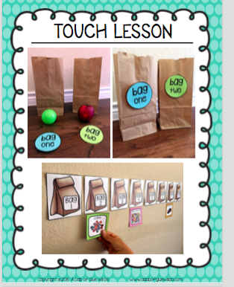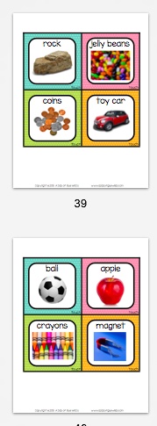 | TEKS:  Five Senses  Taste:  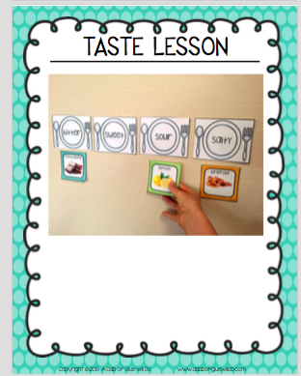
2:40-2:50  Pack Up  2:55 Car Riders  3:00 Buses | Subitizing Race  *Send Home Verbal Counting Letter and Limeades for Learning Letter | Race to the Top with Sight Words Game  *Send Home 3D Shape Letter | Subitizing Race | Race to the Top with Sight Words Game

