Missouri Department of Elementary and Secondary Education

School Improvement Initiatives

Missouri
Professional Learning Communities
Sustaining Exemplary PLC School Application

- Introduction
- Part I – School Demographic Information
- Part II – Documentation of Sustaining Evidence
- Part III – Supporting Student Achievement Data
- Part IV – Summary and Supporting Documentation

Missouri Professional Learning Communities
Sustaining Exemplary School Application

Introduction

Successful completion of this process will result in a school’s two-year designation as a Sustaining Exemplary PLC School. To be considered for this status, it is necessary for a school to complete and submit this application to the selection committee regarding implementation of the PLC practices, structures, and culture which have been sustained at the proficient and/or deep level since initial recognition. This application is to be used by those previously recognized as Exemplary PLC Schools at least two years earlier.

To receive this recognition, a school must:
- Submit an email indicating intent to seek designation as a Sustaining Exemplary PLC School to the PLC Field Director, Dr. Rob Gordon (gordonrl@missouri.edu) by August 17, 2017.
- Complete a perceptual survey, the MO PLC Benchmark Assessment.
- Demonstrate continued high academic achievement as determined by the school’s academic indicators on, but not limited to, the state Annual Performance Report.
- Complete and submit an electronic copy (not a “scanned” version) of this application to the PLC Field Director by October 27, 2017. In order to make artifacts accessible, you may wish to save this document, as well as hyperlinked artifacts, in a folder via Google or Dropbox.

This application is not intended to be completed by a single individual but rather by a collaborative group who have fully participated in the PLC school improvement process. Consider this application an opportunity to assess and reflect on your progress as a sustaining professional learning community, as well as an opportunity to identify meaningful steps to sustain the collective capacity of the staff in this powerful school improvement process.
Part I: School Demographic Information

Please fill in the requested information below
Official Name of District: Fulton Public Schools
Official Name of School: Bartley Elementary
School Mailing Address: 603 S. Business 54, Fulton, MO 65251
Telephone: 573-590-8300 |  | Website: www.fulton58.org/vnews/display.v/SEC/Bartley%20Elementary
RPDC Region: HOM Hook Center | When did you last receive formal training and support from MO PLC?: We currently receive support with on-site visits 3 times per year. Formal training in Columbia concluded in 2015.
Name of Principal: Connie Epperson
Principal Email Address: cepperson@fulton58.org
Name of Superintendent: Jacque Cowherd
Superintendent Email Address: jcowherd@fulton58.org
Number of Students: 260 | Number of Staff: 22 certified, 34 total | % Free/Reduced: current 45% (lowest in recent history)

In 150 to 250 words, share some general information describing your school. Where are you located, what are some specific dynamics about your school/district that impact your work with children. What is unique about your school?
Bartley Elementary is one of three elementary schools in the Fulton Public Schools district. We have 260 students enrolled in our school of which approximately forty five percent are on a free and reduced lunch rate. Our school has implemented PBIS for the last eleven years and have been identified as a gold level recipient the last three years. Once our building started training in the PLC model, we found the perfect compliment to our PBIS program. Not only have we seen student office referral rates go down, but we have seen academic efforts improve. For the last five years, we have shown tremendous growth in our student achievement and we have made systematic program changes that have continued to maximize that growth. These changes are primarily due to our focused efforts to reach all student needs while maintaining high expectations for all students. A prime example of our efforts was illustrated during the 2016 MAP testing when our free and reduced student population (56%) scored higher than our non-free and reduced students on the Math MAP. Additionally, our super subgroup students in both ELA and Math generally score higher than the overall state average or just right at it. This is remarkable given our MAP scores prior to becoming a Professional Learning Communities school.

Part II: Documentation of Sustaining Evidence

In the table provided below, consider the “Outcomes” and the “Related IR Indicators” to be reviewed for sustaining exemplary PLC status. Given the descriptions of outcome evidence and the examples of where and how evidence is recorded and shared, provide a brief narrative (150 to 250 words) documenting your sustained work within each outcomes category. Also, provide no more than 2 to 4 hyperlinks to additional evidence (examples, pictures, documents, data, etc.) lending support to your proficient/deep implementation in each of the areas below.

Evidence of Sustaining Exemplary PLC Status

Outcome |  | Related Implementation Rubric (IR) Indicator
1 | “Living” Your Mission a | 1.A. | The school community regularly revisits and aligns all relevant decisions to the mission. Staff and students can articulate the mission.
 | “Living” Your Vision | 1.B. | The school community regularly revisits the vision, including planning and documenting progress toward achieving the vision. All decisions are aligned to the vision.
Description of Outcome Evidence |  |  |  | Examples of where and how evidence is recorded and shared
Displays of mission and vision; Evidence that teachers are engaged in activities to more deeply understand the mission and vision (unwrapping); Teachers can articulate the mission and its meaning; Students can articulate the mission and it's meaning to them. Staff can share the vision of the school. |  |  |  | Creative displays of mission in hallways and classrooms, websites, social media. Video of staff and/or students articulating living the mission. The vision is prominently available to staff in planning documents.
Narrative (150 to 250 words) |  |  |  | Links to Evidence
At the beginning of every school year our teachers discuss our mission and vision. We decide if there is anything we would like to add to our mission or vision or if there is anything we would like to take out. As a staff we feel it is important to make sure that our mission and vision are something we can live by everyday. If it is not something we feel we can continue to live by then we must change it. Our teachers plan activities for our students to try to understand what our mission and vision mean. We try to teach our students that everyone in the building is responsible for helping them learn. We also make sure that as teachers we are living our mission and vision every day. We have Wednesday Huddle every other Wednesday and we always break from our meeting saying “We are One!” Our mission is displayed throughout our building as a reminder to our students and staff on what we expect of them everyday. We even post our mission and our vision on our website so anyone interested in Bartley Elementary can see it. |  |  |  | - Mission, Vision, Collective Commitments  - Hallway Display  - Saylor Mission  - Elias Mission  - Houseworth Mission  - We are Oe
Outcome |  | Related Implementation Rubric (IR) Indicator
2 | Monitoring of Collective Commitments/Action Plans | 1.C. | Staff members annually revisit collective commitments and values and are mutually accountable.
Description of Outcome Evidence |  |  |  | Examples of where and how evidence is recorded and shared
Describe what you have done to monitor the progress toward implementation of your collective commitments; Action plan with goals, timelines with regular revisits and monitoring, assessments, result indicators; Documentation of feedback given to teams on their implementation of collective commitments. |  |  |  | Evidence in team notebooks, electronic shared drive, videoed interviews describing actions, etc.
Narrative (150 to 250 words) |  |  |  | Links to Evidence
Our staff-created collective commitments are re-evaluated every year. Prior to the first day of school, we review our collective commitments and make sure that everyone can commit to what we are asking of them. As a building we feel that if everyone has taken ownership of our collective commitments then it is something that they agree they are going to focus on. One commitment is observing other teachers. We have a board in our workroom with a picture of every teacher in our building. When a teacher observes another teacher they are to put a sticker by that teacher’s picture. This helps us remember that we need to observe others and hanging it in the workroom is a reminder to all staff. Also, our workroom has a bulletin board with a spot for each grade level. The board is for teachers to put something up there that worked really well in their class. This can be an activity they did or a graphic organizer they used. Our building has a facebook group that is private to just Bartley teachers and we can post things in the facebook group as well. Our data meeting agendas are driven by the Four Corollary Questions with a focus on our collective commitments. Every grade level uses the same agenda so we know that in our meetings we are going to stay focused and data driven. |  |  |  | - Collective Commitments  - Hallway Display  - Teacher Observations  - Teacher Shareboard  - PE Agenda  - Bartley Shareboard 1  - Bartley Shareboard 2  - Bartley Shareboard 3
Outcome |  | Related Implementation Rubric (IR) Indicator
3 | Leadership Team Support | 2.A. | The leadership team applies practices of shared leadership with delineation of roles, processes and responsibilities. The leadership team includes representation from collaborative teams.
 |  | 2.D. | The leadership team progress monitors the work of collaborative teams, including team and school goals, as well as the use of team processes and team functioning.
 |  | 2.E. | The leadership team regularly provides feedback to the collaborative teams through review of agendas and on all teaming practices to ensure fidelity of PLC implementation.
Description of Outcome Evidence |  |  |  | Examples of where and how evidence is recorded and shared
The leadership team has direct representation from all grade levels and/or subject area departments, as well as instructional ancillary staff. Leadership team members should share roles, and are intentional about monitoring the effective work of collaborative teams. |  |  |  | Examples of communication with collaborative teams, rosters of leadership team members, and any tools or processes used to monitor the work of collaborative teams and where the leadership team has provided feedback on team productivity.
Narrative (150 to 250 words) |  |  |  | Links to Evidence/Documents
The leadership team at Bartley is made up of five people. We have representation from our lower grades, upper grades, an academic interventionist, a content specialist, and our principal. Each year, we have at least one of our team members rotate off. All staff are encouraged to fill out an application if they are interested in being a part of the leadership team. Questions are designed specifically toward PLC processes and the four corollary questions. Then, the applications are disseminated to our faculty who determine the members of the leadership team by a vote. This process has actually built trust among our staff.  Our leadership team meets at a minimum twice per month. However, we meet many times over the summer to prepare for and organize for the new year and new staff. Each year we reflect on ways we can improve our leadership within the building. We consistently discuss our current reality and if it is not what we want, rather than placing blame, we look within if we believe we could have done something better. Presuming positive intentions is critical in our building. It creates a better mindset and greater collaborative efforts among our staff.  Within the leadership team, we take specific roles and follow our building norms. Sharing in responsibilities has helped us demonstrate balance and increased efficiency. Our team is able to access grade level data team information within Google Classroom and feedback is provided both at the meeting and via comments within the Google Classroom. |  |  |  | - Grade Level Team Fidelity Checklist  - Leadership Team Fidelity Checklist  - Leadership Team Agenda 9/1  - Leadership Team Agenda 10/13  - Bloogger post example on feedback
Outcome |  | Related Implementation Rubric (IR) Indicator
4 | Collaborative Team Focused Work | 3.A. | Every member of the educational staff participates on a collaborative team specifically aligned with his/her role and teaching assignment. Both horizontal and vertical teaming is evident.
 |  | 4.F. | The school uses a systematic recording and communication mechanism to maintain an accurate record of conversations and work completed through collectively agreed upon agendas/minutes which reflect the four corollary questions (what we want students to know and do, how do we know they are learning, what do we do when they aren’t learning, and what do we do when they do learn what is expected.) Records are accessible between teams.
Description of Outcome Evidence |  |  |  | Examples of where and how evidence is recorded and shared
Samples of team agendas showing the 4 corollary questions are routinely addressed. |  |  |  | Evidence in team notebooks, documents, and/or electronic shared drive of the work of collaborative data teams; also rosters of teams and team members.
Narrative (150 to 250 words) |  |  |  | Links to Evidence
Grade level data teams meet bi-monthly before the school day begins with the following team members: grade level teachers, principal, reading interventionists, counselor, and special education teacher. The grade level teachers create the agenda based around the four corollary questions during daily collaborative time. The agenda is shared prior to the data team meeting, several days in advance so that input from the data team can be added prior to our meeting. The agenda is a common document utilized by each grade level. Besides the four corollary questions, the agenda also looks at strategies used for instruction, celebrations, and reflections of our classroom instruction. We use Google Classroom as a common location for all classroom teachers to share their data team agendas. By sharing our data team agendas with each other, Google Classroom gives us the opportunity to provide feedback and ideas for instructional strategies to other classroom teachers. |  |  |  | - 4th Grade Data Team Agenda  - Third Grade Google Classroom  - Kindergarten Smart Goal
Outcome |  | Related Implementation Rubric (IR) Indicator
5 | Focus on Results from Data | 3.D. | Teams regularly use an easily accessible format for collecting, recording and analyzing student work and data to drive instruction and identify students in need of additional assistance. Team results are shared and analyzed regularly within and across teams.
Description of Outcome Evidence |  |  |  | Examples of where and how evidence is recorded and shared
The work of collaborative data teams should focus upon data which informs the four corollary questions. Evidence should include data which is visually displayed or is shared through a common electronic system. |  |  |  | Pictures of data displayed in hallways and classrooms; team notebooks; electronic shared drives; examples of data cycles, etc.
Narrative (150 to 250 words) |  |  |  | Links to Evidence
Utilizing Google Classroom, all classroom teachers provide evidence for the four corollary questions by using data binders, S.M.A.R.T. goal data displays, goal setting charts, and rubrics. Data is visually transparent to everyone entering Bartley Elementary. When we analyze each of the four corollary questions, we break it down to specifically include evidence of student learning. At the beginning, middle, and end of each school year, we use DIBELS as a benchmark screener for all students kindergarten through fifth grade. Each data team meets with the reading interventionists to analyze the data results to create a plan for our response to intervention (RTI). Bi-monthly, data teams meet to provide and analyze the data that drives our instruction and identifies students in need of additional interventions. Accelerated Reading and Accelerated Math goals are established for grades one through five. These goals are displayed so that students can see their progress. |  |  |  | - Kindergarten Smart Goal  - Third Grade Self-Assessment  - Fourth Grade AR  - Data Binder  - Reading Data  - Math Data
Outcome |  | Related Implementation Rubric (IR) Indicator
6 | Evidence of student involvement in their own assessment monitoring | 5.D. | Teams have developed and applied strategies for engaging students in the assessment process.
Description of Outcome Evidence |  |  |  | Examples of where and how evidence is recorded and shared
Student portfolio examples; Student self-assessment examples; Team agenda and minutes; Students can articulate their self-monitoring and use key terminology. |  |  |  | Evidence of implementation in this area might include clear and understandable learning targets, anchor/criteria charts, student self monitoring and reflection, students tracking and recording their own learning, students goal setting and monitoring their own action steps, student led conferences.
Narrative (300 words or less) |  |  |  | Links to Evidence
Students at Bartley Elementary are actively involved in tracking and monitoring their individual assessment results. In some classrooms, Google Classroom is employed and students are able to monitor their formative assessments. Most classrooms use data binders which allow students to monitor their progress on SMART goals, standardized reading and math assessments and report card objectives. Students also track their own progress during intervention time. Students are informed of their individual goals and most can tell how they are progressing toward mastery when asked. Learning targets are posted in classrooms and many teachers recite the appropriate learning target with the class before engaging in instruction. Learning targets are in user-friendly language so that all students understand what they need to accomplish. Our teachers implement anchor and criteria charts and also share these resources with their colleagues. When a criteria chart is employed, it is devised with student input to further ensure student understanding and buy-in. Student-parent-teacher conferences are held twice a year. Spring conferences are student led and the students are responsible for explaining data folders and progress toward their goals to their parents. |  |  |  | - Dibels Progress Monitoring  - Student Progress Monitoring on AR  - Student Created Criteria Chart  - Anchor Chart  - Google Classroom Student Accountability
Outcome |  | Related Implementation Rubric (IR) Indicator
7 | Establishment of Tiered Intervention Strategies | 6.D. | The school implements the essential components of a Tier 2 intervention plan: identification of intentional non-learners and failed learners; targeted, timely and directive instruction and assessment; data-driven decisions based upon multiple sources; more frequent progress monitoring.
 |  | 6.E. | The school implements the essential components of a Tier 3 intervention plan: multiple sources of data to identify root causes of failed learning; specific, more intensive support delivered by trained professionals; targeted assessments for timely progress monitoring.
Description of Outcome Evidence |  |  |  | Examples of where and how evidence is recorded and shared
A building wide commitment to providing timely interventions to students in need of additional assistance. Evidence of Tier II and Tier III interventions might include building schedules, RtI documents, progress monitoring documents, fidelity checks/check lists, etc. |  |  |  | Data walls; visual displays of data, student portfolios/notebooks, Building RtI Implementation Plan, intervention data, etc.
Narrative (150 to 250 words) |  |  |  | Links to Evidence
Our building has a very strategic plan in place for intervention. Students are benchmark tested three times during the year. After benchmark testing, grade level data teams meet, analyze data, determine appropriate intervention groups, and discuss future instruction. Our reading specialist lead these meetings. Our decision making model for intervention connects students with the types of intervention needed to improve deficit skills or conversely, to push students to higher levels of thinking that exceed benchmark expectation. We have a school-wide system for recording benchmark and progress monitoring data available to staff. Our building utilizes DIBELS, STAR Reading and Math, DRA, and Running Records. Professional development is provided for staff to enhance their instructional strategies in order to provide targeted, meaningful intervention. Within our intervention groups, progress monitoring is done weekly or biweekly depending on the intensity of the intervention. Individual intervention groups are fluid and allow for changes on a six to eight week schedule if needed. In order to maximize the use of our specialist and other staff for intervention time, we have separate times for intervention by grade, level throughout the day. This allows for smaller, more targeted groups. Additionally, we have a built in intervention time for math, mainly focusing on fact fluency. However, we also utilize Accelerated Math for students to practice appropriate math content and standards. This allows us to modify grade level objectives depending on their level of mastery. Our intervention time for both Reading and Math focus on corollary questions 3 and 4. |  |  |  | - Data binder ex. 1  - Data binder ex. 2  - Intervention data  - Data wall example

Part III: Student Achievement Data Showing Sustained and/or Improved Performance Over Time

School Annual Performance Report State Historical Data
In the tables below, provide sources of student achievement data demonstrating improved and/or sustained academic performance over time. “Over time” is generally described in terms of the past three or four years during the time staff are directly involved in professional learning community work.
- For schools with grade 3-12 state assessment data, please fill in the requested APR data in table #1, PLUS three additional sources of positive academic data in table #2.
- For schools who do NOT have state assessment data (preschools, K-2, alternative schools, etc.) disregard table #1, and provide five sources of positive academic achievement data which demonstrate performance over time.
For table #2, examples might be benchmark (common) assessments through the course of a year, universal screening results, examples of consistently effective data team cycles, etc. Show a summary of this data through graphs/charts/tables, etc. in the first cell of each data source, and then very briefly describe what this data is telling us in the second cell for each data source.

TABLE #1 Please fill in the information requested | 2014 |  | 2015 |  | 2016 |  | 2017
 | % Prof or Adv | MPI | % Prof or Adv | MPI | % Prof or Adv | MPI | % Prof or Adv | MPI
ELA Total | 62.4 | 364.8 | 65.2 | 367.4 | 75 | 383.1 | 72.8 | 382.4
Math Total | 60.8 | 373.6 | 53 | 349.2 | 61 | 367.6 | 65.4 | 382.4
ELA Subgroup | 50.7 | 338.4 | 51.2 | 331.7 | 65.1 | 359 | 58.5 | 345.1
Math Subgroup | 53.4 | 354.8 | 45.1 | 325.6 | 59 | 354.2 | 51.2 | 350
Please provide a brief explanation of your state assessment data in the cell below.
Since 2013, our building has been on an upward climb. Our building data was well below the state average and unfortunately, there was complacency within our staff as they were not alarmed by our data. After becoming a part of the PLC state initiative, in year two and three, our building really took off. I am proud to say that our school not only exceed the state’s average by a sizeable margin but our super subgroup population in ELA and Math are either right at the state average or above. Clearly, this is connected to our increased efforts to meet student needs through intervention and our constant attention to data cycles within our school. An additional change relates to the fact that our entire teaching staff “own” our data and see their significance in the overall contributions they make to help students be more successful.

Additional Positive Student Academic Achievement Evidence
TABLE #2
Please fill in the
Information requested
Data Source #1 (graph/charts/tables/etc.)
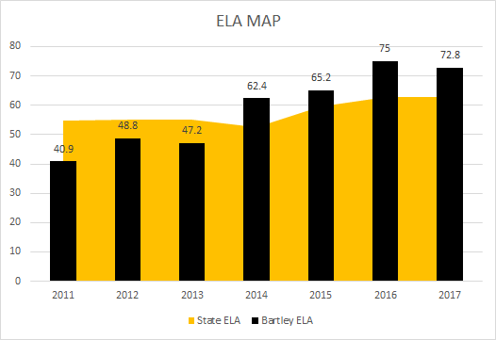
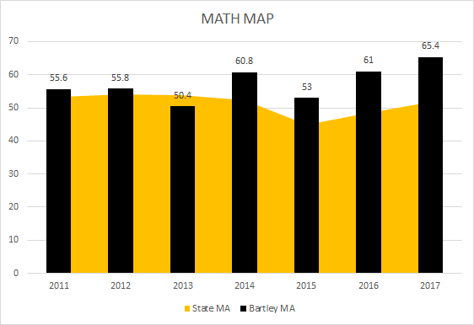

Brief explanation of data source #1
In 2012 we began our PLC training. This training provided our building with a systematic process for change. What is evident is after year two of training our building MAP scores began to show an increased level of proficiency, particularly as it relates to the state. When we first started training, we realized that our work was not cohesively connected. We determined that any building goals we developed needed to focus K-5 not just 3-5. Additionally, we developed an intervention system that looked at specific student needs. We went from a Reading Recovery model to a Title I school-wide building. This allowed us to intervene with more students and thus led us into a new RtI model. Additionally, we realized we could not intervene with 50% or greater of our students. This led to systemic changes in our Tier I instruction. These significant changes have led us to not only improved MAP scores but also to a more connected building. We view each student as “our” student and we all own their struggles or their success.
Data Source #2 (graph/charts/tables/etc.)
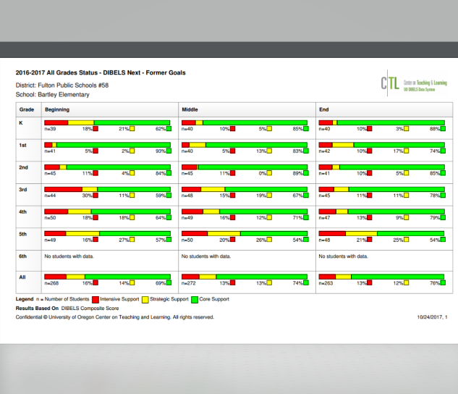

Brief explanation of data source #2
The above graph shows last school year’s benchmark data across the three benchmark screenings window. The data shows our focus of moving more students out of the tier II and tier III levels and increasing our overall success rate in the core support group. This last year, we started with only 69% of our students being in core support and we ended with 76%. While the subtests added to various grade levels show anomalies in places of our data, we are clearly aware of the increased rigor and expectation within those benchmark expectations (for example, when first grade adds DORF to their second benchmark, it impacts their data for core support). We also utilize the individual subset data for our DIBELS benchmark data to determine greatest need for intervention as well.
Data Source #3 (graph/charts/tables/etc.)
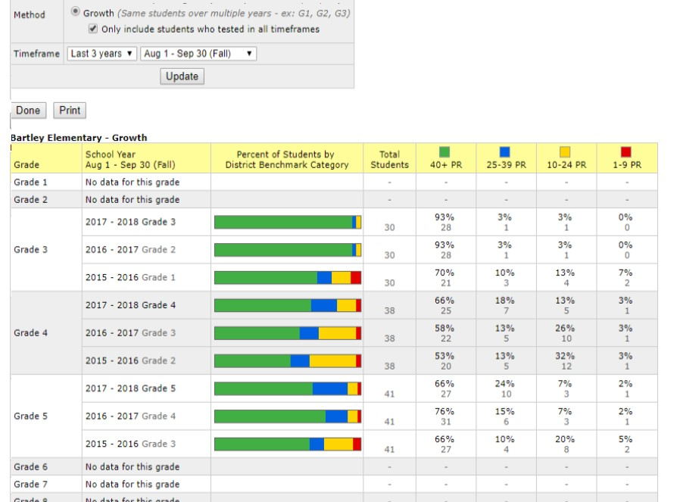
Reading STAR longitudinal data

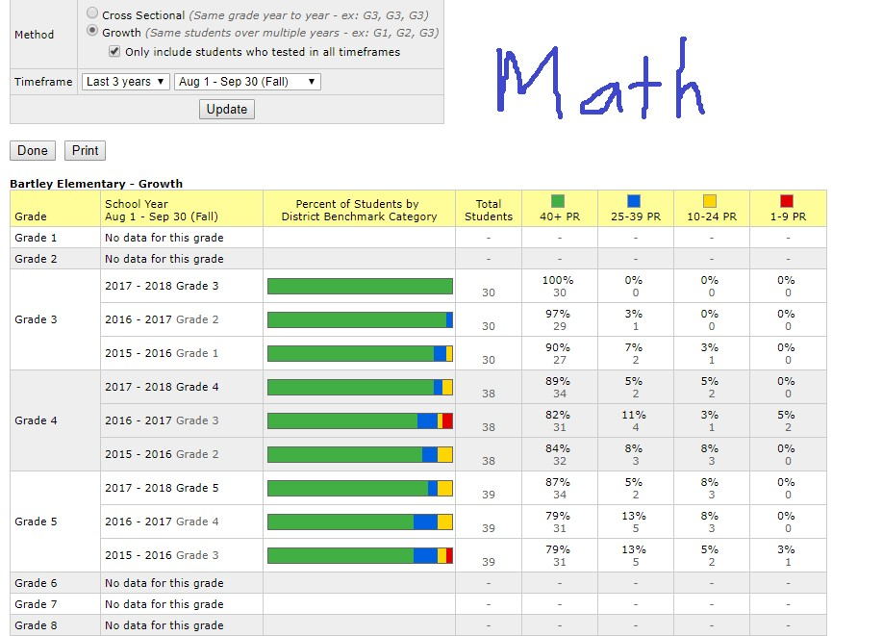
Math STAR longitudinal data

Brief explanation of data source #3
The above graphs represent both our STAR Reading and Math longitudinal data of each group of students. This allows us to see the trend data and if student groups are progressing from grade level to grade level. When appropriate, this allows up have conversation with grade levels when we see that data show students are falling off or they are excelling. This leads us into a deeper look and discussion of student data to determine what changes need to be made in instruction to improve their overall performance and progression from year to year.

Data Source #4 (graph/charts/tables/etc.)
Brief explanation of data source #4
Data Source #5 (graph/charts/tables/etc.)
Brief explanation of data source #5

Part IV: Summary and Supporting Documentation (Optional)

In the box below, please include any additional information which you feel contributes to your evidence of sustained exemplary PLC status, and which may have not been addressed in Part II of this application. Please limit your narrative to 250 words or less.

Summary and Supporting Documentation
Each of the last few years since we began our formal PLC training we have had staff turnover. Our leadership team has had to become more focused on the strategies we use to onboard new staff. It has been critical for us to support our new staff and their understanding of the practices and the “why” behind our work. This last year, we have been more intentional in this process and have laid out a plan for new staff to follow as well. This included the development of a handbook for new staff that outlines our building expectations and processes we use to collect data, utilization of programs, and our overall plan for success. We realized after a year that included some frustrations that our efforts to be more intentional in bringing new staff up to speed was critical.
Our constant attention to data, developing strong teaching strategies that can be adaptable to all grade levels, and purposeful celebration of students and staff efforts and commitment, have resulted in higher levels of student achievement. This is true of our formative data, summative data, building SMART goal data and of our MAP achievement.
This work has not been easy, however, the rewards we have seen have been worth the efforts our staff have put into becoming a Professional Learning Community. The level of pride and trust within our building is at an all time high. Our leadership team takes their responsibility and role seriously and we constantly reflect on what we are doing to ensure our building is moving forward to be the best we can be.

