**Control vs. No Control**

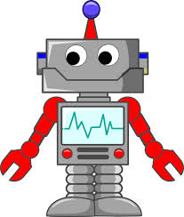**What CAN we control? **

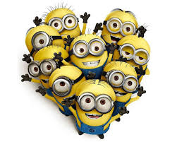**What CAN’T we control? **