MC900230931[1]

Collaborative Team (CT)

Manual

Centreville Elementary School

2012-2013

**Things to think about as we start a new school year at CES…**

**If you want to go fast, go alone. If you want to go far, go together.**

**-African proverb**

**The very essence of a learning community is a focus on and a commitment to the learning of each student.**

**-Richard and Rebecca DuFour**

Our School Philosophy

We believe that all children are inherently talented and we are committed to the success of every student. We’d like to give you an overview of our school so that you can determine if CES would provide the kind of working environment in which you would thrive and grow as a professional.

At our core, at CES we operate as a Professional Learning Community (PLC). As a school-wide professional learning community, we believe that we provide the pathway for all children to develop their talents to be successful at the highest level. We commit to learn and put into practice the best research-based instructional and assessment practices that fully engage our students and result in measurable progress. Each team has a mandatory weekly PLC work sessions in which they engage collaboratively to unpack the standards of the Program of Studies, design assessment and instructional practices, examine assessment results, plan remediation and enrichment activities, participate in collaborative learning visits and celebrate success.

We believe that optimism and positive relationships are the foundation of trust, respect, and strong character. CES has embraced the Positive Behavior Intervention Support (PBIS) program and works collectively and collaboratively to ensure a safe and child-friendly learning environment.

We believe that the integration of the arts, technology, and outdoor learning are essential pieces of a quality education and strive to make them a part of the daily lives of our students. These highly engaging integrated learning opportunities seek to capitalize on our students strengths and enhance their higher order thinking skills.

We are committed to valuing each encounter with every person within our school community as an instructional/learning opportunity. We believe that we are a vital part of the community which we are honored to serve. As such, we take an active part in PTA events and support their efforts. We reach out to build relationships and communicate positively and proactively in ways which support our children, school and community.

Dwayne Young, Principal

**Contents**

* **PLC - What? Why?**
* **Getting Started**
* **PLC Work Sessions**
* **Appendix**
* **Bibliography**

PLC -What? Why?

There are so many things that take place in the school year that it is sometimes difficult to remember all the important details that surround and help support a functioning Collaborative Team (CT). You will find many different resources to help meet the needs for CTs and build capacity for each team/teacher.

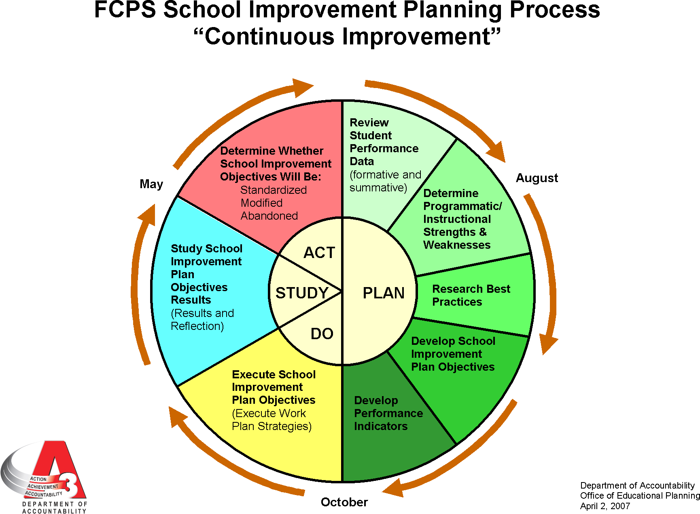

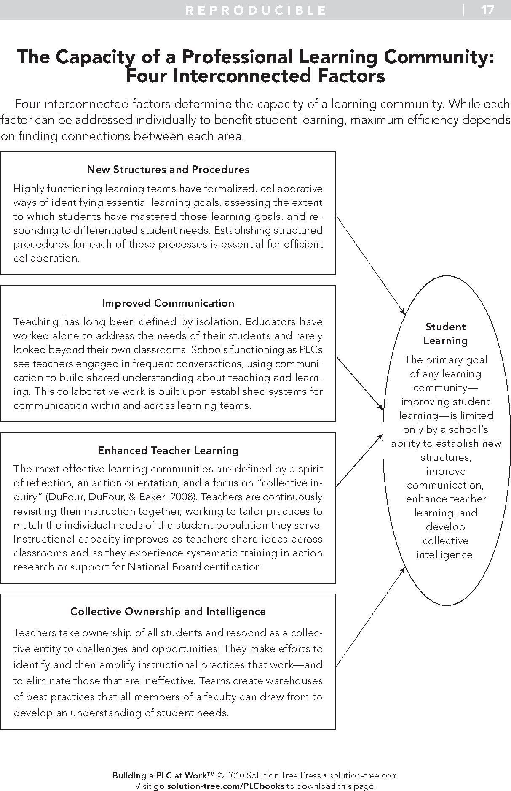

Getting Started

**Collaborative “Commons”**

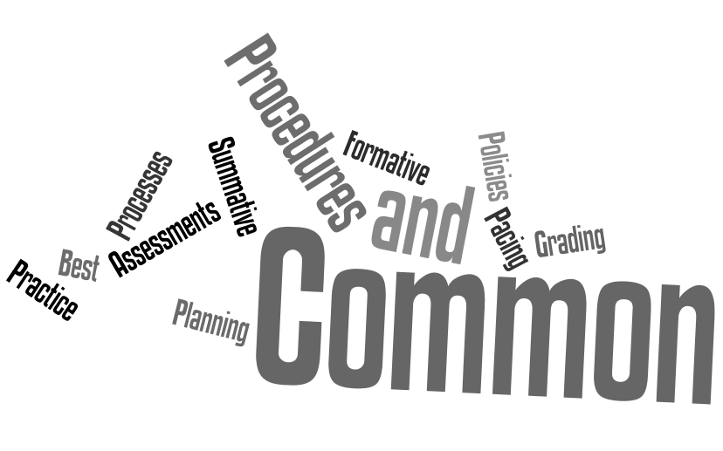

Highlights of Best Practices for Teaching and Learning are provided below. For a complete list of strategies for Best Practices for Teaching and Learning, please consult 24/7 Blackboard.

Create a Student-Centered Learning Environment

• Arrangement of Classroom

Displays Tools

• Safe and Positive Environment

Procedures and Routines

• Relationships

Plan and Teach for Student Learning

• Teacher collaboration

Data Driven Common Assessments

• Content Knowledge

Instructional Delivery Model Lessons Aligned with POS and pacing guides

• Engagement

Cooperative Learning Student Communication Critical and Creative Thinking Grouping of Students High-Yield Instructional Strategies Appropriate Instructional Resources

Assess Student Learning

• Goal Setting and Reflection

• Checking for Understanding

Feedback

• Assessments

End of Unit and End of Course Large Scale External Assessments

[**http://fcpsnet.fcps.edu/is/BestPractices/index.html**](http://fcpsnet.fcps.edu/is/BestPractices/index.html)

**Information available on 24/7 Blackboard**

**And**

**FCPS home site under Best Practices**

**”Having a set of norms-or ground rules-that a group follows encourages behaviors that will help a group do its work and discourages behaviors that interfere with a group’s effectiveness.”-**Joan Richardson, Tools for Schools, August /September 1999.

* **Norms should be developed and followed by all team members. In order for norms to be truly effective, they to be regularly revisited, reinforced, and revised as needed.**
* **Developing norms is an integral part of team building.**
* **Norms establish team protocols.**
* **Norms should be created at the beginning of the school year.**
* **Norms should be visible at all times.**
* **Review norms at each meeting.**
* **Hold each member of the team accountable for following the norms.**

**Sample Norms: Procedural Rules:**

Respect Time Begin and end times

Bring only necessary materials Where the team meets

Be honest, considerate and respectful What roles the team takes on

Stay focused When the agenda is sent out

Respect confidentiality When notes need to be posted

Stay focused and on task.Who gets the agenda?

Participate and share ideas.

Begin and end on time with understood flexibility.

Be open-minded.

Be honest, considerate, and respectful

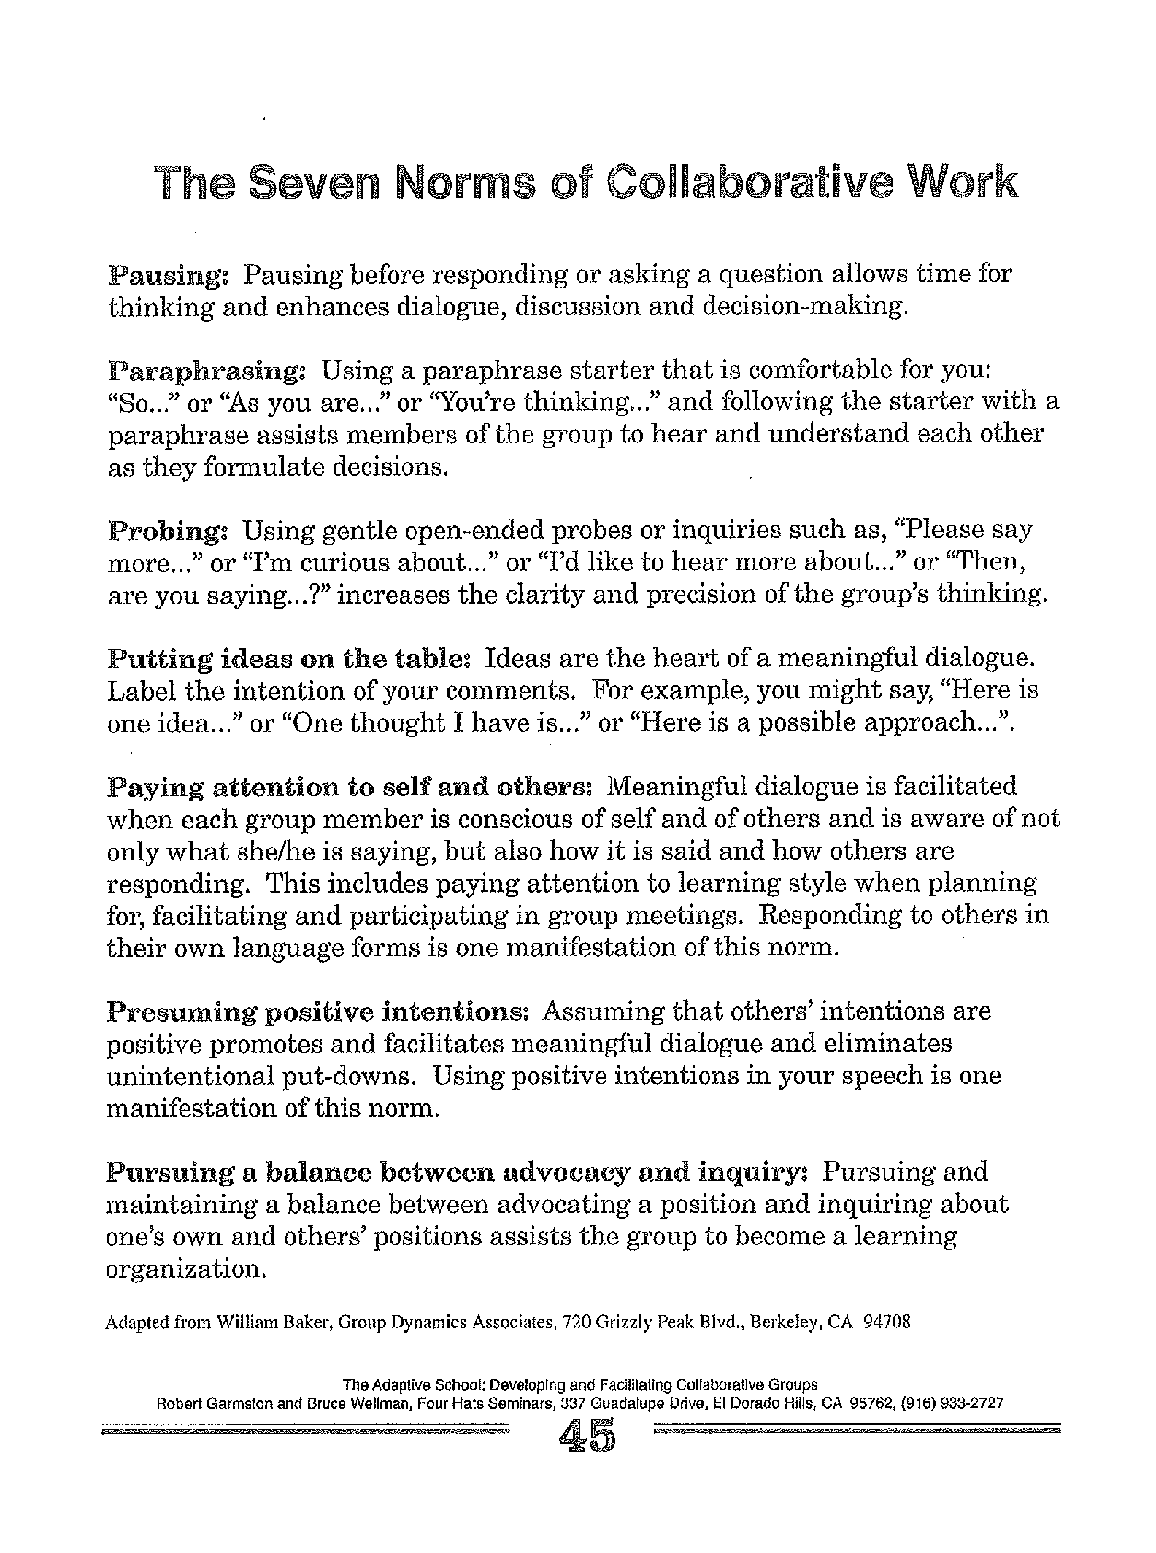

Norms of Collaboration

What do they look like…?

**Pausing**

* Listens attentively to others’ ideas with mind and body
* Allows time for thought after asking a question or making a response
* Rewords time for thought after asking a question or making a response
* Waits until others have finished before entering the conversation

**Paraphrasing**

* Uses paraphrases that acknowledge and clarify content and emotions
* Uses paraphrase that summarize and organize
* Uses paraphrases that shift a conversation to different levels of abstraction
* Use non-verbal communication in paraphrasing

**Probing**

* Seeks agreement on what words mean
* Asks questions to clarify facts, ideas, stories
* Asks questions to clarify explanations, implications, consequences
* Asks questions to surface assumptions, points of view, beliefs, values

**Putting Ideas on the Table and Pulling Them Off**

* States intention of communication
* Reveals all relevant information
* Considers intended communication for relevance and appropriateness before speaking
* Provides facts, inferences, ideas, opinions, suggestions
* Explains reasons behind statements, questions and actions
* Removes or announces the modification of own ideas, opinions, points of view

**Paying Attention to Self and Others**

* Maintains awareness of own thoughts and feelings while having them
* Maintains awareness of others ‘voice patterns, non-verbal communications and use of physical space
* Maintains awareness of group’s task, mood and relevance of own and others’ contributions

**Presuming Positive Intentions**

* Acts as if others mean well
* Restrains impulsivity triggered by own emotional responses
* Uses positive presuppositions when responding to and inquiring of others

**Pursuing a Balance Between Advocacy and Inquiry**

* Advocates for own ideas and inquires into the ideas of others
* Acts to provide equitable opportunities for participation
* Presents rationale for positions, including assumption, facts and feelings
* Disagrees respectfully and openly with ideas and offers rationale for disagreement
* Inquires of others about their reasons for reaching and occupying a position

NORMS FOR: ______________________________________

|  |  |
| --- | --- |
| When Establishing Norms, Consider: | Proposed Norm |
| TIME   * When do we meet? * What is our beginning and ending time? * Will we start and end on time? |  |
| LISTENING   * How will we encourage listening? * How will we discourage interrupting? |  |
| CONFIDENTIALITY   * Will the meetings be open? * Will what we say in the meeting be held in confidence? * What can be said after the meeting? |  |
| DECISION MAKING   * How will we make decisions? * Will we reach decisions by consensus? * How will we deal with conflicts? |  |
| PARTICIPATION   * How will we encourage everyone’s participation? * What do we expect from members? * Are there requirements for participation? |  |

~Adapted from *Keys to Successful Meetings* by Stephanie Hirsh, Ann Delehant, and Sherry Sparks. Oxford, Ohio: National Staff Development Council, 1994.

**Specific:** A specific goal has a much greater chance of being accomplished than a general goal. To set a specific goal you must answer the six “W” questions:

*Who:      Who is involved?

*What:     What do I want to accomplish?

*Where:    Identify a location.

*When:     Establish a time frame.

*Which:    Identify requirements and constraints.

*Why:      Specific reasons, purpose or benefits of accomplishing the goal.

**Measurable -** Establish concrete criteria for measuring progress toward the attainment of each goal you set. When you measure your progress, you stay on track, reach your target dates, and experience the exhilaration of achievement that spurs you on to continued effort required to reach your goal. To determine if your goal is measurable, ask questions such as……How much? How many? How will I know when it is accomplished?

**Attainable** – When you identify goals that are most important to you, you begin to figure out ways you can make them come true. You develop the attitudes, abilities, skills, and financial capacity to reach them. You begin seeing previously overlooked opportunities to bring yourself closer to the achievement of your goals.

**Realistic/ Rigorous**- To be realistic, a goal must represent an objective toward which you are both willing and able to work. A goal can be both high and realistic; you are the only one who can decide just how high your goal should be. But be sure that every goal represents substantial progress.

**Timely** – A goal should be grounded within a time frame. With no time frame tied to it there’s no sense of urgency. If you want to lose 10 lbs, when do you want to lose it by? “Someday” won’t work. But if you anchor it within a timeframe, “by May 1st”, then you’ve set your unconscious mind into motion to begin working on the goal.

**Examples:**

“Johnny will read consonant-vowel-consonant words with 85 percent accuracy after 6 weeks of intervention."

“90% of the first grade students will achieve a passing score on the DRA.

“93% of second graders will be reading at grade level by the end of second grade as defined by the scores on the DRA.”

**SMART goals Worksheet**

**Specific: Write down exactly what you want to achieve-identify an action of an event that will take place.**

**Measurable: Write down how you’ll measure your progress. How will you know if you have reached it?**

**Attainable: Write down what you will DO to reach your goal.**

**Realistic- Rigorous: Make sure that you will have enough time, energy, and ability to finish your goal. It should require you to stretch some, but allow the likelihood of success.**

**Timely: Set a time limit for when the goal must be reached.**

**Getting people more involved can make the team more effective, Increase ownership in both the outcome and the process, Relieve the team leader from doing all the work, And allow him or her to fully participate as a team member.”**

**-Conzemius & O’Neil, The Handbook for SMART School Teams, 2002, p. 66.**

**Roles ensure active participation by team members.**

**Roles ensure a more productive meeting.**

**Roles are often rotated throughout the school year or from one CT to another.**

**Roles:**

**Facilitator**- has the big picture of the meeting’s purpose and the group’s dynamics. They keep the group focused on the task, utilize protocols and processes for productivity, and encourage participation of team members.

**Note Taker**-takes the minutes of the meeting. The notes are then shared with the school community such as the administration and other staff members.

**Timekeeper-**is responsible for the beginning and ending time of the meeting as well as for the time designated for each item on the agenda.

**“Prepare more and meet less,” is a motto for successful groups and effective leaders. By making a personal investment in agenda design, leaders can reduce meeting time by as much as 30%. This in turn produces dramatic increases in productivity and group-member satisfaction.”**-The Adaptive School, by Robert J. Garmston

A well-prepared agenda is the key to a productive meeting.

All team members should receive agendas prior to the meeting day.

**An agenda should include:**

Meeting purpose

What will be covered?

How much time is needed?

Who will be involved?

Essential Questions

SIP connections

Intended outcomes

When planning for your CT, the agenda will be created in the program One Note and sent to all team members including all SIP members.

The agenda should include questions that the team will ask to produce a productive outcome.

The team will discuss and establish agenda items for the next CT meeting.

Notes will be taken on One Note and will be posted for team members.

Notes will be sent to administration.

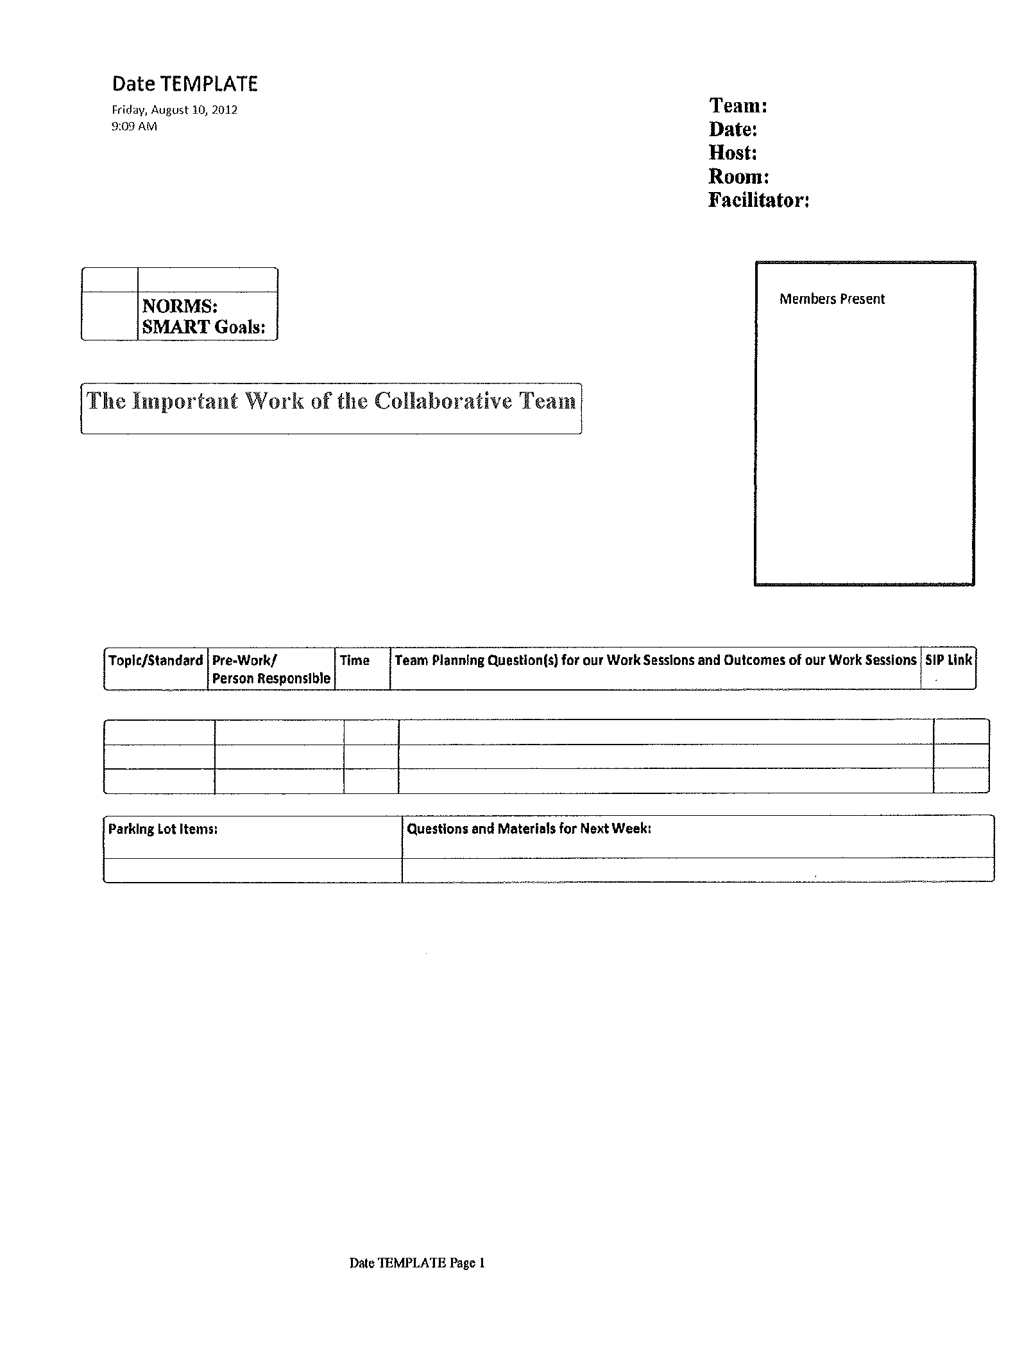

**Essential Questions for Conversation at CT’s**

**PLC Question #1: What do we want students to learn?**

* Create/review standards in Pacing Guide
* Review and “unpack” pacing guide to determine what students need to learn
* Decide what students need to know, understand, and do
* Develop Learning Targets for daily instruction, write in student friendly language
* Develop an understanding about why students are learning concepts (what are the real-life applications?)
* Share resources and strategies for teaching the lessons (manipulatives, books, lessons, technology)
* Decide how we might engage diverse learners and meet their needs
* Read and discuss research about best instructional practices for the unit we are planning
* Decide how we can integrate other content areas
* Decide how students will self assess and monitor their growth
* Look at students’ previous work or pre-tests to plan instruction for differentiation
* Decide which evidence will help us determine the learning
* Develop high-level questions to ask students in order to develop essential understandings

**PLC Question #2: How will we know if each student has learned it?**

* Check for Understanding by administering daily informal assessments (observations, performance, exit tickets, anecdotal records, checklists, Give 1-Get 1, performance based, reading responses, charts/graphs, graphic organizers, student reflection sheets)
* Develop and administer common assessments (eCart or criterion-based assessments) aligned to POS and state standards
* Develop rubrics for performance based assessments
* Look at multiple ways to assess students (Projects, activities, poems, etc.)

**PLC Question #3: What does the data reveal?**

* Analyze formal and informal data
* Compare pre/post test data
* Look for strengths, and gaps in data
* Look at individual student’s needs
* Look at needs of particular subgroups and decide how we can address them
* Look at student work and score them together based on rubric
* Examine how students are understanding concepts
* Discuss grouping of students and how students can help one another
* Create/modify rubrics and assessments
* Analyze growth over time on data trackers
* Celebrate successes!!!

**PLC Question #4: Based on our collaborative analysis of the data, what can we do to improve/extend student learning?**

* Plan intervention or extension activities by name and need
* Develop new strategies for re-teaching and/or enrichment
* Learn from one another about successful instructional practices to teach skills
* Decide whether we need to make changes to pacing
* Look at how a strategy we used to teach one concept can be used to teach another concept
* The norms created by each team.
* The SMART goal(s) for each team.
* A brief explanation regarding how teams are provided collaborative time.
* A brief explanation regarding your strategies for providing students with intervention and enrichment (who receives this support, when, and how).
* The agreed-upon essential outcomes for each team in math and /or language arts.

Optional: You may include any of the following products your team would like to highlight:

* Team developed curriculum pacing guides
* Examples of team developed common assessments
* Examples of how information from common assessments is presented to each teacher on a team
* Analysis sheets summarizing results of a common assessment and indicating team-developed strategies for improvement.
* A brief explanation regarding how the work of teams is monitored and supported.
* Additional information that your team feels will help the audience understand the work your staff members have done to develop their capacity to operate your school as a professional learning community.
* Unpacking lessons in LEARN model
* _________________________________________________
* _________________________________________________
* _________________________________________________

PLC

Work Sessions

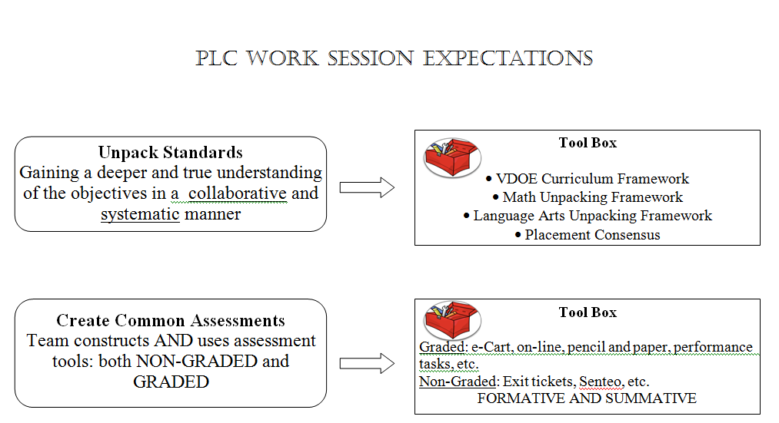

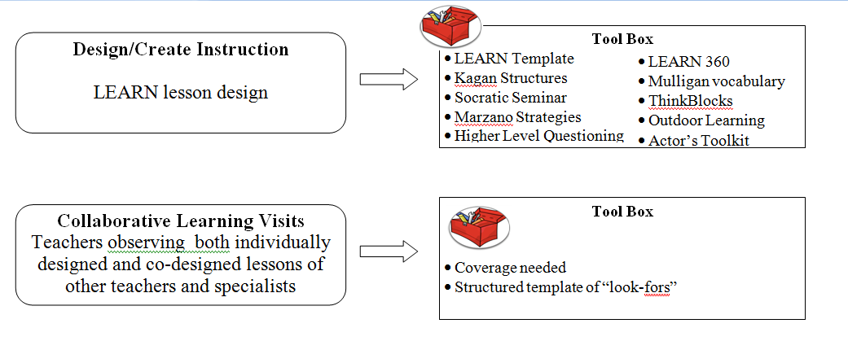

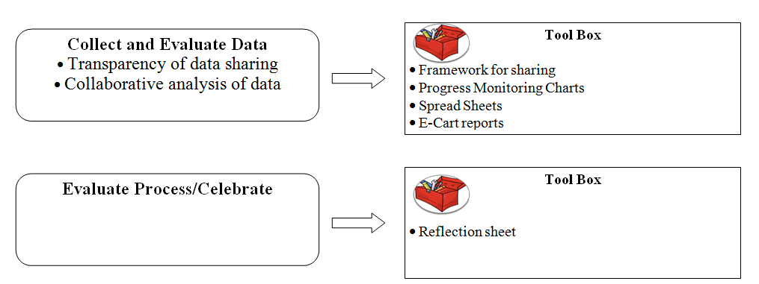

**Unpack Standards**

Gaining a deeper and true understanding of the objectives in a collaborative and systematic manner

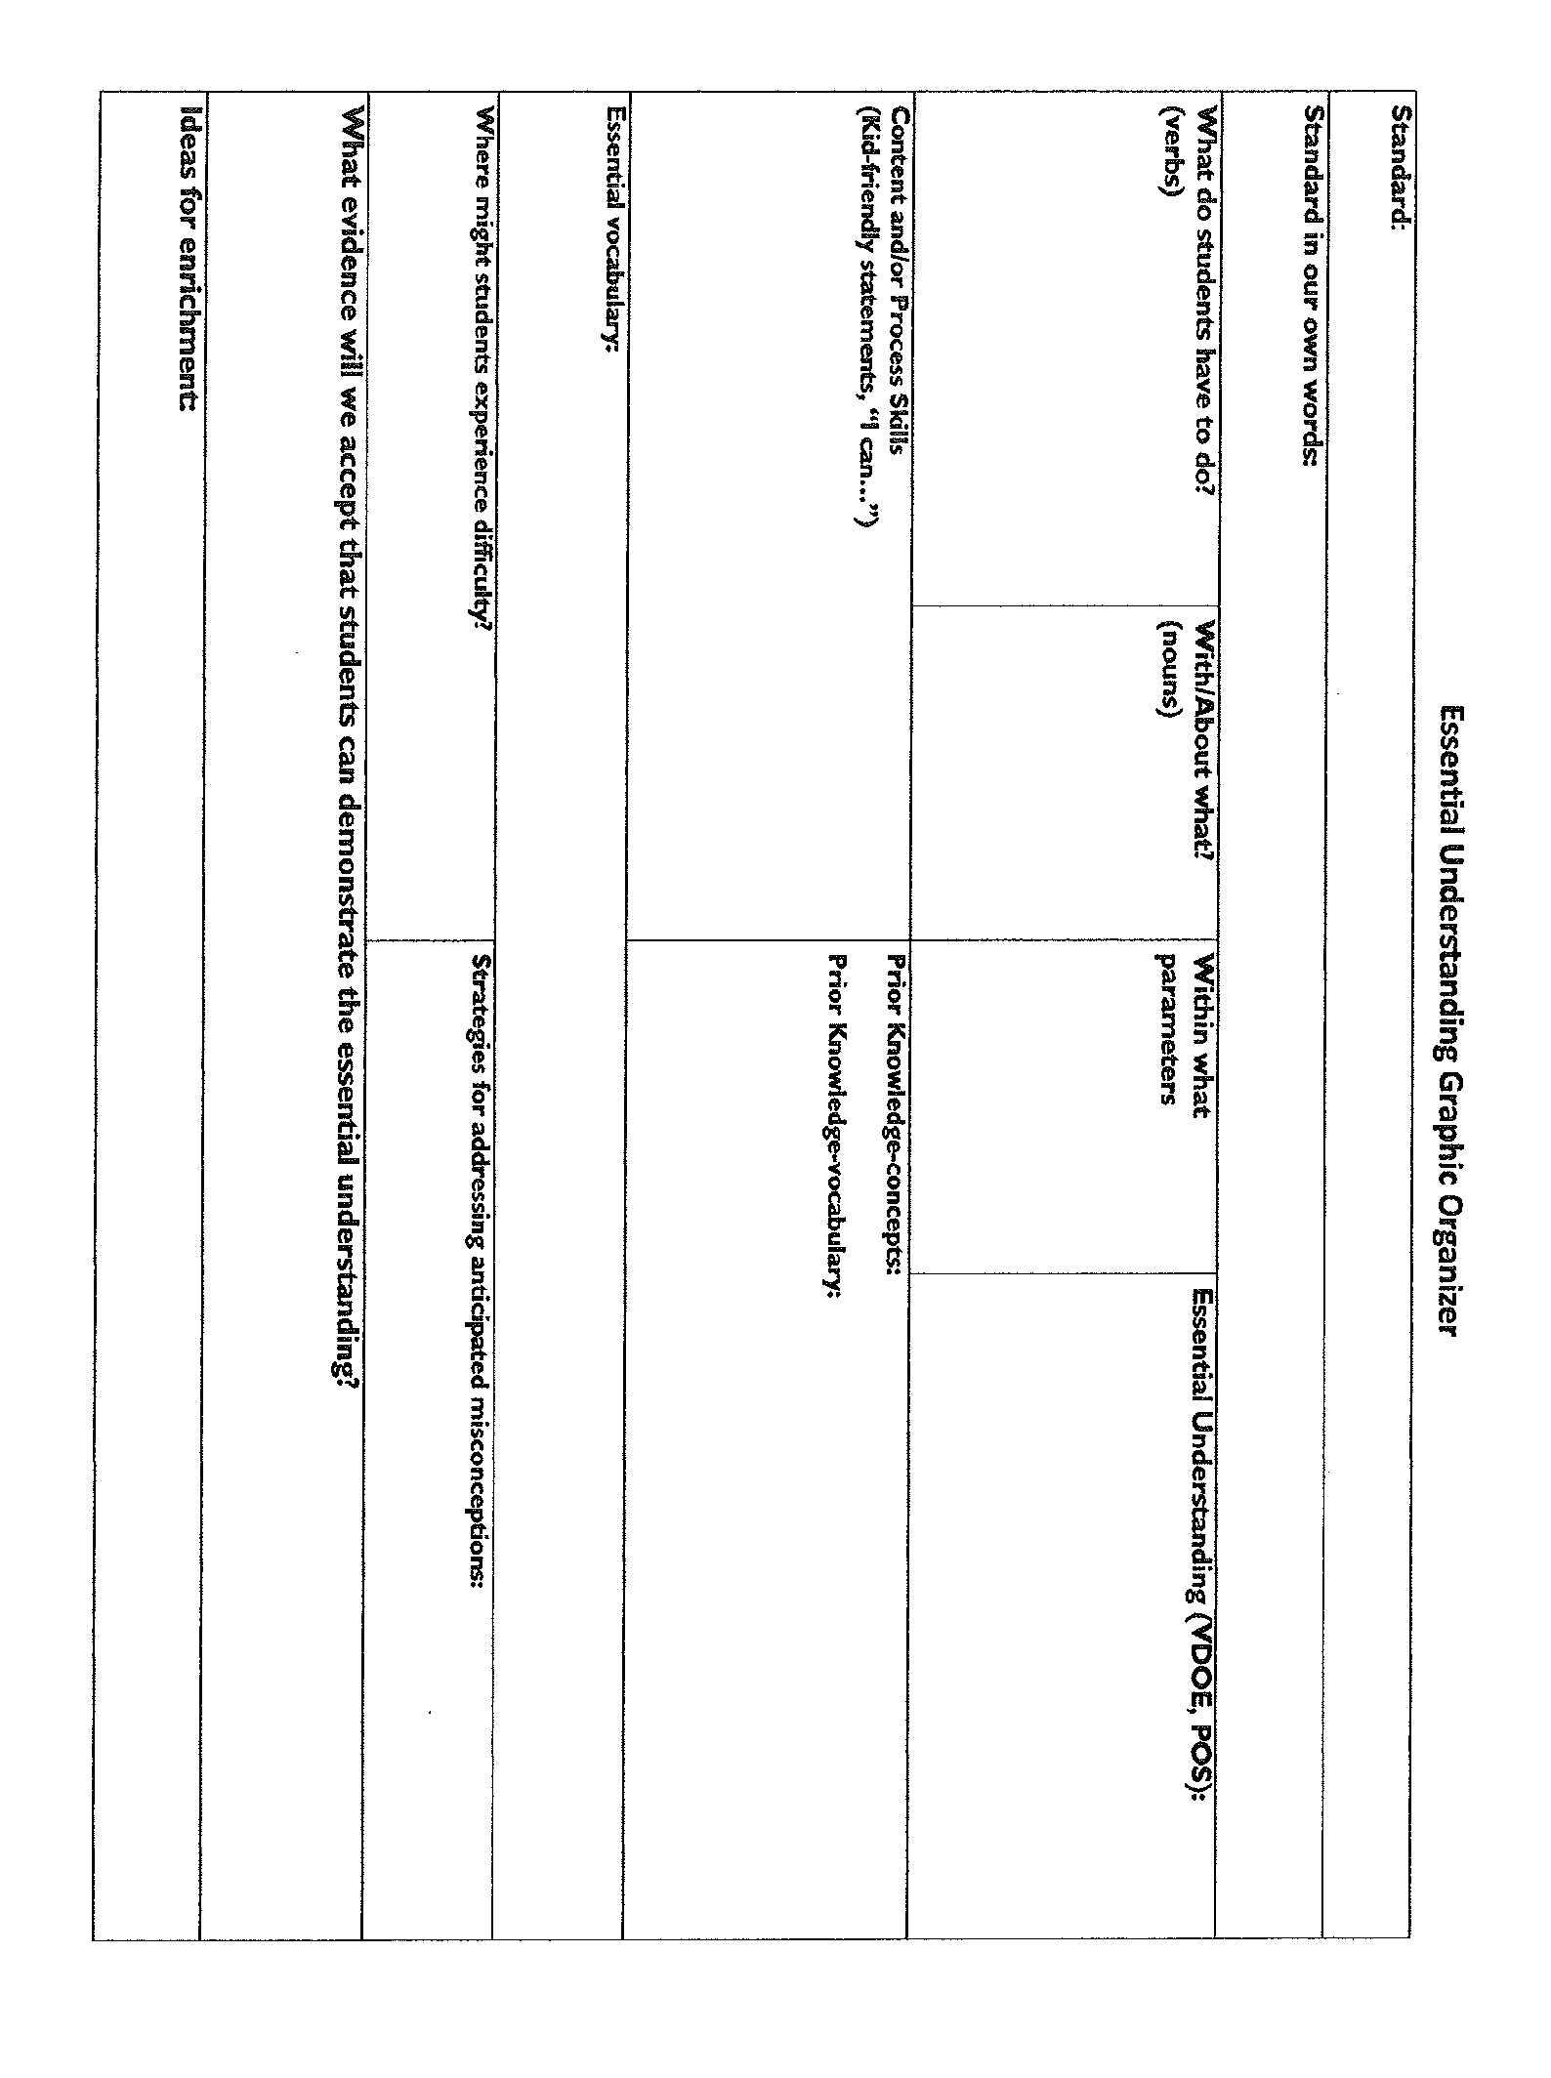

|  |  |  |
| --- | --- | --- |
| Unpacking the Standard/Brainstorming Template  Standard | | |
| Verbs: (what do the students need to do) | To what extent | Essential knowledge and vocabulary |
| Materials/ Resources we will need/have | | |
| Released SOL Question examples, ideas, wording, or vocabulary that we need to expose the kids to specific to this standard | | |
| Ideas for methods of direct instruction/Best Practice | | |

**Create Common Assessments**

Team constructs AND uses assessment tools: both NON-GRADED and GRADED

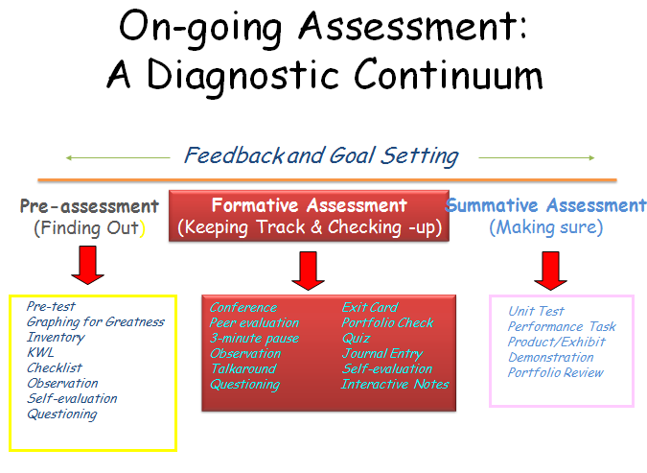

**CREATING COMMON ASSESSMENTS PROTOCOL**

**Establish purpose of testing.**

How will scores be used?

What decision will they inform?

Are results for formative or summative purposes?

**Get clear on learning targets.**

        • What is essential that students need to know / be able to do?

**Create test plan based on targets.**

       • Balance content & cognitive processes.

       • Common performance base.

**Select item format(s).**

     • Selected Response: true / false, multiple choice

     • Constructed Response: short answer, essay

     • Performance Assessment: task rubric, process rubric

     • Personal Communication: interview, think aloud

• Match assessment method to learning target. Pay attention to verb.

      • Consider time to prepare, time to administer, time to score & reliability issues.

**Assemble assessment**.

       • Who is responsible for finding or creating items? Preparing materials?

       • What is the timeline?

       • How will scoring be done?

**Try out assessment and collect data.**

• Look at item & assessment statistics: percent answering correctly, percent choosing each answer option, inter-rater reliability, etc.

      • Do items measure what you intend to measure?

* Revise assessment as needed.
* Stay in alignment with purpose. ~Created by Alyssa Pappas

**Design/Create Instruction**

LEARN lesson design

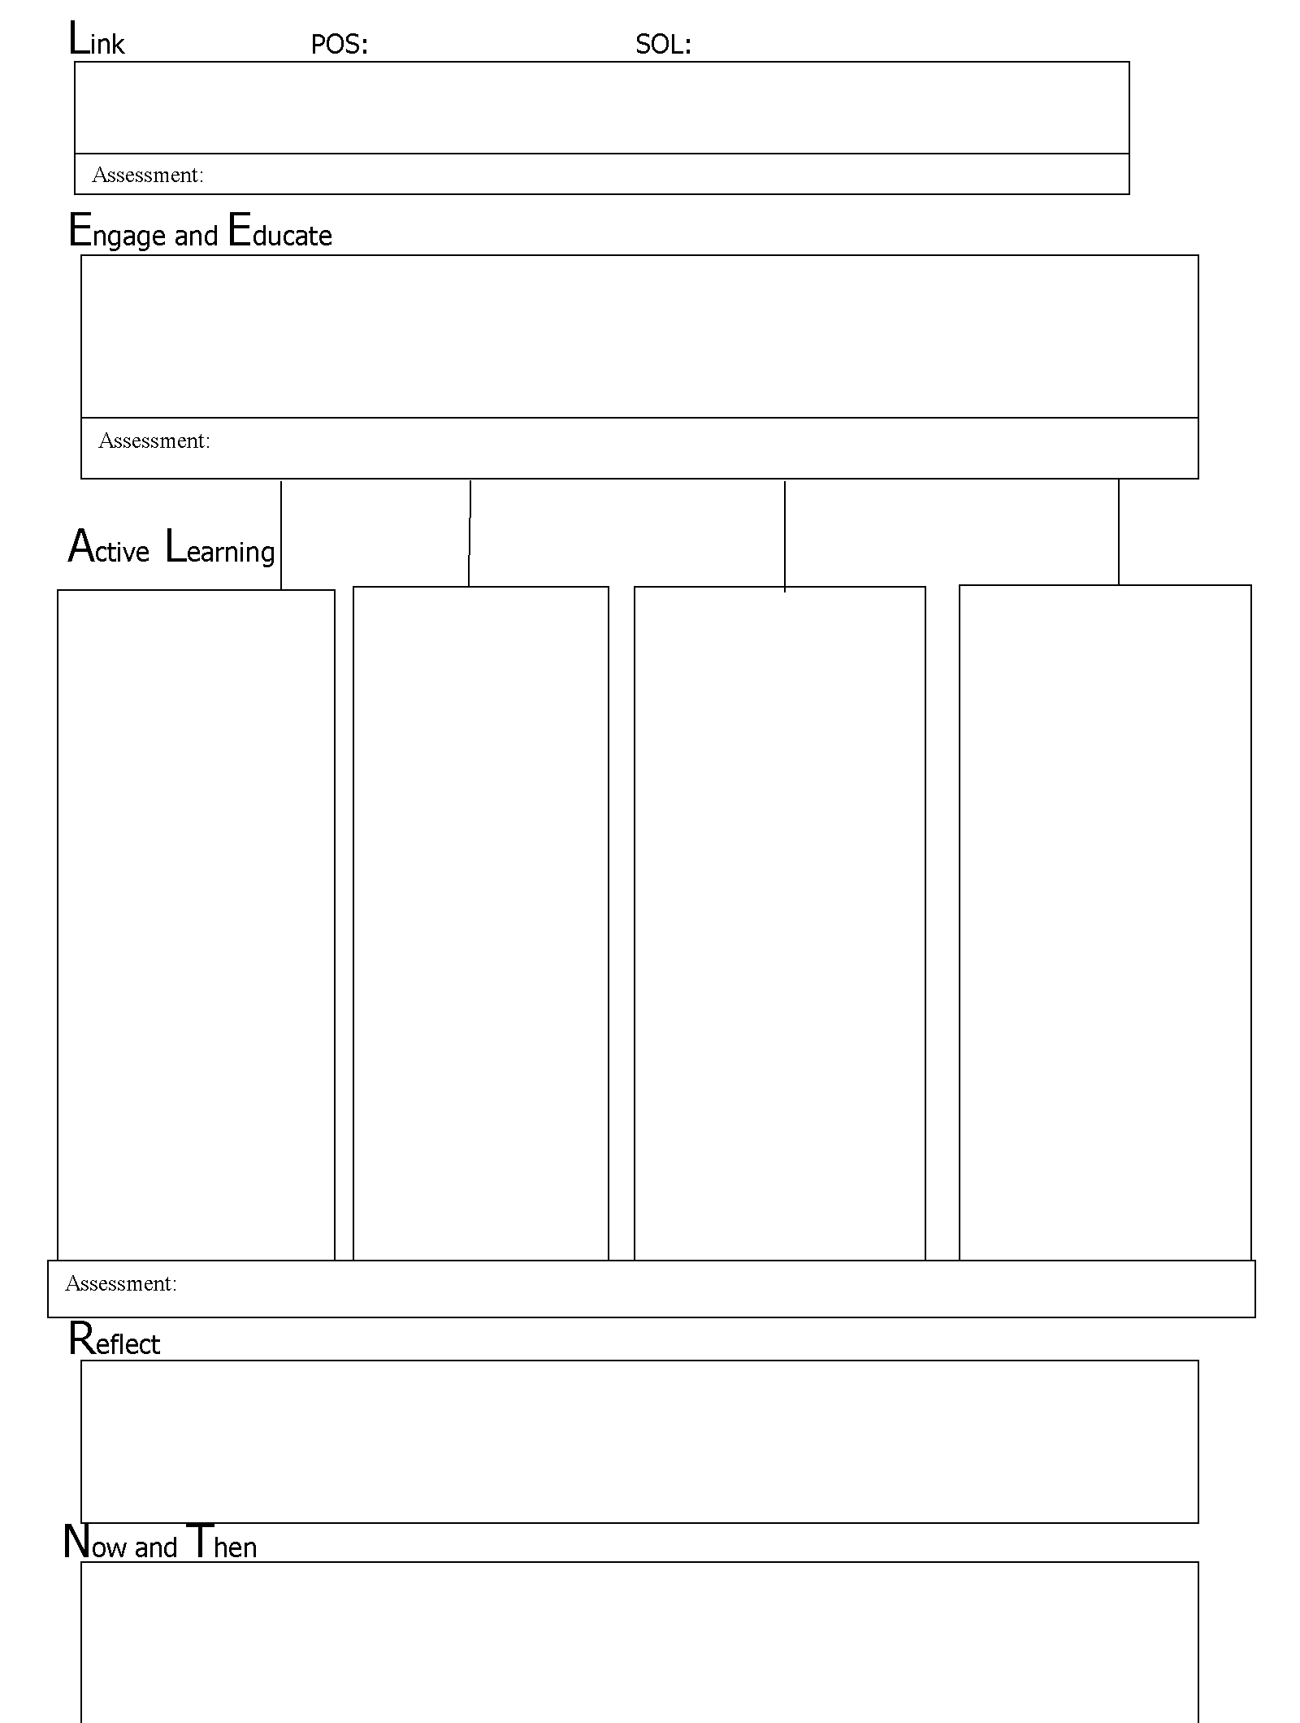

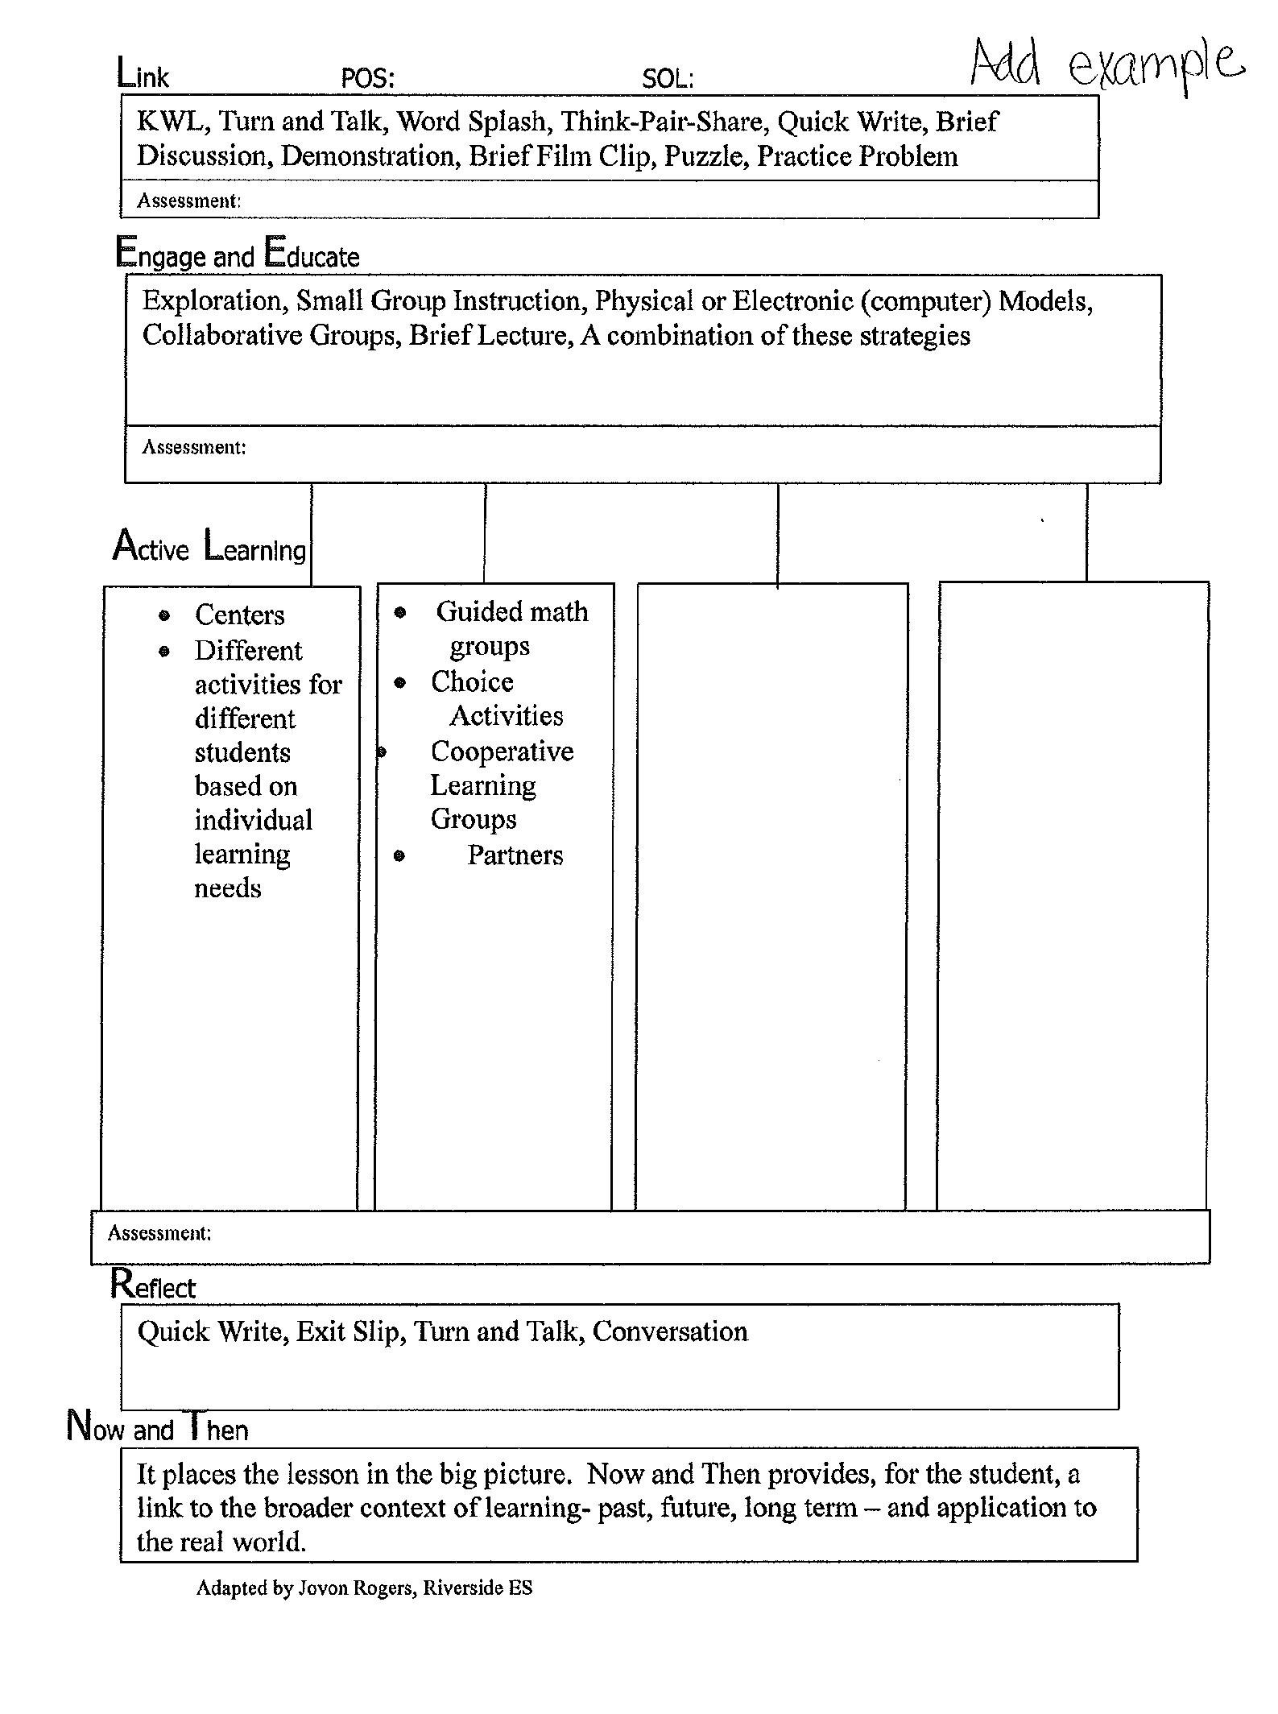

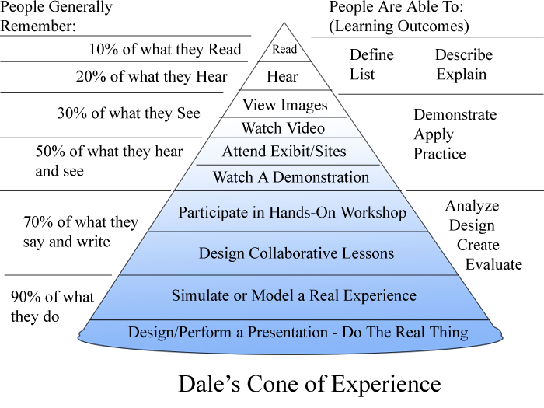

**Collaborative Learning Visits**

Teachers observing both individually

designed and co-designed lessons of other teachers and specialists

Collaborative Learning Visits is a process in which teachers visit classrooms of colleagues, take notes on

evidence observed, and talk about questions they have to help teachers improve their practice. Ultimately, these visits provide a continuous improvement model to help focus staff development needs from year to year.

Collaborative learning visit guide

From FCPS Best Practices for Teaching and Learning

**ROLES OF WALKERS:**

All walkers will be responsible for taking notes on what they have observed related to a best practice in the Best Practices in Teaching and Learning framework.  A limited number of conversations with students can be held without disrupting the overall tone of instruction.  Walkers visit several classrooms for 10-15 minutes each and can engage in any of the following roles:

**GROUP LEADER:**

•     Leads the walking group and keeps walkers to the schedule, fills in when necessary

•     Keeps time during the visit and “gives the signal” when it’s time to go

•     Facilitates the sharing out after the visit

•     Participates in the debrief discussion with the principal and provides the group’s feedback

**NOTING EVIDENCE:**

•   Circulates around the room and notes evidence for the specific best practice

•     Interactions between students and with the teacher

•     Information posted and displayed on walls

•     Listens for evidence of the descriptors from each category

•     Consults the Collaborative Learning Visit Guide when necessary

•     The general classroom environment is designed to support the specific best practice

**TALKING WITH STUDENTS:**

•  Identifies one or more students to speak with during the visit

•     Uses the question stems to talk with them and takes notes on their responses

•     Does not press the issue; if the student is not comfortable, the walker moves on

**LOOKING AT STUDENT WORK**:

•  Circulates around the room and observes evidence in student work for the specific best practice

•     Looks at student work: Student notebooks/portfolio, Student work displayed in the classroom, Student work on assigned task, Student work is aligned with the Program of Studies and Standards of Learning, Student work is aligned with the posted objectives/daily agenda

### Debrief After Class

Collaborative learning visit guide– cont.

The debrief is an opportunity to review and synthesize all of the information walkers have obtained during the course of the walk.  Most of the time the walkers gather in the hall immediately after the visit and each takes a few moments to review his or her notes, looking for evidence around the best practice.  Each walker also thinks of one or more thought-provoking questions designed to guide, encourage, or inspire the principal and staff to learn in order to take instruction in the school to the next level.  At times each walker may not pose questions, and the questions may surface later in the process.  Walkers then take turns, providing their evidence and then their questions.  Patterns will begin to appear.

### Reflection

When all of the visits are completed, the groups of walkers gather and discuss the patterns in the evidence they have observed.  They also pull together their thought-provoking questions.

It is crucial for the building staff to receive feedback about the teaching and learning observed during the Collaborative Learning Visits.  The feedback can be given by the principal or a principal’s designee in the form of a letter to the staff or as informal oral feedback.  Instructional leaders may also include additional components in the letter. Feedback is an opportunity to clarify the school’s focus, identify models of good work, clarify the quality of work expected and set future goals and future staff development needed to reach those goals.  Feedback is always designed to open lines of communication.

### Feedback

**Collect and Evaluate Data**

• Transparency of data sharing

• Collaborative analysis of data

**DATA DISCUSSION PROTOCOL:**

PRIOR to MEETING:

Send out initial email and agenda (attached) including these questions for thought prior to meeting.

• What important points seem to “pop-out?”

• What are some patterns or trends that seem to be emerging?

• What seems to be surprising or unexpected?

• What inferences/explanations/conclusions might we draw? (causation)

• What are some solutions we might explore based on our conclusions? (action/interventions)

AT the MEETING:

• After receiving the data please privately reflect on the questions under Here’s What?

• We will share in a Round Robin fashion.

• Next do this for So What…and follow same procedure for the rest of the process.

|  |  |  |
| --- | --- | --- |
| **Here’s What** | **So What** | **Now What** |
| (Surprises, Revelations, Confirmations) | (Your thoughts about implications of the results) | (Next steps as a result of what you see) |
| • What important points seem to “pop out”?      • What are some patterns,  categories, or trends that are emerging?    • What seems surprising or unexpected?    • What are some things we have not yet explored?   *Data-Driven Dialogue, A Facilitators Guide to Collaborative Inquiry*, 2004*Data-Driven Dialogue, A Facilitators Guide to Collaborative Inquiry*, 2004 | • What inferences/ explanations/conclusions might we draw?  (causation)                  • What additional data sources might we explore to verify our explanations? (confirmation) | • What are some solutions we might explore as a result of our conclusions? (action)                    • What data will we need to collect to guide implementation? (calibration) *Data-Driven Dialogue, A Facilitators Guide to Collaborative Inquiry*, 2004 |

**ASSESSMENT ANALYSIS SHEET AND INSTRUCTIONAL PLAN FOR TEACHER:**

|  |  |  |
| --- | --- | --- |
| **STUDENTS OF MAJOR CONCERN**  **Which students will need small group instruction for re-learning?** | **SMALL GROUP INSTRUCTION:**  **Which standards warrant more time for small group instruction and review?** | **INSTRUCTIONAL PLAN:**  **How and when will you structure small group instruction? How will you re-assess the students?** |
|  |  |  |
| **WHOLE CLASS INSTRUCTION:**  **Which standards warrant more time for whole class instruction, re-teaching, and review?** | **ANALYSIS:**  **Why did students not learn the standards?** | **INSTRUCTIONAL PLAN:**  **Which best practice strategies will you be using to address these standards? How will you re-assess the students?** |
|  |  |  |

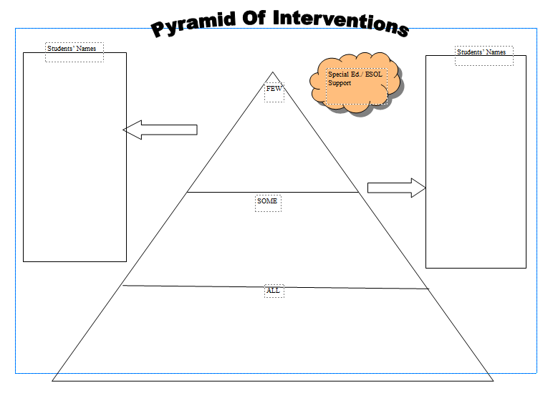

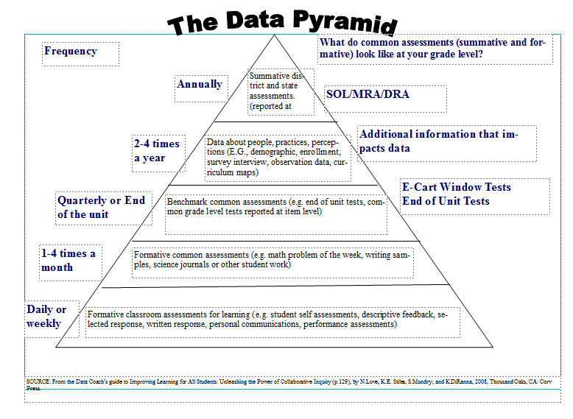

**Evaluate Process/Celebrate**

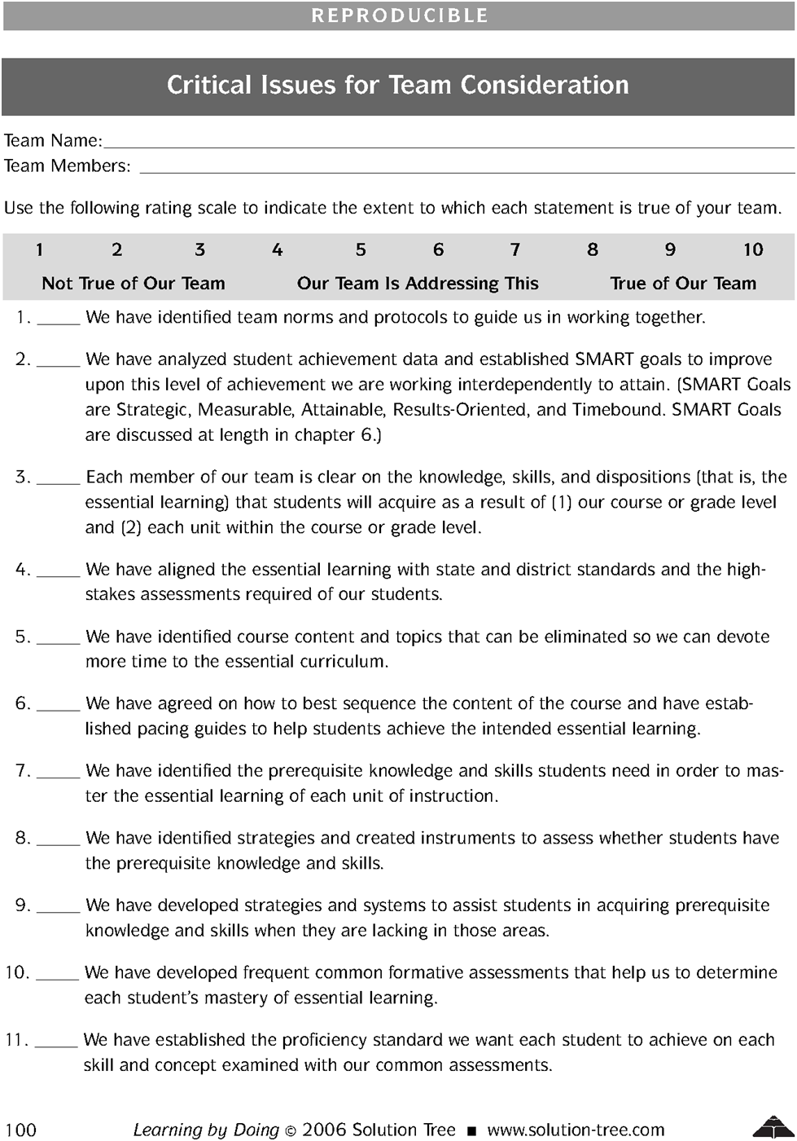

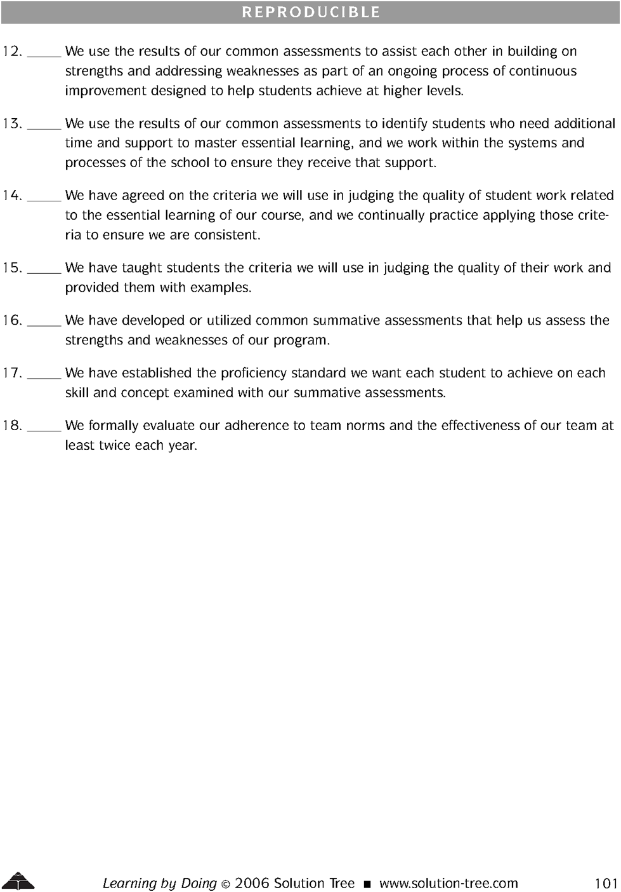

Appendix

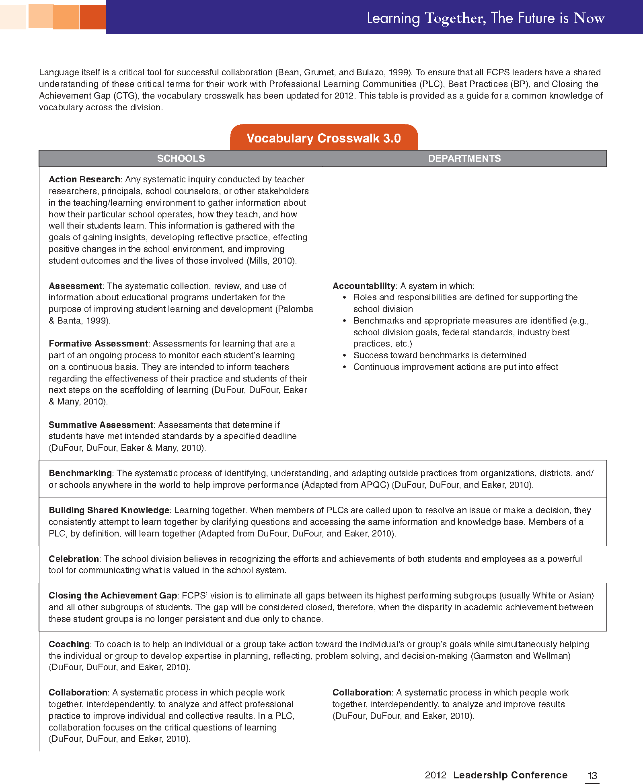

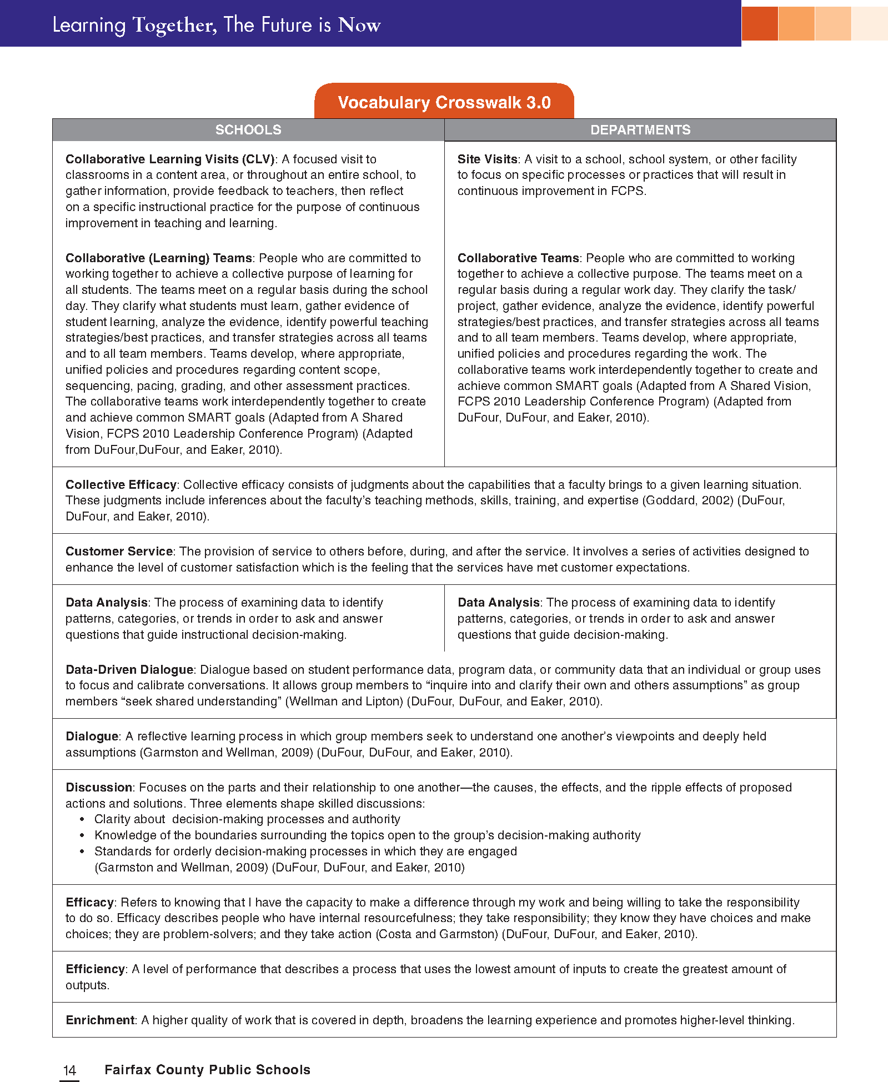

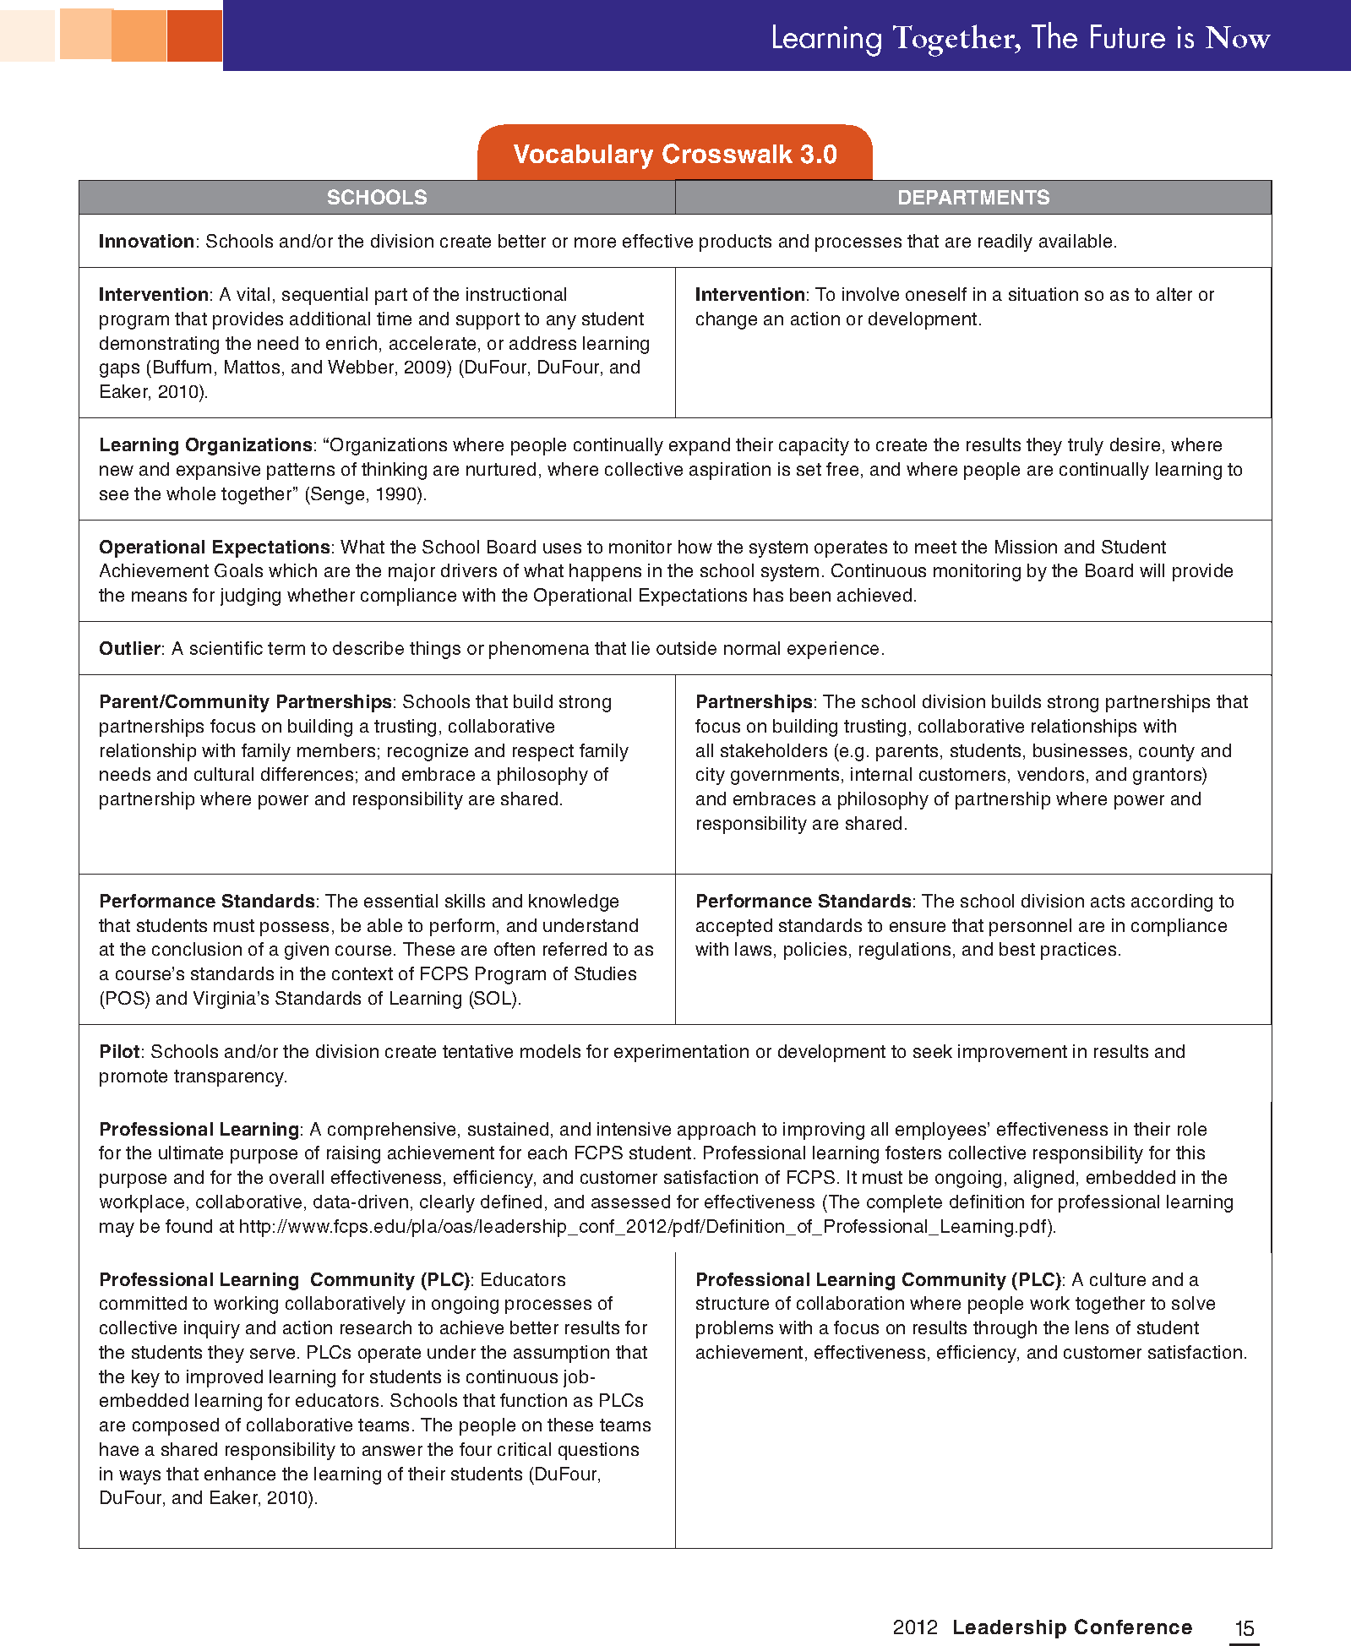

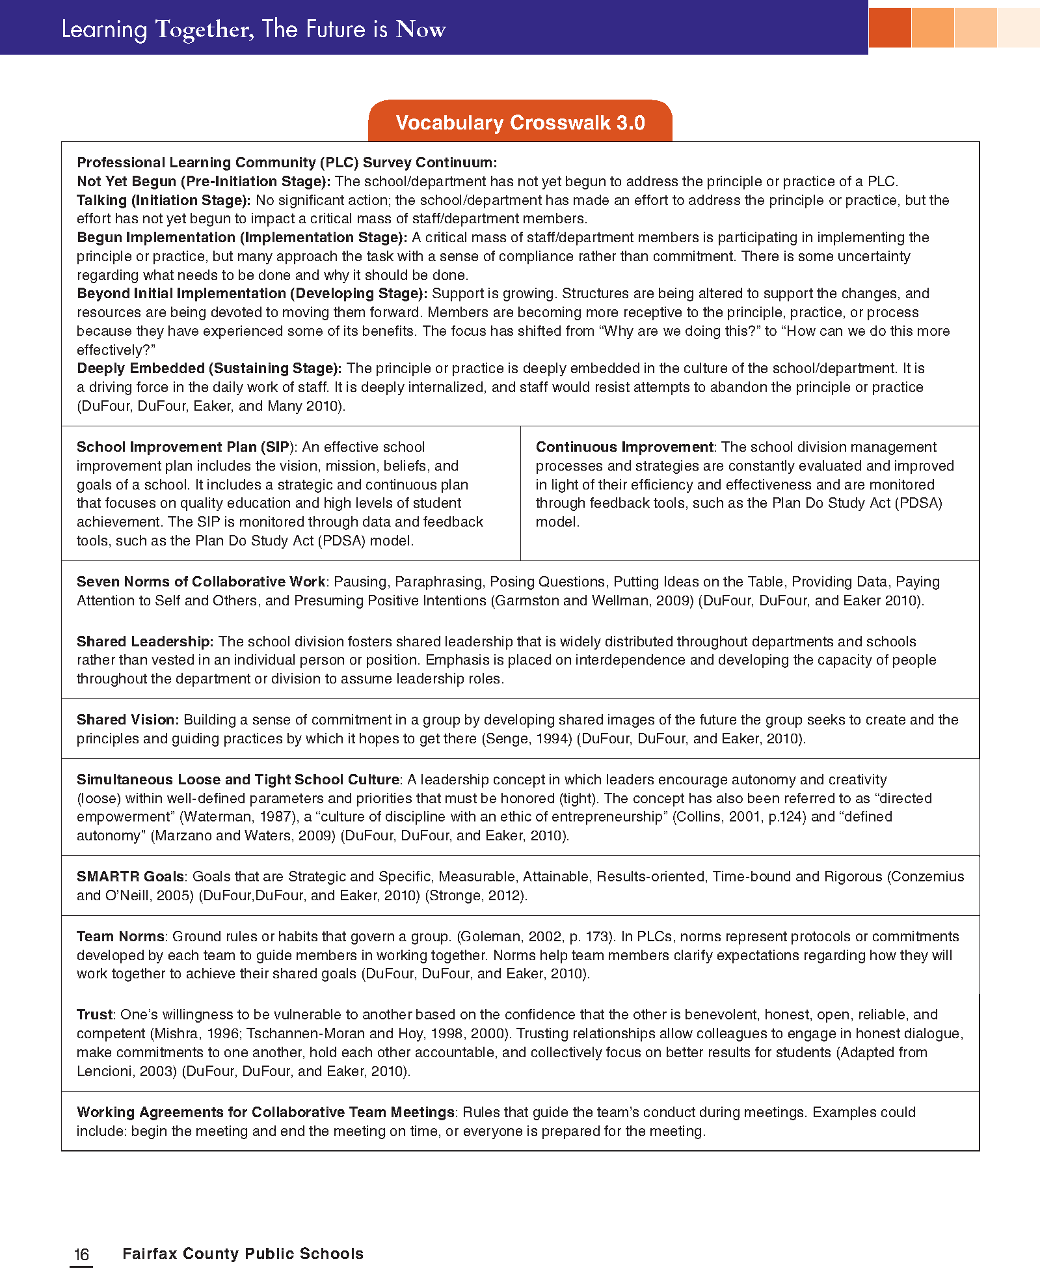

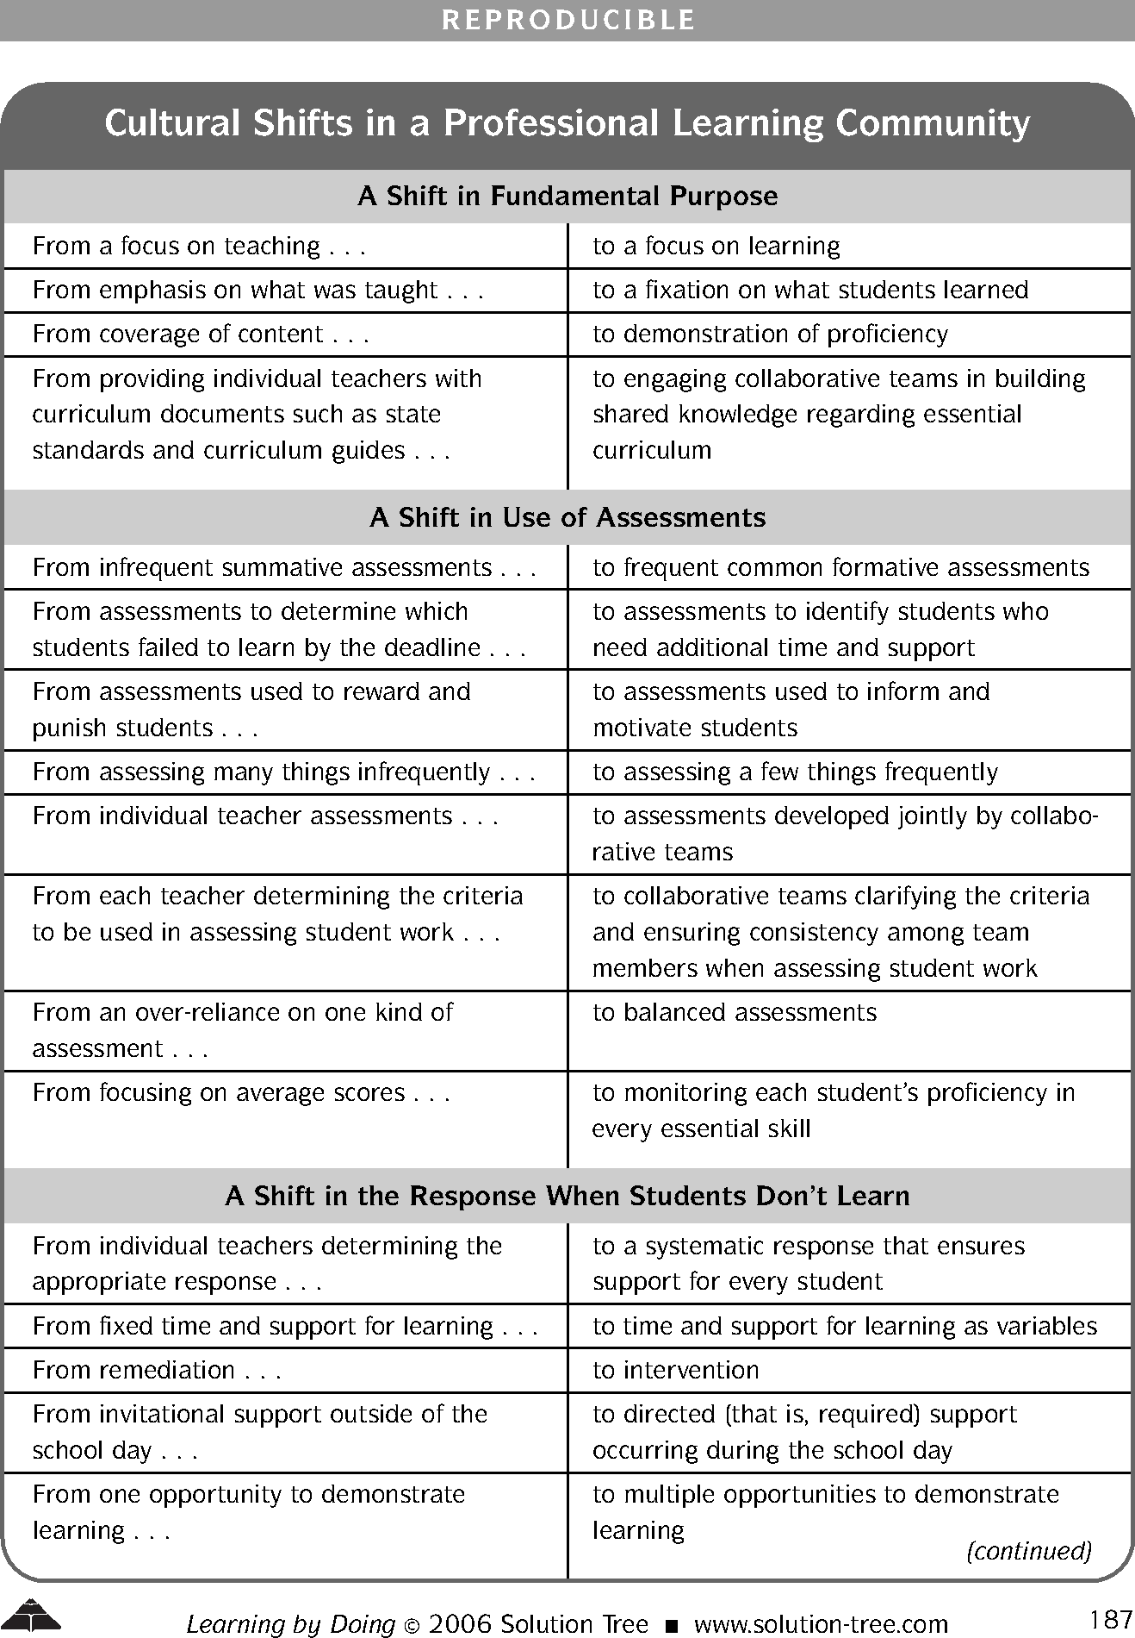

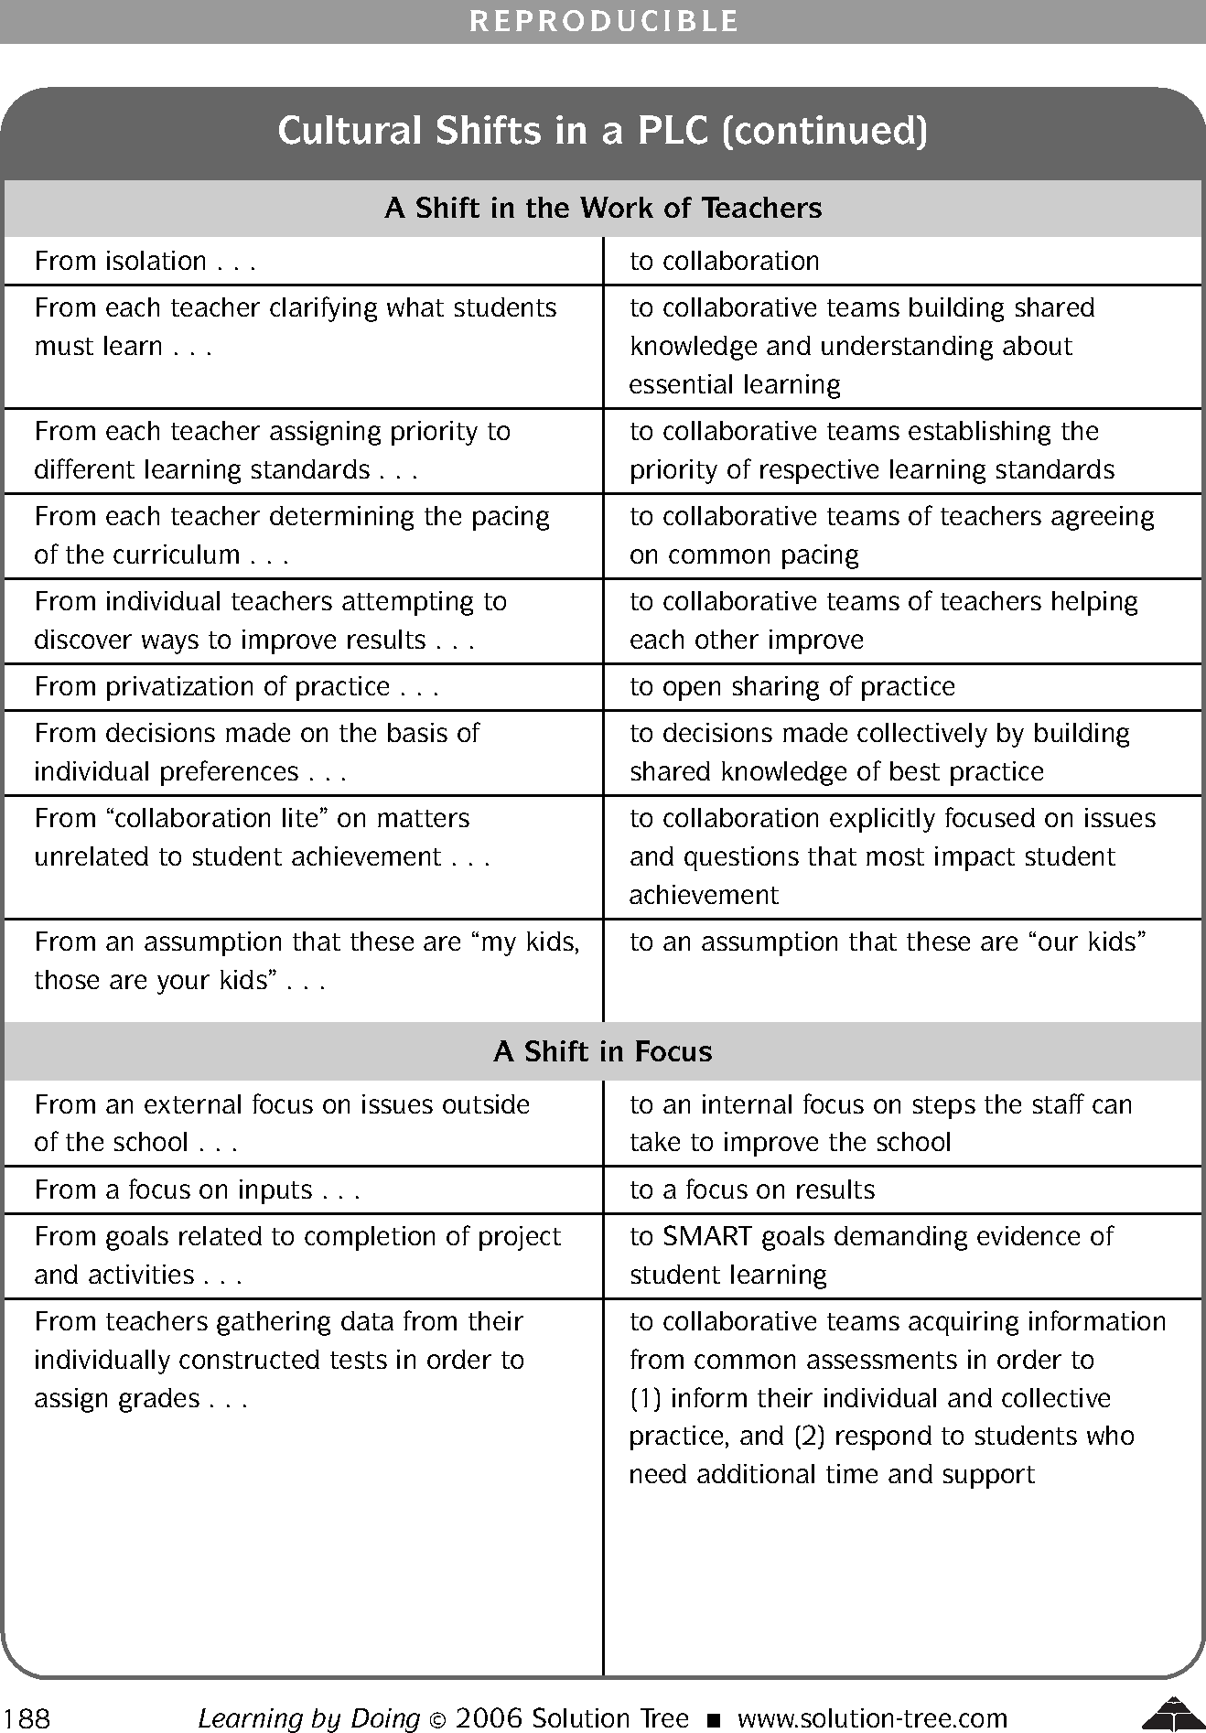

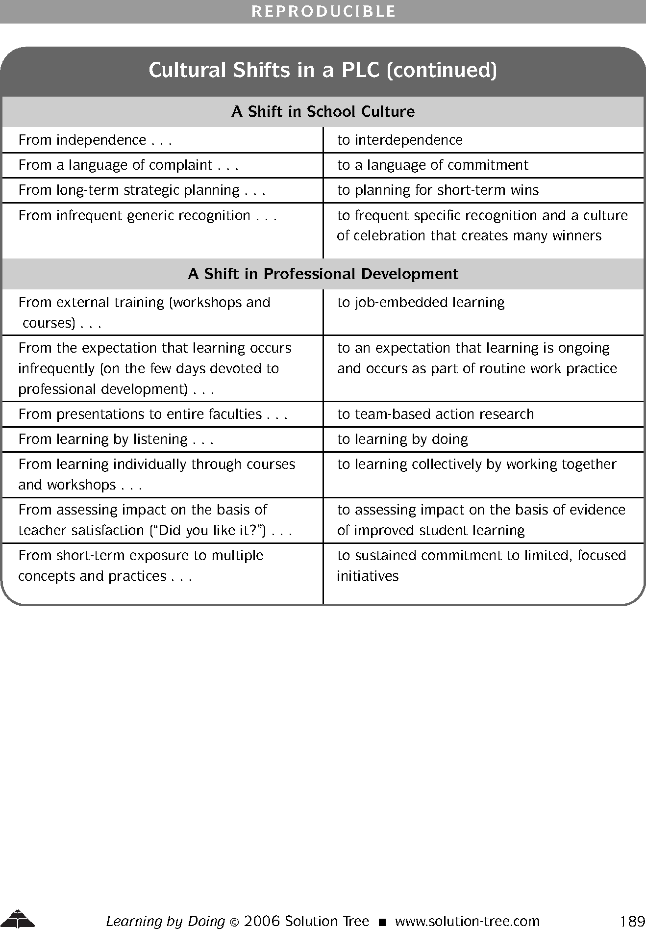

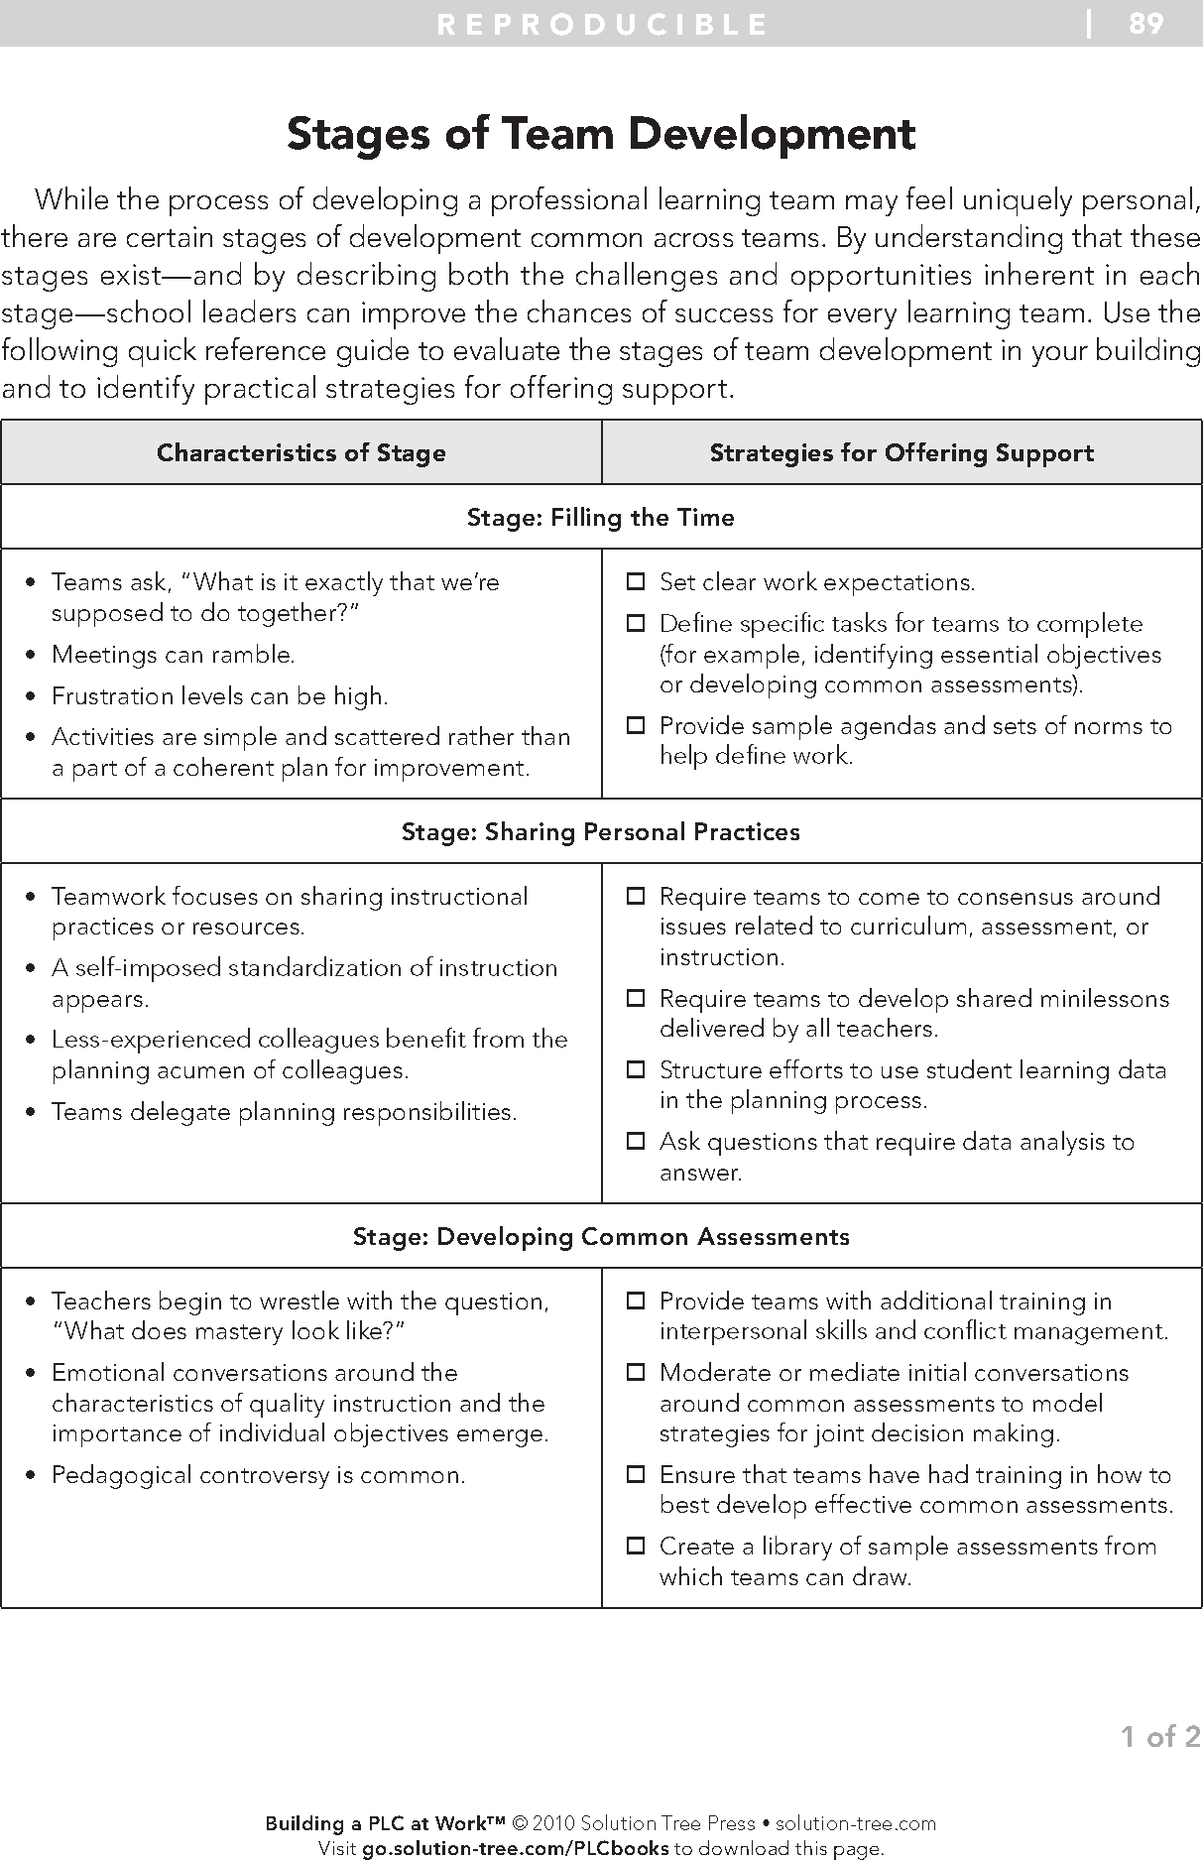

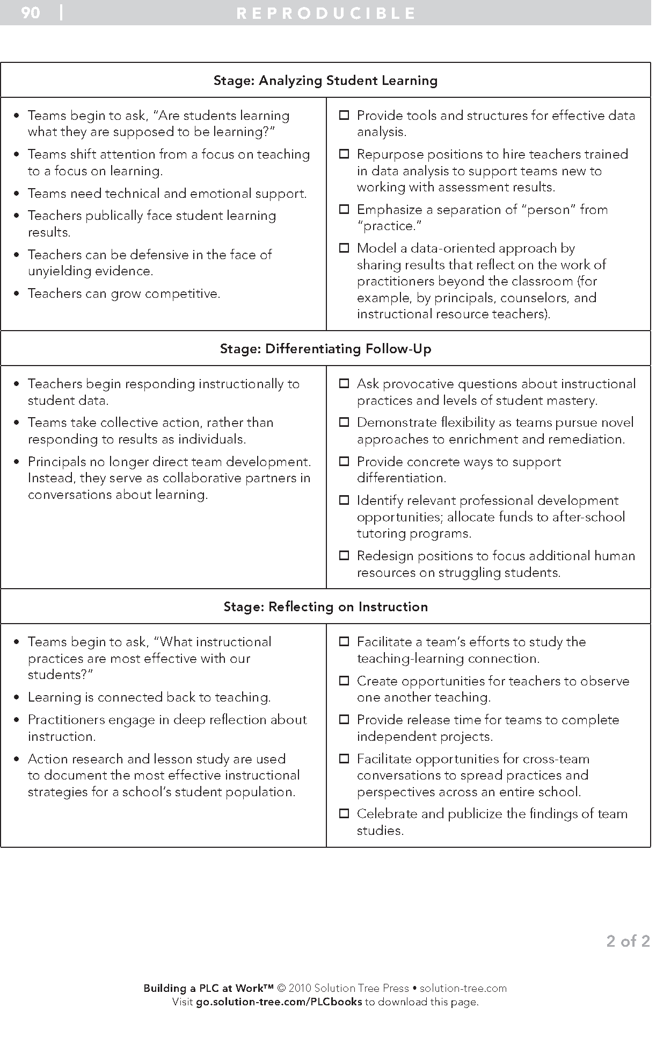

**Conversation Maps: On-Going Cycle of Assessment and Instruction**

Content Area: _______________________________________

1. Who are the students and, based on data (quantitative AND qualitative), what do they need? (Possible reflection prior to conversation.)
   1. What criteria do you use to think about your students and their learning needs?
   2. What are you going to do for these students so that the lesson matches their learning style, interest, gender, readiness, and/or culture?
   3. Consider an AAP student, benchmark student, and struggling student
   4. Describe each student, including: home life, academics (areas of strength and weakness), social skills, relevant data etc.
   5. How do you balance the needs of all learners in your class?
2. Planning for differentiated instruction
   1. What standards will be the focus of the lesson?
   2. How do you know that this is an appropriate focus for your students? What assessments have you previously given?
   3. What differentiation is needed? What pre-teaching will need to be done with students who demonstrated needs on the pre-assessment? What extension opportunities will need to be provided for students who demonstrated mastery of the standard on the pre-assessment?
   4. What teaching strategies will you use? What research/theory supports your decision?
   5. How will you check for understanding? How will you know if your students got it? What will you do it they don't? How will you motivate students who aren't showing innate interest in the topic?
3. Pre-teaching to build background knowledge
   1. What do students need to know and be able to do to understand the upcoming lesson?
   2. What resources (materials and/or people) will you access to support their learning?
   3. What information will you teach them prior to the lesson (what subsumed skills must they have to be successful)?
   4. How will you help them build links between this information and the upcoming lesson?
4. Reflecting upon instruction
   1. How did the lesson go? What happened? Did the lesson go as planned?
      1. How did the students react to the lesson?
      2. Did you need to make adjustments "on the fly"?
      3. What adaptations did you make and why?
   2. In what ways does what happened surprise you?
   3. What explanation can you give for what happened?
   4. What re-teaching (if any) is needed?
   5. If you could replay the lesson how would it go? What would you do differently?
   6. How will this lesson help you think about future lessons?
5. Intervention and Monitoring
   1. What students need additional instruction/support?
   2. What is the intervention?
   3. What best practices instructional strategies will we use for the intervention?
   4. How often will the intervention occur?
   5. Who is implementing the intervention?
   6. What resources and tools will be needed for the intervention?
   7. What data will we collect to guide the implementation of the intervention?
   8. Who will collect the data?
   9. How will it be collected?
   10. When will we regroup to assess and calibrate our action plan?
6. Assessment
   1. Through dialogue (using a protocol), develop a common understanding of the standards.
   2. Decide on the format of the assessment (e.g., multiple choice, short answer, performance) for each standard and how it will be scored (through Horizon or via a rubric).
   3. Determine when assessments will be given within the quarter when planning and pacing instruction for that quarter.
   4. Decide who will create each assessment and when the drafts are due for peer review. (Peer review could be done via e-mail)
   5. Administer the assessment to students within an agreed-upon window of time.
   6. Score the assessment within the agreed-upon time frame.
   7. Analyze the data, individually and collectively.
   8. Based on the results of the data analysis, plan for pre-teaching and teaching. (Return to Conversation Map #1)

~ Ann Delehant

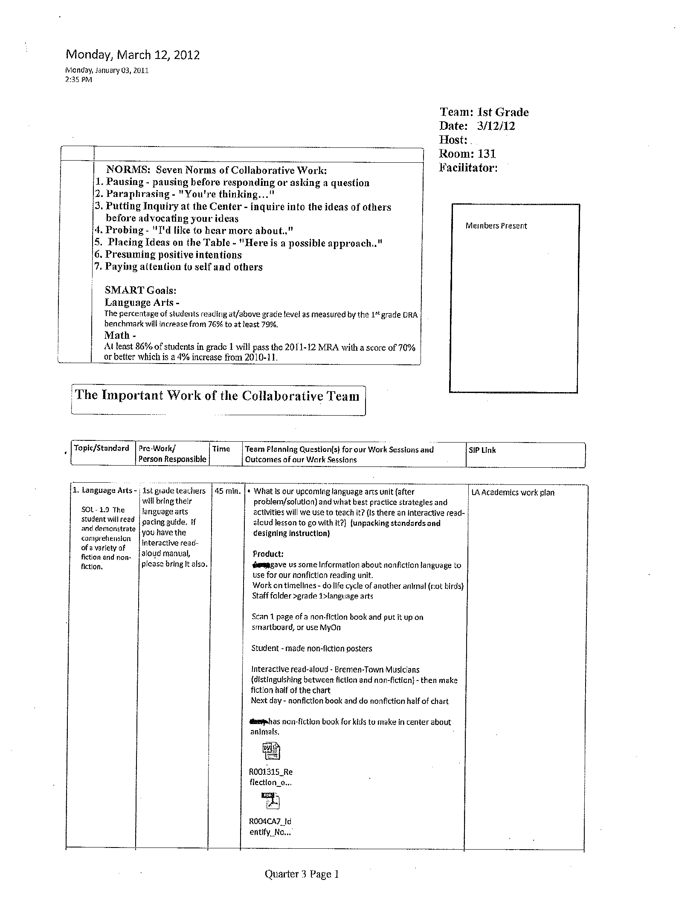

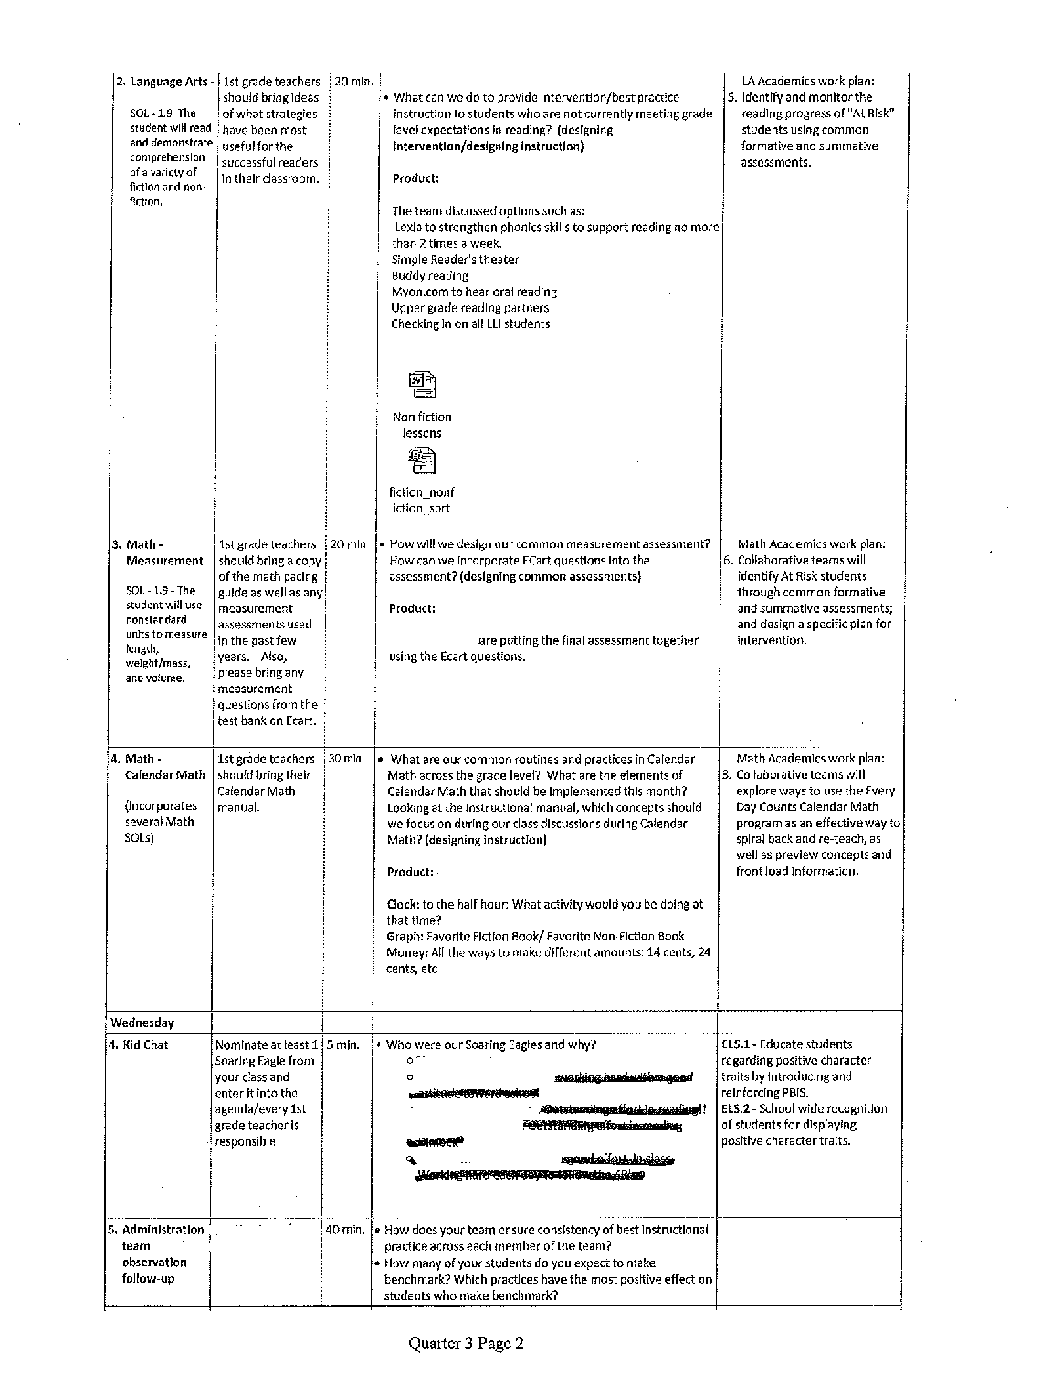

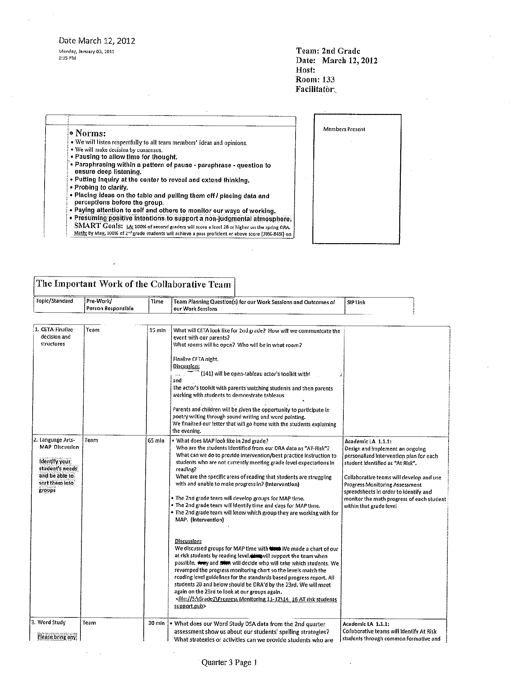

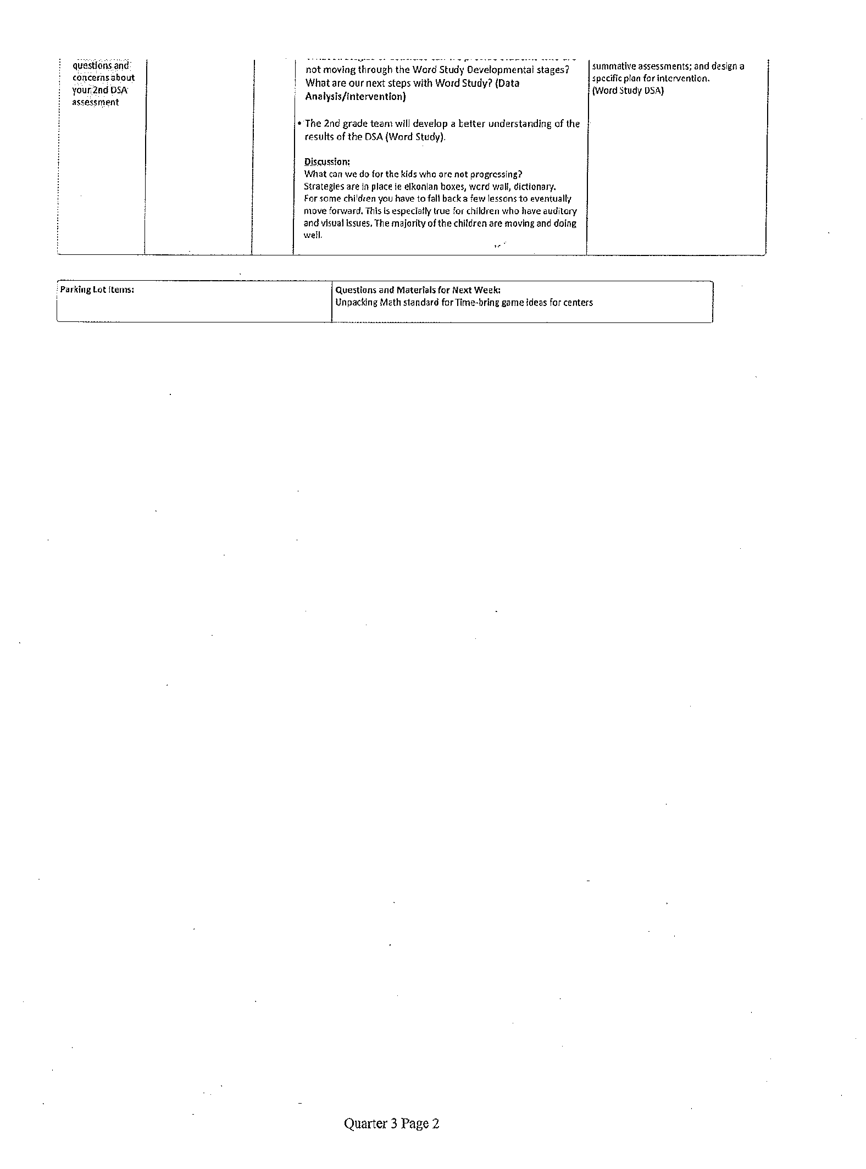

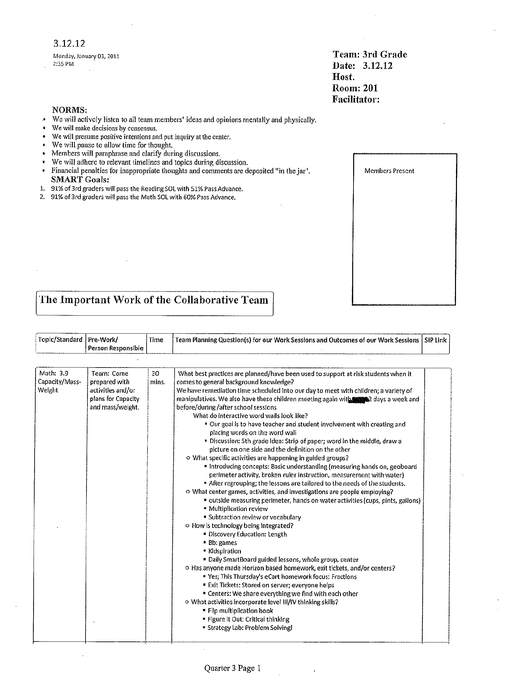

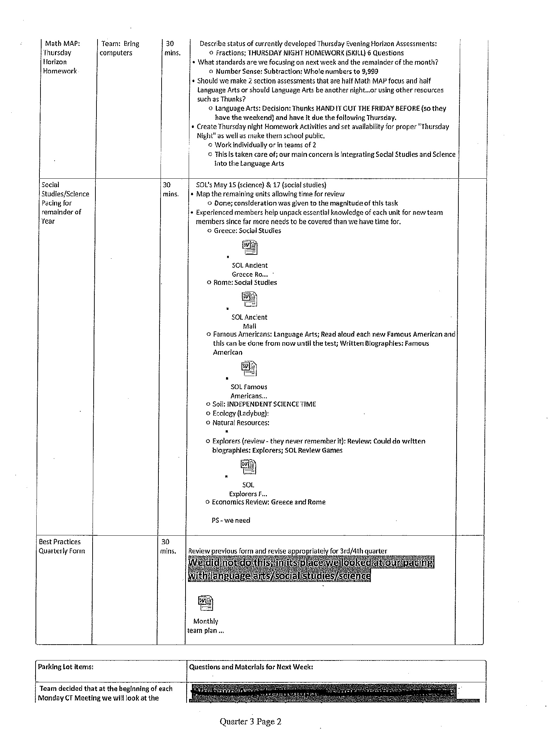



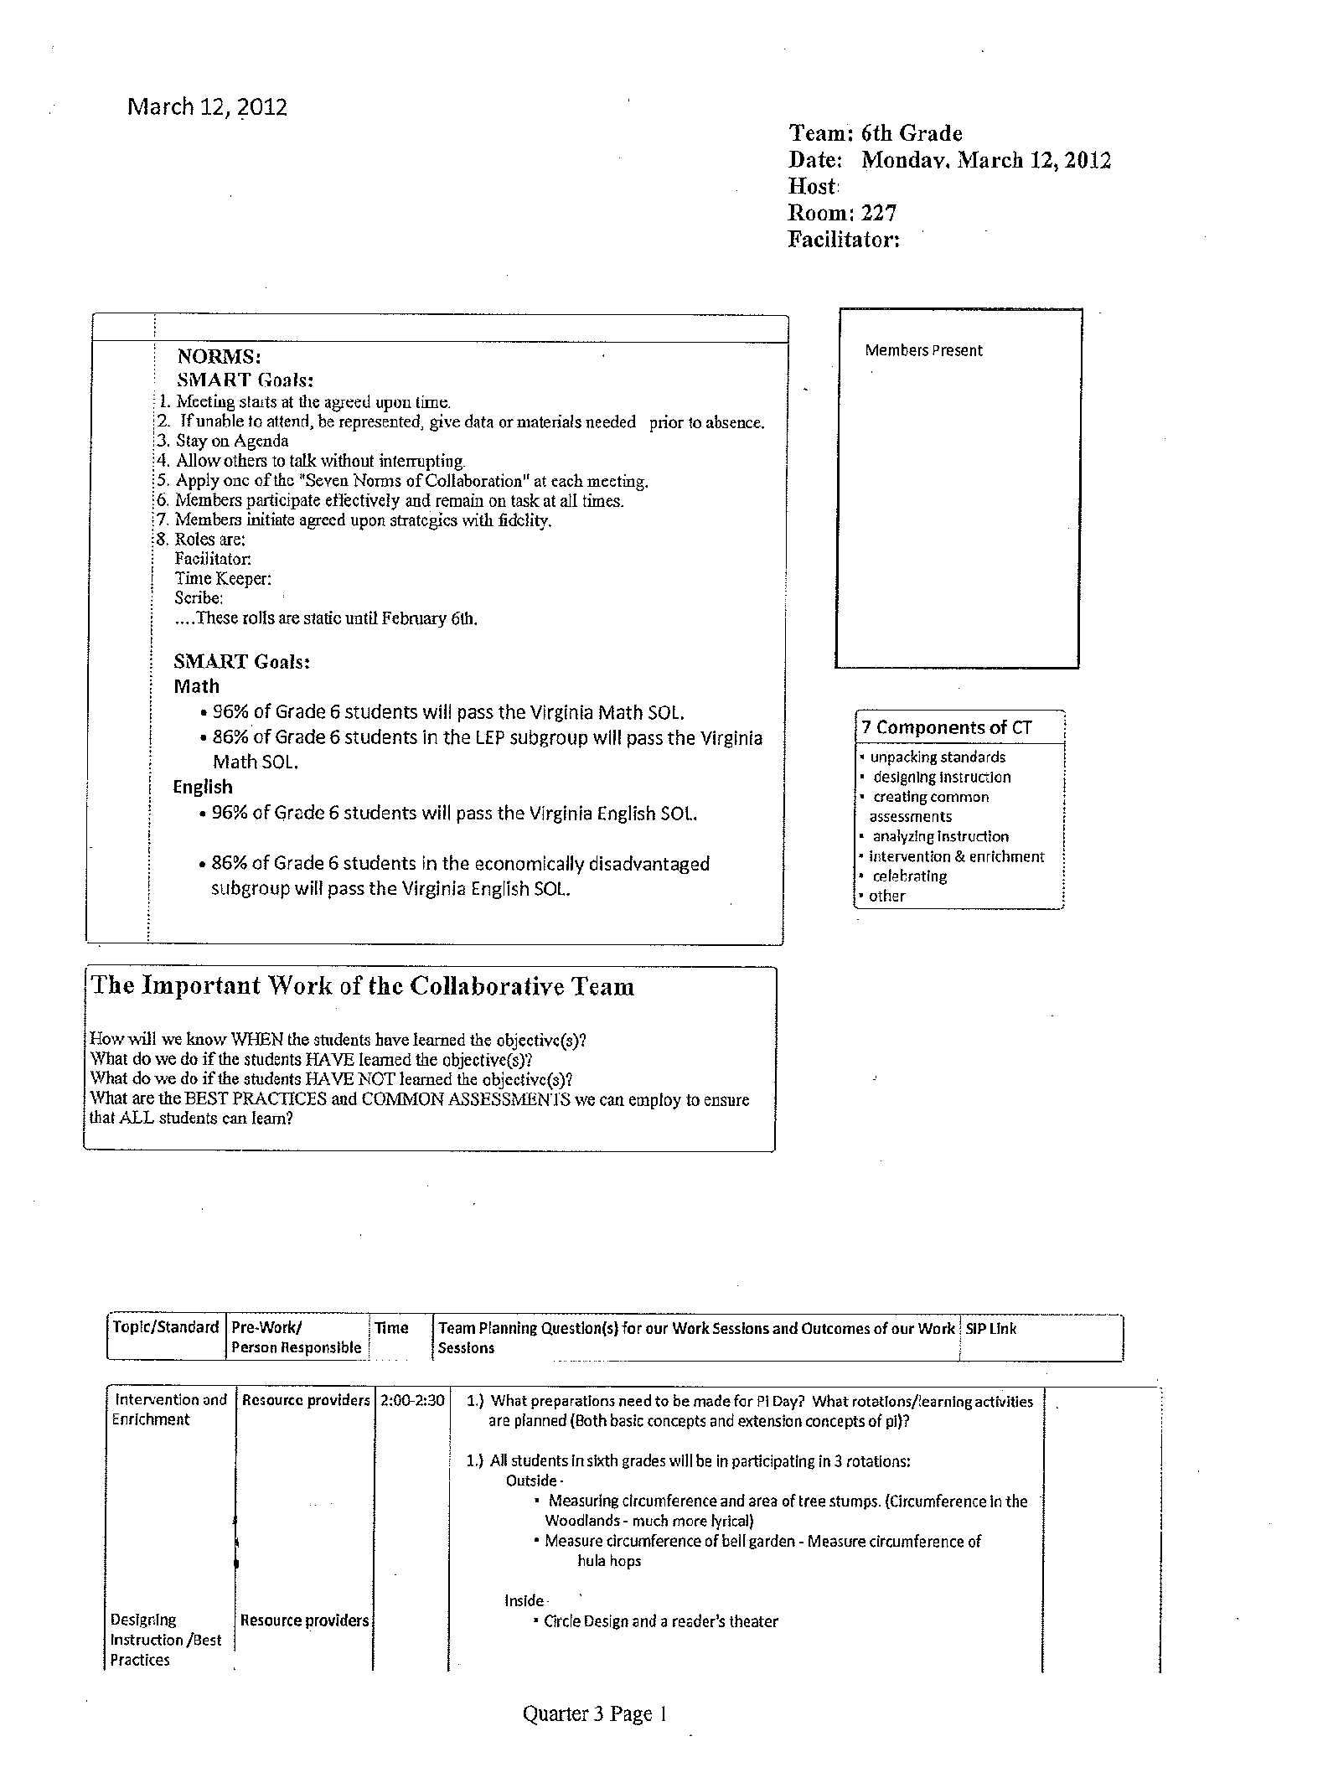

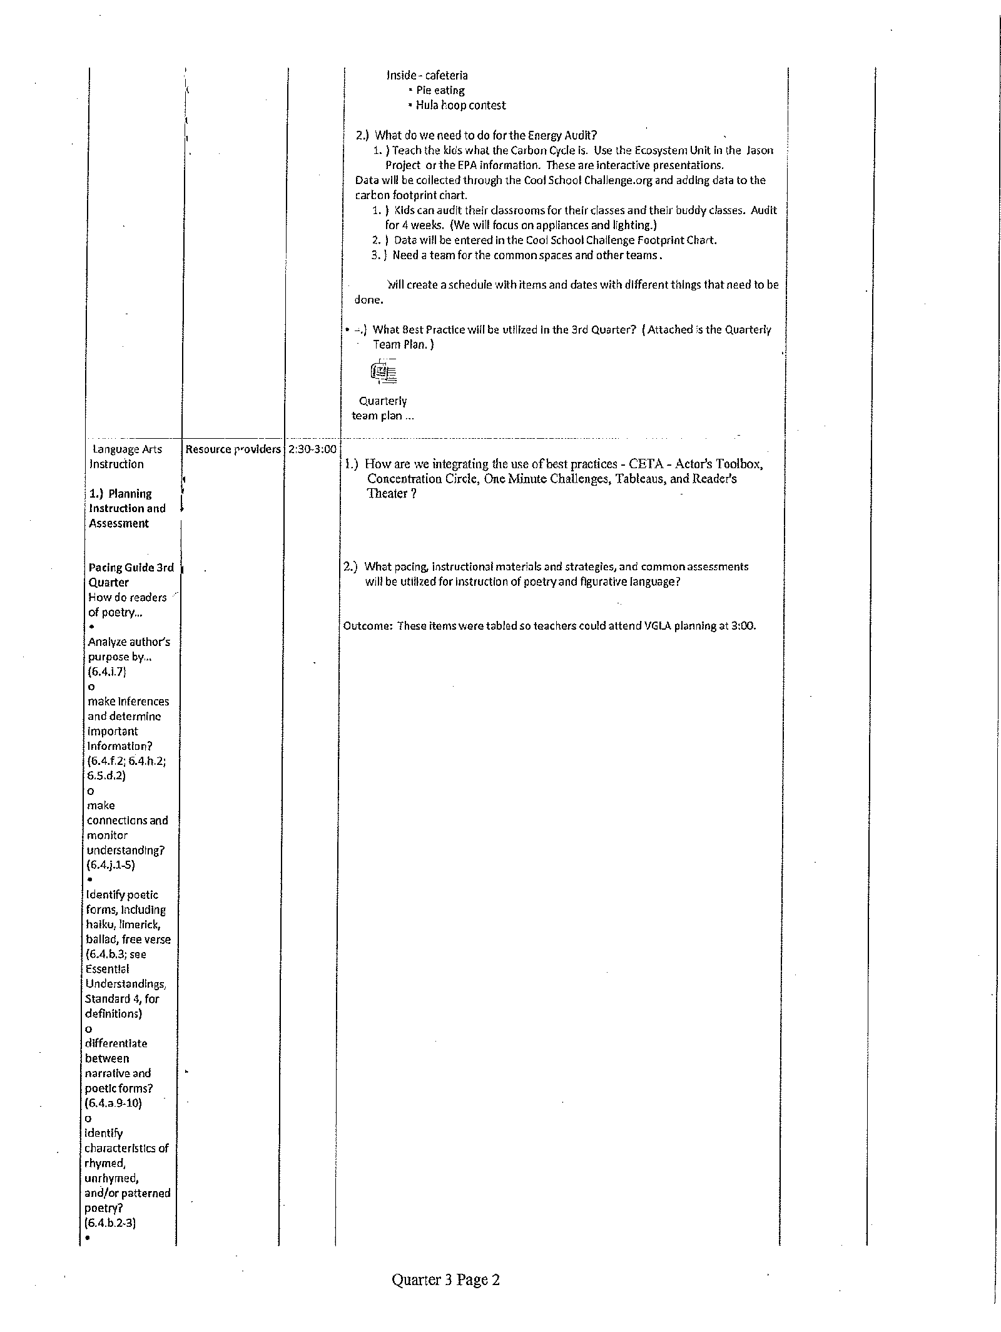

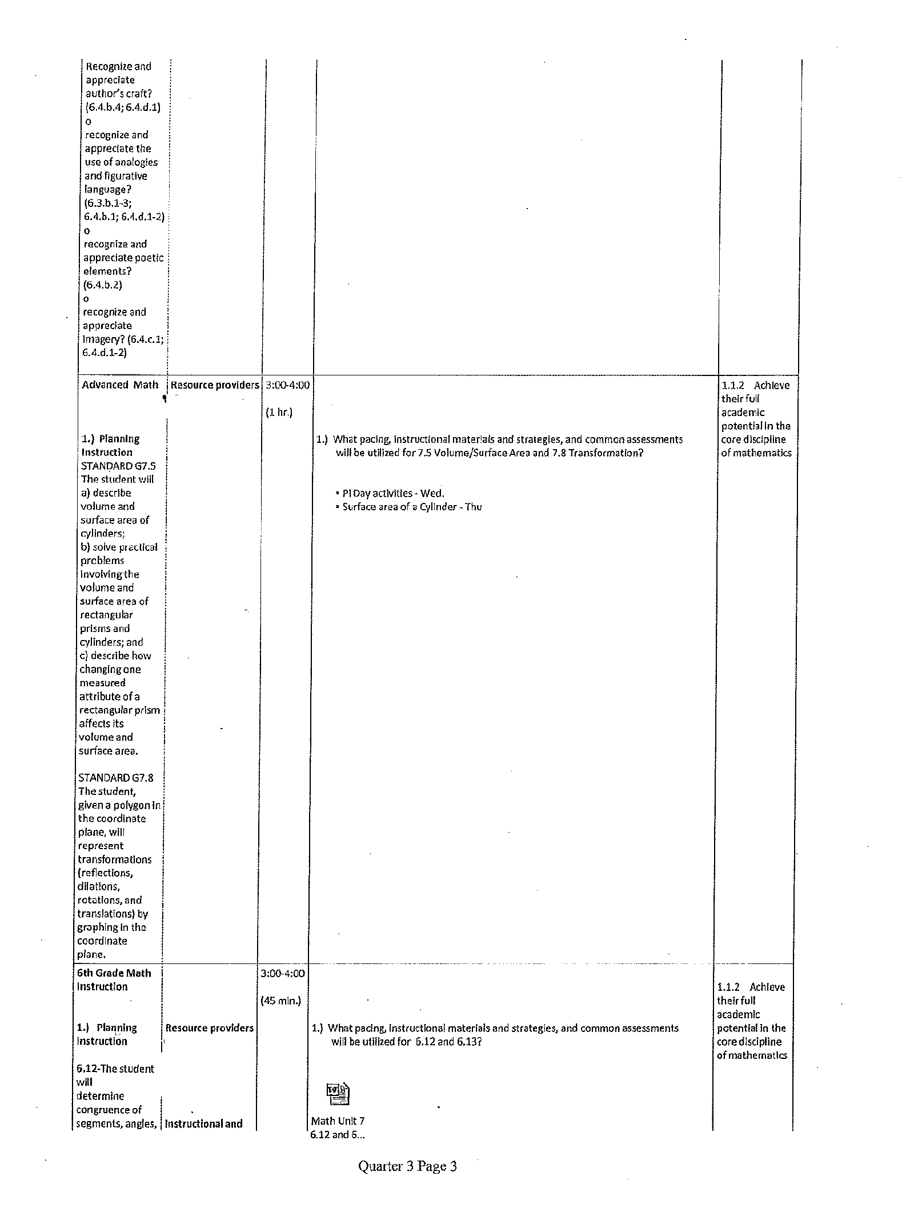



Bibliography

**Books:**

* Dufour, Richard and Rebecca. (2006) Learning by Doing. Solution Tree
* Garmston, Robert and Wellman, Bruce. (2002) The Adaptive School: Developing Collaborative Groups. Christopher-Gordon Publishers, Inc., Norwood, Massachusetts
* Garmston, Robert and Wellman, Bruce. (2009) The Adaptive School: Developing Collaborative Groups. Christopher-Gordon Publishers, Inc., Norwood, Massachusetts
* Data-Driven, A Facilitators Guide to Collaborative Inquiry, 2004.

**Websites:**

[**http://fcpsnet.fcps.edu/is/BestPractices/index.html**](http://fcpsnet.fcps.edu/is/BestPractices/index.html)

<http://go.solution-tree.com>

<http://go.solution-tree.com/plcbooks/>

**http://fcpsnet.fcps.edu/pla.**

[**http://www.allthingsplc.info**](http://www.allthingsplc.info)

**Acknowledgement:**

We look at the creation of this CT manual as another way to continue to learn as a professional community. We hope the contents of the manual help support and contribute to high functioning collaborative meetings. We encourage all staff to use the manual and feel free to help build and increase its contents.

We would like to thank all the individuals who helped us create our own CT manual-Luther Jackson MS, Langston Hughes, and other resources from Fairfax County Public Schools.