1. Summarize text 1: “Rhino Royalty”.
When summarizing remember to:
● Write about the main idea.
● include carefully selected details that link to the main idea.
● use the text structure in your response and keep your summary brief

____________________________________________________________________________

____________________________________________________________________________

____________________________________________________________________________

____________________________________________________________________________

____________________________________________________________________________

____________________________________________________________________________

____________________________________________________________________________

____________________________________________________________________________

____________________________________________________________________________

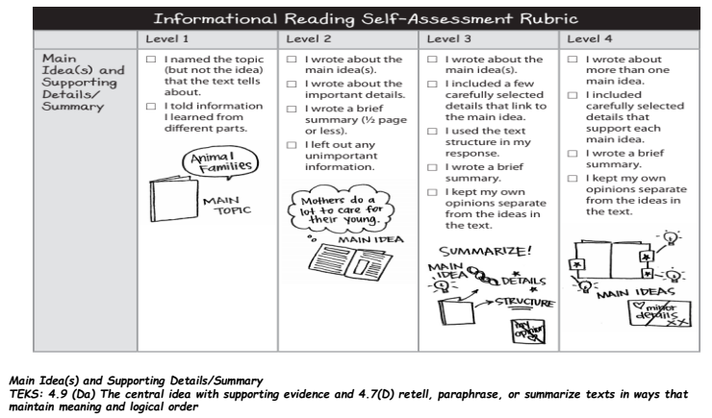

2. Why is the section “Brink of Extinction” important to the text?
When writing about how part(s) of a text fit with others, remember to:
● explain why the part is important.
● explain how the part fits with the rest of the text.

____________________________________________________________________________

____________________________________________________________________________

____________________________________________________________________________

____________________________________________________________________________

____________________________________________________________________________

____________________________________________________________________________

____________________________________________________________________________

____________________________________________________________________________

____________________________________________________________________________
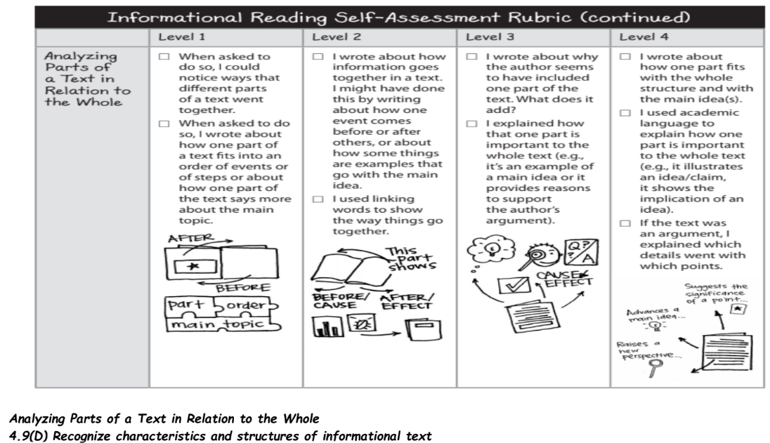

3. Both “Rhino Royalty” and “A Tiger’s Tale” teach about an important subtopic --- animal extinction. Explain briefly what these texts teach about animal extinction and how to help.

____________________________________________________________________________

____________________________________________________________________________

____________________________________________________________________________

____________________________________________________________________________

____________________________________________________________________________

____________________________________________________________________________

____________________________________________________________________________

____________________________________________________________________________

____________________________________________________________________________
